ST. MICHAEL ROMAN CATHOLIC CHURCH

751 Locust Street

PO Box 103

St. Michael, Pennsylvania 15951

Rev. Msgr. David A. Lockard, Administrator MASSES:

(814) 495-9640 Saturday 4:00 pm



Sunday Morning 9:30 am

Secretary: Michele Panick

Bookkeeper: Kathy Kalicky Daily Mass: M, T, Th, F Noon

DRE: Laurie Sloan Wed. 6:00 pm

Maintenance: Rodney Turgeon Holy Days: See Bulletin

PHONES: Office Hours:

Rectory / Office: (814) 495-9640 8:30 am to 3:30 pm

Fax: (814) 495-9424 Monday, Tues., Thurs., Friday

Rel. Education: (814) 495-4873 Confessions:

Parish Website Saturday 3:30 pm to 3:45 pm www.saintmichaelchurch.weebly.com Sunday 9:00 am to 9:15 am

Secretaries’ E-mail By Appointment

[saintmichaelsecretaries@yahoo.com](mailto:saintmichaelsecretaries@yahoo.com)

Facebook page:

St. Michael Catholic Church/St. Michael, PA

22nd Sunday in Ordinary Time

SERVING GOD AND COMMUNITY FOR OVER ONE HUNDRED YEARS!

August 30th, 2020

BAPTISM: By Appointment. Reserve at least one month in advance.

MARRIAGE: Plan at least nine months in advance.

Preparation sessions are necessary.

FUNERALS: Arrangements are made in conjunction with the funeral home.

REGISTRATION Those new to the area, newlyweds, and single adults, (even if registered

and before with their families) are asked to register by calling the Parish Office.

MEMBERSHIP: Every parishioner must be registered. This is a condition for admission

to our Program and reception of the Sacraments of Baptism, Confirmation,

First Penance, First Eucharist, and Matrimony; also, for testimonial letters or sponsorship of Baptism and Confirmation outside the Parish.

VISITATION: We are concerned and want to be advised when someone is ill at home or in the hospital. Call the office to have the shut-in placed on our monthly Holy Communion calls or seriously ill prayer list.

SACRAMENTAL Parish registration and active Mass participation for Baptism is

POLICY: encouraged and is required for Marriage.

BULLETIN ARTICLES: Articles are due to the Parish Office by Noon on Tuesday.

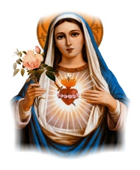 Twenty - Second Sunday in Ordinary Time

August 30th, 2020

The Month of the Immaculate Heart of Mary

**MASS INTENTIONS**: (August 31 – September 6, 2020)

Monday Noon Walter M. Lorek req. by Family

Tuesday Noon Agnes Rhoades req. by Msgr. David Lockard

Wednesday 6:00 PM Tom Paterson req. by Mark & Beverly Hull

Thursday Noon For Catholics to return to Church

First Friday Noon Janet Smith (2nd Anniversary) req. by Reba Vasas & Family

Saturday 4:00 PM Paul F. Eckenrode req. by Hilda Eckenrode

Sunday 9:30 AM People of the Parish

LITURGICIAL APPOINTMENTS:

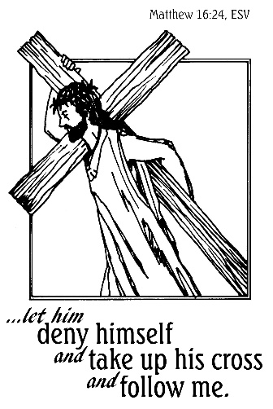

Saturday, September 5 4:00 PM

Lector: Sandy Bambino

Minister of the Host: Babe Richards

Altar Server: Alex Bambino

Cantor: Susan Blazosky

Sunday, September 6 9:30 AM

Lector: Joe Faher

Minister of the Host: Jennifer Steele

Altar Server: Alexia Steele

Cantor: Amy Dobbins

Tuesday, September 8 Collection Counters

George & Pauline Minor

Weare placing names of the sick in the bulletin for prayer providing they give permission. *May the* *Divine Physician send healing grace for those for* *whom we pray:* Allen C. Rosemas, Patricia Murphy, Bernice Myers, Dwight Fyock, Dylon Wills, Missy, Joanne (Kolar) Hufford, Christine Flanagan, Ayden Alan Grata, Mary Lou Offman, Mary Zangaglia, Natalie Zerby, Valencia Tursi, Homer Locher, Brayden Schofield, Michelle Kasper, Diane Kingera, Allison Krischer, Ted Paluch, Brandt Hutzel, Pearl Litzinger, Patrick Munro, Fran Baldassarre, Kristen Sinosky Long, Cresta Micik, Basil Costantino, Madison McCrory, Laura, Joe Yoder, Dolores Yanzetich, Sandy Krug, Wanda Gramling, Jennifer Hagans, Shawn, Holly, Shane, Spencer, Owen Taylor, Keith & Dawnetta Hoyer, Derrick Varnish, Vincent Koshute, Melissa Cordek, Michelle Elliott, Heather Romanow, Mackston Barrick, Connor Thomas, Erin, Pat, Mary Agnes Nastase, Mary Ann Bertolino, Dick Wilson, Izzy Bihun, Dorothy Kaminsky, Patricia Oshaben, Ashlee Madison, Susan Yanzetich, Mike, Danika Faith, Alina Rusnak, Gary Smay, Elizabeth Howell, Helen Bowen, Walter Bodziak, Rhonda, Dan Strinkoski, Anne Robinson, Marlene McCrory, Sharon Poldiak, Carter Bobak, Vince Arena, Mike Morris, Sarah Kelt, Patty Yanzetich Caldwell, Colton Snyder, Betty Delaney, Nancy Edmiston, Leonard Oshaben, Adam, Bill Gideos, Janice Dipyatic, Gerald Delaney, Lily Maloney, Scott, Lisa, Rosalie Ambrose, Audrey Costlow, Cathy Sossong, Rosanne Krug, Paul Snyder, Becky Kakabar, Catherine Tedjeske, Pua Ripper, Howard Delaney, Alivia Ickes, John Poldiak Jr., Ed Myers, Dolores Mucko, Tom Vandzura, Elliana, Ashlee and all of the sick of our parish, the homebound, those in nursing homes, those who care for them, and those in the military along with their families. *(Please call the Rectory to have your name removed from the list when no longer seriously ill. Thank You.)*

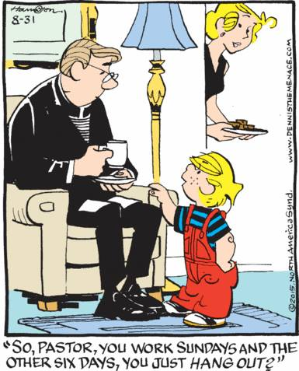

LAST WEEK’S COLLECTION

Adults $2,290.00

Loose $ 65.00

Youth $ 43.00

Monthly $ 790.00

Candles $ 28.00

Maintenance Fund $ 245.00

Ascension Thursday $ 1.00

Assumption $ 72.00

Missionary Co-op $ 150.00

Total $3,684.00

We sincerely thank and ask God’s

blessing upon all who have care

and concern for

our parish.

*August 30, 2020 (MT 16:21-27)*

*Relationships live in a careful balance. If a person changes, the balance is altered requiring a shift in the relationship. In today’s gospel Jesus announced a change and Peter resisted. Sometimes, those we count on for support may actually get in the way. Jesus told Peter: “You are an obstacle to me.”*

During the week of August 30th, 2020

The Sanctuary Candle will burn as a

71st Wedding Anniversary Remembrance for

Paul & Verna Yanzetich

requested by daughter, Susan

[](https://images.search.yahoo.com/search/images;_ylt=A0LEV1kSWptXvOwAKINXNyoA;_ylu=X3oDMTEyZGdkcmRoBGNvbG8DYmYxBHBvcwMxBHZ0aWQDQjIwODlfMQRzZWMDc2M-?p=Clipart+of+a+sanctuary+candle&fr=ush-mailn_02&th=110&tw=110&imgurl=http://www.henningers.com/389-168-wall-sanctuary-lamp.jpg&rurl=http://pixshark.com/sanctuary-lamp.htm&size=43KB&name=Sanctuary+Lamp+Bronze+wall+sanctuary+lamp&h=600&w=600&turl=http://ts2.mm.bing.net/th?id%3DOIP.M68453c67108cdc5ab485d309b395bd03o0%26pid%3D15.1%26rs%3D1%26c%3D1%26qlt%3D95%26w%3D110%26h%3D110#inline&tt=Sanctuary+Lamp+Bronze+wall+sanctuary+lamp&sigr=116keh5le&sigit=13gvlt42j&sigi=11ip0pgm4&sign=119kp6100&sigt=119kp6100)

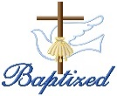BAPTISM ~ On Saturday August 29th, 2020, we celebrated the glorious baptism of Adeline Rose Potter daughter of Tyler and Anne Mary (Rhoades) Potter by Msgr. David Lockard. Adeline Rose became a new creation in Christ in the waters of Holy Baptism. Now joined to us by the gifts of faith, hope, and charity, we warmly welcome her into our St. Michael Parish Family.

FIRST FRIDAY ~ Exposition of the Blessed Sacrament will be this Friday, September 4th with adoration from 12:30 PM until 2:30 PM. Please follow the churches guidelines for social distancing.



TREASURY TICKETS ~ We are asking that each parish household sell or buy one ticket for $10.00 and return the money and ticket stub as soon as possible, but no later than September 21st. The tickets start on October 1st, 2020 and continue for the whole month of October. Winning numbers will be determined by the Pennsylvania Lottery Evening Pick Three Drawing. Weekdays payoff is $75, and weekends are $100. Columbus Day and Halloween payoff is $150. If you are unable to sell or do not want the ticket, PLEASE don’t throw it away, but return it as soon as possible as we always have people looking for extras. If paying by check, please make check payable to St. Michael Church. The money raised from the sale of these tickets will help to build up our Parish Maintenance Fund.

PLEASE NOTE! Tickets will be mailed out this week. If you did not purchase or sell your February 2020 and June 2020 tickets, you were not issued the October 2020 ticket. If you did not get a ticket and would like to purchase the October 2020 ticket, please call the office. We apologize if anyone has been accidentally missed. If you would like a ticket, please call the parish office. We do have extra tickets, so anyone wanting more than one ticket, please call the office. Thank you.

*Parish and Finance Council Members*



Catholic Ministries Drive $25,436.00

Raised: $13,553.00

Balance: $11,883.00

Number of responses: 76

Thank you to all parishioners who have responded to the *2020 Catholic Ministries Drive.* Please join them in supporting our Parish and a select group of ministries that provide outreach to the poor, family life, youth and seminarians. If you did not receive a pledge card in the mail, you may give online at [www.dioceseaj.org](http://www.dioceseaj.org).

*Stewardship Reflections…*

Jesus calls on us to deny ourselves and follow him. Perhaps he is trying to help us see that everything we *think* we own is really a gift from God. Stewardship is a call to discern our wants from our needs, a call to simplicity, a call to prioritize our lives so we can spend our precious time and resources on what is truly important.



Religious Education And Christian Helping

Religious Education News

Religious Education registration is planned for our 2020 / 2021 RE Year. Watch your mail

this coming week for an envelope with a new registration form and other pertinent forms for our

upcoming year. Please complete and return the forms so your children can be registered for

the 2020 / 2021 RE Year. We plan to start our fall semester with a Home Schooling module

with necessary materials being sent home with each family. More information will follow.

St. Teresa of Calcutta Feast Day

September 5

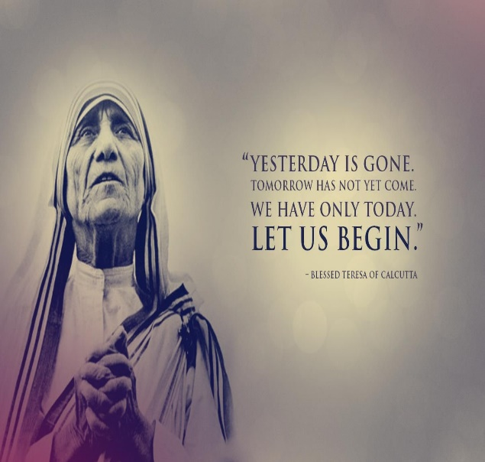

 Sunday, August 30 Mass ~ 9:30 AM

Confessions / 9:00 – 9:15 AM

Monday, August 31 Mass ~ Noon

NO Sunday Choir Practice

Tuesday, September 1 Mass ~ Noon

Wednesday, September 2 Mass ~ 6:00 PM

Thursday, September 3 Mass ~ Noon

NO Saturday Choir Practice

First Friday, September 4 Mass ~ Noon

Exposition of the Blessed Sacrament with Adoration / 12:30 – 2:30 PM

Saturday, September 5 Mass / 4:00 PM

Confessions / 3:30 – 3:45

 UPCOMING EVENTS

September 7 Labor Day / Parish Offices closed

September 12 & 13 Religious Education Collection

Second Sunday Food Pantry Collection

September 19 Voytek/Kostan Nuptials

September 20 Parish Council Meeting

