ST. MICHAEL ROMAN CATHOLIC CHURCH
751 Locust Street
PO Box 103
St. Michael, Pennsylvania 15951

Rev. Msgr. David A. Lockard, Administrator MASSES:
(814) 495-9640 Saturday 4:00 pm
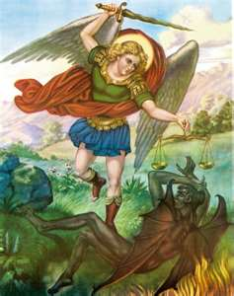
Sunday Morning 9:30 am
Secretary: Michele Panick
Bookkeeper: Kathy Kalicky Daily Mass: M, T, Th, F Noon
DRE: Laurie Sloan Wed. 6:00 pm
Maintenance: Rodney Turgeon Holy Days: See Bulletin
PHONES: Office Hours:
Rectory / Office: (814) 495-9640 8:30 am to 3:30 pm
Fax: (814) 495-9424 Monday, Tues., Thurs., Friday
Rel. Education: (814) 495-4873 Confessions:
Parish Website Saturday 3:30 pm to 3:45 pm www.saintmichaelchurch.weebly.com Sunday 9:00 am to 9:15 am
Secretaries’ E-mail By Appointment
saintmichaelsecretaries@yahoo.com
Facebook page:
St. Michael Catholic Church/St. Michael, PA

21st Sunday in Ordinary Time

SERVING GOD AND COMMUNITY FOR OVER ONE HUNDRED YEARS!

August 23rd, 2020

BAPTISM: By Appointment. Reserve at least one month in advance.
MARRIAGE: Plan at least nine months in advance.
Preparation sessions are necessary.
FUNERALS: Arrangements are made in conjunction with the funeral home.
REGISTRATION Those new to the area, newlyweds, and single adults, (even if registered
and before with their families) are asked to register by calling the Parish Office.
MEMBERSHIP: Every parishioner must be registered. This is a condition for admission
to our Program and reception of the Sacraments of Baptism, Confirmation,
First Penance, First Eucharist, and Matrimony; also, for testimonial letters or sponsorship of Baptism and Confirmation outside the Parish.
VISITATION: We are concerned and want to be advised when someone is ill at home or in the hospital. Call the office to have the shut-in placed on our monthly Holy Communion calls or seriously ill prayer list.
SACRAMENTAL Parish registration and active Mass participation for Baptism is
POLICY: encouraged and is required for Marriage.
BULLETIN ARTICLES: Articles are due to the Parish Office by Noon on Tuesday.

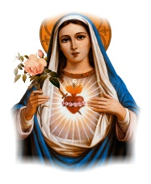
Twenty - First Sunday in Ordinary Time
August 23rd, 2020
The Month of the Immaculate Heart of Mary

MASS INTENTIONS: (August 24 – August 30, 2020)

Monday Noon Ray & Irene Baldwin req. by Carl & Pam Freidhoff
Tuesday Noon Agnes Plummer (Months Mind) req. by George & Janet Minor Family
Wednesday 6:00 PM Michael Hudak Sr. req. by Michael & Regina Barton
Thursday Noon Nancy Facciani req. by Dwayne & Rose Mary Gallager
Friday Noon Cathy McMahon req. by Harteis Family
Saturday 4:00 PM People of the Parish
Sunday 9:30 AM Jane Plummer req. by Cathy & Loretta Tedjeske

LITURGICIAL APPOINTMENTS:

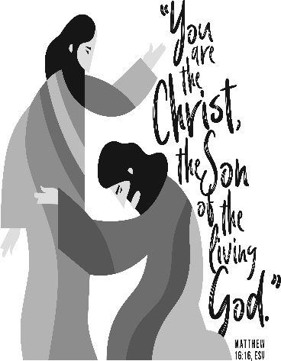
Saturday, August 29 4:00 PM

Lector: Susan Poldiak
Minister of the Host: Theresa Carlson
Altar Server: Karen Myers
Cantor: David Zajdel

Sunday, August 30 9:30 AM

Lector: Arnold Bernard
Minister of the Host: Amanda Williamson
Altar Server: Alexis Henderson
Cantor: Anita Lorek

MINISTRY SCHEDULES ~ Lay ministry schedules have been mailed to ministers that are scheduled for the month of August. If you cannot serve your assigned date & time, please switch with someone who is also on the August schedule. If you cannot find a replacement, please call the office in advance.

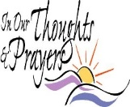
We are placing names of the sick in the bulletin for prayer providing they give permission. May the Divine Physician send healing grace for those for whom we pray: Allen C. Rosemas, Patricia Murphy, Bernice Myers, Dwight Fyock, Dylon Wills, Missy, Joanne (Kolar) Hufford, Christine Flanagan, Ayden Alan Grata, Mary Lou Offman, Mary Zangaglia, Natalie Zerby, Valencia Tursi, Homer Locher, Brayden Schofield, Michelle Kasper, Diane Kingera, Allison Krischer, Ted Paluch, Brandt Hutzel, Pearl Litzinger, Patrick Munro, Fran Baldassarre, Kristen Sinosky Long, Cresta Micik, Basil Costantino, Madison McCrory, Laura, Joe Yoder, Dolores Yanzetich, Sandy Krug, Wanda Gramling, Jennifer Hagans, Shawn, Holly, Shane, Spencer, Owen Taylor, Keith & Dawnetta Hoyer, Derrick Varnish, Vincent Koshute, Melissa Cordek, Michelle Elliott, Heather Romanow, Mackston Barrick, Connor Thomas, Erin, Pat, Mary Agnes Nastase, Mary Ann Bertolino, Dick Wilson, Izzy Bihun, Dorothy Kaminsky, Patricia Oshaben, Ashlee Madison, Susan Yanzetich, Mike, Danika Faith, Alina Rusnak, Gary Smay, Elizabeth Howell, Helen Bowen, Walter Bodziak, Rhonda, Dan Strinkoski, Anne Robinson, Marlene McCrory, Sharon Poldiak, Carter Bobak, Vince Arena, Mike Morris, Sarah Kelt, Patty Yanzetich Caldwell, Colton Snyder, Betty Delaney, Nancy Edmiston, Leonard Oshaben, Adam, Bill Gideos, Janice Dipyatic, Gerald Delaney, Lily Maloney, Scott, Lisa, Rosalie Ambrose, Audrey Costlow, Cathy Sossong, Rosanne Krug, Paul Snyder, Becky Kakabar, Catherine Tedjeske, Pua Ripper, Howard Delaney, Alivia Ickes, John Poldiak Jr., Ed Myers, Dolores Mucko, Tom Vandzura and all of the sick of our parish, the homebound, those in nursing homes, those who care for them, and those in the military along with their families. (Please call the Rectory to have your name removed from the list when no longer seriously ill. Thank You.)

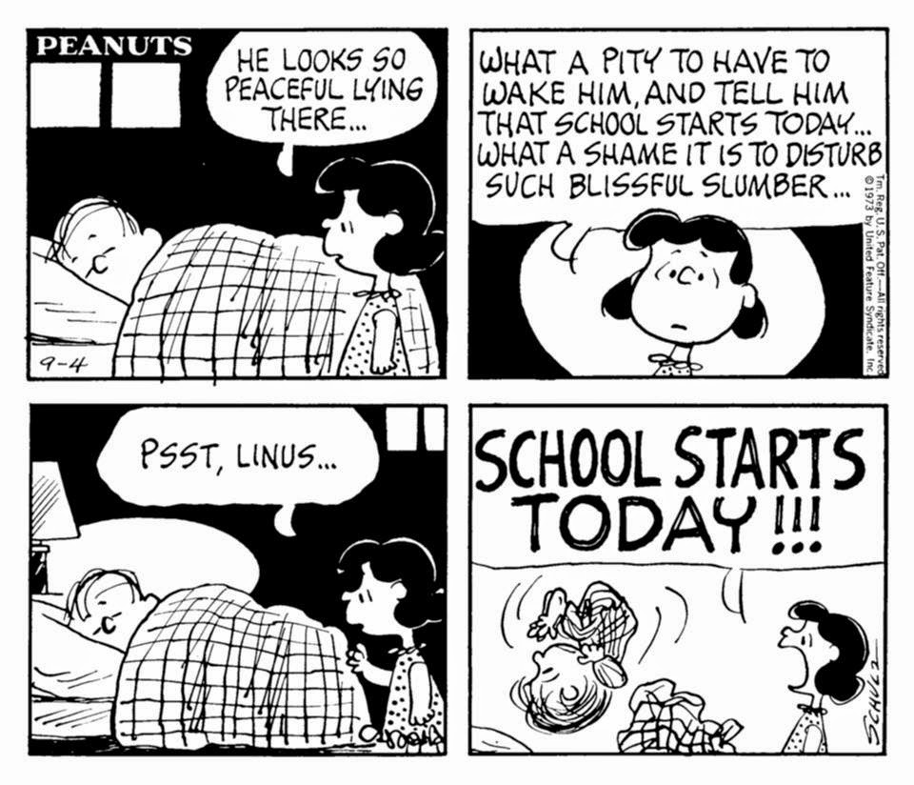

LAST WEEK’S COLLECTION

Adults $2,606.00
Loose $ 59.00
Youth $ 5.00
Monthly $ 145.00
Candles $ 22.00
Maintenance Fund $ 35.00
Assumption $ 431.00
Missionary Co-op $ 702.00
Total $4,005.00

We sincerely thank
and ask God’s
blessing upon all
who have care
and concern for
our parish.

August 23, 2020 (MT 16:13-20)
Like Jesus in today’s gospel, we are seen by others in different ways. Perhaps the name our family gives us is closest to our true identity. They know us best. Who do they say you are?

During the week of August 23rd, 2020
The Sanctuary Candle will burn as a
birthday remembrance for
Marianne Bodenschatz
and
The Our Lady of Grace Candle will burn for the
Students, Teachers, Administration and Parents
that they will have a successful 2020-2021 school year

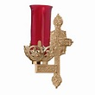

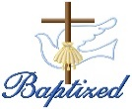
BAPTISM ~ On Saturday August 22nd, 2020, we celebrated the glorious baptism of Henry James Ferrante son of Michael and Cara (Smay) Ferrante by Fr. Brian Warchola. Henry James became a new creation in Christ in the waters of Holy Baptism. Now joined to us by the gifts of faith, hope, and charity, we warmly welcome him into our St. Michael Parish Family.

HOLY NAME SOCIETY ~ The Holy Name Society will be having a meeting this Wednesday, August 26th, after the 6:00 PM Mass at the Pavilion.

MISSIONARY CO-OP ~ Thank you for you generosity to our Missionary Co-op. Our total to date is $702.00.

FIRST FRIDAY ~ Exposition of the Blessed Sacrament will be First Friday, September 4th with adoration from 12:30 PM until 2:30 PM. Please follow the churches guidelines for social distancing.

VISIT ENGLAND’S TREASURES ~ April 21 – May 2, 2021. Visit Liverpool, Bath, Stonehenge, and London. Cost: $4,499 (Single - $5,399) includes Round Trip Air from Pittsburgh, all taxes and fees/surcharges, hotel transfers. Please join a special Zoom Meeting about the trip Tuesday, Sept. 1 from 3 – 4 PM: https://collette.zoom.us/meeting/register/tJAkdOqvrTksG90UF3FrRxcstdWvKciYjhZ4
You can email Fr. Brian Saylor to be sent the above link – bsaylor@diocesaj.org. For more information, contact Collette @ 844-218-2148; Please refer to Booking #987192. Visit the Group Web Page: https://gateway.gocollette.com/link/987192. Fr. Brian Saylor, St. Rose of Lima, Altoona, 944-8509.

Stewardship Reflections…
How can you make an intentional decision to use the gifts given to you by God, “through Him and for Him” to build up the kingdom of God on earth? Make a simple plan that as a family you can begin to “remodel” and strengthen the Kingdom.

St. John the Baptist

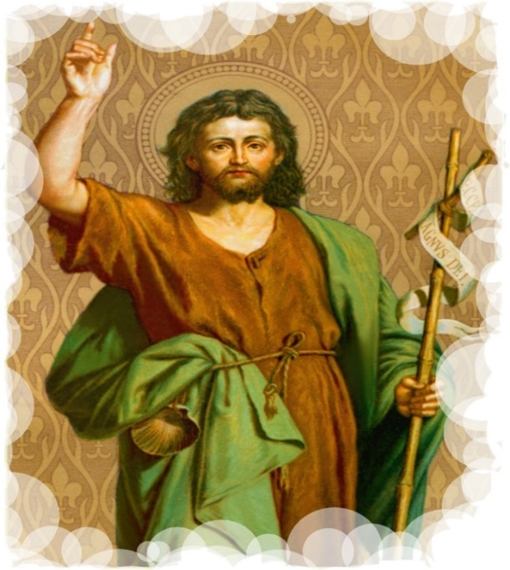

ST. JOHN THE BAPTIST ~ Memorial of the Passion of St. John the Baptist – August 29th, 2020.

St. John the Baptist was truly the forerunner of the Messiah. Always one step ahead of
Jesus’ ministry. John was born first, began his ministry first, and died a martyr’s death first.
And it was clear that Jesus loved him, being deeply grieved when he heard the news of his
beheading at the hand of King Herod. Read: Matthew 14:1-12. Jesus praised John the
Baptist highly by saying, “Truly I tell you, among those born of women no one has arisen
greater than John the Baptist.” One of the most highly venerated saints he has two
feast days: His Nativity on June 24th and his Passion on August 29th.

Sunday August 23 Mass ~ 9:30 AM
Confessions / 9:00 – 9:15 AM

Monday, August 24 Mass ~ Noon
NO Sunday Choir Practice

Tuesday, August 25 Mass ~ Noon

Wednesday, August 26 Mass ~ 6:00 PM
Holy Name Society Meeting / Pavilion / After 6:00 PM Mass

Thursday, August 27 Mass ~ Noon
NO Saturday Choir Practice

Friday, August 28 Mass ~ Noon

Saturday, August 29 Mass / 4:00 PM
Confessions / 3:30 – 3:45
Adeline Rose Potter Baptism / 10:00 AM

UPCOMING EVENTS
September 4 First Friday / Eucharistic Adoration
September 7 Labor Day / Parish Offices closed
September 19 Voytek/Kostan Nuptials

