ST. MICHAEL ROMAN CATHOLIC CHURCH

751 Locust Street

PO Box 103

St. Michael, Pennsylvania 15951

Rev. Msgr. David A. Lockard, Administrator MASSES:

(814) 495-9640 Saturday 4:00 pm



Sunday Morning 9:30 am

Secretary: Michele Panick

Bookkeeper: Kathy Kalicky Daily Mass: M, T, Th, F Noon

DRE: Laurie Sloan Wed. 6:00 pm

Maintenance: Rodney Turgeon Holy Days: See Bulletin

PHONES: Office Hours:

Rectory / Office: (814) 495-9640 8:30 am to 3:30 pm

Fax: (814) 495-9424 Monday, Tues., Thurs., Friday

Rel. Education: (814) 495-4873 Confessions:

Parish Website Saturday 3:30 pm to 3:45 pm www.saintmichaelchurch.weebly.com Sunday 9:00 am to 9:15 am

Secretaries’ E-mail By Appointment

[saintmichaelsecretaries@yahoo.com](mailto:saintmichaelsecretaries@yahoo.com)

Facebook page:

St. Michael Catholic Church/St. Michael, PA

17th Sunday in Ordinary Time

SERVING GOD AND COMMUNITY FOR OVER ONE HUNDRED YEARS!

July 26th, 2020

BAPTISM: By Appointment. Reserve at least one month in advance.

MARRIAGE: Plan at least nine months in advance.

Preparation sessions are necessary.

FUNERALS: Arrangements are made in conjunction with the funeral home.

REGISTRATION Those new to the area, newlyweds, and single adults, (even if registered

and before with their families) are asked to register by calling the Parish Office.

MEMBERSHIP: Every parishioner must be registered. This is a condition for admission

to our Program and reception of the Sacraments of Baptism, Confirmation,

First Penance, First Eucharist, and Matrimony; also, for testimonial letters or sponsorship of Baptism and Confirmation outside the Parish.

VISITATION: We are concerned and want to be advised when someone is ill at home or in the hospital. Call the rectory to have the shut-in placed on our monthly Holy Communion calls or seriously ill prayer list.

SACRAMENTAL Parish registration and active Mass participation for Baptism is

POLICY: encouraged and is required for Marriage.

BULLETIN ARTICLES: Articles are due to the Parish Office by Noon on Tuesday.

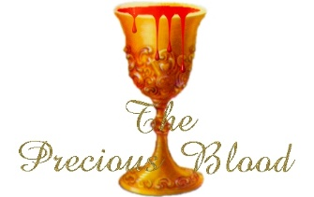 Seventeenth Sunday in Ordinary Time

July 26th, 2020

The Precious Blood of Jesus

**MASS INTENTIONS**: (July 27 – August 2, 2020)

Monday Noon Edward & Margaret Yanzetich req. by David & Patricia Caldwell

Tuesday Noon Sally Castel (Month’s Mind) req. by Uncle Nick & Aunt Pauline Minor

Wednesday 6:00 PM Kevin Smay req. by Elaine Barton

Thursday Noon Joseph Ropecka req. by Terry & Ethel Sheppard

First Friday Noon Francis Ritz req. by Joan Patterson & Janice Gracner

Saturday 4:00 PM People of the Parish

Sunday 9:30 AM Nicoletta Cononie req. by Mike & Lucia Ann Brezovec

LITURGICIAL APPOINTMENTS:

Saturday, August 1 4:00 PM



Lector: Sandy Bambino

Minister of the Host: Mike Barton

Altar Server: Alex Bambino

Cantor: David Zajdel

Sunday, August 2 9:30 AM

Lector: Cathy Faher

Minister of the Host: Paul Kundrod

Altar Server: Zach Fisher

Cantor: Amy Dobbins

Sunday, August 2 Collection Counters

Chris Smay, Sara Zybura

Mary Ann DeRosa

MINISTRY SCHEDULES ~ Lay ministry schedules have been mailed to ministers that are scheduled for the month of August. If you cannot serve your assigned date & time, please switch with someone who is also on the August schedule. If you cannot find a replacement, please call the office in advance.

Weare placing names of the sick in the bulletin for prayer providing they give permission. *May the* *Divine Physician send healing grace for those for* *whom we pray:* Allen C. Rosemas, Patricia Murphy, Bernice Myers, Dwight Fyock, Dylon Wills, Missy, Joanne (Kolar) Hufford, Christine Flanagan, Ayden Alan Grata, Mary Lou Offman, Mary Zangaglia, Natalie Zerby, Valencia Tursi, Homer Locher, Brayden Schofield, Michelle Kasper, Diane Kingera, Allison Krischer, Ted Paluch, Brandt Hutzel, Pearl Litzinger, Patrick Munro, Fran Baldassarre, Kristen Sinosky Long, Cresta Micik, Basil Costantino, Madison McCrory, Laura, Joe Yoder, Dolores Yanzetich, Sandy Krug, Wanda Gramling, Agnes Plummer, Jennifer Hagans, Shawn, Holly, Shane, Spencer, Owen Taylor, Keith & Dawnetta Hoyer, Derrick Varnish, Vincent Koshute, Melissa Cordek, Michelle Elliott, Heather Romanow, Mackston Barrick, Connor Thomas, Erin, Pat, Mary Agnes Nastase, Mary Ann Bertolino, Dick Wilson, Izzy Bihun, Dorothy Kaminsky, Patricia Oshaben, Ashlee Madison, Susan Yanzetich, Mike, Danika Faith, Alina Rusnak, Gary Smay, Elizabeth Howell, Helen Bowen, Walter Bodziak, Rhonda, Dan Strinkoski, Anne Robinson, Marlene McCrory, Sharon Poldiak, Carter Bobak, Vince Arena, Mike Morris, Sarah Kelt, Patty Yanzetich Caldwell, Colton Snyder, Betty Delaney, Nancy Edmiston, Leonard Oshaben, Adam, Bill Gideos, Janice Dipyatic, Gerald Delaney, Lily Maloney, Adam Wingard, Scott, Lisa, Rosalie Ambrose, Audrey Costlow, Carole Horner, Ross Linert, Cathy Sossong, Rosanne Krug, Paul Snyder, Becky Kakabar, Catherine Tedjeske, Pua Ripper, Howard Delaney, Alivia Ickes, John Poldiak Jr., Sandy Hoyer and all of the sick of our parish, the homebound, those in nursing homes, those who care for them, and those in the military along with their families. *(Please call the Rectory to have your name removed from the list when no longer seriously ill. Thank You.)*

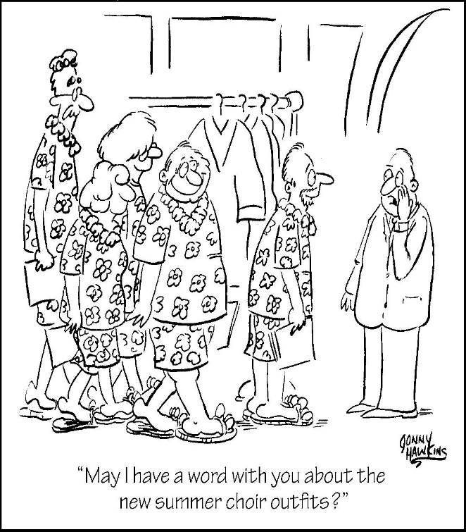

LAST WEEK’S COLLECTION

Adults $2,904.00

Loose $ 14.00

Youth $ 6.00

Monthly $ 718.00

Candles $ 23.00

Maintenance Fund $ 130.00

Ascension Thursday $ 5.00

Assumption $ 15.00

Catholic Register Sub. $ 15.00

Catholic Communication $ 1.00

Cemetery Maintenance $ 35.00

Easter Flowers $ 5.00

Total $3,871.00

We sincerely thank and ask

God’s blessing upon all

who have care and

concern for our

parish.

*July 26, 2020*

*Like King Solomon, using God’s gifts of wisdom and understanding, we should be able to discern what treasures we have been given to be used to meet the greatest public needs. The parables in today’s readings from Matthew are also about choices and whether we have the discernment to choose wisely what we will share of the portions of the gifts we have been given through God’s goodness and generosity.*

During the week of July 26th, 2020

the Sanctuary Candle will burn for the

Sick & Shut-Ins of our Parish

[](https://images.search.yahoo.com/search/images;_ylt=A0LEV1kSWptXvOwAKINXNyoA;_ylu=X3oDMTEyZGdkcmRoBGNvbG8DYmYxBHBvcwMxBHZ0aWQDQjIwODlfMQRzZWMDc2M-?p=Clipart+of+a+sanctuary+candle&fr=ush-mailn_02&th=110&tw=110&imgurl=http://www.henningers.com/389-168-wall-sanctuary-lamp.jpg&rurl=http://pixshark.com/sanctuary-lamp.htm&size=43KB&name=Sanctuary+Lamp+Bronze+wall+sanctuary+lamp&h=600&w=600&turl=http://ts2.mm.bing.net/th?id%3DOIP.M68453c67108cdc5ab485d309b395bd03o0%26pid%3D15.1%26rs%3D1%26c%3D1%26qlt%3D95%26w%3D110%26h%3D110#inline&tt=Sanctuary+Lamp+Bronze+wall+sanctuary+lamp&sigr=116keh5le&sigit=13gvlt42j&sigi=11ip0pgm4&sign=119kp6100&sigt=119kp6100)

[](http://www.churchart.com/subscriber/viewimages.aspx?keywords=In%20Sympathy&entry_date=1/1/0001&image_type=,cl#no)

MAY SHE REST IN PEACE ~ In your charity, please pray for the eternal rest of Anna Podrebarac whose Funeral Mass was celebrated on Thursday, July 23rd, 2020 by Msgr. Lockard. May she know the eternal peace and happiness promised by our Savior, Lord Jesus. Please pray for the consolation of all her family and friends.

FIRST FRIDAY ~ Exposition of the Blessed Sacrament will be First Friday, August 7th with adoration from 12:30 PM until 2:30 PM. Please follow the churches guidelines for social distancing.

LAY MINISTERS ~ Ministry schedules were mailed for the month of August. If you are unable to keep your assigned date & time, please find a replacement or call the office in advance.

FALL CLASSES ~ Faith formation is a life-long endeavor. By virtue of our baptism, we are called to continually grow closer to Christ through a life of prayer, service, and knowledge of our faith. The Office of Adult Enrichment and Lay Ecclesial Ministry has announced the following classes for the 2020 Fall Schedule: *Heart of Faith, Old Testament, New Testament, Wisdom Literature and Psalms.* For a description of classes, locations, times, registration forms and to learn more about our programs visit [www.dioceseaj.org/lay-ecclesial-ministry/](http://www.dioceseaj.org/lay-ecclesial-ministry/) or contact Marybeth at 814-361-2000. All are welcome!

ANNUAL WEDDING ANNIVERSARY LITURGY ~ Bishop Mark Bartchak and the Family Life Office cordially invite all couples celebrating 1, 5, 10, 25, 40, 50, 55, and 60+ Wedding Anniversary in 2020 (and their families) to attend the Annual Wedding Anniversary Liturgy. Couples may attend Sunday, September 13 in ALTOONA at Cathedral of the Blessed Cathedral or Sunday, September 20 in JOHNSTOWN at St. John Gualbert Cathedral. Both locations are handicap accessible. Liturgies in each location begin at 2:00 PM. Bishop Mark will be the celebrant and homilist at each celebration. Refreshments/snacks will be available after the mass for anniversary couples and their families. Reservations must be made through your parish for either celebration by Wednesday, August 19th.



Religious Education And Christian Helping

FIRST HOLY COMMUNION ~ Our Second-Grade class is preparing to receive First Holy Communion on Saturday, August 1st, 2020 at a 10:00 AM Mass. Reconciliation for them will be on Wednesday, July 29th at 6:30 PM. First Communion Practice will be on Friday, July 31st at 6:30 PM.

KNIGHTS OF COLUMBUS SCHOLARSHIP AWARDS ~ Attention 2020 high school graduates and parents! Our Knights of Columbus council #2275 will be awarding two (2) $500 scholarship awards to 2 graduates among the churches we serve in our local area. It does not matter which school you attended as long as you are a member of one of the five churches our council serves. They are St. Michael, Most Holy Trinity, St. Bartholomew or Immaculate Conception and St. Johns. An application and questionnaire can be obtained by contacting Don Dipko, council #2275 Financial Secretary, by phone or e-mail. The phone number is 487-5655 the e-mail address is [djdipko@comcast.net](mailto:djdipko@comcast.net). The paperwork will be sent to respondents by regular U.S. Mail and must be returned to council #2275 by August 1st, 2020.

KNIGHTS OF COLUMBUS ~ Members of the Knights of Columbus worked at cleaning the Outdoor Stations here at St. Michael on Friday, June 25th, 2020. Attending was: John Bizzarri, George Minor, George Mehall, John Papcun, Don Dipko, Dave Brown & Rod Turgeon.

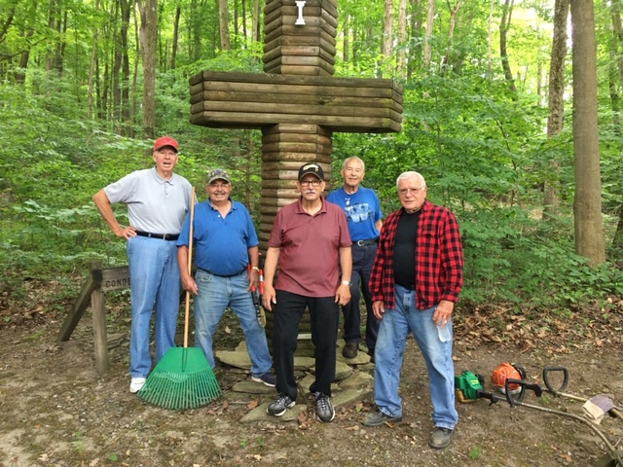

Minutes of St. Michael Catholic Church Parish Council Meeting

July 12, 2020

Attendance: Msgr. Lockard, Jim Lashinsky, John Bizzarri, Mary Ann Spangler, Rod Turgeon, Amy Dobbins, Kathy Kalicky, & Laurie Sloan

Absent: Katie Kundrod, Paul Kundrod, Pete Parisi & Amy Spangler

Council Chair Jim Lashinsky called the meeting to order at 10:20 AM. The minutes from the Feb. 9, 2020 meeting were reviewed. With no additions or corrections, the minutes stood as submitted.

Reports:

State of the Parish:

Msgr. Lockard discussed the current state of the parish. With the reopening of grounds and Masses being permitted with limited numbers, the parish is in a much better state than in recent months. However, large scale events are not permitted at this time. It will take time for the church to get back to where we were before the quarantine.

Financial Report:

Kathy Kalicky submitted a financial report for review to the council. A discussion was held on the current financial status of the parish. One topic of discussion was the impact of the quarantine and the effect on offertory collections. Kathy will prepare a report containing a yearly income projection and an actual income report. This report will be emailed to all council members for comparison. Kathy also reported that the parish was able to receive funds from the Catholic Church federal coronavirus loan. These monies were used to pay the salaries of employees of the parish during the shutdown.

Projects:

Rod Turgeon updated the council on parish projects. With the grounds being closed due to the Covid-19 shutdown, all projects have been at a standstill. Rod discussed the need for resurfacing the parking lots and replacing a sidewalk near the office due to sinkage. The lower parking lot was noted as the area of most need. Estimates were obtained for resurfacing, sealing, and painting lines in the lots, and replacement of sidewalks. The information will be taken to the Finance Council for discussion.

Religious Education:

Laurie Sloan reported that due to the Covid-19 quarantine the last five classes of religious education and all REACH activities were canceled. However, all 11th grade confirmation students had completed all of the requirements for the sacrament. Some of the students were confirmed on July 9th at St. Michael Church by Msgr. Lockard. The remaining members of the class will be confirmed on July 14th by Msgr. Lockard. Second grade students were contacted by Mrs. Minor regarding First Holy Communion. The students in the class will receive First Holy Communion on August 1st, 2020.

Next, the diocese is offering virtual opportunities for Camp Timothy and Camp Zacchaeus this year due to

Covid-19.

Mrs. Sloan stated that many CCD teachers will be updating their required clearances due to the five-year expiration date of state clearances. Additionally, religious education classes are slated to begin on September 13th, 2020. Stay at home lessons are also being explored as an option if classes are canceled due to a change in Covid-19 mandates.

Holy Name:

With the absence of Mr. Parisi, Mrs. Sloan reported that the Holy Name Society has nothing new to report due to not being able to meet with the quarantine.

Boy Scouts:

Amy Dobbins thanked the parish for their support of the troop at their recent take out dinner. The funds raised and donations received will enable the troop to purchase a trailer for the boys to take to their upcoming resident camp.

Mrs. Dobbins also discussed a large increase in membership dues for the scouts in the upcoming year. She stated that the troop is looking at fundraising options to help offset the cost of registration for the scouts.

Finally, Mrs. Dobbins outlined the plans for the troop shed, which will be placed on the church grounds. The troop will need to raise the funds for the shed before construction can begin.

Old Business:

Holy Week and Easter:

With the Covid-19 quarantine, Masses were not able to be held at St. Michael Church. However, the parish has received the holy oils for usage for the year.

New Business:

Reopening of the Church:

Msgr. Lockard discussed that the current weekend Mass attendance has been well attended. In the near future there may be a need to add a third Mass. The council discussed adding a second Sunday Mass that could accommodate the CCD class timeframe. Suggestions for Mass times were given to Msgr.

Diocesan Directives on Parish Socials:

The diocese has given detailed instructions on the holding of parish social functions. Msgr. Lockard discussed concerns of the Funeral Luncheon Committee in regard to the instructions and the safety of workers and guests. With difficulties with maintaining social distancing, and the safety of all involved, it was decided to cease funeral luncheons at the social hall until further notice.

Items from the floor:

John Bizzarri brought up concerns with the current system of exiting the church after receiving communion. The members of the council discussed the issue and devised a new plan for exiting the church after receiving communion. People on the right-hand side of the church will exit the handicapped entrance. Those on the left-hand side will proceed down the side aisle and exit through the back doors of the church.

Next Meeting Date:

The next regularly scheduled meeting of St. Michael Parish Council will be on September 20th, 2020. John Bizzarri volunteered to act in the role as prayer leader for the meeting.

With no new business to discuss, Jim Lashinsky made a request for the closing prayer. Mary Ann Spangler led the council in the prayer. The meeting was adjourned at 11:25 AM.

Respectfully submitted,

Amy Dobbins

LAY MINISTERS ~ The ministers schedule for the month of August has been mailed to those that are scheduled to serve in August. If you are unable to serve your assigned time, please call for a replacement or let the office know in advance.

|  |  |  |  |  |  |  |
| --- | --- | --- | --- | --- | --- | --- |
| LAY MINISTRY SCHEDULES - AUGUST 2020 | | | | | |  |
|  |  |  |  |  |  |  |
|  | August 1, 2020 - 4 pm | |  | August 2, 2020 - 9:30 am | |  |
|  | Cantor | David Zajdel |  | Cantor | Amy Dobbins |  |
|  | Reader | Sandy Bambino |  | Reader | Cathy Faher |  |
|  | Altar Server | Alex Bambino |  | Altar Server | Zach Fisher |  |
|  | Eucharistic Minister | Mike Barton |  | Eucharistic Minister | Paul Kundrod |  |
|  |  |  |  |  |  |  |
|  | August 8, 2020 - 4 pm | |  | August 9, 2020 - 9:30 am | |  |
|  | Cantor | Amanda Williamson |  | Cantor | Sharon Dibble |  |
|  | Reader | Don Dipko |  | Reader | David Knepper |  |
|  | Altar Server | Brooke Williamson |  | Altar Server | Colby Rearick |  |
|  | Eucharistic Minister | Susan Blazosky |  | Eucharistic Minister | Eric Tedjeske |  |
|  |  |  |  |  |  |  |
|  | August 15, 2020 - 4 pm | |  | August 16, 2020 - 9:30 am | |  |
|  | Cantor | Amy Spangler |  | Cantor | Lou McCloskey |  |
|  | Reader | Sherry Dipko |  | Reader | Terri Leach |  |
|  | Altar Server | Eva Spangler |  | Altar Server | Landon Fisher |  |
|  | Eucharistic Minister | Karen Myers |  | Eucharistic Minister | Beth Kundrod |  |
|  |  |  |  |  |  |  |
|  | August 22, 2020 - 4 pm | |  | August 23, 2020 - 9:30 am | |  |
|  | Cantor | Susan Blazosky |  | Cantor | Elizabeth Dobbins |  |
|  | Reader | Tony Bambino |  | Reader | Amy Spinos |  |
|  | Altar Server | Caden & Kaylee Roberts |  | Altar Server | Kirstyn Vitez |  |
|  | Eucharistic Minister | Alice Podrebarac |  | Eucharistic Minister | Robert Oshaben |  |
|  |  |  |  |  |  |  |
|  | August 29, 2020 - 4 pm | |  | August 30, 2020 - 9:30 am | |  |
|  | Cantor | David Zajdel |  | Cantor | Anita Lorek |  |
|  | Reader | Susan Poldiak |  | Reader | Arnold Bernard |  |
|  | Altar Server | Karen Myers |  | Altar Server | Alexis Henderson |  |
|  | Eucharistic Minister | Theresa Carlson |  | Eucharistic Minister | Amanda Williamson |  |

Sunday, July 26 Mass ~ 9:30 AM

 Confessions / 9:00 – 9:15 AM

Monday, July 27 Mass ~ Noon

NO Sunday Choir Practice

Tuesday, July 28 Mass ~ Noon

Wednesday, July 29 Mass ~ 6:00 PM

Second Grade Reconciliation / 6:30 PM

Thursday, July 30 Mass ~ Noon

NO Saturday Choir Practice

 Friday, July 31 Mass ~ Noon First Holy Communion Practice / 6:30 PM

Saturday, August 1 Mass / 4:00 PM

Confessions / 3:30 – 3:45

First Holy Communion / 10:00 AM

UPCOMING EVENTS

August 2 Elsy Lynn Nedwreski Baptism

August 7 First Friday / Eucharistic Adoration

August 8 & 9 Second Sunday Food Pantry Collection

August 8 Anna Louise Kostan Baptism

FRIAR’S NOOK GIFT SHOP ~ The shop will continue to have modified hours through Labor Day which are Fridays and Saturdays, 10:00 AM – 4:00 PM, and is located on the campus of St. Bernardine Monastery at 793 Monastery Road, Hollidaysburg. For any questions, please call 814-695-3802. Please note, face coverings *must* be worn for gift shop entry.



Thank you to all parishioners who have responded to the *2020 Catholic Ministries Drive.* Please join them in supporting our Parish and a select group of ministries that provide outreach to the poor, family life, youth, and seminarians. If you did not receive a pledge card in the mail, you may give online at [www.dioceseaj.org](http://www.dioceseaj.org).

Catholic Ministries Drive $25,436.00

Raised: $13,430.00

Balance: $12,006.00

Number of responses: 75