Rev. 12:7

ST. MICHAEL ROMAN CATHOLIC CHURCH

751 Locust Street

PO Box 103

St. Michael, Pennsylvania 15951

Rev. Msgr. David A. Lockard, Administrator MASSES:

(814) 495-9640 Saturday 4:00 pm



Sunday Morning 8:00 am

Secretary: Michele Panick 10:30 am

Bookkeeper: Kathy Kalicky Daily Mass See Bulletin

DRE: Laurie Sloan Holy Days See Bulletin

Maintenance: Rodney Turgeon Office Hours:

PHONES: 8:30 am to 3:30 pm

Rectory / Office: (814) 495-9640 Monday, Tues., Thurs., Friday

Fax: (814) 495-9424 Confessions:

Rel. Education: (814) 495-4873 Saturday 3:30 pm to 3:45 pm

Parish Website Sunday 7:30 am to 7:45 am

www.saintmichaelchurch.weebly.com 10:00 am to 10:15 am

Secretaries’ E-mail By Appointment

[saintmichaelsecretaries@yahoo.com](mailto:saintmichaelsecretaries@yahoo.com)

Facebook page:

St. Michael Catholic Church/St. Michael, PA

Fourth Sunday of Easter

SERVING GOD AND COMMUNITY FOR OVER ONE HUNDRED YEARS!

May 3, 2020

BAPTISM: By Appointment. Reserve at least one month in advance.

MARRIAGE: Plan at least nine months in advance.

Preparation sessions are necessary.

FUNERALS: Arrangements are made in conjunction with the funeral home.

REGISTRATION Those new to the area, newlyweds, and single adults, (even if registered

and before with their families) are asked to register by calling the Parish Office.

MEMBERSHIP: Every parishioner must be registered. This is a condition for admission

to our Program and reception of the Sacraments of Baptism, Confirmation, First Penance, First Eucharist, and Matrimony; also, for testimonial letters or sponsorship of Baptism and Confirmation outside the Parish.

VISITATION: We are concerned and want to be advised when someone is ill at home or in the hospital. Call the rectory to have the shut-in placed on our monthly Holy Communion calls or seriously ill prayer list.

SACRAMENTAL Parish registration and active Mass participation for Baptism is

POLICY: encouraged and is required for Marriage.

BULLETIN ARTICLES: Articles are due to the Parish Office by Noon on Tuesday.

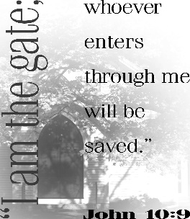

Fourth Sunday of Easter

May 3rd, 2020

The Blessed Virgin Mary

Dear Sisters and Brothers,

Greetings from the parish office! I hope you are well physically, mentally and above all, spiritually. I thank God that I am healthy currently. I am also bored! How many books can a person read? I want you to know that I do pray for the people of St. Michael Parish every day. I encourage you to do the same.

Someone asked, “How much longer will this lock-down go on?” The answer was “One more day than we think we can take it.” The point being that we can take this ordeal if we open our minds and hearts to God and ask Him to give us strength. So, make that your daily prayer – “Lord give me strength to fight this virus one more day.”

Pray especially for all the health – care professionals on the front lines. They need the grace of God, whether they are believers or not.

Pray for those out of work who don’t know where their next meal is coming from. Pray that our country will find ways to feed them.

And pray for all those who have died and for their families God bless you, too, and be careful!

Msgr. Lockard

**[](https://images.search.yahoo.com/search/images;_ylt=A0LEV1kSWptXvOwAKINXNyoA;_ylu=X3oDMTEyZGdkcmRoBGNvbG8DYmYxBHBvcwMxBHZ0aWQDQjIwODlfMQRzZWMDc2M-?p=Clipart+of+a+sanctuary+candle&fr=ush-mailn_02&th=110&tw=110&imgurl=http://www.henningers.com/389-168-wall-sanctuary-lamp.jpg&rurl=http://pixshark.com/sanctuary-lamp.htm&size=43KB&name=Sanctuary+Lamp+Bronze+wall+sanctuary+lamp&h=600&w=600&turl=http://ts2.mm.bing.net/th?id%3DOIP.M68453c67108cdc5ab485d309b395bd03o0%26pid%3D15.1%26rs%3D1%26c%3D1%26qlt%3D95%26w%3D110%26h%3D110#inline&tt=Sanctuary+Lamp+Bronze+wall+sanctuary+lamp&sigr=116keh5le&sigit=13gvlt42j&sigi=11ip0pgm4&sign=119kp6100&sigt=119kp6100)**

The Sanctuary candle will burn for

The Parishioners of St. Michael

during the week of May 3rd, 2020

TREASURY TICKETS ~ We are asking that each parish household sell or buy one ticket for $10.00 and return the money and ticket stub as soon as possible, but no later than May 24th. The tickets start on June 1st, 2020 and continue for the whole month of June. Winning numbers will be determined by the Pennsylvania Lottery Evening Pick Three Drawing. Weekdays payoff is $75, and weekends are $100. Father’s Day payoff is $150. If you are unable to sell or don’t want the ticket, PLEASE don’t throw it away, but return it as soon as possible as we always have people looking for extras. If paying by check, please make check payable to St. Michael Church. The money raised from the sale of these tickets will help to build up our Parish Treasury.

PLEASE NOTE! If you did not purchase or sell your October 2019 and February 2020 tickets, you were not issued the June 2020 ticket. If you did not get a ticket and would like to purchase the June 2020 ticket, please call the office. We apologize if anyone has been accidentally missed. If you would like a ticket, please call the parish office. We do have extra tickets, so anyone wanting more than one ticket, please call the office. Thank you.

*Parish and Finance Council Members*

Weare placing names of the sick in the bulletin for prayer providing they give permission. *May the* *Divine Physician send healing grace for those for* *whom we pray:* Allen C. Rosemas, Patricia Murphy, Bernice Myers, Dwight Fyock, Dylon Wills, Missy, Joanne (Kolar) Hufford, Christine Flanagan, Ayden Alan Grata, Mary Lou Offman, Mary Zangaglia, Natalie Zerby, Valencia Tursi, Homer Locher, Brayden Schofield, Michelle Kasper, Diane Kingera, Allison Krischer, Ted Paluch, Brandt Hutzel, Pearl Litzinger, Patrick Munro, Fran Baldassarre, Kristen Sinosky Long, Helen Ranieri, Cresta Micik, Basil Costantino, Madison McCrory, Laura, Joe Yoder, Dolores Yanzetich, Sandy Krug, Wanda Gramling, Agnes Plummer, Jennifer Hagans, Shawn, Holly, Shane, Spencer, Owen Taylor, Keith & Dawnetta Hoyer, Derrick Varnish, Vincent Koshute, Melissa Cordek, Michelle Elliott, Heather Romanow, Mackston Barrick, Connor Thomas, Erin, Pat, Mary Agnes Nastase, Mary Ann Bertolino, Dick Wilson, Izzy Bihun, Dorothy Kaminsky, Patricia Oshaben, Ashlee Madison, Susan Yanzetich, Mike, Danika Faith, Alina Rusnak, Gary Smay, Elizabeth Howell, Helen Bowen, Walter Bodziak, Rhonda, Dan Strinkoski, Anne Robinson, Marlene McCrory, Sharon Poldiak, Carter Bobak, Vince Arena, Mike Morris, Sarah Kelt, Patty Yanzetich Caldwell, Colton Snyder, Betty Delaney, Nancy Edmiston, Bill Krajewski, Leonard Oshaben, Adam, Bill Gideos, Janice Dipyatic, John Poldiak Jr., Gerald Delaney, Lily Maloney, Adam Wingard, Scott, Lisa, Rosalie Ambrose, John Patrick, Audrey Costlow, Carole Horner, Ross Linert, Mary Ann Peretin DeRosa, Cathy Sossong, Rosanne Krug, Paul Snyder, Becky Kakabar and all of the sick of our parish, the homebound, those in nursing homes, those who care for them, and those in the military along with their families. *(Please call the Rectory to have your name removed from the list when no longer seriously ill. Thank You.)*

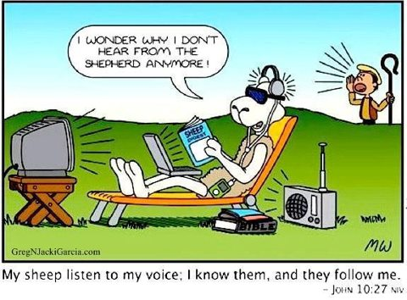

LAST WEEK’S COLLECTION

Adults $2,926.00

Youth $ 10.00

Monthly $1,255.00

Initial Offering $ 5.00

Mother’s Day $ 20.00

Father’s Day $ 20.00

Maintenance Fund $ 160.00

Solemnity of Mary $ 10.00

Christmas (2019) $ 20.00

Cemetery Maintenance $ 50.00

Mandeville Diocese $ 5.00

Catholic Relief Services $ 25.00

Easter $ 733.00

Holy Land $ 30.00

Holy Thurs./Food Pantry $ 160.00

Catholic Home Missions $ 103.00

Ascension Thursday $ 15.00

Total $5,547.00

We sincerely thank and

ask God’s blessing upon

all who have care and

concern for our

parish.

**TELEVISED MASS** ~ Remember that since Churches are closed, you can still “attend” Mass by watching it on television. Every Sunday on WATM ABC 23 at 11:00 AM Mass is televised from St. John Gualbert Cathedral in Johnstown. On **Sunday, May 3rd, Msgr. Lockard** will be the concelebrant for the televised Mass! Please join him! And also watch PROCLAIM TV program which airs every Sunday at 10:30 AM on WATM ABC 23.

NEW OFFICE HOURS! ~ The Parish Office will be open Mon, Tues, Thurs, Fri. approximately from 10:00 AM – 12:30 PM. There will be someone in the office at that time to take your calls or to pick up your offertory envelopes from the green tote located outside the Parish Office door. Please try to drop off your offertory envelopes between the hours of 10:00 AM – 12:30 PM.

CONFESSIONS ~ Msgr. will hear confessions of anyone wanting to go. Please call the Parish Office to make an appointment with him. Please wear a mask or face covering.

BULLETINS ~ Paper bulletins will now be available every weekend. They will be in the green tote outside the Parish Office door every Friday afternoon. You are welcome to stop by and pick one up. You can also read the bulletin on our parish website: www.saintmichaelchurch.weebly.com

FACEBOOK PAGE ~ St. Michael Church now has a Facebook page! Check us out at St. Michael Catholic Church / St. Michael, PA

MASSES ~ There will be no Daily Masses or Weekend Masses until further notice.

CATHOLIC HOME MISSIONS ~ Thank you for your generous support of last week’s Catholic Home Missions Appeal. The money raised will help strengthen the Church at home and ensure that the Gospel is spread across the United States. If you missed the appeal, it’s not too late to give! Just visit [*www.usccb.org/nationalcollections*](http://www.usccb.org/nationalcollections)

WEEKLY OFFERING ~ Parishioners can continue to support their Parish of St. Michael either by mailing their envelopes to the Parish address, dropping them off at the Parish Office from 10:00 AM-12:30 PM, or the Diocese has provided the use of their online giving platform and created a specific “Your Parish Offertory” giving site. “Your Parish Offertory” is available on the diocese’s home page featuring a GIVING button located at the top of the home page in the right-hand corner that directly takes you to the portal. Go to [www.dioceseaj.org/giving](http://www.dioceseaj.org/giving).

PROTECTING GOD’S CHILDREN ARTICLE ~ The diocese has provided an article on Protecting God’s Children: Adult Ongoing Training Bulletin. You can find this article in the green tote by the office door. Please feel free to take one.



Catholic Ministries Drive $24,436.00

Raised: $10,403.00

Balance: $14,033.00

Number of responses: 64

Thank you to all parishioners who have responded to the *2020 Catholic Ministries Drive.* Please join them in supporting our Parish and a select group of ministries that provide outreach to the poor, family life, youth and seminarians. If you did not receive a pledge card in the mail, you may give online at [www.dioceseaj.org](http://www.dioceseaj.org).

Office Hours: Mon, Tues, Thurs, Fri: 10:00 AM – 12:30 PM

Church is closed until further notice!

Sunday, April 26 NO Mass

NO High School Religious Ed.

Catholic Home Missions / Envelopes in your packet



Monday, April 27 NO Mass

NO Sunday Choir Practice

Tuesday, April 28 NO Mass

Wednesday, April 29 NO Mass

Thursday, April 30 NO Mass

NO K—5 Religious Ed.

NO Saturday Choir Practice

Friday, May 1 NO Mass

Bulletins in Green Tote

Saturday, May 2 NO Mass

UPCOMING EVENTS



Religious Education And Christian Helping

Worship@Home ~ Free Sunday Prayer Service for families

In this challenging time when many of us are unable to attend Mass in person,

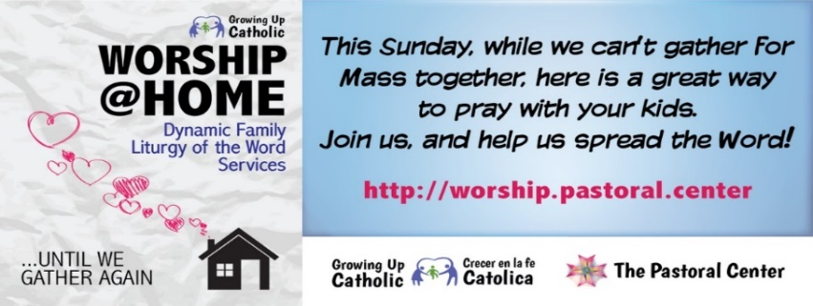 here’s a great way that you can pray together as a family at home.