John 6:54

ST. MICHAEL ROMAN CATHOLIC CHURCH

751 Locust Street

PO Box 103

St. Michael, Pennsylvania 15951

Rev. Brian L. Warchola, Administrator MASSES:

(814) 495-9640 Saturday 4:00 pm



Sunday Morning 8:00 am

Secretary: Michele Panick 10:30 am

Bookkeeper: Kathy Kalicky Daily Mass See Bulletin

DRE: Laurie Sloan Holy Days See Bulletin

Maintenance: Rodney Turgeon

Office Hours:

PHONES: 8:30 am to 3:30 pm

Rectory / Office: (814) 495-9640 Monday, Tues., Thurs., Friday

Fax: (814) 495-9424 Confessions:

Rel. Education: (814) 495-4873 Saturday 3:30 pm to 3:45 pm

Parish Website Sunday 7:30 am to 7:45 am

www.saintmichaelchurch.weebly.com 10:00 am to 10:15 am

Secretaries’ E-mail Anytime Requested

[saintmichaelsecretaries@yahoo.com](mailto:saintmichaelsecretaries@yahoo.com)

YEAR: 2019 NUMBER: 19

SERVING GOD AND COMMUNITY FOR OVER ONE HUNDRED YEARS!

BAPTISM: By Appointment. Reserve at least one month in advance.

MARRIAGE: Plan at least nine months in advance.

Preparation sessions are necessary.

FUNERALS: Arrangements are made in conjunction with the funeral home.

REGISTRATION Those new to the area, newlyweds, and single adults, (even if registered

and before with their families) are asked to register by calling the Parish Office.

MEMBERSHIP: Every parishioner must be registered. This is a condition for admission

to our Program and reception of the Sacraments of Baptism, Confirmation, First Penance, First Eucharist, and Matrimony; also, for testimonial letters or sponsorship of Baptism and Confirmation outside the Parish.

VISITATION: We are concerned and want to be advised when someone is ill at home or in the hospital. Call the rectory to have the shut-in placed on our monthly Holy Communion calls or seriously ill prayer list.

SACRAMENTAL Parish registration and active Mass participation for Baptism is

POLICY: encouraged and is required for Marriage.

BULLETIN ARTICLES: Articles are due to the Parish Office by Noon on Tuesdays.

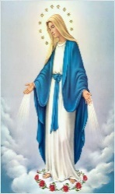 Fourth Sunday of Easter

May 12, 2019

**Month of The Blessed Virgin Mary**

**MASS INTENTIONS**: (May 13 – May 19, 2019)

Monday 8:00 AM People of the Parish

Tuesday 8:00 AM Grace Martin req. by Rose Marie Myers & Family

Wednesday NO MASS

Thursday 8:00 AM Albert Andrykovitch req. by Mrs. Pat Schramm

Friday 8:00 AM Richard Jerome & Brennan Seese req. by Dorothy Seese

Saturday 4:00 PM People of the Parish

Sunday 8:00 AM Jane Plummer req. by Brandon & Amanda Penatzer

Sunday 10:30 AM Claudia McCloskey req. by Ed & Henrietta Snyder

LITURGICIAL APPOINTMENTS:

Saturday, May 18 4:00 PM Offertory Procession

Lector: Madison Kundrod Ed & Karen Myers

Minister of the Host: Janet Minor

Minister of the Cup: Helen Slonac & George Minor

Altar Servers: Carson & Dylan Kundrod

Cantor: Susan Blazosky

Greeter: Phyllis Slonac

Sunday, May 19 8:00 AM Offertory Procession

Lector: Arnold Bernard Jane Plummer Family

Minister of the Host: Marie Jo Plummer

Minister of the Cup: Paul Kundrod & Marie Bernard

Altar Servers: Griffin & Kaden Christ

Cantor: Joseph Faher

Greeter: Pauline Minor

Sunday, May 1910:30 AM Offertory Procession

Lector: Carole Kakabar Claudia McCloskey Family

Minister of the Host: Michael Barton

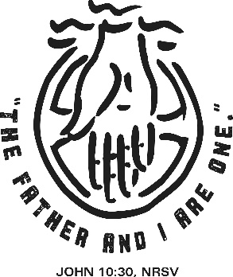Minister of the Cup: Dave & Edie Knobloch

Altar Servers: Shannan Elgin & Adalynne Webb

Cantor: Anita Lorek

Greeter: Wendy Blough

Sunday, May 19 Collection Counters

Bob Casti, Sharon Paterson

Phyllis Slonac

Weare placing names of the sick in the bulletin for prayer providing they give permission. *May the* *Divine Physician send healing grace for those for* *whom we pray:* Allen C. Rosemas, Patricia Murphy, Bernice Myers, Dwight Fyock, Lori Facciani, Dylon Wills, Missy, Joanne (Kolar) Hufford, Christine Flanagan, Ayden Alan Grata, Mary Lou Offman, Mary Zangaglia, Dorothy Rosemas, Natalie Zerby, Patricia Grata, Michael Wadsworth, Valencia & Frank Tursi, Homer Locher, Brayden Schofield, Michelle Kasper, Diane Kingera, Allison Krischer, Ted Paluch, Brandt Hutzel, Pearl Litzinger, Patrick Munro, Fran Baldassarre, Kristen Sinosky Long, Helen Ranieri, Cresta Micik, Basil Costantino, Madison McCrory, Laura, Joe Yoder, Dolores Yanzetich, Sandy Krug, Wanda Gramling, Merna Smay, Muriel “Jean” Wiesheier, Agnes Plummer, Jennifer Hagans, Shawn, Holly, Shane, Spencer, Owen Taylor, Keith & Dawnetta Hoyer, Derrick Varnish, Vincent Koshute, Melissa Cordek, Michelle Elliott, Heather Romanow, Mackston Barrick, Connor Thomas, Erin, Pat, Mary Agnes Nastase, Mary Ann Bertolino, Dick Wilson, Izzy Bihun, Erica Mitzelfeld, Dorothy Kaminsky, Patricia Oshaben, Ashlee Madison, Susan Yanzetich, Mike, Mary Sivec, Danika Faith, Alina Rusnak, Marcia Costlow, Gary Smay, Elizabeth Howell, Helen Bowen, James Macy, Walter Bodziak, Rhonda, Dan Strinkoski, Anne Robinson, Marlene McCrory, Sharon Poldiak, Carter Bobak, Vince Arena, Mike Morris, Sarah Kelt, Mildred Andrykovitch, Patty Yanzetich Caldwell, Mary Secriskey, Colton Snyder, Betty Delaney, Nancy Edmiston, Elizabeth Stoker Thomas, Albert Sracic, Arthur Byers, Joseph Ropecka, Bill Krajewski, Leonard Oshaben, Florence Smith, Michael Chalan Jr., Adam and all of the sick of our parish, the homebound, those in nursing homes, those who care for them, and those in the military along with their families. *(Please call the Rectory to have your name removed from the list when no longer seriously ill. Thank You.)*

LAST WEEK’S COLLECTION

Adults $3,813.00

Loose $ 347.00

Youth $ 26.75

Monthly $1,477.00

Candles $ 30.00

Maintenance $ 133.00

Catholic Home Missions $ 5.00

Catholic Communication $ 10.00

Peter’s Pence (Holy Father) $ 10.00

Holy Thursday/Food Pantry $ 30.00

Easter Offering $ 50.00

Mother’s Day $ 255.00

Father’s Day $ 10.00

Ascension Thursday $ 45.00

Total $6,241.75

We sincerely thank and ask God’s

blessing upon all who have care

and concern for our parish.



*May 12, 2019 John 10:27-30*

*“The works that I do testify to me.” Jesus walked the talk. He was a shepherd who “knew his sheep and they followed him.” Mother’s Day gives us the opportunity to celebrate the unconditional love of mothers. Whether living or dead, a mother’s love always invites us to follow her example by loving generously and selflessly.*

MAY 2018 PARISH TICKET WINNERS

 Day Date Amount No. Winner

Friday May 3, 2019 $75 644 Paul J. Kundrod

Saturday May 4, 2019 $100 334 Kathy Kalicky

Sunday May 5, 2019 $100 876 Vince Arena

Monday May 6, 2019 $75 941 Reba Vasas

Tuesday May 7, 2019 $75 310 Joe Krupka

Wednesday May 8, 2019 $75 449 Ticket not returned

Thursday May 9, 2019 $75 057 Sara Zybura

WORLD DAY OF PRAYER FOR VOCATIONS ~ Sunday, May 12. The theme that Pope Francis would like us to focus on is, “*The courage to take a risk for God’s promise.”* Our Church, our Diocese, NEEDS men and women who are strong enough to have the courage necessary to take a risk by answering yes to God’s call to priesthood and religious life in order for God’s promise for all people to be fulfilled. For more information about a vocation to the diocesan priesthood and for references to religious orders, please contact the diocesan vocation office at: Fr. Matthew Reese, Director @ 814-695-5579 ext. 2681.

FATIMA DEVOTIONS ~ The Franciscan Friars, T.O.R., from Loretto, invite you to participate with them in celebrating the Fatima Devotions on Monday May 13th at 6:30 PM at the Basilica of St. Michael the Archangel. The singing will be led by the Basilica of St. Michael the Archangel and the sermon will be delivered by Fr. Peter Lyons, T.O.R. We would like to extend a cordial welcome to all.

TIME FOR A CHANGE ~ PRECIOUS LIFE will be undertaking the Baby Bottle Campaign. They will deliver the empty baby bottles to St. Michael in time for Mother’s Day, May 12th. They will be placed in the Bridal Room. Please take as many as you like, fill them, and bring them back by Father’s Day, June 16th. PRECIOUS LIFE is a Christian ministry dedicated to providing positive alternatives to abortion. We provide free pregnancy testing, confidential counseling, material support and housing to young women in need. This simple fundraiser has been very successful. Last year close to 110 churches & businesses participated, and we raised over $85,000 just through change.

CARMELITE COMMUNITY OF THE WORD GOLF TOURNAMENT ~ The Carmelite Community of the Word sisters will hold our 15th Annual Golf Tournament on Friday, June 7 at Scotch Valley Country Club. Shotgun start at 12:00 noon. Casual Dinner is served at 4:30 PM. Live auction begins at 5 PM. *Early “Birdie” Special!* If you register before May 22, the cost is $115 per golfer; $425 per foursome. After May 22, the cost is $125 per golfer; $475 per foursome. Cost to attend dinner only is $20 per person. Final deadline for Registration is May 31. To register, or for more information, contact Kelli Murphy at 814-886-4098 or email at [communityofficeccw@gmail.com](mailto:communityofficeccw@gmail.com).

OFFICE OF ADULT ENRICHMENT AND LAY ECCLESIAL MINISTRY ~ Is looking into the possibility of offering daytime classes. Although nothing has been decided at this time, we are looking to gauge interest in this possibility. If you *would* be interested in daytime classes, email [mheinze@dioceseaj.org](mailto:mheinze@dioceseaj.org).

Catholic Ministries Drive $26,768.00

Raised: $ 2,925.00

Balance: $23,843.00

Number of responses: 23

Thank you to all parishioners who have responded to the *2018 Catholic Ministries Drive.* Please join them in supporting our Parish and a select group of ministries that provide outreach to the poor, family life, youth and seminarians. If you did not receive a pledge card in the mail, you may give online at [www.dioceseaj.org](http://www.dioceseaj.org).



The Sanctuary Candle will burn in memory of

all deceased Mothers and Daughters of the Parish

and

The Our Lady of Grace Candle will burn in honor of

all living Mothers and Daughters of the Parish

during the week of May 12, 2019.

[](https://images.search.yahoo.com/search/images;_ylt=A0LEV1kSWptXvOwAKINXNyoA;_ylu=X3oDMTEyZGdkcmRoBGNvbG8DYmYxBHBvcwMxBHZ0aWQDQjIwODlfMQRzZWMDc2M-?p=Clipart+of+a+sanctuary+candle&fr=ush-mailn_02&th=110&tw=110&imgurl=http://www.henningers.com/389-168-wall-sanctuary-lamp.jpg&rurl=http://pixshark.com/sanctuary-lamp.htm&size=43KB&name=Sanctuary+Lamp+Bronze+wall+sanctuary+lamp&h=600&w=600&turl=http://ts2.mm.bing.net/th?id=OIP.M68453c67108cdc5ab485d309b395bd03o0&pid=15.1&rs=1&c=1&qlt=95&w=110&h=110#inline&tt=Sanctuary+Lamp+Bronze+wall+sanctuary+lamp&sigr=116keh5le&sigit=13gvlt42j&sigi=11ip0pgm4&sign=119kp6100&sigt=119kp6100)

[](http://www.churchart.com/subscriber/viewimages.aspx?keywords=In%20Sympathy&entry_date=1/1/0001&image_type=,cl#no)

MAY SHE REST IN PEACE ~ In your charity, please pray for the eternal rest of Rose Marie Myers. May she know the eternal peace and happiness promised by our Savior, Lord Jesus. Please pray for the consolation of all her family and friends.

SECOND SUNDAY FOOD COLLECTION ~ This weekend is our Second Sunday Food Collection. Please bring in non-perishable food items or toiletries with you. Monetary donations are also appreciated.

LAY MINISTRY SCHEDULES ~ Lay ministry schedules for the summer months of June through September are now being made up. Anyone who would like to serve as an Altar Server, Reader, Cantor, Greeter or any current minister who has scheduling preferences at this time, should call Suzi Blazosky at 495-5287 or e-mail her at [sublazosky@gmail.com](mailto:sublazosky@gmail.com) no later than Sunday, May 19th.

[](https://www.google.com/url?sa=i&rct=j&q=&esrc=s&source=images&cd=&cad=rja&uact=8&ved=2ahUKEwjG-pvv147iAhXOnuAKHZHJAroQjRx6BAgBEAU&url=http%3A%2F%2Fwww.shopmorganhill.com%2Fjazzercise%2F&psig=AOvVaw3ceR4MJ4B2P1COL_SRuJfP&ust=1557499316634425)

ST. MICHAEL’S FITNESS SERIES CONTINUES ~ There will be a Jazzercize class here at our Church hall from 11:00 AM – 12:00 PM on Saturday June 1st. Please call the Parish Office to register at 495-9640.

MOTHER’S DAY BRUNCH ~ All mothers and daughters of the parish are invited to a Mother’s Day Brunch on Sunday, May 12th sponsored by the Holy Name Society. They will be paying for, preparing and serving the meal in the church hall immediately following the 10:30 a.m. Mass. Sunday morning help is needed in the preparation, serving of the meal and the clean up after. Please call Pete Parisi at 487-5351. (This is a good way for male REACH students to earn service hours. Contact the Religious Education Office at 495-4873 to volunteer.)

MOTHER’S DAY MASS INTENTIONS ~ Envelopes for Mother’s Day Mass Intentions are in your packet of envelopes. The envelopes will be placed on the altar during the month of May in remembrance of all mothers, both living and deceased. Extra envelopes can be found at the entrances of the church.

C:\Documents and Settings\Susan\Local Settings\Temporary Internet Files\Content.IE5\XHXVAJYK\CAK5OTOS.wmf

MOTHER’S DAY CARNATIONS FOR BIRTHRIGHT ~ REACH students will be handing out carnations before each Mass on Mother's Day weekend to the women of the parish.  REACH funds will make a donation to Birthright for their Pro-Life efforts. Birthright is an interdenominational pregnancy support service that enables women who are facing an unintended pregnancy to choose life for their unborn babies by providing emotional and material support. Birthright helps women in these situations find medical care, clothing, food, even housing. For thousands of women, Birthright is hope. Hope that they, and their unborn children, are not alone. Since 1980, over 5,000 babies have been born in our area under the auspices of Birthright.

*Stewardship Reflections…*

Placing our trust in Jesus puts us in direct opposition to many of the values that our society finds acceptable. However, we can take comfort in the assurance of today’s readings that the reward of eternal life is ours when we commit ourselves to be wise and generous stewards and disciples of the Risen Lord.

Upcoming REACH Service Projects

If interested in helping, contact the Religious Education Office at 495-4873.

WPA Road Clean-up – Saturday, May 18, 2019 – The Spring WPA Road Clean-up for REACH students and parent chaperones is scheduled for Saturday, May 18, 2019 at 10:00 AM. The cleanup will last approximately 1-½ hours (10:00 a.m. to 11:30 a.m.) with lunch provided following the clean-up with our project being complete between 11:30 and 12 noon for pick up.

Adult / Student Permission / Liability forms will be available at the church entrances and during RE classes.

PARTICIPATION IS NOT PERMITTED WITHOUT RETURNED FORMS.

Volunteer Safety is of primary importance!

1. Proper clothing should be worn -- i.e., tennis shoes -- NO FLIP FLOPS/SANDALS!

Long pants/long-sleeve shirts may also be appropriate.

Safety Vests and gloves will be provided.

1. Please be sure to indicate any allergies on the Waiver/Consent Form.

*Angel Fund 2019*

*Consider giving a gift now that will enrich the life of a young camper in the Summer of 2019!*

*Camp Zacchaeus Grades 4-9*

*and Camp Timothy Grades 10-12 (and newly graduated seniors 2019)*

We are looking for people, groups, parishes or organizations to sponsor a child to attend

Camp Zacchaeus 2019 or Camp Timothy 2019 through the *Angel Fund*.

We will accept full or partial sponsorships of any amount to help cover the cost of camp—(100 percent of the funds collected through Angel Fund donations are dispersed to needy campers)! If you are interested in sponsoring a child, or for more information, please contact Francine Swope at the Diocesan Youth Ministry Office (814)317-2646 or mail your contribution directly to Camp Zacchaeus or Camp Timothy Angel Fund, 933 S. Logan Boulevard, Hollidaysburg, PA 16648. Become an Angel Fund sponsor and help send a child to camp to experience a wonderful faith-filled week in the great outdoors!

Our Saint Michael Parish will be hosting Yee Haw VBS this summer along with Most Holy Trinity and Saint Bartholomew Parishes.

Yee Haw will be held on July16, 17 & 18 from 6—8 p.m. in our Saint Michael Parish Hall. VBS Registration forms are available on the back table and at the side entrance of the church along with our Volunteers Registration forms.

REACH students and adult volunteers are needed to help with prep ahead of VBS week and we will also need help the week of VBS. High School students can earn service hour credits for helping. Please join us to make this a wonderful adventure for our kids. If you would like to share in the fun, call the Parish Office at 495-9640 or the RE Office at 495-4873.

 Religious Education And Christian Helping

May 12, 2019

2019 First Holy Communion

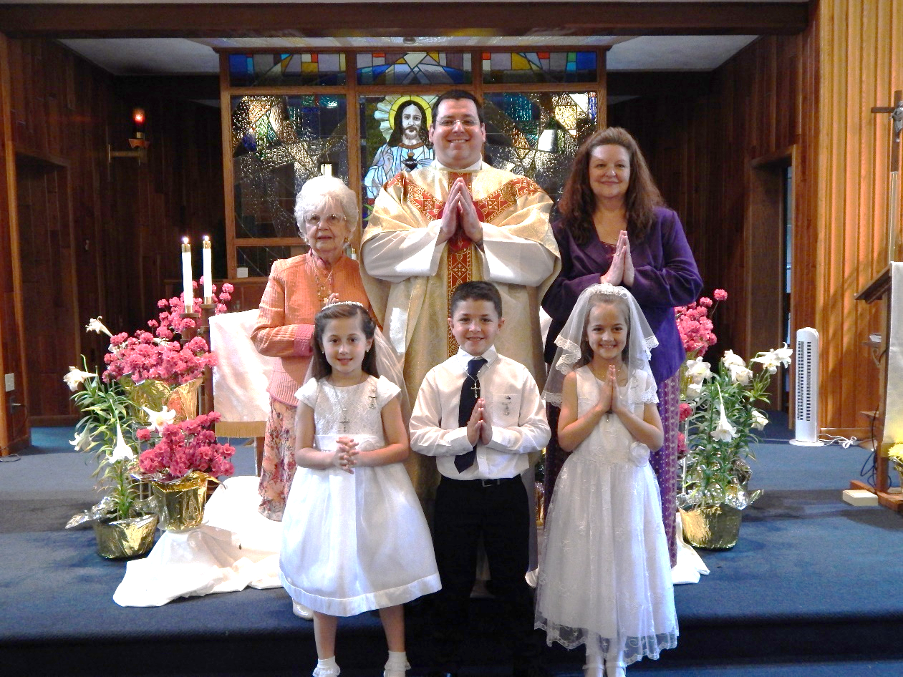

Our 2nd grade class received their First Holy Communion on Sunday, May 5th.

Members of the class are pictured above left to right,

Front Row: Bryn Roberts, Andrew Raptosh and Sabrina Macy.

Back Row: Pauline Minor, catechist, Fr. Brian Warchola, and Laurie Sloan, DRE.

*************************************************************************************

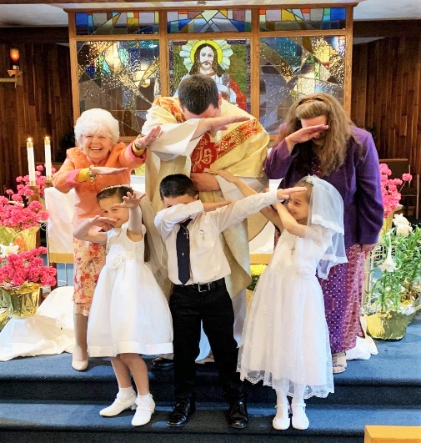

The lighter side of things!

Fr. Brian and the First Holy Communion class

doing “THE DAB” along with Pauline Minor, catechist

and Laurie Sloan, DRE.

SPAGHETTI DINNER & BASKET PARTY ~ Sunday, May 19th. St. Michael Catholic Church Hall, St. Michael. Tickets $15. Doors open at 12, Dinner at 12:30 & basket raffle to follow dinner. Sponsored by team “Blue Skies Over Purple Hearts” in Memory of Jane Plummer. All proceeds go to Alzheimer’s Association. To purchase tickets, call Mary Ann Tedjeske–814-341-5463, Janet Minor-814-241-5106 & Krista Hershberger-814-421-9325. END ALZ *Any Parishioner wanting to donate an assembled basket would be greatly appreciated. Please drop off assembled baskets in the Bridal Room no later than Friday, May 17th

CORNHOLE TOURNAMENT & BASKET AUCTION ~ May 25 – Cresson American Legion. Tourney: $10 per person, Registration begins 2 PM, Tourney begins 3 PM, Basket Auction Noon – 5 PM. Winners get a Cash Prize. Must use bags provided by Tourney.

CHRISTIAN BOOK STORE ~ We are sad to inform you that we are going out of business. Our Johnstown store (1238 Scalp Ave.) will be closing on Saturday, June 15, 2019. Everything must go! Almost everything 25% off! Open Mon. – Sat. 9 AM – 7 PM. We want to say a heartfelt Thank You to all of our customers for your support over the years. May God Bless & Keep You!

58th ANNUAL FESTIVAL ~ HOLY NAME PARISH, EBENSBURG, is sponsoring its 58th Annual Festival on May 31, June 1 & 2 featuring a Fish Dinner (Fried or Baked) on Friday from 4:00 to 7:00 PM, (Adults $10, children under 12 $5). Take out dinners available. Refreshments, rides, games, baked goods, activities for kids, flea market, basket raffle with over 100 baskets and more!

FOREST HILLS COMMUNITY BAND ~ Concert Schedule – Sun. May 26 Galleria Mall Richland 2 PM, Sun. June 2 Mount Hope Church 6 PM, Sunday June 9, South Fork U.M. Church 7 PM. Bring Chairs.

 Sunday, May 12 Mother’s Day Brunch / After the 10:30 AM Mass

Second Sunday Food Pantry Collection

Monday, May 13 Martha’s Group / 6:00 PM

Sunday Choir Practice / 7:00 PM

Tuesday, May 14 Boy Scouts / 7:30–9:00 PMPMPM

Wednesday, May 15 No Mass

Thursday, May 16 Saturday Choir Practice / 4:30 PM

Knights of Columbus / 6:00 PM

Girl Scouts

 Friday, May 17

Saturday, May 18 WPA Road Cleanup / 10:00 AM

Hall Rental / 12:00 PM

UPCOMING EVENTS

 May 19 ALZ Spaghetti dinner & basket party

Baptism

May 26 Baptism

May 27 Memorial Day / Parish Offices Closed

May 29 Ascension Thursday Vigil

May 30 Ascension Thursday / Holy Day of Obligation

Parish Offices Closed