John 6:54

ST. MICHAEL ROMAN CATHOLIC CHURCH

751 Locust Street

PO Box 103

St. Michael, Pennsylvania 15951

Rev. Brian L. Warchola, Administrator MASSES:

(814) 495-9640 Saturday 4:00 pm



Sunday Morning 8:00 am

Secretary: Michele Panick 10:30 am

Bookkeeper: Kathy Kalicky Daily Mass See Bulletin

DRE: Laurie Sloan Holy Days See Bulletin

Maintenance: Rodney Turgeon

Office Hours:

PHONES: 8:30 am to 3:30 pm

Rectory / Office: (814) 495-9640 Monday, Tues., Thurs., Friday

Fax: (814) 495-9424 Confessions:

Rel. Education: (814) 495-4873 Saturday 3:30 pm to 3:45 pm

Parish Website Sunday 7:30 am to 7:45 am

www.saintmichaelchurch.weebly.com 10:00 am to 10:15 am

Secretaries’ E-mail Anytime Requested

[saintmichaelsecretaries@yahoo.com](mailto:saintmichaelsecretaries@yahoo.com)

YEAR: 2019 NUMBER: 17

SERVING GOD AND COMMUNITY FOR OVER ONE HUNDRED YEARS!

BAPTISM: By Appointment. Reserve at least one month in advance.

MARRIAGE: Plan at least nine months in advance.

Preparation sessions are necessary.

FUNERALS: Arrangements are made in conjunction with the funeral home.

REGISTRATION Those new to the area, newlyweds, and single adults, (even if registered

and before with their families) are asked to register by calling the Parish Office.

MEMBERSHIP: Every parishioner must be registered. This is a condition for admission

to our Program and reception of the Sacraments of Baptism, Confirmation, First Penance, First Eucharist, and Matrimony; also, for testimonial letters or sponsorship of Baptism and Confirmation outside the Parish.

VISITATION: We are concerned and want to be advised when someone is ill at home or in the hospital. Call the rectory to have the shut-in placed on our monthly Holy Communion calls or seriously ill prayer list.

SACRAMENTAL Parish registration and active Mass participation for Baptism is

POLICY: encouraged and is required for Marriage.

BULLETIN ARTICLES: Articles re due to the Parish Office by Noon on Tuesdays.

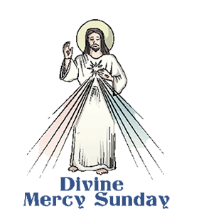 Second Sunday of Easter

(Sunday of Divine Mercy)

April 28, 2019

**Month of The Holy Eucharist**

**MASS INTENTIONS**: (April 29 – May 5, 2019)

Monday 8:00 AM Thomas Murin req. by Mary Ann Murin & Family

Tuesday 8:00 AM Hermine Sivec req. by Betty Gerwert

Wednesday No Mass

Thursday 8:00 AM For Catholics to return to the Church

First Friday 8:00 AM Our Father J. David Michaels req. by Blaise Michaels and

Starchville Families

Saturday 4:00 PM Julia Bridge req. by Susan Poldiak

Sunday 8:00 AM People of the Parish

Sunday 10:30 AM First Holy Communion Class

LITURGICIAL APPOINTMENTS:

Saturday, May 4 4:00 PM Offertory Procession

Lector: Amy Spinos John & Susan Poldiak

Minister of the Host: Karen Myers

Minister of the Cup: Theresa Carlson & Babe Richards

Altar Servers: Ana Spangler & Natalie Stohon

Cantor: Amy Spangler

Greeter: Darlene Marshall

Sunday, May 5 8:00 AM Offertory Procession

Lector: David Knepper Holy Name Society

Minister of the Host: Tracy Yakicic

Minister of the Cup: Ellen Grattan & Sally Kolar

Altar Servers: Elizabeth & Ian Dobbins

Cantor: Joseph Faher

Greeter: Pete Parisi

Sunday, May 510:30 AM Offertory Procession

Lector: Peter Bernard First Holy Communion Class

Minister of the Host: Sharon Paterson

Minister of the Cup: Michael Steele & Robert Oshaben

Altar Servers: Kristyn & Cameron Vitez

Cantor: Susan Blazosky

Greeter: Deborah Macy

Sunday, May 5 Collection Counters

Christine Smay, Sara Zybura

Mary Ann DeRosa

Weare placing names of the sick in the bulletin for prayer providing they give permission. *May the* *Divine Physician send healing grace for those for* *whom we pray:* Allen C. Rosemas, Patricia Murphy, Bernice Myers, Dwight Fyock, Lori Facciani, Dylon Wills, Missy, Joanne (Kolar) Hufford, Christine Flanagan, Ayden Alan Grata, Mary Lou Offman, Mary Zangaglia, Dorothy Rosemas, Natalie Zerby, Patricia Grata, Michael Wadsworth, Valencia & Frank Tursi, Homer Locher, Brayden Schofield, Michelle Kasper, Diane Kingera, Allison Krischer, Ted Paluch, Brandt Hutzel, Pearl Litzinger, Patrick Munro, Fran Baldassarre, Kristen Sinosky Long, Helen Ranieri, Cresta Micik, Basil Costantino, Madison McCrory, Laura, Joe Yoder, Dolores Yanzetich, Sandy Krug, Wanda Gramling, Merna Smay, Muriel “Jean” Wiesheier, Agnes Plummer, Jennifer Hagans, Shawn, Holly, Shane, Spencer, Owen Taylor, Keith & Dawnetta Hoyer, Derrick Varnish, Vincent Koshute, Melissa Cordek, Michelle Elliott, Heather Romanow, Mackston Barrick, Connor Thomas, Erin, Pat, Mary Agnes Nastase, Mary Ann Bertolino, Dick Wilson, Izzy Bihun, Erica Mitzelfeld, Dorothy Kaminsky, Ed Ripper Sr., Patricia Oshaben, Ashlee Madison, Susan Yanzetich, Mike, Mary Sivec, Danika Faith, Alina Rusnak, Marcia Costlow, Gary Smay, Elizabeth Howell, Helen Bowen, James Macy, Walter Bodziak, Rhonda, Dan Strinkoski, Anne Robinson, Marlene McCrory, Sharon Poldiak, Carter Bobak, Vince Arena, Mike Morris, Sarah Kelt, Mildred Andrykovitch, Patty Yanzetich Caldwell, Mary Secriskey, Colton Snyder, Betty Delaney, Nancy Edmiston, Elizabeth Stoker Thomas, Albert Sracic, Arthur Byers, Joseph Ropecka, Bill Krajewski, Leonard Oshaben, Florence Smith, Michael Chalan Jr. and all of the sick of our parish, the homebound, those in nursing homes, those who care for them, and those in the military along with their families. *(Please call the Rectory to have your name removed from the list when no longer seriously ill. Thank You.)*

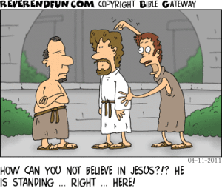

LAST WEEK’S COLLECTION

Adults $2,131.00

Loose $ 598.25

Youth $ 28.00

Monthly $ 265.00

Candles $ 15.00

Maintenance $ 50.00

Catholic Home Missions $ 10.00

Holy Land $ 561.00

Holy Thursday/Food Pantry $1,111.00

Lenten Folders $ 440.00

Easter Offering $6,446.25

Total $11,655.50

We sincerely thank and ask God’s

blessing upon all who have care

and concern for our parish.

*April 28, 2019 John 20:19-31*

*Jesus connects PEACE and FORGIVENESS in today’s gospel. In our families we will only experience peace to the extent we forgive one another. Peace is purchased with the currency of forgiveness. When we allow our anger and pride to lock out others, we also lock out peace and harmony.*

COMBINED CHOIR PRACTICE ~ Combined Choir for First Holy Communion practice will be Friday, May 3rd at 7:00 PM. All are invited and encouraged to attend practice to prepare for this most special occasion for the children of our Parish.

CCW ANNUAL “HANDS & HEARTS HAITI FET” ~ The Carmelite Community of the Word invites you to our Annual Hands & Hearts Haiti Fet (Paschal Festival), on Sunday, May 5, at Our Lady of Loretto Hall, 279 St. Elizabeth St., Loretto, PA. Please join us for an afternoon of good food, and enriching entertainment through Haiti stories and information on the CCW Hands & Hearts Ministry efforts. The afternoon will include a silent auction and opportunity to purchase Haitian Art and Craft items. Doors open at 1:15 PM; Dinner and Program at 2:00 PM. Tickets are $35 for adults and $15 for children under 13. In addition, each participate is asked to contribute an item of children’s or teens new underwear or socks. Contact the CCW Incarnation Center at 814-886-4098 for tickets or for more information. Ticket deadline is April 29. All proceeds will benefit the CCW Hands & Hearts Haiti Ministry.

DIOCESAN PRAYER DAY /LUNCHEON ~ For those who have lost a spouse through death. Remember your loved ones on Wednesday, May 8 with Mass at 11:00 AM. All spouses will be mentioned and remembered at Mass. Luncheon to follow. Sponsored by the Diocesan Family Life Office and hosted by the Immaculate Conception Church, New Germany Road, Summerhill. Reservations required by May 1. A $5 donation is suggested. Contact the Family Life Office at 814-886-5551 or [familylife@dioceseaj.org](mailto:familylife@dioceseaj.org)

NATIONAL CENTER FOR ST. PADRE PIO ~ Join Fr. Dave Peles and Deacon Michael Russo for a day-long Pilgrimage to the National Center for St. Padre Pio, June 26, 2019. Round trip bus fare is $55 per person (based on 40 passengers). Lunch is $21 per person. *All gratuities are included.* Located in beautiful Barto, PA, the National Centre for Padre Pio is a scenic destination filled with the peace and prayerfulness of Padre Pio’s spirit. Built to resemble Padre Pio’s friary in San Giovanni Rotondo, Italy, the Centre offers a number of outdoor statues, a magnificent chapel, and a full museum filled with cultural and religious relics. Explore the gallery and visit the center to see each location for yourself. The bus for the Pilgrimage will leave the upper parking lot of St. Benedict Church at 7:00 AM on June 26th. The bus will depart from the Padre Pio Center at 4:30 PM. For more information contact: Deacon Michael Russo 814-288-3036 or email [michael.russo@atlanticbb.net](mailto:michael.russo@atlanticbb.net). *All Are Welcome*

HOW CAN I LEARN MORE ABOUT PROTECTING CHILDREN?

Prevention training for adults creates a culture of awareness. It gives people the skills to create safer environments. It makes them more willing to intervene in unsafe behaviors by adults with children.

*Stewards of Children* is a program that teaches adults to:

* Prevent sexual abuse before it can happen.
* Recognize signs of sexual abuse in children.
* Recognize unsafe behaviors by adults.
* React responsibly when a child discloses, or when an adult discovers or suspects sexual abuse.

Visit [www.D2L.org](http://www.D2L.org) to learn more about *Stewards of Children*, see where it is being offered in your area, or find ways to get your community involved in a grassroots initiative to end child sexual abuse.

Catholic Ministries Drive $26,768.00

Raised: $ 2,925.00

Balance: $23,843.00

Number of responses: 23

Thank you to all parishioners who have responded to the *2018 Catholic Ministries Drive.* Please join them in supporting our Parish and a select group of ministries that provide outreach to the poor, family life, youth and seminarians. If you did not receive a pledge card in the mail, you may give online at [www.dioceseaj.org](http://www.dioceseaj.org).



The Sanctuary Candle will burn in memory of

John Zibura requested by Family

The Our Lady of Grace Candle will burn in memory of

Our Mom Elvida Bovino

requested by daughters Louise Neff & Joyce Suckenik

during the week of April 28, 2019.

[](https://images.search.yahoo.com/search/images;_ylt=A0LEV1kSWptXvOwAKINXNyoA;_ylu=X3oDMTEyZGdkcmRoBGNvbG8DYmYxBHBvcwMxBHZ0aWQDQjIwODlfMQRzZWMDc2M-?p=Clipart+of+a+sanctuary+candle&fr=ush-mailn_02&th=110&tw=110&imgurl=http://www.henningers.com/389-168-wall-sanctuary-lamp.jpg&rurl=http://pixshark.com/sanctuary-lamp.htm&size=43KB&name=Sanctuary+Lamp+Bronze+wall+sanctuary+lamp&h=600&w=600&turl=http://ts2.mm.bing.net/th?id=OIP.M68453c67108cdc5ab485d309b395bd03o0&pid=15.1&rs=1&c=1&qlt=95&w=110&h=110#inline&tt=Sanctuary+Lamp+Bronze+wall+sanctuary+lamp&sigr=116keh5le&sigit=13gvlt42j&sigi=11ip0pgm4&sign=119kp6100&sigt=119kp6100)

EASTER FLOWERS ~ In Memory Of: Deceased members of the Franchic Family by Jarod Mucker, Deceased members of Stridinger Family by Dolores, Evan & Susan Yanzetich, Andrew & Valeria Kush by Lawrence & Suellen Kush. Again, we thank all those who so generously gave donations for the Easter Flowers. The extra money collected will help to defray the cost of flowers purchased throughout 2019.

FIRST FRIDAY ~ Exposition of the Blessed Sacrament will be First Friday, May 3th with adoration from 8:30 AM until 3:00 PM. Sign-up sheets can be found at the entrances of the Church.

HOLY NAME SOCIETY ~ Will hold their monthly meeting next Sunday, May 5th after the 8:00 AM Mass.

LAY MINISTRY SCHEDULES ~ Lay ministry schedules for the summer months of June through September are now being made up. Anyone who would like to serve as an Altar Server, Reader, Cantor, Greeter or any current minister who has scheduling preferences at this time, should call Suzi Blazosky at 495-5287 or e-mail her at [sublazosky@gmail.com](mailto:sublazosky@gmail.com) no later than Sunday, May 19th.

CATHOLIC HOME MISSIONS APPEAL ~ Support the Catholic Home Missions Appeal today! Right now, over 40% of dioceses in the United States are considered mission territory because they are unable to fund essential pastoral work in their communities. Your donations support programs, such as religious education, seminary formation, and lay ministry training, to build vibrant faith communities right here in the United States. Please be generous. Find more information at [www.usccb.org/home-missions](http://www.usccb.org/home-missions).

MOTHER’S DAY BRUNCH ~ All mothers and daughters of the parish are invited to a Mother’s Day Brunch on Sunday, May 12th sponsored by the Holy Name Society. They will be paying for, preparing and serving the meal in the church hall immediately following the 10:30 a.m. Mass. Sunday morning help is needed in the preparation, serving of the meal and the clean up after. Please call Pete Parisi at 487-5351. (This is a good way for male REACH students to earn service hours. Contact the Religious Education Office at 495-4873 to volunteer.)

MOTHER’S DAY MASS INTENTIONS ~ Envelopes for Mother’s Day Mass Intentions are in your packet of envelopes. The envelopes will be placed on the altar during the month of May in remembrance of all mothers, both living and deceased. Extra envelopes can be found at the entrances of the church.

C:\Documents and Settings\Susan\Local Settings\Temporary Internet Files\Content.IE5\XHXVAJYK\CAK5OTOS.wmfMOTHER’S DAY CARNATIONS FOR BIRTHRIGHT ~ REACH students will be handing out carnations before each Mass on Mother's Day weekend to the women of the parish.  REACH funds will make a donation to Birthright for their Pro-Life efforts. Birthright is an interdenominational pregnancy support service that enables women who are facing an unintended pregnancy to choose life for their unborn babies by providing emotional and material support. Birthright helps women in these situations find medical care, clothing, food, even housing. For thousands of women, Birthright is hope. Hope that they, and their unborn children, are not alone. Since 1980, over 5,000 babies have been born in our area under the auspices of Birthright.

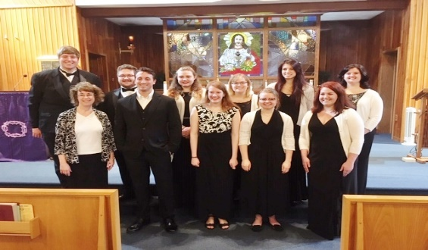

We would like to Thank the Mount Aloysius Vox Nova Singers for their beautiful performance on Friday April 12th of the Stations of the Cross.

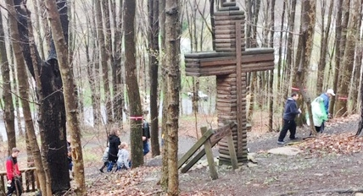

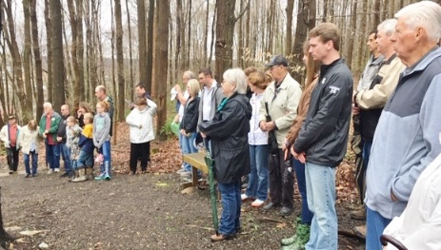

The Outdoor Stations, Friday, April 19th

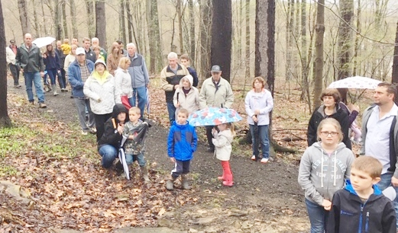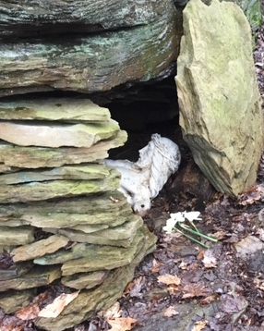



Our Saint Michael Parish will be hosting Yee Haw VBS this summer along with Most Holy Trinity and Saint Bartholomew Parishes. Yee Haw will be held on July16, 17 & 18 from 6—8 p.m. in our Saint Michael Parish Hall. VBS Registration forms are being sent home with our students from Religious Education classes and are also available on the tables at the entrances of the church along with our Volunteers Registration forms.

REACH students and adult volunteers are needed to help with prep ahead of VBS week and we will also need help the week of VBS. High School students can earn service hour credits for helping. A planning meeting is scheduled for next Thursday, May 2nd at 6 p.m. in our Saint Michael Parish Hall. Please join us to make this a wonderful adventure for our children. If you are unable to attend the meeting but would like to share in the fun, call the Parish Office at 495-9640 or the RE Office at 495-4873.

 Religious Education And Christian Helping

April 28, 2019

Good Friday “Living Stations of the Cross” ~ April 19, 2019

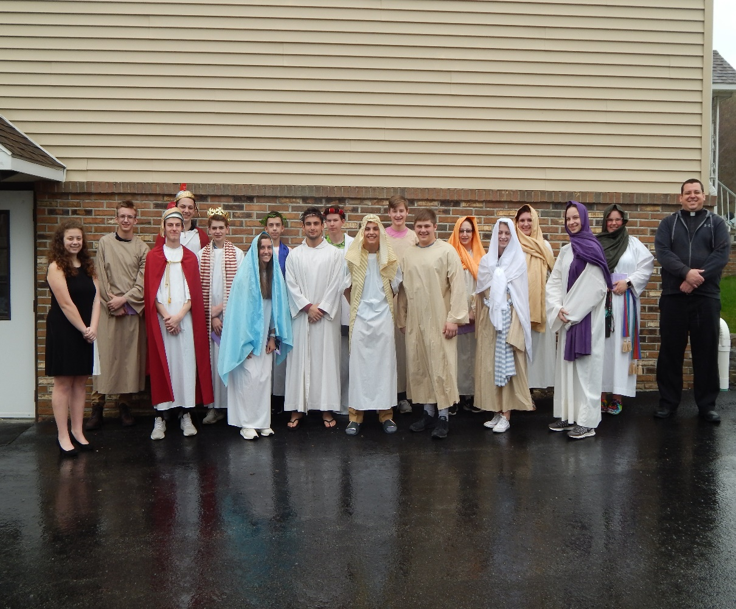

Pictured above are the participants of our REACH Youth Ministry Living Stations.

Left to Right: Eva Spangler, (Station Leader); Luke Docherty, (The Thief); Jeremy Weis (Soldier who stripped Jesus); Quinn Spangler (Soldier Who Nailed Jesus to the Cross); Dylan Kundrod, (King Herod); Elisabeth Zajdel, (Mary, Mother of Jesus); Ian Dobbins, (Pilate); Brycen Rearick, (Jesus); Carson Kundrod, (Caiaphas); Colby Rearick, (Simon of Cyrene); Alex Bambino, (Barabbas & Nicodemus); Luke Hribar, (Dismas); Haidyn Koch, (Woman of Jerusalem); Alexia Steele, (Veronica); Mykala Drobnick, (Salome); Elizabeth Dobbins, (Mary Magdalene); Shannan Elgin, (Women of Jerusalem) and Fr. Brian.

 *************************************************************************

*Congratulations to our Saint Michael Confirmation Class of 2019! The following class members received their sacrament of Confirmation on Thursday, April 25th at Saint John Gualbert Cathedral in Johnstown:*

*Luke Docherty, Mykala Drobnick, Shannan Elgin, Luke Hribar, Brycen Rearick, Hadan Romanow and Elisabeth Zajdel.*

*************************************************************************

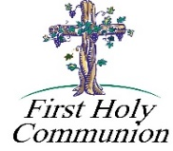

*First Holy Communion ~ Our Second Grade class is preparing to receive their Sacrament of Reconciliation on Saturday, May 4th at 10:00 AM and First Holy Communion on Sunday, May 5th at the 10:30 Mass.*

*************************************************************************

*Religious Education Class Schedule*

*Sunday, 6—12: Sunday, April 28th is the last class for our Students in Grades 6—12.*

*Thursday, K—5: Thursday, May 2nd will be the last class for our K—5 students.*

43rd ANNUAL ROAST BEEF DINNER/SPRING FESTIVAL ~ At St. Demetrius Parish in Gallitzin on Sunday, April 28th. Location: Church hall (former St. Patrick building) at the top of Church St. Time: 10:30 AM to…? Tickets: Adults (eat-in or take-out) $10; Children 6 to 12, $6; 5 and under FREE.

GNOCCHI DINNER ~ St. Anthony of Padua, Windber Gnocchi Dinner: Take Out Only! Sunday, April 28th,

11 AM – 2 PM. $9.00

LIFT JOHNSTOWN’S REGIONAL PROJECT PARTY ~ Tuesday, April 30, 12 PM to 5:30 PM. Frank J. Pasquerilla Conference Center. Downtown Johnstown. For more information go to: [www.liftjohnstown.org](http://www.liftjohnstown.org), email: [liftjohnstown@johnstownchamber.com](mailto:liftjohnstown@johnstownchamber.com) or call 814-536-5107. Free event – open to the public!

BINGO ~ Our 1st Monthly Bingo! St. Mary’s Byzantine Church on Friday, May 3rd. 803 Somerset Ave., Windber. Doors open 5:00 PM, Early Bird 6:15 PM, Bingo starts 6:30 PM. Food & Beverages available for sale. Any questions call Theresa Smith @ 814-467-4756 after 7 PM or 814-691-1434 after 5 PM.

SPAGHETTI DINNER & BASKET PARTY ~ Sunday, May 19th. St. Michael Catholic Church Hall, St. Michael. Tickets $15. Doors open at 12, Dinner at 12:30 & basket raffle to follow dinner. Sponsored by team Blue Skies Over Purple Hearts in Memory of Jane Plummer. All proceeds go to Alzheimer’s Association. To purchase tickets, call Mary Ann Tedjeske–814-341-5463, Janet Minor-814-241-5106 & Krista Hershberger-814-421-9325. END ALZ

GREATER JOHNSTOWN COMMUNITY CHORUS ~ Presents “To Visions and Dreams” directed by Kim Rauch. Sunday May 5th at 3 PM at Grove Avenue United Methodist Church located at 501 Grove Ave. Johnstown. Suggested donation of $10 at the door.

Sunday, April 28 Last High School Religious Education / 9:00–10:20 AM

Catholic Home Missions Appeal / Second Collection

Hall Rental / 12:00 PM

 Girl Scouts

Monday, April 29 Sunday Choir Practice / 7:00 PM

Tuesday, April 30 Boy Scouts / 7:30–9:00 PMPMPM

Wednesday, May 1 No Mass

Thursday, May 2 Last K-5 Religious Education / 3:30 – 4:30 PM

Saturday Choir Practice / 4:30 PM

VBS Meeting / 6:00 PM

Friday, May 3 Exposition of the Blessed Sacrament with Adoration / 8:30 AM-3:00 PM

Combined Choir Practice / 7:00 PM

Saturday, May 4 Practice & First Reconciliation / Second Graders / 10:00 AM

UPCOMING EVENTS

May 5 First Holy Communion / May Crowning

Holy Name Meeting

Girl Scouts

Mayl 11 & 12 Second Sunday Food Pantry Collection

May 12 Mother’s Day Brunch

Girl Scouts