ST. MICHAEL ROMAN CATHOLIC CHURCH
751 Locust Street
PO Box 103
St. Michael, Pennsylvania 15951

Rev. Msgr. David A. Lockard, Administrator MASSES:
(814) 495-9640 Saturday 4:00 pm
Sunday Morning 8:00 am
Secretary & Bookkeeper: 10:30 am
Michele Panick Daily Mass: M, T, W, Th, F
DRE: Laurie Sloan 9:00 am
Maintenance: Rodney Turgeon Holy Days: See Bulletin
PHONES: Office Hours:
Rectory / Office: (814) 495-9640 8:30 am to 3:30 pm
Fax: (814) 495-9424 Monday, Tues., Thurs., Friday
Rel. Education: (814) 495-4873 Closed Wednesdays
Parish Website Confessions:
www.saintmichaelchurch.weebly.com Saturday 3:30 pm to 3:45 pm
Secretaries’ E-mail Sunday 7:30 am to 7:45 am
saintmichaelsecretaries@yahoo.com 10:00 am to 10:15 am
Facebook page: By Appointment
St. Michael Catholic Church/St. Michael, PA

Eighth Sunday in Ordinary Time

SERVING GOD AND COMMUNITY FOR OVER ONE HUNDRED YEARS!

February 27th, 2022

BAPTISM: By Appointment. Reserve at least one month in advance.
MARRIAGE: Plan at least nine months in advance.
Preparation sessions are necessary.
FUNERALS: Arrangements are made in conjunction with the funeral home.
REGISTRATION Those new to the area, newlyweds, and single adults, (even if
and registered before with their families) are asked to register by calling
Membership: the Parish Office. Every parishioner must be registered. This is a condition for admission to our Program and reception of the Sacraments of Baptism, Confirmation, First Penance, First Eucharist, and Matrimony; also, for testimonial letters or sponsorship of Baptism and Confirmation outside the Parish.
VISITATION: We are concerned and want to be advised when someone is ill at home or in the hospital. Call the office to have the shut-in placed on our monthly Holy Communion calls or seriously ill prayer list.
SACRAMENTAL Parish registration and active Mass participation for Baptism is
POLICY: encouraged and is required for Marriage.
BULLETIN ARTICLES: Articles are due to the Parish Office by Noon on Tuesday

Eighth Sunday in Ordinary Time
February 27th, 2022
Month of The Holy Family

MASS INTENTIONS: (February 28 – March 6, 2022)

Monday, February 28 9:00 AM Albert & Katherine Demko req. by Carl & Pam Freidhoff
Tuesday, March 1 9:00 AM Ed Myers req. by Karen Myers & family
Wednesday, March 2 9:00 AM Jason Plummer req. by Parents
Noon Prayer Service with Distribution of Ashes
6:00 PM Mary Alice Colosimo req. by Carl & Carol Sax
Thursday, March 3 9:00 AM John Cook req. by Pheobe Burkett
Friday, March 4 9:00 AM Irene Danel req. by Paul & Susan Snyder
Saturday, March 5 4:00 PM Vince Arena req. by Bob & Ellen Grattan
Sunday, March 6 8:00 AM People of the Parish
10:30 AM Mary Sivec req. by Mr. & Mrs. Robert Cannizzaro

LITURGICIAL APPOINTMENTS:

Saturday, March 5 4:00 PM Offertory Procession

Lector: Susan Poldiak Vince Arena Family
Minister of the Host: Alice Podrebarac
Choir Minister: Susan Blazosky
Altar Server: Chase Williamson
Cantor: Amanda Williamson
Greeter: Joanne Thomas

Sunday, March 6 8:00 AM Offertory Procession

Lector: Cathy Faher Richard & Carol Hautz
Minister of the Host: Terri Leach
Choir Minister: Sally Kolar
Altar Server: Eva Spangler
Cantor: Joseph Faher
Greeter: Lori George

Sunday, March 6 10:30 AM Offertory Procession

Lector: Anthony Bambino The Dobbins Family
Minister of the Host: Haidyn Koch
Choir Minister: Michael Steele
Altar Server: Zach Fisher
Cantor: Elizabeth Dobbins
Greeter: Wendy Blough

Monday, March 7 Collection Counters
George & Pauline Minor

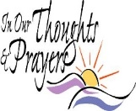
We are placing names of the sick in the bulletin for prayer providing they give permission. May the Divine Physician send healing grace for those for whom we pray: Allen C. Rosemas, Patricia Murphy, Dwight Fyock, Dylon Wills, Missy, Joanne (Kolar) Hufford, Christine Flanagan, Ayden Alan Grata, Mary Lou Offman, Natalie Zerby, Valencia Tursi, Brayden Schofield, Michelle Kasper, Diane Kingera, Ted Paluch, Pearl Litzinger, Patrick Munro, Fran Baldassarre, Kristen Sinosky Long, Cresta Micik, Basil Costantino, Laura, Joe Yoder, Dolores Yanzetich, Sandy Krug, Wanda Gramling, Jennifer Hagans, Shawn, Holly, Shane, Spencer, Owen Taylor, Derrick Varnish, Vincent Koshute, Michelle Elliott, Heather Romanow, Mackston Barrick, Connor Thomas, Erin, Pat, Mary Agnes Nastase, Mary Ann Bertolino, Dick Wilson, Izzy Bihun, Dorothy Kaminsky, Ashlee Madison, Susan Yanzetich, Alina Rusnak, Gary Smay, Elizabeth Howell, Walter Bodziak, Rhonda, Anne Robinson, Carter Bobak, Mike Morris, Sarah Kelt, Patty Yanzetich Caldwell, Colton Snyder, Nancy Edmiston, Leonard Oshaben, Adam, Janice Dipyatic, Lily Maloney, Scott, Lisa, Audrey Costlow, Rosanne Krug, Becky Kakabar, Dolores Mucko, Elliana, Ashlee, Helen Soohy, Carol K. Fabrizio, Peggy Carpenter, Dave Seder, Rosalie Ambrose, Pearl Borlie, Joe (Runk) Slonac, Patty Gdula, Lori Gramling, Babe Richards, Ruth Ferchalk, Kathy Glenn Ripper, Ernie Martinage, Mildred Andrykovitch, Katelyn Engle, John Patterson, Colin Wingard, Betty Duray and all of the sick of our parish, the homebound, those in nursing homes, those who care for them, and those in the military along with their families. (Please call the Rectory to have your name removed from the list when no longer seriously ill. Thank You.)

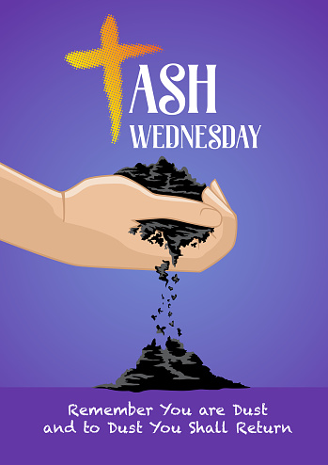

LAST WEEK’S COLLECTION

Regular Offertory $3,508.50
Maintenance $ 35.00
Holy Days $ 10.00
Easter Flowers $ 10.00
Total $3,563.50

We sincerely thank
and ask God’s blessing
upon all who have care
and concern for
our parish.

ASH WEDNESDAY MANDEVILLE COLLECTION
On Ash Wednesday, March 2nd, we will take up a special collection for those living within the Diocese of Mandeville, Jamaica – one of the poorest regions in the Americas. As we begin the Season of Lent, may our generosity be a reflection of God’s own generosity to us. Envelopes can be found in your packet.

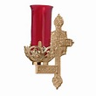
During the week of February 27th, 2022
the Sanctuary Candle will burn in memory of
Renee Robinson

LENT ~ Ash Wednesday, the first day of Lent, falls on March 2nd this year. Blessed ashes will be distributed during a 9:00 AM and a 6:00 PM Mass that day. There will also be a prayer service at Noon on Ash Wednesday during which blessed ashes will be distributed. Plan now to attend. Ash Wednesday is a day of Fast and Abstinence – no meat, no eating between meals and only one “big meal.”

CONFESSIONS & STATIONS OF THE CROSS ~ We will pray the Stations of the Cross on the Fridays of Lent at 6:00 PM. Following the Stations there will be an opportunity to go to confession. Let us make the most of this opportunity to participate in these Lenten devotions.

WEDNESDAY EVENING MASS ~ Beginning on Ash Wednesday, March 2nd through April 13th, we will be having an evening Mass at 6:00 PM for Lent. This is a wonderful opportunity to attend a daily Mass to help us in our Lenten journey. There will be NO 9:00 AM Mass on Wednesdays during Lent (except Ash Wednesday).

LENTEN “LITTLE BLACK BOOK” ~ Once again, the parish is providing the Lenten “Little Black Book” free of charge to all parishioners. The “Little Black Book” can be found at the side entrance of the Church and on the table at the back of the Church.

LENTEN FOLDERS ~ Lenten folders are available at the side entrance and on the table at the back of the Church. Your contribution will be added to your Easter Collection and will be a financial help to our local Forest Hills Food Pantry.

CRS RICE BOWLS ~ Catholic Relief Services Rice Bowls are being distributed to the Religious Education students, one per family, in their RE classes. The extra Rice Bowls can be found at the side entrance and on the table at the back of the Church for anyone that wants one. Your Rice Bowl donations will support the missions. Please, one per family.

EASTER FLOWERS ~ If you would like to purchase an Easter Flower for a living (In Honor Of) or a deceased (In Memory Of) member of your family, please do so by using the Easter Flower envelope in your packet. The normal offering is $10. Please return the envelopes on or before April 10th. Extra envelopes can be found at the Church entrances.

LITURGY COMMITTEE MEETING ~ Will be held this Sunday, February 27th after the 10:30 AM Mass in the Church.

SCRIPTURAL FAITH SHARING GROUP ~ Scriptural faith sharing groups are forming for the Lenten season. Consider joining a Synodal Faith Sharing Group based on scripture, to be held during the Lenten season. Two groups are offered to best suit your schedule. Each group will run for six consecutive weeks. Group 1: Starting Tuesday, March 8th in the Church Hall at 9:30 AM (after the morning Mass). Group 2: Starting Wednesday, March 9th, in the Church Hall at 6:30 PM (after the evening Mass). Sign-up sheets are in the back of the Church.

BLACK & INDIAN MISSION ~ Next week, our parish will take up a second collection for the 138th annual National Black & Indian Mission Collection. Our support of this collection helps build the Church in African American, Native American, and Alaska Native communities from coast to coast. Schools, parish religious education programs, and diocesan ministries depend on your generosity to help them spread the Gospel of Jesus Christ! Envelopes can be found in your packet.

Ash Wednesday Lay Ministry Assignments
March 2nd, 2022

9:00 AM 6:00 PM

Reader: Pauline Minor Reader: Arnold Bernard
Minister of the Host: Ellen Grattan Minister of the Host: Amanda Williamson
Choir Minister: Karen Myers Choir Minister: Robert Oshaben
Altar Server: Adult Altar Server: Ian Dobbins
Cantor: Theresa Arena Cantor: Amy Dobbins
Greeter: Helen Slonac Greeter: Darlene Marshall
Offertory Procession: Plummer Family Offertory Procession: Rick Roberts Family

SYNOD SURVEY ~ How can the Church better teach and spread the Good News of Jesus Christ? Tell us by completing the Synod Survey by going to dioceseaj.org/synod for the online survey, or paper surveys can be found at the entrances of the Church, or you can join our Scriptural Faith Sharing Group. Please return your surveys by Offertory Collection, mail them to the Office or place them in the drop off box located by the Office door.

BOY SCOUTS ~ Adventure is calling, all we need is you! Our parish-chartered Boy Scout troop is accepting new members. Do you like spending time in the outdoors, learning new skills, making new friends, having fun, and deepening your faith by participating in a religious award opportunity? If so, scouting is for you! Boys who are 10 years old and have completed 5th grade are eligible to join Boy Scouts. Look for a flyer this week in CCD to learn more about joining Troop #2251. Please contact Ronald Dobbins, Scoutmaster, at 814-243-1975 for more information.

GREATER JOHNSTOWN COMMUNITY CHORUS ~ Do you like to sing? The Greater Johnstown Community Chorus is accepting new members. We are a local performing and social group of singers who enjoy all forms of music from classical to pop. Under the direction of Michael Miketa, we meet Tuesdays 7 – 9 PM at Mount Calvary United Methodist Church on Scalp Ave. in the back lower level. If you are interested come on over and join us or you can contact Anita Lorek at 814-487-7769, 814-243-0149 or email wlorek1852@comcast.net for additional information. Auditions are not required. Covid vaccinations and masks are required.

FEBRUARY 2022 PARISH TICKET WINNERS

UNSOLD TICKETS/NOT RETURNED TICKETS ~ If the winning number is a ticket that was not sold or returned, the money will be split with the number above the winning number and the number below the winning number. If the number above or below the winning number was not returned, we will go above or below that number.

Day Date Amount Number Winner

Friday February 18 $75 932 Mary P. Vontorcik

Saturday February 19 $100 281 Tom Hammond

Sunday February 20 $100 487 Leah Baxter

Monday February 21 $150 933 Judy Rothgeb
Tuesday February 22 $75 370 Chris Haberl
Wednesday February 23 $75 478 Charles Bertolino
Thursday February 24 $75 667 Edward Puchko

Sunday, February 27 Mass ~ 8:00 AM & 10:30 AM
Confessions / 7:30 – 7:45 AM & 10:00 - 10:15 AM / Confessional
HS Religious Education / Hall / 9 – 10:15 AM
Liturgy Committee Meeting / Church / After 10:30 AM Mass
Girl Scouts Meeting / Hall / 1-2:30 PM & 4-5:30 PM

Monday, February 28 Mass ~ 9:00 AM
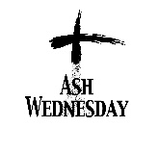
Sunday Choir Practice / 7:00 PM
Leadership Team Meeting / Hall / 6:30 PM

Tuesday, March 1 Mass ~ 9:00 AM
Boy Scout Meeting / Hall / 7:30 – 9:00 PM

Wednesday, March 2 Mass ~ 9:00 AM & 6:00 PM / Ash Wednesday
Prayer Service with Distribution of Ashes / Noon
Mandevile Diocese Collection

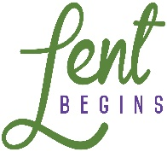
Thursday, March 3 Mass ~ 9:00 AM
K – 5 Religious Education / Hall / 3:30 – 4:30 PM
Saturday Choir Practice / 4:30 PM

Friday, March 4 Mass ~ 9:00 AM
Stations of the Cross / 6:00 PM
Confessions following Stations of the Cross

Saturday, March 5 Mass ~ 4:00 PM
Confessions / 3:30 – 3:45 PM / Confessional
Black & Indian Mission Second Collection

UPCOMING EVENTS
March 6 Black & Indian Mission Second Collection
March 8 Finance Council Meeting
March 10 Pastoral Council Meeting

LENTEN FISH FRY ~ The St. Michael Fire Department is hosting our annual Lenten Fish Fries – Every Friday during lent thru Good Friday – April 15th. Meals are Fried or Baked Fish or Shrimp Dinners. A Grab-n-Go sandwich and child’s dinners are also available. Meals are takeout only and local delivery. Adult Fish Dinners are $11 and Adult Shrimp dinners are $12. Please Phone at 814-495-4111. Hours are 11 AM to 6 PM.

FISH FRY ~ Every Friday during Lent including Good Friday. 4:00 – 6:30 PM New Germany Grove Hall, 1635 New Germany Road, Summerhill. Dine-In now open. Adults: $15, Children 6-11, $7.50, children under 6 – Free. Take-out available by drive thru only. Drive-thru price is $14 with choice of baked or fried fish.

LENTEN JOURNEY SERIES AT ST. BERNARDINE MONASTERY ~ “As We Journey Through Lent” – Join the Friars at St. Bernardine Monastery, 768 Monastery Rd, Hollidaysburg, for a time of reflection, prayer, and fellowship during this Lenten season. Wednesday – March 9th, 16th, 23rd and 30th from 10 AM – 1 PM. Lunch is included and a free-will offering will be taken. Registration is necessary by calling the Monastery office by Friday, March 4th at 814-695-3802.

A PRAYER FOR PEACE BY POPE FRANCIS

Lord God of peace, hear our prayer!
We have tried so many times and over so many years
to resolve our conflicts by our own powers and by the force of our arms.
How many moments of hostility and darkness have we experienced?
how much blood has been shed?
how many lives have been shattered?
how many hopes have been buried?
But our efforts have been in vain.
Now, Lord, come to our aid!
Grant us peace, teach us peace;
guide our steps in the way of peace.
Open our eyes and our hearts,
and give us the courage to say: "Never again war!"; "With war everything is lost".
Instill in our hearts the courage to take concrete steps to achieve peace.
Lord, God of Abraham, God of the Prophets, God of Love,
you created us and you call us to live as brothers and sisters.
Give us the strength daily to be instruments of peace;
enable us to see everyone who crosses our path as our brother or sister.
Make us sensitive to the plea of our citizens
who entreat us to turn our weapons of war into implements of peace,
our trepidation into confident trust,
and our quarreling into forgiveness.
Keep alive within us the flame of hope,
so that with patience and perseverance
we may opt for dialogue and reconciliation.
In this way may peace triumph at last,
and may the words "division," "hatred," and "war"
be banished from the heart of every man and woman.
Lord, defuse the violence of our tongues and our hands.
Renew our hearts and minds,
so that the word which always brings us together will be "brother,"
and our way of life will always be that of: Shalom, Peace, Salaam!
Amen.

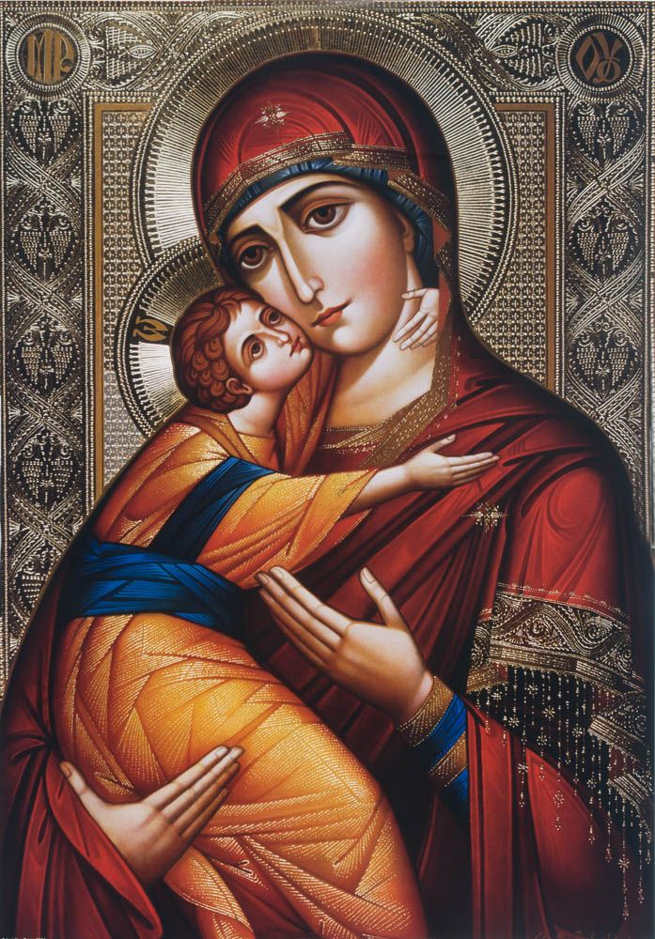

We fly to Your patronage, O Virgin Mother of God.
Despise not our prayers in our needs,
but deliver us from all dangers,
since you alone are pure and blessed.
O most glorious Ever-Virgin Mary,
the Mother of Christ our God, accept our prayers
and present them to Your Son and our God,
that for the sake of You, He enlighten and save our souls.

