ST. MICHAEL ROMAN CATHOLIC CHURCH

751 Locust Street

PO Box 103

St. Michael, Pennsylvania 15951

Rev. Msgr. David A. Lockard, Administrator MASSES:

(814) 495-9640 Saturday 4:00 pm

 Sunday Morning 8:00 am

Secretary & Bookkeeper: 10:30 am

Michele Panick Daily Mass: M, T, W, Th, F

DRE: Laurie Sloan 9:00 am

Maintenance: Rodney Turgeon Holy Days: See Bulletin

PHONES: Office Hours:

Rectory / Office: (814) 495-9640 8:30 am to 3:30 pm

Fax: (814) 495-9424 Monday, Tues., Thurs., Friday

Rel. Education: (814) 495-4873 Closed Wednesdays

Parish Website Confessions:

[www.saintmichaelchurch.weebly.com](http://www.saintmichaelchurch.weebly.com) Saturday 3:30 pm to 3:45 pm

Secretaries’ E-mail Sunday 7:30 am to 7:45 am

[saintmichaelsecretaries@yahoo.com](mailto:saintmichaelsecretaries@yahoo.com) 10:00 am to 10:15 am

Facebook page: By Appointment

St. Michael Catholic Church/St. Michael, PA

Sixth Sunday in Ordinary Time

SERVING GOD AND COMMUNITY FOR OVER ONE HUNDRED YEARS!

February 13th, 2022

BAPTISM: By Appointment. Reserve at least one month in advance.

MARRIAGE: Plan at least nine months in advance.

Preparation sessions are necessary.

FUNERALS: Arrangements are made in conjunction with the funeral home.

REGISTRATION Those new to the area, newlyweds, and single adults, (even if

and registered before with their families) are asked to register by calling

Membership: the Parish Office. Every parishioner must be registered. This is a condition for admission to our Program and reception of the Sacraments of Baptism, Confirmation, First Penance, First Eucharist, and Matrimony; also, for testimonial letters or sponsorship of Baptism and Confirmation outside the Parish.

VISITATION: We are concerned and want to be advised when someone is ill at home or in the hospital. Call the office to have the shut-in placed on our monthly Holy Communion calls or seriously ill prayer list.

SACRAMENTAL Parish registration and active Mass participation for Baptism is

POLICY: encouraged and is required for Marriage.

BULLETIN ARTICLES: Articles are due to the Parish Office by Noon on Tuesday

Sixth Sunday in Ordinary Time

February 13th, 2022

Month of The Holy Family

**MASS INTENTIONS**: (February 14 - February 20, 2022)

Monday, February 14 9:00 AM For the Health & Well Being of Betty Duray req. by

4:00 PM Saturday Choir Tuesday, February 15 9:00 AM Grace Penatzer req. by Gary & Dee Dee Breto

Wednesday, February 16 9:00 AM Josephine Castorina req. by Joyce Myers

Thursday, February 17 9:00 AM Michael Bertolino req. by Robert Sikora

Friday, February 18 9:00 AM Frances Ritz req. by children Judy Livengood, Edward

Ritz, grandchildren & great granchildren

Saturday, February 19 4:00 PM John Cook req. by Pheobe Burkett

Sunday, February 20 8:00 AM Stanley Brezovec req. by Mike & Lucia Ann Brezovec

10:30 AM People of the Parish

LITURGICIAL APPOINTMENTS:

Saturday, February 19 4:00 PM Offertory Procession

Lector: Madison Kundrod Tony Bambino Family

Minister of the Host: Babe Richards

Choir Minister: Karen Myers

Altar Server: Bella Bambino & Kaylee Roberts

Cantor: Susan Blazosky

Greeter: Joanne Thomas

Sunday, February 20 8:00 AM Offertory Procession

Lector: Joseph Faher Michael & Lucia Ann Brezovec

Minister of the Host: Pauline Minor

Choir Minister: Ellen Grattan

Altar Server: Kaden Christ

Cantor: Susan Yanzetich

Greeter: Carol Hautz

Sunday, February 20 10:30 AM Offertory Procession

Lector: Michael Barton Robert & Joan Oshaben

Minister of the Host: Michael Steele

Choir Minister: Haidyn Koch

Altar Server: Alexia & Mackenzie Steele

Cantor: Louis McCloskey

Greeter: Wendy Blough

Sunday, February 20 Collection Counters

Sara Zybura, Chris Smay

Mary Ann DeRosa

Weare placing names of the sick in the bulletin for prayer providing they give permission. *May the* *Divine Physician send healing grace for those for* *whom we pray:* Allen C. Rosemas, Patricia Murphy, Dwight Fyock, Dylon Wills, Missy, Joanne (Kolar) Hufford, Christine Flanagan, Ayden Alan Grata, Mary Lou Offman, Natalie Zerby, Valencia Tursi, Brayden Schofield, Michelle Kasper, Diane Kingera, Ted Paluch, Pearl Litzinger, Patrick Munro, Fran Baldassarre, Kristen Sinosky Long, Cresta Micik, Basil Costantino, Laura, Joe Yoder, Dolores Yanzetich, Sandy Krug, Wanda Gramling, Jennifer Hagans, Shawn, Holly, Shane, Spencer, Owen Taylor, Derrick Varnish, Vincent Koshute, Michelle Elliott, Heather Romanow, Mackston Barrick, Connor Thomas, Erin, Pat, Mary Agnes Nastase, Mary Ann Bertolino, Dick Wilson, Izzy Bihun, Dorothy Kaminsky, Ashlee Madison, Susan Yanzetich, Alina Rusnak, Gary Smay, Elizabeth Howell, Walter Bodziak, Rhonda, Anne Robinson, Carter Bobak, Mike Morris, Sarah Kelt, Patty Yanzetich Caldwell, Colton Snyder, Nancy Edmiston, Leonard Oshaben, Adam, Janice Dipyatic, Lily Maloney, Scott, Lisa, Audrey Costlow, Rosanne Krug, Becky Kakabar, Dolores Mucko, Elliana, Ashlee, Helen Soohy, Carol K. Fabrizio, Peggy Carpenter, Dave Seder, Rosalie Ambrose, Pearl Borlie, Joe (Runk) Slonac, Patty Gdula, Lori Gramling, Babe Richards, Ruth Ferchalk, Kathy Glenn Ripper, Ernie Martinage, Mildred Andrykovitch, Katelyn Engle, John Patterson, Colin Wingard, Betty Duray and all of the sick of our parish, the homebound, those in nursing homes, those who care for them, and those in the military along with their families. *(Please call the Rectory to have your name removed from the list when no longer seriously ill. Thank You.)*

LAST WEEK’S COLLECTION

Regular Offertory $5,175.00

Maintenance $ 40.00

Holy Days $ 10.00

Total $5,225.00

We sincerely thank

and ask God’s blessing

upon all who have care

and concern for

our parish.

*February 13th, 2022 LK 6:17, 20-26*

*Don’t look very far when you hear today’s gospel speak of poverty, sorrow, or exclusion. These things happen in families. Children feel “insulted” when they are constantly criticized. Spouses “hunger” for affection. Grandparents feel “excluded” by divorce and custody decisions. Parents “weep” because they feel alienated from their children.*

During the week of February 13th, 2022

the Sanctuary Candle will burn in memory of

Bruno Bovino

requested by daughters

Louise Neff & Joyce Suckenik

[](https://images.search.yahoo.com/search/images;_ylt=A0LEV1kSWptXvOwAKINXNyoA;_ylu=X3oDMTEyZGdkcmRoBGNvbG8DYmYxBHBvcwMxBHZ0aWQDQjIwODlfMQRzZWMDc2M-?p=Clipart+of+a+sanctuary+candle&fr=ush-mailn_02&th=110&tw=110&imgurl=http://www.henningers.com/389-168-wall-sanctuary-lamp.jpg&rurl=http://pixshark.com/sanctuary-lamp.htm&size=43KB&name=Sanctuary+Lamp+Bronze+wall+sanctuary+lamp&h=600&w=600&turl=http://ts2.mm.bing.net/th?id%3DOIP.M68453c67108cdc5ab485d309b395bd03o0%26pid%3D15.1%26rs%3D1%26c%3D1%26qlt%3D95%26w%3D110%26h%3D110#inline&tt=Sanctuary+Lamp+Bronze+wall+sanctuary+lamp&sigr=116keh5le&sigit=13gvlt42j&sigi=11ip0pgm4&sign=119kp6100&sigt=119kp6100)

[](http://www.churchart.com/subscriber/viewimages.aspx?keywords=In%20Sympathy&entry_date=1/1/0001&image_type=,cl#no)MAY HE REST IN PEACE ~ In your charity, please pray for the eternal rest of Dennis Grattan whose Funeral Mass was celebrated by Fr. Gardner on Monday, February 7th, 2022. May he know the eternal peace and happiness promised by our Savior, Lord Jesus. Please pray for the consolation of all his family and friends.

SECOND SUNDAY FOOD PANTRY COLLECTION ~ This weekend is our Second Sunday Food Pantry Collection. Please bring in non-perishable food items or toiletries with you. Monetary donations are also appreciated.

HOLY NAME SOCIETY ~ Will hold their monthly meeting this Sunday, February 13th in the Church Hall after the 8:00 AM Mass.

COFFEE & DONUTS ~ There will be coffee & donuts in the Church Hall this Sunday, February 13th after the 8:00 AM Mass.

CANDLEMAS CANDLES ~ Blessed candles (two to a box) are available in the Church for those who want them. We ask an offering of $3.00 per box/$5 per glass candle to cover expenses.

SYNOD SURVEY ~ Pope Francis wants to hear from you! Share with us how the Church can better live out the mission of Jesus Christ by completing the Synod Survey. To participate go to dioceseaj.org/synod for the online survey, or paper surveys can be found at the entrances of the church or think about joining a local small faith sharing group!

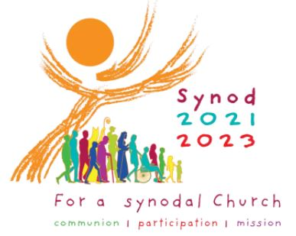

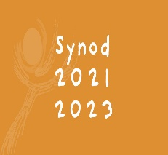SYNOD 2021-2023 FOR A SYNODAL CHURCH ~ Pope Francis wants to hear from the whole Church about what is happening in local parishes! He wants to hear from you as parishioners as to what you think should be done to help make our parishes better. The way he has proposed is by holding a Synod, which is journeying together to listen and discern what the Holy Spirit is saying to our Church today. There will be many opportunities throughout the diocese for parishioners to engage and share their inspired thoughts. The first experience will be that of Small Faith Sharing Groups. The diocese, through Sr. Linda LaMagna, will be offering several workshops as well as a zoom meeting to highlight the synod, so that Small Faith Sharing Groups can help people’s hopes flourish, and restore strength to our hands for our common mission. Dates & times for the workshops are in this week’s bulletin and a flyer is posted on the bulletin boards at the entrances of the church.

PRAYING WITH ICONS: ZOOM CLASS OFFERED ~ Icons are not simply art; they are a way into contemplative prayer, and therefore one way to let God speak to us. The class, *Praying With Icons,* focuses on the Festal Icons (the major events in the life of Christ and the Theotokos) and the Sacred Scripture that speaks to us through the sacred images. Deacon Michael Russo will be presenting this six week Zoom class Monday evenings from 6:30-8:30 PM beginning February 14th. The cost of the class (which includes registration and materials) is $65. To register please contact Marybeth at 814-361-2000 or email at [mheinze@dioceseaj.org](mailto:mheinze@dioceseaj.org). All are welcome!

SLOVAK CLASS AND SPECIAL MASS ~ As a way to celebrate Slovak heritage and culture a special Mass will be celebrated on Monday, February 14th at 6 PM at Queen of Angels Parish in Central City (St. John – 164 Wheeler St.) in honor of Sts. Cyril and Methodius, patron saints of the Slavs. Following Mass, Dr. Michal Kopanic will offer an hour-long class on the origins of the Slovak people, Sts. Cyril and Methodius, and a brief overview of various regions in Slovakia. In addition to a PhD from the University of Pittsburgh and a M.A. from the University of Notre Dame, Dr. Kopanic has studied at Comenius University in Bratislava and currently teaches at the University of Maryland. All are invited to attend the Mass & lecture. If you plan to attend, please phone Queen of Angels Rectory 814-754-5224, so that an accurate estimate of refreshments may be determined.

FEBRUARY 2022 PARISH TICKET WINNERS

UNSOLD TICKETS/NOT RETURNED TICKETS ~ If the winning number is a ticket that was not sold or returned, the money will be split with the number above the winning number and the number below the winning number. If the number above or below the winning number was not returned, we will go above or below that number.

Day Date Amount Number Winner

Friday February 4 $75 145 Patricia Reneri-Doyle

Saturday February 5 $100 730 No Winner

$50 731 Alice Podrebarac

$50 729 Mary Anne Davis

Sunday February 6 $100 238 Jim Miller

Monday February 7 $75 700 Garrett Kundrod

Tuesday February 8 $75 513 Carole Kakabar

Wednesday February 9 $75 098 Kayla Walls

Thursday February 10 $75 053 Theresa Arena

 Religious Education And Christian Helping

February 13, 2022

Spring Confirmation Sessions

Grade 9 ~ Session 9 B ~ Prayer: Communion with God

Our 9th Grade students will be participating in their Spring Session 9 B from 9 to 10:20 a.m.

with their classmates on Sunday, March 6, 2022.

*****************************************************************************

*Confirmation Retreats*

Our Confirmation retreats are scheduled to take place on the following dates for

our 10th, and 11th grade candidates during class time, 9—10:20 a.m.

Sunday, March 6th ~ 10th Grade – Baptism Retreat (Make-up from 9th Grade year)

11th Grade – Parables Retreat

*Confirmation candidates must be present for their retreat date to fulfill their confirmation requirements and be eligible to receive their Sacrament of Confirmation*

*****************************************************************************



*Sacrament of First Reconciliation ~* Our First Holy Communion class has been preparing for and will receive their Sacrament of Reconciliation for the first time on Saturday, March12, 2022 at 1:00 PM in the church.

Please remember these children in your prayers as they prepare and anticipate the arrival of this very special day.

**********************************************************************

Confirmation ~ Our 11th Grade Confirmation class is preparing to receive their Sacrament of Confirmation on Thursday, April 21st, 2022. A 7:00 PM Mass will be celebrated at Saint John Gualbert Cathedral in Johnstown. *Confirmation Practice will be held on Wednesday evening, April 20th at 6:30 PM.*

First Holy Communion ~ Our First Holy Communion class

is preparing to receive their Sacrament of First Holy Communion

on Sunday, May 1, 2022 at 2:00 PM.

Synod on Synodality

2021 – 2023

*Gatherings for Small Faith*

*Sharing Group Leaders for*

*Facilitating Synodal Consultations*

February 16 February 13

1:00-3:00 PM 6:00-8:00 PM

St. Mark’s Church Holy Name Church

416 6th Ave. Altoona 500 N Julian St. Ebensburg

February 19 February 23

9:00-11:00 AM 6:00-7:30 PM

Most Holy Trinity Church via Zoom

524 Mifflin St. Huntingdon

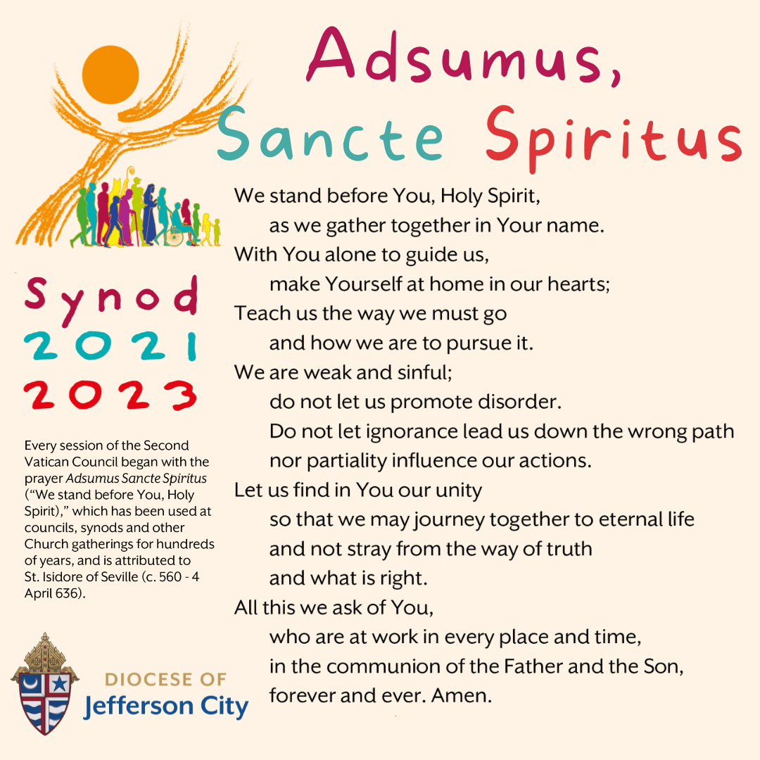

Sister Linda LaMagna

623 East 3rd Street

Bellwood, PA 16614

llamagna@dioceseaj.org

Sunday, February 13 Mass ~ 8:00 AM & 10:30 AM

Confessions / 7:30 – 7:45 AM & 10:00 - 10:15 AM / Confessional

HS Religious Education / Hall / 9 – 10:15 AM

Second Sunday Food Pantry Collection

Holy Name Society Meeting / Hall / After 8:00 AM Mass

Coffee & Donuts / Hall / After 8:00 AM Mass

Girl Scouts / Hall / 1-2:30 PM & 4 – 5:30 PM

 Monday, February 14 Mass ~ 9:00 AM

Sunday Choir Practice / 7:00 PM

Tuesday, February 15 Mass ~ 9:00 AM

Boy Scout Meeting / 7:30 – 9:00 PM

Wednesday, February 16 Mass ~ 9:00 AM

Thursday, February 17 Mass ~ 9:00 AM

K – 5 Religious Education / Hall / 3:30 – 4:30 PM

Saturday Choir Practice / 4:30 PM

Friday, February 18 Mass ~ 9:00 AM

Saturday, February 19 Mass ~ 4:00 PM

Confessions / 3:30 – 3:45 PM / Confessional



UPCOMING EVENTS

February 21 President’s Day / Parish Offices Closed

February 23 Boy Scouts Painting Party / Hall / 6 – 8:30 PM

PUBLIC ROSARY ~ To Pray for Our Country. Saturday, February 26th at NOON. St. John Gualbert Cathedral – St. Ann Shrine – Downtown Johnstown.

TRIVIA NIGHT! ~ Bishop Carroll Catholic High School, Saturday, February 26th. Doors open at 6 PM, Dinner at 6:30 PM. Game begins at 7:30 PM. Open to age 21 and over. Pre-paid ticket $30, Door $35. Registration deadline February 21st. For information email [jnagy@bishopcarroll.org](mailto:jnagy@bishopcarroll.org).

LENTEN JOURNEY SERIES AT ST. BERNARDINE MONASTERY ~ “As We Journey Through Lent” – Join the Friars at St. Bernardine Monastery, 768 Monastery Rd, Hollidaysburg, for a time of reflection, prayer, and fellowship during this Lenten season. Wednesday – March 9th, 16th, 23rd and 30th from 10 AM – 1 PM. Lunch is included and a free-will offering will be taken. Registration is necessary by calling the Monastery office by Friday, March 4th at 814-695-3802.