ST. MICHAEL ROMAN CATHOLIC CHURCH

751 Locust Street

PO Box 103

St. Michael, Pennsylvania 15951

Rev. Msgr. David A. Lockard, Administrator MASSES:

(814) 495-9640 Saturday 4:00 pm

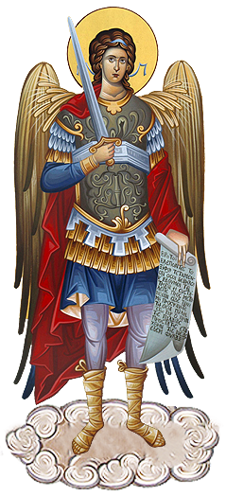 Sunday Morning 8:00 am

Secretary & Bookkeeper: 10:30 am

Michele Panick Daily Mass: M, T, W, Th, F

DRE: Laurie Sloan 9:00 am

Maintenance: Rodney Turgeon Holy Days: See Bulletin

PHONES: Office Hours:

Rectory / Office: (814) 495-9640 8:30 am to 3:30 pm

Fax: (814) 495-9424 Monday, Tues., Thurs., Friday

Rel. Education: (814) 495-4873 Closed Wednesdays

Parish Website Confessions:

[www.saintmichaelchurch.weebly.com](http://www.saintmichaelchurch.weebly.com) Saturday 3:30 pm to 3:45 pm

Secretaries’ E-mail Sunday 7:30 am to 7:45 am

[saintmichaelsecretaries@yahoo.com](mailto:saintmichaelsecretaries@yahoo.com) 10:00 am to 10:15 am

Facebook page: By Appointment

St. Michael Catholic Church/St. Michael, PA

Fifth Sunday in Ordinary Time

SERVING GOD AND COMMUNITY FOR OVER ONE HUNDRED YEARS!

February 6th, 2022

BAPTISM: By Appointment. Reserve at least one month in advance.

MARRIAGE: Plan at least nine months in advance.

Preparation sessions are necessary.

FUNERALS: Arrangements are made in conjunction with the funeral home.

REGISTRATION Those new to the area, newlyweds, and single adults, (even if

and registered before with their families) are asked to register by calling

Membership: the Parish Office. Every parishioner must be registered. This is a condition for admission to our Program and reception of the Sacraments of Baptism, Confirmation, First Penance, First Eucharist, and Matrimony; also, for testimonial letters or sponsorship of Baptism and Confirmation outside the Parish.

VISITATION: We are concerned and want to be advised when someone is ill at home or in the hospital. Call the office to have the shut-in placed on our monthly Holy Communion calls or seriously ill prayer list.

SACRAMENTAL Parish registration and active Mass participation for Baptism is

POLICY: encouraged and is required for Marriage.

BULLETIN ARTICLES: Articles are due to the Parish Office by Noon on Tuesday



Fifth Sunday in Ordinary Time

February 6th, 2022

Month of The Holy Family

**MASS INTENTIONS**: (February 7 - February 13, 2022)

Monday, February 7 9:00 AM Josh Faher req. by Mom & Dad

Tuesday, February 8 9:00 AM Thomas Vandzura req. by Eric Tedjeske

Wednesday, February 9 9:00 AM Martin & Mary Brown req. by Mary Jean Brown

Thursday, February 10 9:00 AM Agnes Noon req. by Matt & Lori Murphy

Friday, February 11 9:00 AM Prudence Rulli req. by Karen Myers (rescheduled from 2-4)

Saturday, February 12 4:00 PM Mary Ann Daniels req. by Joe Daniels

Sunday, February 13 8:00 AM Albert & Clara Long req. by Carl & Pam Freidhoff

10:30 AM People of the Parish

LITURGICIAL APPOINTMENTS:

Saturday, February 12 4:00 PM Offertory Procession

Lector: Amy Spinos Daniels Family

Minister of the Host: Alice Podrebarac

Choir Minister: Michael Barton

Altar Server: Bella Bambino & Natalie Stohon

Cantor: David Zajdel

Greeter: Karen Myers

Sunday, February 13 8:00 AM Offertory Procession

Lector: Bryan Spangler Long Family

Minister of the Host: Sally Kolar

Choir Minister: Terri Leach

Altar Server: Eva Spangler

Cantor: Amy Dobbins

Greeter: Lori George

Sunday, February 13 10:30 AM Offertory Procession

Lector: James Lashinsky Michael Steele Family

Minister of the Host: Robert Oshaben

Choir Minister: Amanda Williamson

Altar Server: Landon Fisher

Cantor: Alexis Henderson

Greeter: REACH Students

Monday, February 14 Collection Counters

George & Pauline Minor

Weare placing names of the sick in the bulletin for prayer providing they give permission. *May the* *Divine Physician send healing grace for those for* *whom we pray:* Allen C. Rosemas, Patricia Murphy, Dwight Fyock, Dylon Wills, Missy, Joanne (Kolar) Hufford, Christine Flanagan, Ayden Alan Grata, Mary Lou Offman, Natalie Zerby, Valencia Tursi, Brayden Schofield, Michelle Kasper, Diane Kingera, Ted Paluch, Pearl Litzinger, Patrick Munro, Fran Baldassarre, Kristen Sinosky Long, Cresta Micik, Basil Costantino, Laura, Joe Yoder, Dolores Yanzetich, Sandy Krug, Wanda Gramling, Jennifer Hagans, Shawn, Holly, Shane, Spencer, Owen Taylor, Derrick Varnish, Vincent Koshute, Michelle Elliott, Heather Romanow, Mackston Barrick, Connor Thomas, Erin, Pat, Mary Agnes Nastase, Mary Ann Bertolino, Dick Wilson, Izzy Bihun, Dorothy Kaminsky, Ashlee Madison, Susan Yanzetich, Alina Rusnak, Gary Smay, Elizabeth Howell, Walter Bodziak, Rhonda, Anne Robinson, Carter Bobak, Mike Morris, Sarah Kelt, Patty Yanzetich Caldwell, Colton Snyder, Nancy Edmiston, Leonard Oshaben, Adam, Janice Dipyatic, Lily Maloney, Scott, Lisa, Audrey Costlow, Rosanne Krug, Becky Kakabar, Dolores Mucko, Elliana, Ashlee, Helen Soohy, Carol K. Fabrizio, Peggy Carpenter, Dave Seder, Rosalie Ambrose, Pearl Borlie, Joe (Runk) Slonac, Patty Gdula, Lori Gramling, Babe Richards, Ruth Ferchalk, Kathy Glenn Ripper, Ernie Martinage, Mildred Andrykovitch, Katelyn Engle, John Patterson, Colin Wingard, George Noel, Dennis Grattan, Betty Duray and all of the sick of our parish, the homebound, those in nursing homes, those who care for them, and those in the military along with their families. *(Please call the Rectory to have your name removed from the list when no longer seriously ill. Thank You.)*

LAST WEEK’S COLLECTION

Regular Offertory $4,423.29

Maintenance $ 33.00

Holy Days $ 20.00

Total $4,476.29

We sincerely thank

and ask God’s blessing

upon all who have care

and concern for

our parish.

*February 6th, 2022 LK 5:1-11*

*In today’s gospel Jesus asked Simon to start by “going a short distance.” Later he asked Simon to “go into deeper water.” The first step toward reconciliation is usually a “short distance” which gives us the courage to go further “into deeper water.” Reconciliation starts with the first short step!*

During the week of February 6th, 2022

the Sanctuary Candle will burn in memory of

Connie Werfel

requested by Helen Slonac

and The Our Lady of Grace Candle

will burn in memory of

Josh Faher

requested by Mom & Dad

[](https://images.search.yahoo.com/search/images;_ylt=A0LEV1kSWptXvOwAKINXNyoA;_ylu=X3oDMTEyZGdkcmRoBGNvbG8DYmYxBHBvcwMxBHZ0aWQDQjIwODlfMQRzZWMDc2M-?p=Clipart+of+a+sanctuary+candle&fr=ush-mailn_02&th=110&tw=110&imgurl=http://www.henningers.com/389-168-wall-sanctuary-lamp.jpg&rurl=http://pixshark.com/sanctuary-lamp.htm&size=43KB&name=Sanctuary+Lamp+Bronze+wall+sanctuary+lamp&h=600&w=600&turl=http://ts2.mm.bing.net/th?id%3DOIP.M68453c67108cdc5ab485d309b395bd03o0%26pid%3D15.1%26rs%3D1%26c%3D1%26qlt%3D95%26w%3D110%26h%3D110#inline&tt=Sanctuary+Lamp+Bronze+wall+sanctuary+lamp&sigr=116keh5le&sigit=13gvlt42j&sigi=11ip0pgm4&sign=119kp6100&sigt=119kp6100)

LITURGY COMMITTEE MEETING ~ This Sunday, February 6th, there is a Liturgy Committee Meeting in the Church after the 10:30 AM Mass.

SECOND SUNDAY FOOD PANTRY COLLECTION ~ Next weekend is our Second Sunday Food Pantry Collection. Please bring in non-perishable food items or toiletries with you. Monetary donations are also appreciated.

HOLY NAME SOCIETY ~ Will hold their monthly meeting next Sunday, February 13th in the Church Hall after the 8:00 AM Mass.

COFFEE & DONUTS ~ There will be coffee & donuts in the Church Hall next Sunday, February 13th after the 8:00 AM Mass.

CANDLEMAS CANDLES ~ Blessed candles (two to a box) are available in the Church for those who want them. We ask an offering of $3.00 per box/$5 per glass candle to cover expenses.

LAY MINISTRY SCHEDULES ~ The Spring 2022 Lay Ministry Schedules are available. They can be found on the wall inside the front doors.

FEBRUARY 2022 PARISH TICKET WINNERS

UNSOLD TICKETS/NOT RETURNED TICKETS ~ If the winning number is a ticket that was not sold or returned, the money will be split with the number above the winning number and the number below the winning number. If the number above or below the winning number was not returned, we will go above or below that number.

Day Date Amount Number Winner

Tuesday February 1 $75 833 No Winner

$37.50 834 Laurie Molnar

832 No Winner

$37.50 831 Fr. Charles Bodziak

Wednesday February 2 $75 527 No Winner

$37.50 528 Sally Kolar

$37.50 526 Diane Skoner

Thursday February 3 $75 935 No Winner

$37.50 936 Kelly Wantiez

$37.50 934 Sheila Mickus

SYNOD 2021-2023 FOR A SYNODAL CHURCH ~ Pope Francis wants to hear from the whole Church about what is happening in local parishes! He wants to hear from you as parishioners as to what you think should be done to help make our parishes better. The way he has proposed is by holding a Synod, which is journeying together to listen and discern what the Holy Spirit is saying to our Church today. There will be many opportunities throughout the diocese for parishioners to engage and share their inspired thoughts. The first experience will be that of Small Faith Sharing Groups. The diocese, through Sr. Linda LaMagna, will be offering several workshops as well as a zoom meeting to highlight the synod, so that Small Faith Sharing Groups can help people’s hopes flourish, and restore strength to our hands for our common mission. Dates & times for the workshops are in this week’s bulletin and a flyer is posted on the bulletin boards at the entrances of the church.

WORLD DAY FOR CONSECRATED LIFE ~ Was celebrated in the Church on Wednesday, February 2nd and in Parishes over the weekend of February 5th-6th. Please pray for all those who have made commitments in the Consecrated Life and be sure to thank them on their special day. May they continue to be inspired by Jesus Christ and respond generously to God’s gift of their vocation.

CHOOSING CATHOLIC EDUCATION…WHY? ~ As we celebrate Catholic Schools Week January 30th-February 6th, you may be asking yourself, why. Why choose a Catholic Education for my children? There are many reasons…choosing to educate in a faith-based environment where daily prayer is embraced, small class sizes in a welcoming atmosphere with dedicated instructors who go beyond the norm for their students are just a few. Give your child the opportunity that will last a lifetime, schedule a tour today by calling Divine Mercy Catholic Academy (814) 961-3622, St. Peters Catholic School (814) 445-6662 or Bishop McCort Catholic High School (814) 536-8991. For something to believe in, choose Catholic education! Please support our Catholic Schools by donating today.

PRAYING WITH ICONS: ZOOM CLASS OFFERED ~ Icons are not simply art; they are a way into contemplative prayer, and therefore one way to let God speak to us. The class, *Praying With Icons,* focuses on the Festal Icons (the major events in the life of Christ and the Theotokos) and the Sacred Scripture that speaks to us through the sacred images. Deacon Michael Russo will be presenting this six week Zoom class Monday evenings from 6:30-8:30 PM beginning February 14th. The cost of the class (which includes registration and materials) is $65. To register please contact Marybeth at 814-361-2000 or email at [mheinze@dioceseaj.org](mailto:mheinze@dioceseaj.org). All are welcome!

SLOVAK CLASS AND SPECIAL MASS ~ As a way to celebrate Slovak heritage and culture a special Mass will be celebrated on Monday, February 14th at 6 PM at Queen of Angels Parish in Central City (St. John – 164 Wheeler St.) in honor of Sts. Cyril and Methodius, patron saints of the Slavs. Following Mass, Dr. Michal Kopanic will offer an hour-long class on the origins of the Slovak people, Sts. Cyril and Methodius, and a brief overview of various regions in Slovakia. In addition to a PhD from the University of Pittsburgh and a M.A. from the University of Notre Dame, Dr. Kopanic has studied at Comenius University in Bratislava and currently teaches at the University of Maryland. All are invited to attend the Mass & lecture. If you plan to attend, please phone Queen of Angels Rectory 814-754-5224, so that an accurate estimate of refreshments may be determined.

 Religious Education And Christian Helping

February 6, 2022

Spring Confirmation Sessions

*Grade 11 ~ Session 11 C ~ Morality: Your Call to Christian Living and Social Justice*

Our 11th Grade students will be participating in their Spring Session 11 C from 9 to 10:20 a.m. with their

classmates on Sunday, February 6, 2022.

Grade 9 ~ Session 9 B ~ Prayer: Communion with God

Our 9th Grade students will be participating in their Spring Session 9 B from 9 to 10:20 a.m. with their

classmates on Sunday, March 6, 2022.

***************************************************************************

*Confirmation Retreats*

Our Confirmation retreats are scheduled to take place on the following dates for

our 9th, 10th, and 11th grade candidates during class time, 9—10:20 a.m.

Sunday, February 6th ~ 9th Grade - Baptism Retreat

10th Grade - Gifts of the Holy Spirit Retreat

Sunday, March 6th ~ 10th Grade – Baptism Retreat (Make-up from 9th Grade year)

11th Grade – Parables Retreat

*Confirmation candidates must be present for their retreat date to fulfill their confirmation requirements and be eligible to receive their Sacrament of Confirmation*

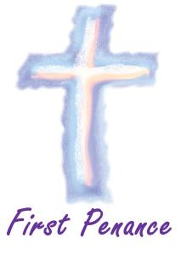

***************************************************************************

*Sacrament of First Reconciliation ~* Our First Holy Communion class has been preparing for and will receive their Sacrament of Reconciliation for the first time on Saturday, March12, 2022 at 1:00 PM in the church.

Please remember these children in your prayers as they prepare and anticipate the arrival of this very special day.

*********************************************************************



Confirmation ~ Our 11th Grade Confirmation class is preparing to receive their Sacrament of Confirmation on Thursday, April 21st, 2022. A 7:00 PM Mass will be celebrated at Saint John Gualbert Cathedral in Johnstown. *Confirmation Practice will be held on Wednesday evening, April 20th at 6:30 PM.*

First Holy Communion ~ Our First Holy Communion class is preparing to

receive their Sacrament of First Holy Communion on Sunday, May 1, 2022 at 2:00 PM.

Synod on Synodality

2021 – 2023

*Gatherings for Small Faith*

*Sharing Group Leaders for*

*Facilitating Synodal Consultations*

February 5 February 12

9:30-11:30 AM 9:00-11:00 AM

St. Francis of Assisi Church Church of the Good Shepherd

120 Barron Ave. Johnstown 867 Gray’s Wood Blvd, Port Matilda

February 13 February 16

1:00-3:00 PM 6:00-8:00 PM

St. Mark’s Church Holy Name Church

416 6th Ave. Altoona 500 N Julian St. Ebensburg

February 19 February 23

9:00-11:00 AM 6:00-7:30 PM

Most Holy Trinity Church via Zoom

524 Mifflin St. Huntingdon

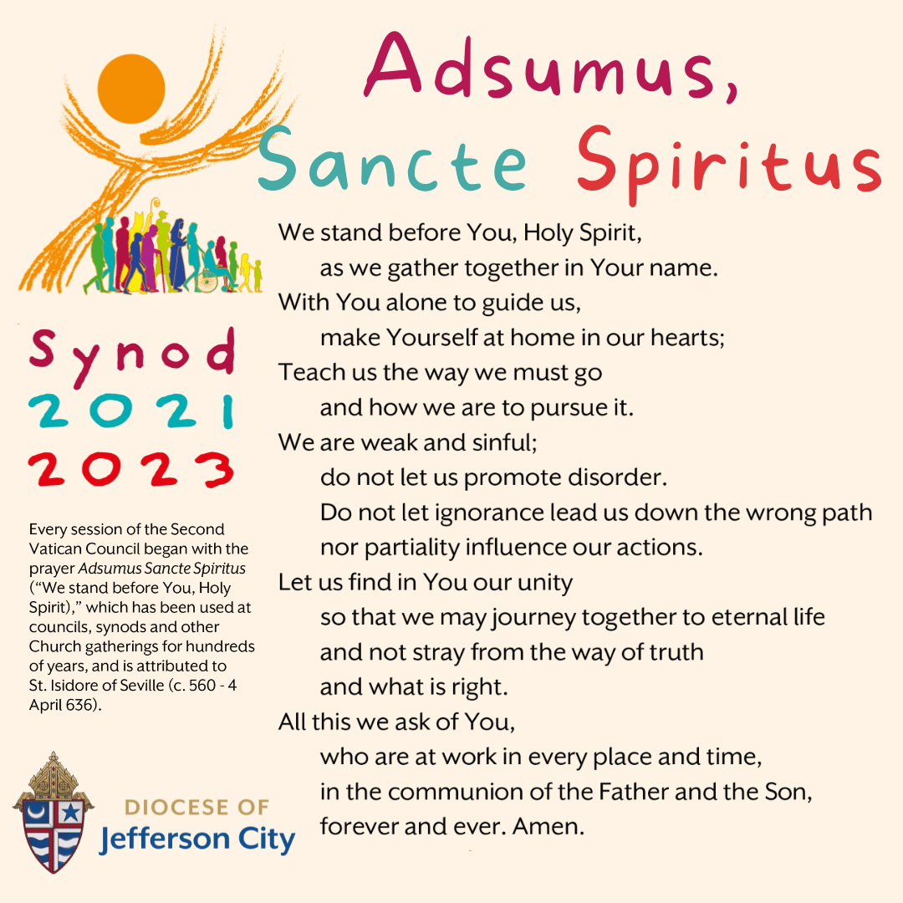 Sister Linda LaMagna

623 East 3rd Street

Bellwood, PA 16614

llamagna@dioceseaj.org

Sunday, February 6 Mass ~ 8:00 AM & 10:30 AM

Confessions / 7:30 – 7:45 AM & 10:00 - 10:15 AM / Confessional

HS Religious Education / Hall / 9 – 10:15 AM

9th & 10th Gr. Retreat / Hall / 9 – 10:20 AM

11th Gr. Session / Hall / 9 – 10:20 AM

Liturgy Committee Meeting / Church / After the 10:30 AM Mass

Monday, February 7 Mass ~ 9:00 AM

 Sunday Choir Practice / 7:00 PM

Tuesday, February 8 Mass ~ 9:00 AM

Boy Scout Meeting / 7:30 – 9:00 PM

Wednesday, February 9 Mass ~ 9:00 AM

Thursday, February 10 Mass ~ 9:00 AM

K – 5 Religious Education / Hall / 3:30 – 4:30 PM

Saturday Choir Practice / 4:30 PM

Friday, February 11 Mass ~ 9:00 AM

Saturday, February 12 Mass ~ 4:00 PM

Confessions / 3:30 – 3:45 PM / Confessional

Second Sunday Food Pantry Collection



UPCOMING EVENTS

February 13 Second Sunday Food Pantry Collection

Holy Name Society Meeting

Coffee & Donuts After 8 AM Mass

February 23 Boy Scouts Painting Party / Hall / 6 – 8:30 PM

PUBLIC ROSARY ~ To Pray for Our Country. Saturday, February 26th at NOON. St. John Gualbert Cathedral – St. Ann Shrine – Downtown Johnstown.

TRIVIA NIGHT! ~ Bishop Carroll Catholic High School, Saturday, February 26th. Doors open at 6 PM, Dinner at 6:30 PM. Game begins at 7:30 PM. Open to age 21 and over. Pre-paid ticket $30, Door $35. Registration deadline February 21st. For information email [jnagy@bishopcarroll.org](mailto:jnagy@bishopcarroll.org).

LENTEN JOURNEY SERIES AT ST. BERNARDINE MONASTERY ~ “As We Journey Through Lent” – Join the Friars at St. Bernardine Monastery, 768 Monastery Rd, Hollidaysburg, for a time of reflection, prayer, and fellowship during this Lenten season. Wednesday – March 9th, 16th, 23rd and 30th from 10 AM – 1 PM. Lunch is included and a free-will offering will be taken. Registration is necessary by calling the Monastery office by Friday, March 4th at 814-695-3802.