ST. MICHAEL ROMAN CATHOLIC CHURCH

751 Locust Street

PO Box 103

St. Michael, Pennsylvania 15951

Rev. Msgr. David A. Lockard, Administrator MASSES:

(814) 495-9640 Saturday 4:00 pm



Sunday Morning 8:00 am

Secretary: Michele Panick 10:30 am

Bookkeeper: Kathy Kalicky Daily Mass: M,T,W,Th,F Noon

DRE: Laurie Sloan Holy Days: See Bulletin

Maintenance: Rodney Turgeon Office Hours:

PHONES: 8:30 am to 3:30 pm

Rectory / Office: (814) 495-9640 Monday, Tues., Thurs., Friday

Fax: (814) 495-9424 Confessions:

Rel. Education: (814) 495-4873 Saturday 3:30 pm to 3:45 pm

Parish Website Sunday 10:00 am to 10:15 am

[www.saintmichaelchurch.weebly.co](http://www.saintmichaelchurch.weebly.co)m By Appointment

Secretaries’ E-mail

[saintmichaelsecretaries@yahoo.com](mailto:saintmichaelsecretaries@yahoo.com)

Facebook page:

St. Michael Catholic Church/St. Michael, PA

Holy Family of Jesus, Mary and Joseph

SERVING GOD AND COMMUNITY FOR OVER ONE HUNDRED YEARS!

December 27th, 2020

BAPTISM: By Appointment. Reserve at least one month in advance.

MARRIAGE: Plan at least nine months in advance.

Preparation sessions are necessary.

FUNERALS: Arrangements are made in conjunction with the funeral home.

REGISTRATION Those new to the area, newlyweds, and single adults, (even if registered

and before with their families) are asked to register by calling the Parish Office.

MEMBERSHIP: Every parishioner must be registered. This is a condition for admission

to our Program and reception of the Sacraments of Baptism, Confirmation,

First Penance, First Eucharist, and Matrimony; also, for testimonial letters or sponsorship of Baptism and Confirmation outside the Parish.

VISITATION: We are concerned and want to be advised when someone is ill at home or in the hospital. Call the office to have the shut-in placed on our monthly Holy Communion calls or seriously ill prayer list.

SACRAMENTAL Parish registration and active Mass participation for Baptism is

POLICY: encouraged and is required for Marriage.

BULLETIN ARTICLES: Articles are due to the Parish Office by Noon on Tuesday.

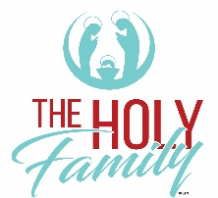

Holy Family, Jesus, Mary, and Joseph

November 27th, 2020

The Immaculate Conception

**MASS INTENTIONS**: (December 28, 2020 – January 3, 2021 )

Monday Noon Agnes Noon req. by Susan & Paul Snyder & Carol Noon

Tuesday Noon Edward & Margaret Yanzetich req. by David & Patricia Caldwell

Wednesday Noon Hermine Sivec req. by Galen, Ann Marie & Andrew Martin

(Rescheduled from 12-16-20)

Masses for the Solemnity of Mary, Mother of God:

Thursday 4:00 PM Alan Oshaben req. by Joan & Bob Oshaben

Friday 9:00 AM People of the Parish

Saturday 4:00 PM Grace Martin req. by Gary, Brenda, Madison, Garrett & Carson Kundrod

Sunday 8:00 AM People of the Parish

10:30 AM Thomas Murin req. by Mary Ann Murin & Family

LITURGICIAL APPOINTMENTS:

Saturday, January 2 4:00 PM

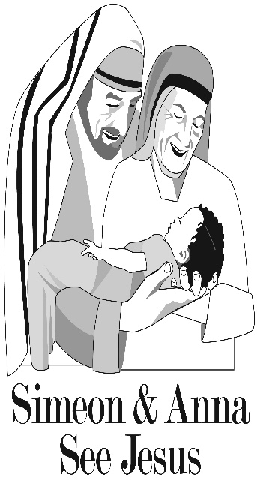Lector: Tony Bambino

Minister of the Host: Susan Blazosky

Altar Server: Chase Williamson

Cantor: Amanda Williamson

Sunday, January 3 8:00 AM

Lector: Arnold Bernard

Minister of the Host: Marie Bernard

Altar Server: Ian Dobbins

Cantor: Amy Dobbins

Sunday, January 3 10:30 AM

Lector: Carole Kakabar

Minister of the Host: Jennifer Steele

Altar Server: Alexis Henderson

Cantor: Sharon Dibble

Weare placing names of the sick in the bulletin for prayer providing they give permission. *May the* *Divine Physician send healing grace for those for* *whom we pray:* Allen C. Rosemas, Patricia Murphy, Bernice Myers, Dwight Fyock, Dylon Wills, Missy, Joanne (Kolar) Hufford, Christine Flanagan, Ayden Alan Grata, Mary Lou Offman, Mary Zangaglia, Natalie Zerby, Valencia Tursi, Homer Locher, Brayden Schofield, Michelle Kasper, Diane Kingera, Ted Paluch, Pearl Litzinger, Patrick Munro, Fran Baldassarre, Kristen Sinosky Long, Cresta Micik, Basil Costantino, Laura, Joe Yoder, Dolores Yanzetich, Sandy Krug, Wanda Gramling, Jennifer Hagans, Shawn, Holly, Shane, Spencer, Owen Taylor, Derrick Varnish, Vincent Koshute, Michelle Elliott, Heather Romanow, Mackston Barrick, Connor Thomas, Erin, Pat, Mary Agnes Nastase, Mary Ann Bertolino, Dick Wilson, Izzy Bihun, Dorothy Kaminsky, Patricia Oshaben, Ashlee Madison, Susan Yanzetich, Mike, Alina Rusnak, Gary Smay, Elizabeth Howell, Walter Bodziak, Rhonda, Dan Strinkoski, Anne Robinson, Carter Bobak, Vince Arena, Mike Morris, Sarah Kelt, Patty Yanzetich Caldwell, Colton Snyder, Nancy Edmiston, Leonard Oshaben, Adam, Bill Gideos, Janice Dipyatic, Lily Maloney, Scott, Lisa, Audrey Costlow, Cathy Sossong, Rosanne Krug, Becky Kakabar, Catherine Tedjeske, Howard Delaney, Ed Myers, Dolores Mucko, Elliana, Ashlee, Helen Soohy, Carol K. Fabrizio, Peggy Carpenter, Sharon Vance, Janet Minor, Dave Seder and all of the sick of our parish, the homebound, those in nursing homes, those who care for them, and those in the military along with their families. *(Please call the Rectory to have your name removed from the list when no longer seriously ill. Thank You.)*

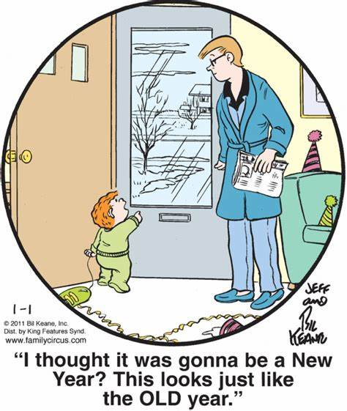

LAST WEEK’S COLLECTION

Adults $2,388.00

Loose $ 81.00

Youth $ 23.00

Monthly $ 220.00

Initial Offering $ 10.00

Candles $ 24.00

Maintenance Fund $ 75.00

Solemnity of Mary $ 25.00

Immaculate Conception $ 35.00

Christmas Offering $ 975.00

Christmas Flowers $ 80.00

Religious Retirement Fund $ 100.00

Total $4,036.00

We sincerely thank and ask God’s

blessing upon all who have care

and concern for our parish.

*Holy Family*

*Jesus, the Blessed Virgin Mary and Joseph serve as the ultimate example of true discipleship and stewardship. They give without measure. Christian stewards are called to “give thanks to God” as we offer our gifts in the “peace of Christ.” We are called to offer everything we have in faith as an offering to God, in the name of the Lord Jesus. This leads to fruits of love, trust, accountability, and generosity. Good stewards see the evidence of God in all things, small and large.*

During the week of December 27th, 2020

The Sanctuary Candle

will burn in memory of

Theresa Fleck

requested by Helen Slonac & Family

[](https://images.search.yahoo.com/search/images;_ylt=A0LEV1kSWptXvOwAKINXNyoA;_ylu=X3oDMTEyZGdkcmRoBGNvbG8DYmYxBHBvcwMxBHZ0aWQDQjIwODlfMQRzZWMDc2M-?p=Clipart+of+a+sanctuary+candle&fr=ush-mailn_02&th=110&tw=110&imgurl=http://www.henningers.com/389-168-wall-sanctuary-lamp.jpg&rurl=http://pixshark.com/sanctuary-lamp.htm&size=43KB&name=Sanctuary+Lamp+Bronze+wall+sanctuary+lamp&h=600&w=600&turl=http://ts2.mm.bing.net/th?id%3DOIP.M68453c67108cdc5ab485d309b395bd03o0%26pid%3D15.1%26rs%3D1%26c%3D1%26qlt%3D95%26w%3D110%26h%3D110#inline&tt=Sanctuary+Lamp+Bronze+wall+sanctuary+lamp&sigr=116keh5le&sigit=13gvlt42j&sigi=11ip0pgm4&sign=119kp6100&sigt=119kp6100)

MESSAGE FROM MSGR. ~ Recently our parish received a gift of seven beautiful Mass vestments from the children of Francis and Patricia Powers in honor of their parents’ 64th wedding anniversary. On behalf of St. Michael Parish, I wish to thank them for this beautiful gift. They arrived in time for the Advent/Christmas season and I have begun wearing them at Masses.

SOLEMNITY OF MARY, MOTHER OF GOD ~ Masses here at St. Michael are Thursday, December 31st at 4:00 PM and Friday, January 1st, 2021 at 9:00 AM.

PARISH OFFICES ~ Parish Offices will be closed on Thursday, December 31st, and Friday January 1st, 2021 for the New Year’s Holiday.

PARISH COUNCIL ~ There will be a Parish Council Meeting Sunday, January 3rd in the Church Hall following the 10:30 AM Mass.

2021 CALENDARS ~ 2021 calendars are available at the entrances of the Church. Please, one calendar per family. Special thanks to the C.O. Dimond Funeral Home for donating these calendars to our Parish.

ADDITIONAL CHRISTMAS FLOWERS DONATIONS ~ In memory of Kevin Smay and Agnes Rhoades by Ross & Mary Carpenter; Ann Blazosky by Family; Carlos A. Diaz, Michael & Mary Blazosky, John & Clara Glovany by Blazosky Family; Francis Smith, Joe Huber, Tom & Magdalene Plummer, Sr. Margy Cecelia Kirsh, CSJ by Patty Hammond; Helen Krisko, Carter Robinson, & Mary Leppado by John & Sheila Leppado.

RETIRING! ~ After over six years of dedicated and faithful service to St. Michael Parish, our parish bookkeeper, Kathy Kalicky’s last day with us will be Thursday, December 31st! We want to thank Kathy for all she has done for us over the years and wish her happy times in the future.

YEAR-END GIFT DEADLINES ~ All checks, donor documentation, and parish reports must be received in the Office of Stewardship and Development by Thursday, January 7th, 2021. 1.) Donor gifts must be received, dated, and postmarked by 12/31/2020 for the donor to receive a tax deduction for 2020. 2.) All parish report checks must reflect a donor’s gift received on or before 12/31/2020. Include all donor documentation with the parish report check, including the date of donation. 3.) Any check or donation written or received in 2021 will not be included in gift receipting for 2020. Any questions, please contact Pam Seasoltz: Diocese of Altoona-Johnstown 2713 West Chestnut Ave. Altoona, PA 16601-1720. Office: 814-695-5577 or cell 814-931-0316 or [pseasoltz@dioceseaj.org](mailto:pseasoltz@dioceseaj.org)



Thank you to all parishioners who have responded to the *2020 Catholic Ministries Drive.* Please join them in supporting our Parish and a select group of ministries that provide outreach to the poor, family life, youth and seminarians. If you did not receive a pledge card in the mail, you may give online at [www.dioceseaj.org](http://www.dioceseaj.org).

Catholic Ministries Drive / 2020

Diocesan Goal $ 25,436.00

Pledged $ 14,032.50

Balance $ 11,403.50

Number of Responses 82

Solemnity of Mary Vigil & Solemnity of Mary

Liturgical Appointments

*Please check the following schedules. If unable to keep your Lay ministry*

*assignment, please find a replacement.*

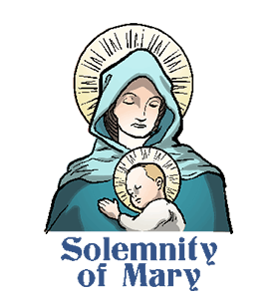

Solemnity of Mary Vigil December 31st 4:00 PM

Lector: Pauline Minor

Minister of the Host: Eric Tedjeske

Altar Server: Eva Spangler

Cantor: Elizabeth Dobbins

Solemnity of Mary January 1st, 2021 9:00 AM

Lector: Mary Anne Davis

Minister of the Host: Sally Kolar

Altar Server: Kaden Christ

Cantor: Theresa Arena



Religious Education And Christian Helping

December 27, 2020

Religious Education News

Home Lesson Packets ~ Lesson Packet #4 will be available for Grades K—11 in January 2021. More information on dates to follow.

If you were unable to come to the last pick-up times, contact the RE Office at 495-4873 or the Parish Office at 495-9640 to make arrangements for another time to pick up new lessons and to drop off the completed lessons.

*******************************************************************************************************************

Sunday, December 27 Mass ~ 8:00 & 10:30 AM

Confessions / 10:00 – 10:15 AM / St. Paul Room

Monday, December 28 Mass ~ Noon

NO Sunday Choir Practice



Tuesday, December 29 Mass ~ Noon

Wednesday, December 30 Mass ~ Noon

Thursday, December 31 Mass ~ Solemnity of Mary Vigil / 4:00 PM

NO Saturday Choir Practice

 Parish Offices Closed

Friday, January 1, 2021 Mass ~ Solemnity of Mary / 9:00 AM

Parish Offices Closed

Saturday, January 2 Mass / 4:00 PM

Confessions / 3:30 – 3:45 / St. Paul Room

UPCOMING EVENTS

January 3 Parish Council Meeting

January 9 & 10 Second Sunday Food Pantry Collection



We received the following note from Patsy Senft

who is in charge of the Food Pantry:

St. Michael Catholic Church

Thank you so much for your faithful and generous

donations the F.H. Food Pantry.

We appreciate you all.

Sincerely,

Patsy