ST. MICHAEL ROMAN CATHOLIC CHURCH

751 Locust Street

PO Box 103

St. Michael, Pennsylvania 15951

Rev. Brian Warchola, Administrator MASSES:



(814) 495-9640 Saturday 4:00 pm Sunday Morning 8:00 am

Secretary: Michele Panick 10:30 am

Daily Mass See Bulletin

Bookkeeper: Kathy Kalicky Holy Days See Bulletin

DRE: Laurie Sloan

Maintenance: Rodney Turgeon Office Hours:

PHONES: 8:30 am to 3:30 pm

Rectory / Office: (814) 495-9640 Monday, Tues., Thurs., Friday

Fax: (814) 495-9424 Confessions:

Rel. Education: (814) 495-4873 Saturday 3:30 pm to 3:45 pm

Parish Website Sunday 7:30 am to 7:45 am

www.saintmichaelchurch.weebly.com 10:00 am to 10:15 am

Secretaries’ E-mail Anytime Requested

[saintmichaelsecretaries@yahoo.com](mailto:saintmichaelsecretaries@yahoo.com)

YEAR: 2017 NUMBER: 49

SERVING GOD AND COMMUNITY FOR OVER ONE HUNDRED YEARS!

BAPTISM: By Appointment. Reserve at least one month in advance.

Preparation classes are necessary.

MARRIAGE: Make arrangements at least nine months in advance.

Preparation sessions are necessary.

FUNERALS: Arrangements are made in conjunction with the funeral home.

Eulogies must be given at the funeral home at the time of the wake service or at the luncheon. No eulogies at the funeral liturgy, please.

REGISTRATION Those new to the area, newlyweds, and single adults, (even if registered

and before with their families) are asked to register by calling the Parish Office.

MEMBERSHIP: Every parishioner must be registered. This is a condition for admission

to our Program and reception of the Sacraments of Baptism, Confirmation, First Penance, First Eucharist, and Matrimony; also, for testimonial letters or sponsorship of Baptism and Confirmation outside the Parish.

VISITATION: We are concerned and want to be advised when someone is ill at

home or in the hospital. Call the rectory to have the shut-in placed on our monthly Holy Communion calls or seriously ill prayer list.

SACRAMENTAL Requires parish registration and active Mass participation for Baptism

POLICY: and Marriage.

BULLETIN ARTICLES: Articles are due to the Parish Office by Noon on TUESDAYS.

First Sunday in Advent December 3, 2017

Month of The Immaculate Conception

[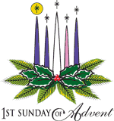](https://www.churchart.com/subscriber/viewimages?topic_id=230&image_type=cl&page=10&ipp=12)MASS INTENTIONS: (December 4 – December 10, 2017)

Monday 8:00 AM Michael & Mary Kundrod req. by Paul & Clare Kundrod

Tuesday 8:00 AM Steve Domen req. by a Friend

Wednesday 8:00 AM MHT, South Fork & St. Benedict’s, Johnstown

12:05 PM St. Benedict’s, Johnstown

Thursday 8:00 AM Mary Jane Chulick req. by Steve & Irene Chulick

6:00 PM Ann Blazosky req. by Robin Yakicic

Friday 9:00 AM Ann Profaizer req. by Nick & Pauline Minor

Office Closed

Saturday 4:00 PM People of the Parish

Sunday 8:00 AM Rev. John Martvon, 1st Catholic Slovak Union Jednota req. by Members

10:30 AM Mary T. Volker req. by Volker Family

LITURGICIAL APPOINTMENTS:

Saturday, December 9 4:00 PM Offertory Procession

Lector: Devon Michaels Ed & Karen Myers

Minister of the Host: Mary Partsch

Ministers of the Cup: Alice Podrebarac & Susan Blazosky

Altar Servers: Ana Spangler & Mykala Drobnick

Cantor: Amy Spangler

Greeter: Shirley Walls

Sunday, December 10 8:00 AM Offertory Procession

Lector: Terri Leach Camillus & Betty Long

Minister of the Host: Paul Kundrod

Ministers of the Cup: Walter Christ & Marie Jo Plummer

Altar Servers: Quinn & Eva Spangler

Cantor: Joseph Faher

Greeter: Pete Parisi

Sunday, December 1010:30 AM Offertory Procession

Lector: Carole Kakabar Volker Family

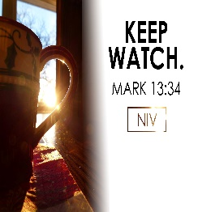Minister of the Host: Robert Oshaben

Ministers of the Cup: Greg Stiffler & Amanda Williamson

Altar Servers: Colby Rearick & Brooke Williamson

Cantor: Ian Wieczorek

Greeter: 8th Grade REACH Students

Sunday, December 10 Collection Counters

Debbie Dupnock, Camillus Long

Mary Ann Davis, Sara Zybura

FR. BRIAN’S MESSAGE: With all due respect to all my beloved parishioners. I have noticed for a while that some people are chewing gum during Mass. The main reason this is a problem is because I don’t believe all of them are disposing of the gum prior to receiving Holy Communion. We should also be mindful of our 1 hour fast before receiving Communion. The reason being if even the tiniest particle of the Eucharist or the smallest droplet of our Lord’s Precious Blood gets into the gum and later the gum is spit out into a wastebasket, or Heaven knows where, then the real Presence of Jesus Christ is now in the garbage with used tissues, etc.… Having said that NEVER approach Holy Communion with gum or anything in your mouth. The Most Holy Eucharist is the source and summit of our Catholic Faith and must be revered with all our hearts and souls.

PLEASE NOTE ~ Second collections will only be taken up when announced at the beginning of the Mass, otherwise there will not be a second collection.

OFFICE CLOSED ~ The Office will be closed for the Holy Day, Friday, December 8th in accordance with diocesan regulations.

PARISH COUNCIL ~ There will be a Parish Council Meeting on Thursday, December 7th after the Vigil Mass for the Immaculate Conception in the St. Paul’s Room.

[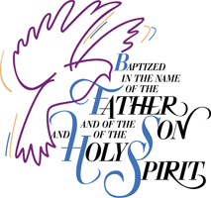](http://www.churchart.com/Subscriber/ViewImages.aspx?keywords=Baptism&entry_date=1/1/0001&image_type=,cl&topic_id=&image_source_id=&page=1#no)

BAPTISM ~ On Sunday, November 26th, we celebrated the glorious baptism of Madison Jean McClelland, daughter of Donald and Karah Anne (Rusnak) McClelland by Father Brian Warchola. She became a new creation in Christ in the waters of Holy Baptism. Now joined to us by the gifts of faith, hope and charity, we warmly welcome her into our St. Michael Parish Family.

ADVENT CONFESSIONS ~ Advent Confessions will be here at St. Michael’s Thursday, December 14th at 6:00 PM. A couple priests will be present to assist Fr. Brian. Mark your calendars now. We will combine with Most Holy Trinity, South Fork. St. Bartholomew’s, Wilmore, will be having confessions on Thursday, December 21st, at 6:00 PM. Everyone welcome!

AREA ADVENT PENANCE SERVICES ~ Sunday, December 10th, Saint John Gualbert Cathedral, Johnstown at 1:30 PM; Monday, December 11th, Holy Family Parish, Portage at 7:00 PM; Thursday, December 14th, Basilica of St. Michael the Archangel, Loretto at 7:00 PM; Sunday, December 17th, Holy Name Parish, Ebensburg at 2:00 PM and Saint Benedict Parish, Johnstown at 5:00 PM; Friday, December 22nd, Saint Aloysius Parish, Cresson at 7:00 PM.

OPLATKI ~ Oplatki will be available next weekend at all Masses.



CHRISTMAS FLOWERS ~ If you would like to purchase a Christmas flower for a living (In Honor Of) or a deceased (In Memory Of) member of your family, please do so by using the Christmas Flower envelope in your packet. The normal offering is $10.00. Extra envelopes can be found at the church entrances.

SECOND SUNDAY FOOD PANTRY COLLECTION ~ Next weekend is our Second Sunday Food Collection. Please bring in non-perishable food items or toiletries with you. Monetary donations are also appreciated.

BABY BOTTLES FOR PRO-LIFE ~ Baby Bottles are to be returned this weekend in the Bridal Room. Thank you to all that so generously gave.

HOLY NAME SOCIETY ~ There will be a Holy Name Society Meeting next Sunday, December 10th, after the 8:00 AM Mass.

HOLLIDAYSBURG VETERANS HOME ~ Please see insert on how to donate a gift to a resident at the Veterans Home in Hollidaysburg.

[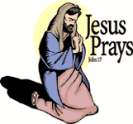](https://www.churchart.com/subscriber/viewimages?book_number=43&chapter=17&verse=1&entry_date=1/1/0001&image_type=cl)[](http://www.churchart.com/Subscriber/ViewImages.aspx?keywords=&entry_date=1/1/0001&image_type=,cl&topic_id=346&image_source_id=&page=1#no)Weare placing names of the sick in the bulletin for prayer providing they give permission. *May the* *Divine Physician send healing grace for those for* *whom we pray:* Allen C. Rosemas, Patricia Murphy, Bernice Myers, Dwight Fyock, Lori Facciani, Dylon Wills, Dawn Hagen, Debbie Dibert, Missy, Joanne (Kolar) Hufford, Christine Flanagan, Ayden Alan Grata, Remy Beaver, Mary Lou Offman, Marian Chuckalovcak, Arlene Diamond, Mary Zangaglia, Dorothy Rosemas, Natalie Zerby, Patricia Grata, Michael Wadsworth, Valencia & Frank Tursi, Homer Locher, Brayden Schofield, Michelle Kasper, Diane Kingera, Allison Krischer, Ted Paluch, Brandt Hutzel, Pearl Litzinger, Patrick Munro, Fran Baldassarre, Corey Lybarger, Kristen Sinosky Long, Helen Ranieri, Cresta Micik, Basil Costantino, Madison McCrory, Laura, Joe Yoder, Dolores Yanzetich, Sandy Krug, Wanda Gramling, Merna Smay, Muriel “Jean” Wiesheier, Agnes Plummer, Jennifer Hagans, Mary McCall, Sean, Holly, Shane, Owen Taylor, Keith & Dawnetta Hoyer, Gail Faher, Marjorie (Latshaw) Feldman, Derrick Varnish, Daniel Koshute, Vincent Koshute, Karen Lovrich, Melissa Cordek, Michelle Elliott, Heather Romanow, Mackston Barrick, Connor Thomas, Erin, Pat, Mary Agnes Nastase, Mary Ann Bertolino, Dick Wilson, Dan Pauley, Peggy Mulvihill, Jane Plummer, Izzy Bihun, Erica Mitzelfeld, Heidi Allison, Dorothy Kaminsky, Ed Ripper Sr., Patricia Oshaben, Craig Kraber, Ashlee Madison, Marlene McCrory, Bob Casti and all of the sick of our parish, the homebound, those in nursing homes, those who care for them, and those in the military along with their families. (Please call the Rectory to have your name removed from the list when no longer seriously ill. Thank You.)

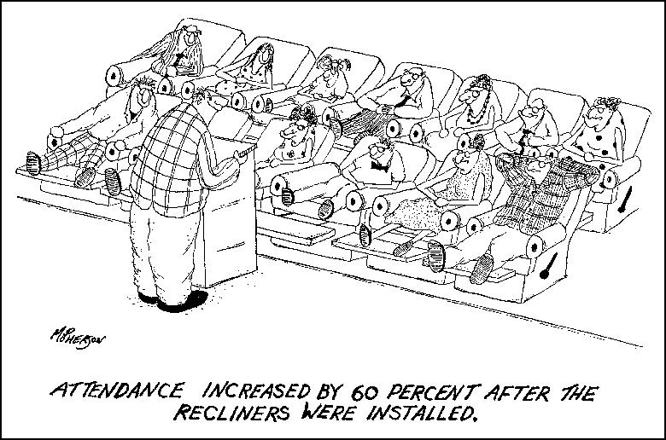

LAST WEEK’S COLLECTION

Adults $3,056.25

Loose $ 182.00

Youth $ 38.00

Monthly $ 10.00

Maintenance Fund $ 354.00

Candles $ 25.00

All Saints $ 1.00

All Souls $ 1.00

Christmas Flowers $ 958.00

Catholic Charities $ 49.00

Total $4,674.25

We sincerely thank and ask God’s blessing upon all who have care and concern for our parish.

December 3, 2017 Mark 1:1-8

Today’s gospel tells us to “Be watchful.” This comes natural to families. Parents are watchful of their children’s health, grades and friends. Children are watchful of parental moods. Today’s gospel encourages us to use this ability to see God acting in the innocence, tenderness, love and forgiveness of your family. “Be watchful,” the Lord is already with you.

*FEAST OF THE IMMACULATE CONCEPTION*

*Holy Day of Obligation*

Thursday December 7 6:00 PM Friday December 8 9:00 AM

Lector: Michael Barton Lector: Pauline Minor

Minister of the Host: Theresa Carlson Minister of the Host: Ellen Grattan

Ministers of the Cup: Karen Myers & Ministers of the Cup: Robert Grattan &

Helen Slonac Sally Kolar

Altar Servers: Haidyn & Amilyah Koch Altar Servers: None Scheduled

Cantor: Louis McCloskey Cantor: Theresa Arena

Greeter: Phyllis Slonac Greeter: Betty Long

Offertory Procession: Blazosky Family Offertory Procession: Nick & Pauline Minor

RETIREMENT FUND FOR RELIGIOUS ~ Help care for elders. “Thanks to support from the Retirement Fund for Religious, we are now in a much better position to care for our elders,” writes a religious sister. Your donation helps her religious community and hundreds of others provide for aging members and plan for long-term needs. Please give to next week’s (December 9 & 10) second collection for Retirement Fund for Religious.

MARCH FOR LIFE ~ Citizens Concerned for Human Life and St. Benedict Church is coordinating a bus to the March for Life on Friday, January 19th, 2018. The bus will depart from St. Benedict Church at 7:15 AM. Mass will be offered at 6:30 AM at St. Benedict. The cost to reserve a seat is $10/student and $15/adult. Money must be received prior to January 19. All people under the age of 18, we ask that you be accompanied by a parent or legal guardian. Please don’t let the cost of a ticket defer you from attending-if you need financial assistance, please contact Fr. Crowe at the rectory (814-266-9718 ext. 507). The bus will return to St. Benedict’s about 10 PM the same day. We will stop for dinner, but please pack a breakfast and lunch. If you are unable to physically attend, financial assistance is also

greatly appreciated to help cover the cost of the bus reservation. This is a very rewarding experience and a powerful witness for life at all stages of life. Please contact Heidi Bence to register (814)536-7335 a seat on the bus.

SALVATION ARMY TREASURES FOR CHILDREN PROJECT ~

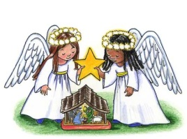

* Return your UNWRAPPED gift(s) with the tag attached to the St. Michael Catholic Church St. Paul Room by December 10th so that we can check them off and deliver them to the Salvation Army in time for distribution to the families.
* If you wish, you could provide an “extra” gift of your choice to be used for those tags that are not chosen at all. Gifts and larger clothing for pre-teens ages 11-13 are particularly hard to fill.

*Stewardship Reflections* ~

As the Church begins a new liturgical year, we are reminded in today’s Gospel that we are nothing more than servants, stewards of our Master’s possessions, but who do not know when our Master will return. We have been given the responsibility of sharing our gifts in order to build up the Master’s kingdom. May we be awake and alive in our faith when He comes again in glory!

Catholic Ministries Drive $23,811.00

Raised: $15,575.00

Balance: $ 8,236.00

Number of Responses: 92



Religious Education And Christian Helping

December 3, 2017

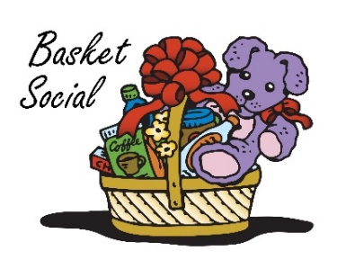Our annual REACH Basket Social this Sunday, December 3rd!

Tickets will be available at the door for $5.00 each which includes 25 perforated basket chances and 1 door prize chance. Multiple tickets may be purchased. *Doors will open at 1:00 p.m. with 'chancing off' beginning at 2:00 p.m.* Come early to purchase your tickets and have ample time to view all baskets available and place your chances before the drawing begins.

*Attention—Parents of REACH Students:* We are asking each REACH student from grades 6—12 to donate the following items to help with our Basket Social fundraiser. Non-perishable items (Soda, Candy, and Snacks) can be dropped off anytime over the next two weeks. Cakes, Desserts and Ice Tea can be brought to the church hall by Noon on Sunday, December 3.

Grades 7 & 11 Bag of chocolate candy (Asst. minis, snack size or kisses)

Grades 6 & 8 Cake / Dessert

Grade 12 Two 2-liters of soda

Grade 9 Bags of snacks (potato chips or pretzels)

Grade 10 One Gallon of Ice Tea

Fall Confirmation Sessions

Grade 11 ~ Session 11B ~ Sacraments and the Paschal Mystery ~ Sunday, December 10, 2017 ~ All 11th Grade students All will attend their Fall Session 11B from 9 to 10:30 a.m. in the Saint Paul Room to fulfill this session requirement. \*

*\* If the students miss this scheduled session, they are required to attend another*

*parishes scheduled session to fulfill these requirements.*

C:\Users\Laurie\Downloads\c_hllybrdr.jpg

*REACH Holiday Service Projects*

*Holy Name K—5 Treats ~* Our Holy Name Society will sponsor a Christmas Pizza Party for our K—5 students on Thursday, December 21st. REACH student volunteers are needed to help pack the Christmas treats that they distribute to students. They will be gathering for this task on Tuesday, December 19th at 6:00 p.m. in the Parish Hall.



Any interested students should stop in or contact the RE Office at 495-4873 to sign up

Sunday, December 3 First Sunday of Advent

Religious Ed / Grades 6-12 / 9:00 AM – 10:20 AM

REACH Basket Party / 2:00-4:00 PM

Baby Bottles for Pro-Life returned in Bridal Room

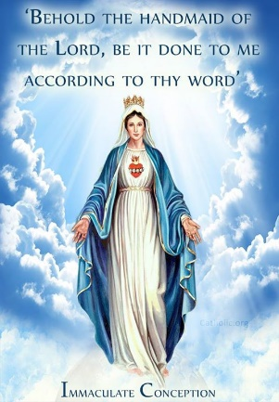 Monday, December 4 Sunday Choir Practice / 7:00 PM

Tuesday, December 5 Combined Choir for Christmas / 7:00 PM

Wednesday, December 6 No Mass

Thursday, December 7 Immaculate Conception Vigil / 6:00 PM

Parish Council Meeting / After Vigil Mass

Religious Ed / Grades K-5 / 3:30-4:30 PM

Friday, December 8 Immaculate Conception Mass / 9:00 AM

(Holy Day of Obligation)

Office Closed

Saturday, December 9 Retirement Fund for Religious Second Collection

Second Sunday Food Pantry Collection

UPCOMING EVENTS

December 10 Retirement Fund for Religious Second Collection

Holy Name Society Meeting

11th Grade Fall Session

Second Sunday Food Pantry Collection

Hall Rental

December 14 Communal Advent Confessions / 6:00 PM

[](https://www.churchart.com/subscriber/viewimages?topic_id=195&image_type=cl,ph,pp,bc,ca,mv,wt,nt,pt,ft,ch&page=17&ipp=12)COMMUNITY BAND ~ The Forest Hills Community Band will present their annual Christmas Concert beginning on Sunday, December 3rd at Mt. Hope UM Church at 6:00 PM; then Friday, December 8th at Forest Hills Elementary Cafeteria at 7:30 PM. On Saturday, December 9th a special concert will be held at the Ebensburg Center at 1:00 PM. If you miss these performances, the band will play again on Sunday, December 10th at 2:00 PM at the Galleria Mall near the Bon Ton. Admission is FREE! All are welcome. Hope to see you there!

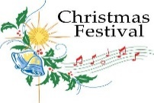

CHRISTMAS FESTIVAL ~ Most Holy Trinity is sponsoring a CHRISTMAS FESTIVAL on Sunday, December 3rd, from 11:30 to 1:30 PM, 550 Main Street, South Fork, with homemade soups, sandwiches, baked goods and Santa is arriving at 12:30 PM. There will be a basket raffle at 1:00 PM. Bring your family and friends and support our students. Everyone is welcome!

AN ADVENT OF CHRISTMAS CONCERT will be held 7:00 PM, Saturday, December 23rd at St John Gualbert Cathedral, 117 Clinton Street, Johnstown.  The program will feature the Greater Johnstown Diocesan Festival Choir and Youth Chorale under the direction of Cathedral music director, Evonne Yanzetich-Homway. The choral groups will be accompanied by the Hilltop Chamber Music Ensemble. Admission is free and open to the public. A free-will offering will be taken.