ST. MICHAEL ROMAN CATHOLIC CHURCH

751 Locust Street

PO Box 103

St. Michael, Pennsylvania 15951

Rev. Msgr. David A. Lockard, Administrator MASSES:

(814) 495-9640 Saturday 4:00 pm



Sunday Morning 8:00 am

Secretary: Michele Panick 10:30 am

Bookkeeper: Kathy Kalicky Daily Mass: M,T,W,Th,F Noon

DRE: Laurie Sloan Holy Days: See Bulletin

Maintenance: Rodney Turgeon Office Hours:

PHONES: 8:30 am to 3:30 pm

Rectory / Office: (814) 495-9640 Monday, Tues., Thurs., Friday

Fax: (814) 495-9424 Confessions:

Rel. Education: (814) 495-4873 Saturday 3:30 pm to 3:45 pm

Parish Website Sunday 10:00 am to 10:15 am

[www.saintmichaelchurch.weebly.co](http://www.saintmichaelchurch.weebly.co)m By Appointment

Secretaries’ E-mail

[saintmichaelsecretaries@yahoo.com](mailto:saintmichaelsecretaries@yahoo.com)

Facebook page:

St. Michael Catholic Church/St. Michael, PA

First Sunday of Advent

SERVING GOD AND COMMUNITY FOR OVER ONE HUNDRED YEARS!

November 29th, 2020

BAPTISM: By Appointment. Reserve at least one month in advance.

MARRIAGE: Plan at least nine months in advance.

Preparation sessions are necessary.

FUNERALS: Arrangements are made in conjunction with the funeral home.

REGISTRATION Those new to the area, newlyweds, and single adults, (even if registered

and before with their families) are asked to register by calling the Parish Office.

MEMBERSHIP: Every parishioner must be registered. This is a condition for admission

to our Program and reception of the Sacraments of Baptism, Confirmation,

First Penance, First Eucharist, and Matrimony; also, for testimonial letters or sponsorship of Baptism and Confirmation outside the Parish.

VISITATION: We are concerned and want to be advised when someone is ill at home or in the hospital.

Call the office to have the shut-in placed on our monthly Holy Communion calls or seriously

ill prayer list.

SACRAMENTAL Parish registration and active Mass participation for Baptism is

POLICY: encouraged and is required for Marriage.

BULLETIN ARTICLES: Articles are due to the Parish Office by Noon on Tuesday.

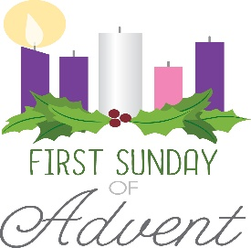

First Sunday of Advent

November 29th, 2020

**MASS INTENTIONS**: (November 30 – December 6, 2020 )

Monday Noon Andrew Pcola req. by his Loving Family

Tuesday Noon Albert Long req. by Camillus & Betty Long

Wednesday Noon Marie Minor req. by Pam, Mike, Julie, Justin, Merielle & Levi

Thursday Noon For Catholics to Return to Church

Friday Noon Steve Domen req. by Ed Hudak

Saturday 4:00 PM Ann Marie Swelfer req. by daughter Mary Ann Strayer

Sunday 8:00 AM Stephen Yanzetich Jr. req. by Mom, EJ. & Susan Yanzetich

10:30 AM People of the Parish

LITURGICIAL APPOINTMENTS:

Saturday, December5 4:00 PM

Lector: Susan Poldiak

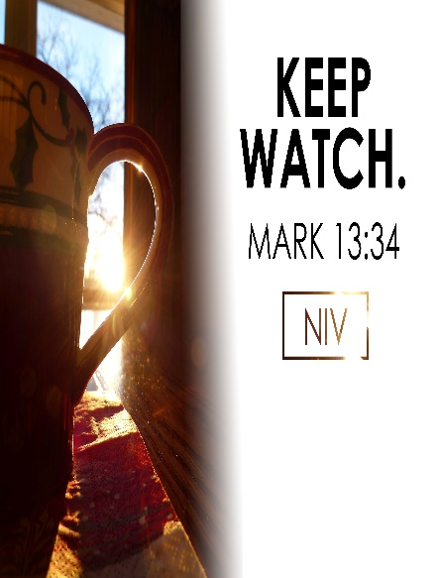Minister of the Host: Alice Podrebarac

Altar Server: Caden & Kaylee Roberts

Cantor: Amanda Williamson

Sunday, December 6 8:00 AM

Lector: Amy Spinos

Minister of the Host: Eric Tedjeske

Altar Server: Natalie Stohon

Cantor: Susan Yanzetich

Sunday, December 6 10:30 AM

Lector: Mike Barton

Minister of the Host: Jennifer Steele

Altar Server: Alexia Steele

Cantor: Amy Dobbins

Sunday, December 6 Collection Counters

Chris Smay, Sara Zybura

Mary Ann DeRosa

During the week of November 29th, 2020

The Sanctuary Candle will burn for the

Special Intentions of the Donor

and

The Our Lady of Grace Candle will burn for the

Health & Well-Being of

Baby Vada Sloan

requested by Family

[](https://images.search.yahoo.com/search/images;_ylt=A0LEV1kSWptXvOwAKINXNyoA;_ylu=X3oDMTEyZGdkcmRoBGNvbG8DYmYxBHBvcwMxBHZ0aWQDQjIwODlfMQRzZWMDc2M-?p=Clipart+of+a+sanctuary+candle&fr=ush-mailn_02&th=110&tw=110&imgurl=http://www.henningers.com/389-168-wall-sanctuary-lamp.jpg&rurl=http://pixshark.com/sanctuary-lamp.htm&size=43KB&name=Sanctuary+Lamp+Bronze+wall+sanctuary+lamp&h=600&w=600&turl=http://ts2.mm.bing.net/th?id%3DOIP.M68453c67108cdc5ab485d309b395bd03o0%26pid%3D15.1%26rs%3D1%26c%3D1%26qlt%3D95%26w%3D110%26h%3D110#inline&tt=Sanctuary+Lamp+Bronze+wall+sanctuary+lamp&sigr=116keh5le&sigit=13gvlt42j&sigi=11ip0pgm4&sign=119kp6100&sigt=119kp6100)

FIRST FRIDAY ~ Exposition of the Blessed Sacrament will be First Friday, December 4th with adoration from 12:30 PM until 2:30 PM. Please follow the churches guidelines for social distancing.

LITURGY COMMITTED MEETING ~ There will be a Liturgy Committee Meeting next Sunday, December 6th in the Church following the 10:30 AM Mass.

PLEASE NOTE!! ~ If you are filling out a tag for the Salvation Army Treasures for Children Project or wanting to light a votive candle, please remember to bring your own pens and your own lighters and take them with you when you leave per the Bishop’s Directives.

IMMACULATE CONCEPTION ~ Masses here at St. Michael for the Immaculate Conception will be on Tuesday, December 8th at 12 noon & 6:00 PM.

SACRAMENT OF RECONCILIATION ~ On Saturday, December 12th at 1:30 PM, Msgr. Lockard, along with Fr. Joseph Nale from Most Holy Trinity & St. Bartholomew Parishes, will be hearing confessions here at St. Michael Church.

SACRAMENTS – 8 WEEK COURSE ~ Fr. Timothy Grimme will be teaching Sacraments at St. Michael Church Hall, St. Michael beginning Tuesday, January 5 from 6:30 – 8:30 PM. The cost for this class is $65, which includes registration & books. These classes may be taken for continuing education credit & Master Catechist requirements. For registration, please contact Marybeth at 814-361-2000 or by email at mheinze@dioceseaj.org . Registration forms are also available online at wwwdioceseaj.org/lay-ecclesial-ministry/ All are welcome!

ST PAUL CLASS VIA ZOOM ~ This 6-week course, taught by Christopher Klopp, investigates the life and writing of St. Paul within the context of early Judaism in order to understand the Apostle’s role as the most significant theologian of the New Testament. Classes will begin Tuesday, January 5th, 6:30-9:00 PM. Costs for this class include a registration fee of $45 and the required book Paul A New Covenant Jew, by Brant Pitre, which can be purchased online at Amazon.com or through the Office of Lay Ministry for $35. Also suggested, but not required is the Ignatius Catholic Study Bible New Testament available online at Amazon.com. For further information and to register for this class please contact Marybeth at 814-361-2000 or by email at [mheinze@dioceseaj.org](mailto:mheinze@dioceseaj.org). All are welcome to attend! Please register by December 16th, 2020.

Weare placing names of the sick in the bulletin for prayer providing they give permission.

*May the* *Divine Physician send healing grace for those for* *whom we pray:* Allen C. Rosemas, Patricia Murphy, Bernice Myers, Dwight Fyock, Dylon Wills, Missy, Joanne (Kolar) Hufford, Christine Flanagan, Ayden Alan Grata, Mary Lou Offman, Mary Zangaglia, Natalie Zerby, Valencia Tursi, Homer Locher, Brayden Schofield, Michelle Kasper, Diane Kingera, Allison Krischer, Ted Paluch, Brandt Hutzel, Pearl Litzinger, Patrick Munro, Fran Baldassarre, Kristen Sinosky Long, Cresta Micik, Basil Costantino, Madison McCrory, Laura, Joe Yoder, Dolores Yanzetich, Sandy Krug, Wanda Gramling, Jennifer Hagans, Shawn, Holly, Shane, Spencer, Owen Taylor, Keith & Dawnetta Hoyer, Derrick Varnish, Vincent Koshute, Melissa Cordek, Michelle Elliott, Heather Romanow, Mackston Barrick, Connor Thomas, Erin, Pat, Mary Agnes Nastase, Mary Ann Bertolino, Dick Wilson, Izzy Bihun, Dorothy Kaminsky, Patricia Oshaben, Ashlee Madison, Susan Yanzetich, Mike, Danika Faith, Alina Rusnak, Gary Smay, Elizabeth Howell, Walter Bodziak, Rhonda, Dan Strinkoski, Anne Robinson, Marlene McCrory, Sharon Poldiak, Carter Bobak, Vince Arena, Mike Morris, Sarah Kelt, Patty Yanzetich Caldwell, Colton Snyder, Betty Delaney, Nancy Edmiston, Leonard Oshaben, Adam, Bill Gideos, Janice Dipyatic, Gerald Delaney, Lily Maloney, Scott, Lisa, Rosalie Ambrose, Audrey Costlow, Cathy Sossong, Rosanne Krug, Becky Kakabar, Catherine Tedjeske, Howard Delaney, Alivia Ickes, John Poldiak Jr., Ed Myers, Dolores Mucko, Elliana, Ashlee, Helen Soohy, Carol K. Fabrizio, Peggy Carpenter, David Poldiak, Mary Kiel, Sharon Vance, Baby Vada Sloan, Janet Minor and all of the sick of our parish, the homebound, those in nursing homes, those who care for them, and those in the military along with their families. *(Please call the Rectory to have your name removed from the list when no longer seriously ill. Thank You.)*

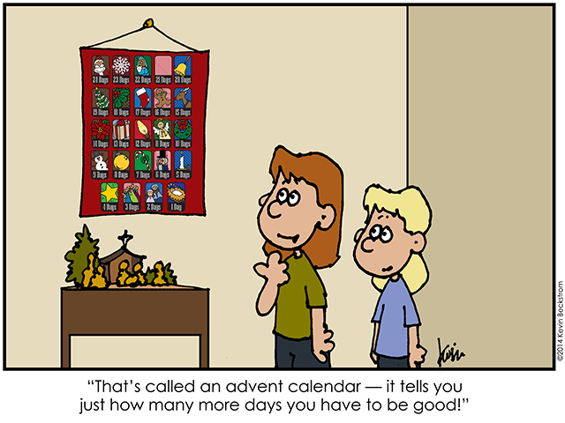

LAST WEEK’S COLLECTION

Adults $3,058.00

Loose $ 73.00

Youth $ 26.00

Monthly $ 202.00

Initial Offering $ 5.00

Candles $ 21.00

Maintenance Fund $ 227.00

All Saints $ 41.00

All Souls $ 45.00

Christmas Offering $ 20.00

Christmas Flowers $ 518.00

World Mission Sunday $ 10.00

Catholic Charities $ 290.00

Total $4,536.00

We sincerely thank and ask God’s

blessing upon all who have care

and concern for our parish.

*First Sunday of Advent Mark 13:33-37*

*Today’s gospel tells us to “Be watchful.” This comes natural to families. Parents are watchful of their children’s health, grades, and friends. Children are watchful of parental moods. Today’s gospel encourages us to use this ability to see God acting in the innocence, tenderness, love, and forgiveness of your family. “Be watchful,” the Lord is already with you.*



Religious Education And Christian Helping

November 22, 2020

Religious Education News

Home Lesson Packets ~ Lesson Packet #3 is ready for Grades K—11.

If you were unable to come to either of the pick-up dates this past week, contact the RE Office at 495-4873 or the Parish Office at 495-9640 to make arrangements for another time to pick up new lessons.

Parables Retreat ~ Our Saint Michael Confirmation students are scheduled for their Virtual Parables Retreat starting on Sunday, December 13th with Sr. Suzanne Thibault at The Bethany Youth Retreat Center via e-mail and Zoom sessions.  Our parish is registered as a whole, and now our students need to register individually with Sr. Suzanne. An email with the registration form has been sent out to all parents who have students scheduled for this retreat. Registration forms need to be returned directly to Sr. Suzanne A.S.A.P. for students to be included.

******************************************************************************************************************

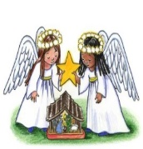

SALVATION ARMY TREASURES FOR CHILDREN PROJECT

*Our parish will again participate in the Salvation Army*

*Treasures for Children Project. We have tags available for both*

*children and senior citizens. The guidelines are as follows:*

* Tags include first name, sex, age, clothing sizes and some gift ideas for a child or senior citizen.
* The tags are displayed along the walls of the church. After you have chosen a tag, please write

your name and phone number on the copy and leave ONLY the copy on a windowsill.

* Return your UNWRAPPED gift(s) with the tag attached to the St. Michael Catholic Church

Bridal Room by December 6th so that we can check them off and deliver them to the

Salvation Army in time for distribution to the families.

* If you wish, you could provide an “extra” gift of your choice to be used for those tags that are not chosen at all. Gifts and larger clothing for pre-teens ages 11-13 are particularly hard to fill.

The tags are displayed along the walls of the Church & are available beginning this weekend.

Sunday, November 29 Mass ~ 8:00 & 10:30 AM

Confessions / 10:00 – 10:15 AM / St. Paul Room

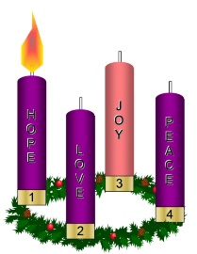 Girls Scouts / 1:00 – 2:30 PM

Monday, November 30 Mass ~ Noon

NO Sunday Choir Practice

Tuesday, December 1 Mass ~ Noon

Boy Scout Meeting / 7:30 – 9:00 PM

Wednesday, December 2 Mass ~ Noon

Thursday, December 3 Mass ~ Noon

NO Saturday Choir Practice

Friday, December 4 Mass ~ Noon

Exposition of the Blessed Sacrament with Adoration / 12:30 – 2:30 PM

Saturday, December 5 Mass / 4:00 PM

Confessions / 3:30 – 3:45 / St. Paul Room

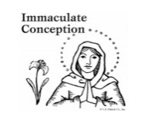 UPCOMING EVENTS

December 6 Liturgy Committee Meeting

December 8 Immaculate Conception

Parish Offices Closed

December 12 & 13 Retirement for Religious Collection

December 12 Confessions / 1:30 PM / Msgr. & Fr. Nale

POLISH CLASS OFFERED ~ Mother Agneska Kijowska, SSCJ, a native of Krakow, Poland and former Superior General of the Sacred Heart Sisters, will offer a class on Polish Christmas customs on Sunday, December 6th from 2 PM to 4 PM at St. Anne’s Church hall in Davidsville. To register, please contact the parish office at either St. Anne 479-2664 or Queen of Angels 754-5224 by December 4th. The class is free and is open to anyone who has an interest in Polish customs. Social distancing is required.



CHRISTMAS SHOPPING EXTRAVAGANZE ~ Bishop Carroll Cafeteria. Saturday, December 12th, 8:00 AM – 2:00 PM. Basket Raffle, Wineries, Soup & Bread Sale, Specialty Vendors, Christmas Cookie Sale, Hand Made Crafts, Christmas Trees. CDC recommendations followed.