ST. MICHAEL ROMAN CATHOLIC CHURCH

PO Box 103

St. Michael, Pennsylvania 15951

Rev. Brian L. Warchola, Administrator MASSES:



(814) 495-9640 Saturday 4:00 pm

Sunday Morning 8:00 am

Secretary: Michele Panick 10:30 am

Bookkeeper: Kathy Kalicky Daily Mass See Bulletin

DRE: Laurie Sloan Holy Days See Bulletin

Maintenance: Rodney Turgeon

Office Hours:

PHONES: 8:30 am to 3:30 pm

Rectory / Office: (814) 495-9640 Monday, Tues., Thurs., Friday

Fax: (814) 495-9424 Confessions:

Rel. Education: (814) 495-4873 Saturday 3:30 pm to 3:45 pm

Parish Website Sunday 7:30 am to 7:45 am

www.saintmichaelchurch.weebly.com 10:00 am to 10:15 am

Secretaries’ E-mail Anytime Requested

[saintmichaelsecretaries@yahoo.com](mailto:saintmichaelsecretaries@yahoo.com)

YEAR: 2017 NUMBER: 48

SERVING GOD AND COMMUNITY FOR OVER ONE HUNDRED YEARS!

BAPTISM: By Appointment. Reserve at least one month in advance.

Preparation classes are necessary.

MARRIAGE: Plan at least nine months in advance.

Preparation sessions are necessary.

FUNERALS: Arrangements are made in conjunction with the funeral home.

Eulogies should be given at the funeral home at the time of the wake service or at the luncheon.

REGISTRATION Those new to the area, newlyweds, and single adults, (even if registered

and before with their families) are asked to register by calling the Parish Office.

MEMBERSHIP: Every parishioner must be registered. This is a condition for admission

to our Program and reception of the Sacraments of Baptism, Confirmation, First Penance, First Eucharist, and Matrimony; also, for testimonial letters or sponsorship of Baptism and Confirmation outside the Parish.

VISITATION: We are concerned and want to be advised when someone is ill at

home or in the hospital. Call the rectory to have the shut-in placed on our monthly Holy Communion calls or seriously ill prayer list.

SACRAMENTAL Requires parish registration and active Mass participation for Baptism

POLICY: and Marriage.

BULLETIN ARTICLES: Articles are due to the Parish Office by Noon on Mondays

Solemnity of Our Lord Jesus Christ, King of the Universe

November 26, 2017

**The Holy Souls in Purgatory**

**MASS INTENTIONS**: (November 27 – December 3, 2017)

Monday 8:00 AM Lois Jean Papcunik req. by Agnes Zibura

Tuesday 8:00 AM John T. Plummer req. by Betty (Wirfel) McMahon & Family

Wednesday 8:00 AM Most Holy Trinity, South Fork & St. Benedict’s, Johnstown

12:05 PM St. Benedict’s, Johnstown

Thursday 8:00 AM Andrew Pcola req. by His Loving Family

First Friday 8:00 AM Carl Tokarsky req. by Barbara Katrancha

Saturday 4:00 PM Albert Andrykovitch req. by Mary Jo Andrykovitch & Delores Mucko

Sunday 8:00 AM People of the Parish

Sunday 10:30 AM Fern & Rose Danel req. by The Family

LITURGICIAL APPOINTMENTS:

Saturday, December 2 4:00 PM Offertory Procession

Lector: Anthony Bambino John & Bonnie Bizzarri

Minister of the Host: Susan Blazosky

Ministers of the Cup: Vince Arena & Babe Richards

Altar Servers: Victoria Russic & Elisabeth Zajdel

Cantor: David Zajdel

Greeter: Joanne Thomas

Sunday, December 3 8:00 AM Offertory Procession

Lector: Joseph Faher Richard & Carol Hautz

Minister of the Host: Eric Tedjeske

Ministers of the Cup: Betty Long & Terri Leach

Altar Servers: Andrew Martin & Michael Kresic

Cantor: Sharon Dibble

Greeter: Pauline Minor

Sunday, December 310:30 AM Offertory Procession

Lector: Michael Caddy Rose Danel Family Minister of the Host: Dave Knobloch

Ministers of the Cup: Joan Oshabe & Michael Barton

Altar Servers: Elizabeth & Ian Dobbins

Cantor: Amy Dobbins

Greeter 8th Grade REACH Students

[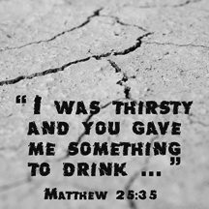](https://www.churchart.com/subscriber/viewimages?book_number=40&chapter=25&entry_date=1/1/0001&image_type=cl,ph,pp,bc,ca,mv,wt,nt,pt,ft,ch&page=3&ipp=12)

Sunday, December 3 Collection Counters

John Bizzarri, Rod Kundrod

Mary Ann DeRosa, Phyllis Slonac

[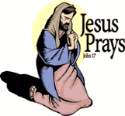](https://www.churchart.com/subscriber/viewimages?book_number=43&chapter=17&verse=1&entry_date=1/1/0001&image_type=cl)

[](http://www.churchart.com/Subscriber/ViewImages.aspx?keywords=&entry_date=1/1/0001&image_type=,cl&topic_id=346&image_source_id=&page=1#no)Weare placing names of the sick in the bulletin for prayer providing they give permission. *May the* *Divine Physician send healing grace for those for* *whom we pray:* Allen C. Rosemas, Patricia Murphy, Bernice Myers, Dwight Fyock, Lori Facciani, Dylon Wills, Dawn Hagen, Debbie Dibert, Missy, Joanne (Kolar) Hufford, Christine Flanagan, Ayden Alan Grata, Remy Beaver, Mary Lou Offman, Marian Chuckalovcak, Arlene Diamond, Mary Zangaglia, Dorothy Rosemas, Natalie Zerby, Patricia Grata, Michael Wadsworth, Valencia & Frank Tursi, Homer Locher, Brayden Schofield, Michelle Kasper, Diane Kingera, Allison Krischer, Ted Paluch, Brandt Hutzel, Pearl Litzinger, Patrick Munro, Fran Baldassarre, Corey Lybarger, Kristen Sinosky Long, Helen Ranieri, Cresta Micik, Basil Costantino, Madison McCrory, Laura, Joe Yoder, Dolores Yanzetich, Sandy Krug, Wanda Gramling, Merna Smay, Muriel “Jean” Wiesheier, Agnes Plummer, Jennifer Hagans, Mary McCall, Sean, Holly, Shane, Owen Taylor, Keith & Dawnetta Hoyer, Gail Faher, Marjorie (Latshaw) Feldman, Derrick Varnish, Daniel Koshute, Vincent Koshute, Karen Lovrich, Melissa Cordek, Michelle Elliott, Heather Romanow, Mackston Barrick, Connor Thomas, Erin, Pat, Mary Agnes Nastase, Mary Ann Bertolino, Dick Wilson, Dan Pauley, Peggy Mulvihill, Jane Plummer, Izzy Bihun, Erica Mitzelfeld, Heidi Allison, Dorothy Kaminsky, Ed Ripper Sr., Patricia Oshaben, Craig Kraber, Ashlee Madison, Marlene McCrory and all of the sick of our parish, the homebound, those in nursing homes, those who care for them, and those in the military along with their families. (Please call the Rectory to have your name removed from the list when no longer seriously ill. Thank You.)

*November 26, 2017 Mt. 25:31-46*

*“When you feed or give a drink or clothing to the least, you did it for me.” Today Jesus teaches us that parenting is sacramental. The routine actions of family life are religious and priestly for we make Christ present in what we do. Family Life is Beatitude Life.*

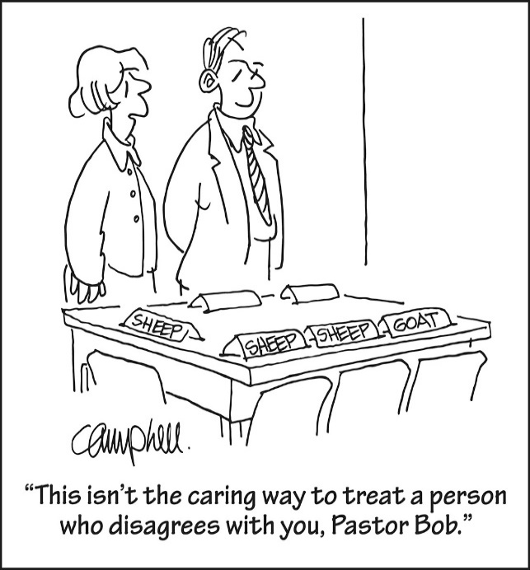

LAST WEEK’S COLLECTION

Adults $3,391.00

Loose $ 154.00

Youth $ 35.25

Monthly $ 250.00

Candles $ 31.00

Maintenance Fund $ 25.00

All Saints $ 5.00

All Souls $ 10.00

Immaculate Conception $ 30.00

Christmas $ 110.00

World Mission Sunday $ 5.00

Catholic Charities $ 757.00

Religious Retirement $ 5.00

Christmas Flowers $ 55.00

Total $4,863.25

We sincerely thank and ask God’s blessing upon all who have care and concern for our parish.

[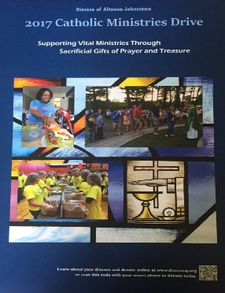](https://www.dioceseaj.org/wp-content/uploads/2017/04/Catholic-Ministries-Drive-2017.jpg)

Catholic Ministries Drive $23,811.00

Raised: $15,575.00

Balance: $ 8,236.00

Number of Responses: 92

Please join them in supporting our Parish and our Diocesan ministries.

If you do not have a pledge card, you may send your gift (made payable

to the “Catholic Ministries Drive”) directly to the parish office. Thank you

for your generous response!

*Stewardship Reflections ~* When the Son of Man comes in glory, may we be among those who feed the hungry, nourish the thirsty, welcome the stranger, clothe the naked, and visit and care for the ill and imprisoned. By sharing our gifts through the practice of good stewardship, Jesus tells us that we will receive God’s blessing and inherit the eternal kingdom.

OVERNIGHT RETREAT – LIVING THE CHRISTMAS STORY, THEN AND NOW ~ December 1-2, 7 PM Friday to 3 PM Saturday. Meet and engage in prayerful reflections with the people of the original advent. Discover these powerful figures as they respond to God’s plan and allow oneself to recognize something of oneself in each character. Retreat includes presentations, time for reflection and prayer and conversation. Meals & housing included. Retreat fee: $40 per person, $55 for married couples. Pre-registration is required by Nov. 27 with a non-refundable deposit of $15 per person. Reservations are limited to 10 participants with private rooms. Sessions & retreats will be held at Carmelite Community of the Work Incarnation Center, 394 Rd., Gallitzin. To register, get directions, or for more information, call 814-886-4098.

TRINITY DOME MOSAIC ~ His Eminence Donald Cardinal Wuerl Archbishop of Washington *and* Chairman of the Board of Trustees Basilica of the National Shrine of the Immaculate Conception *together with* Monsignor Walter R. Rossi Rector are having a dedication of the TRINITY DOME MOSAIC Friday, December 8, 2017 Solemnity of the Immaculate Conception. 12:00 Noon ~ Great Upper Church.

ADVENT REFLECTION: ~ A 3-week DVD series, Untold Blessings: 3 Paths to Holiness, by Bishop Robert Baron, followed by discussion, will be offered Wednesday mornings at 9:00 AM at Most Holy Trinity, South Fork, on November 29, December 6 and 13. Start your day with Mass at 8 AM, followed by a coffee klatch, and the DVD series. Call the rectory to register, 495-4419. If there is interest, and evening program may be scheduled.

[](https://images.search.yahoo.com/search/images;_ylt=A0LEV1kSWptXvOwAKINXNyoA;_ylu=X3oDMTEyZGdkcmRoBGNvbG8DYmYxBHBvcwMxBHZ0aWQDQjIwODlfMQRzZWMDc2M-?p=Clipart+of+a+sanctuary+candle&fr=ush-mailn_02&th=110&tw=110&imgurl=http://www.henningers.com/389-168-wall-sanctuary-lamp.jpg&rurl=http://pixshark.com/sanctuary-lamp.htm&size=43KB&name=Sanctuary+Lamp+Bronze+wall+sanctuary+lamp&h=600&w=600&turl=http://ts2.mm.bing.net/th?id%3DOIP.M68453c67108cdc5ab485d309b395bd03o0%26pid%3D15.1%26rs%3D1%26c%3D1%26qlt%3D95%26w%3D110%26h%3D110#inline&tt=Sanctuary+Lamp+Bronze+wall+sanctuary+lamp&sigr=116keh5le&sigit=13gvlt42j&sigi=11ip0pgm4&sign=119kp6100&sigt=119kp6100)

The Sanctuary Candle will burn for

Melissa Cordek

during the week of December 3, 2017

ADVENT “LITTLE BLUE BOOK” ~ December 3rd is the beginning of the Advent Season. The parish is providing the Little Blue Book free of charge to all parishioners. This booklet will be available at the side exit and on a table at the back of the Church this weekend.

GODPARENT/SPONSOR QUALIFICATIONS ~ For one to be a Godparent/Sponsor for Baptism or Confirmation, he or she is to be a practicing Catholic who is confirmed and in a valid Sacramental Marriage. If one is not from St. Michael Parish, he or she must obtain a certificate from his or her pastor. This is in full accordance with Canon Law.

BABY BOTTLES FOR PRO-LIFE ~ St. Benedict Parish, Johnstown, PA is collecting donations for pro-life organizations in our local area. In the bridal room, you will find baby bottles that will be used to collect your spare change for donation. Feel free to take as many as you would like, and please return them by Sunday, December 3rd.

NOTE ~ The 2018 MARRIAGE PREPARATION Schedule is at the Church entrances. This is for the Pre-Cana Program which every engaged couple MUST attend before marriage.

MILITARY MAIL ~ The youth of the parish will be sending out mail for our military. If you know of anyone in the military that would appreciate receiving mail, please contact us with an address. You can call the rectory at 495-9640 or contact the RE Office at 495-4873.

LECTORS WORKBOOKS ~ The new Lector Workbooks are available in the sacristy. The readings start with the First Sunday of Advent (December 3rd).

[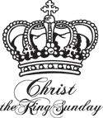](https://www.churchart.com/subscriber/viewimages?topic_id=233&image_type=cl,ph,pp,bc,ca,mv,wt,nt,pt,ft,ch&page=4&ipp=12)

Family Ritual

Feast of Christ the King-November 26

This feast is celebrated on the last Sunday of the Church calendar. Whatever may happen, Jesus Christ will reign in the end. He is the King of all creation.

During your seasonal preparation, invite Christ the King to rule your heart by

Loving and serving others, especially the poor and by forgiving your enemies.



Religious Education And Christian Helping

November 26, 2017

*Religious Education Classes ~*  For the Thanksgiving Holiday break, there will be No Religious Education classes on Sunday, November 26th for grades 6—12.

Classes will resume on Thursday, November 30th for our K—5 students and on Sunday, December 3rd for our grades 6—12 students.

*\*\*\*\*\*\*\*\*\*\*\*\*\*\*\*\*\*\*\*\*\*\*\*\*\*\*\*\*\*\*\*\*\*\*\*\*\*\*\*\*\*\*\*\*\*\*\*\*\*\*\*\*\*\*\*\*\*\*\*\*\*\*\*\*\*\*\*\*\*\*\*\*\*\*\*\*\*\*\*\*\*\*\*\*\*\*\*\*\*\*\*\*\**

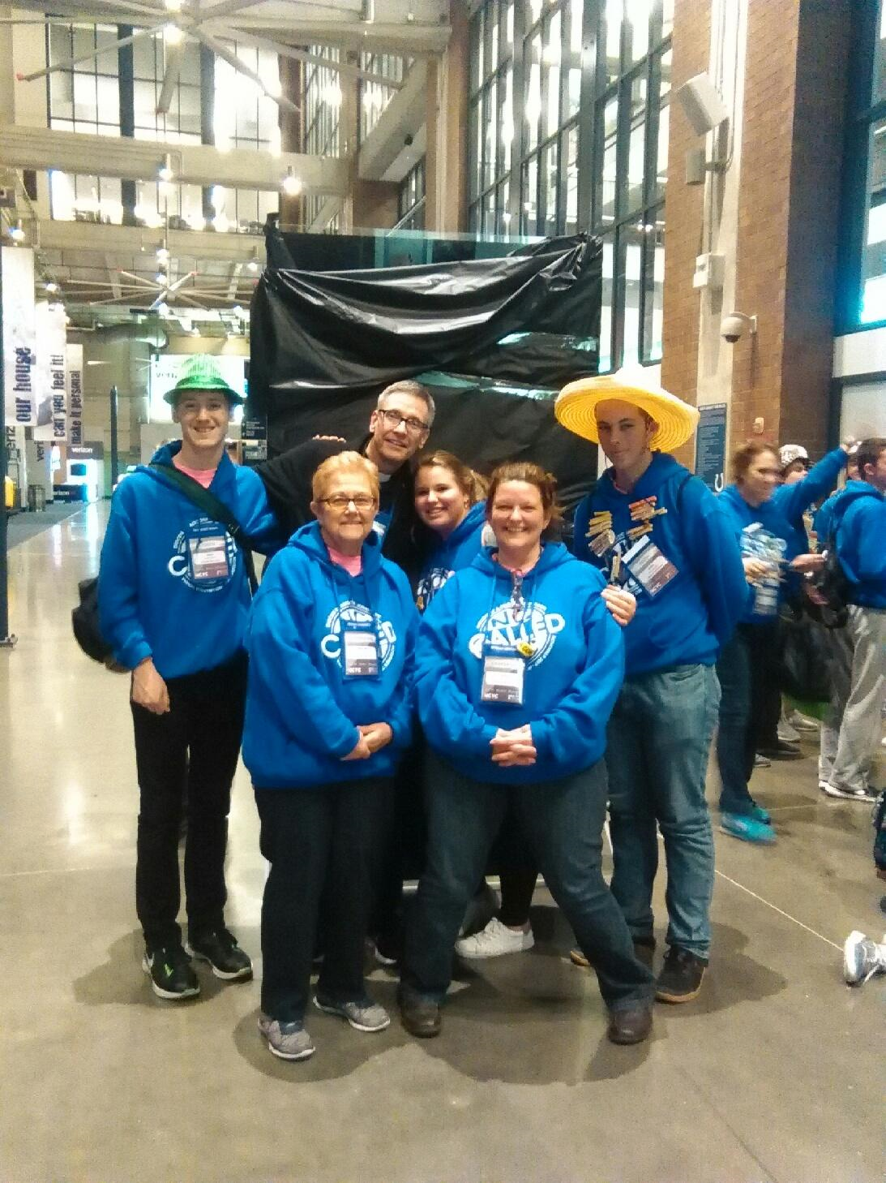

NCYC 2017 ~ Indianapolis, Indiana

Our Saint Michael group is pictured here with Bishop Mark Bartchak enjoying our trip to National Catholic Youth Conference in Indianapolis November 15—18. Pictured left to right: Adam Bambino, Mary Ann Spangler, Bishop Mark, Shannan Elgin, Laurie Sloan and Quinn Spangler.

We all had a very uplifting and spiritual experience in Indianapolis along with over 23,000 other catholic youth from all over the United States. Can’t wait until NCYC 2019 !!!

C:\Users\Laurie\Downloads\c_hllybrdr.jpg

*REACH Holiday Service Projects*

*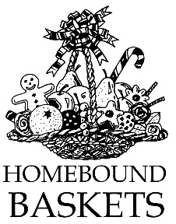*

*Christmas Fruit Baskets for our Homebound Parish Members*

Help is needed to assemble fruit baskets on Monday, November 27th at 6:00 p.m. in the Parish Hall. These fruit baskets will be delivered to the homebound members of our parish by Fr. Brian during his home visits.

Come help spread some holiday cheer and well wishes to our parish shut-ins by being part of this endeavor.

Any interested students should contact the RE Office at 495-4873 to sign up.



*Holy Name K—5 Treats ~* Our Holy Name Society will sponsor a Christmas Pizza Party for our K—5 students on Thursday, December 21st. Help is needed to pack the Christmas treats that they distribute to students. They will be gathering for this task on Tuesday, December 19th at 6:00 p.m. in the Parish Hall.

C:\Users\Laurie\Downloads\c_hllybrdr.jpg

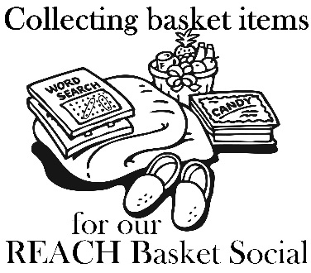

*It’s time to make the baskets!* ~ Our REACH Youth Ministry will sponsor their annual REACH Basket Social on Sunday, December 3rd! Any help with this is greatly appreciated!

*\*If you are still able to make a donation, please have them in by Friday, December 1st.. Our Prep Day is December 2nd.*

Donation envelopes can be dropped in the weekend collection basket at Masses or bagged items can be placed in the Bridal Room or brought to the Religious Education Office or Parish Office.

On Sunday December 3rd, tickets will be available at the door for $5.00 each which includes 25 perforated basket chances and 1 door prize chance. Multiple tickets may be purchased. *Doors will open at 1:00 p.m. with 'chancing off' beginning at 2:00 p.m.* Come early to purchase your tickets and have ample time to view all baskets available and place your chances before the drawing begins.

*Attention—Parents of REACH Students:* We are asking each REACH student from grades 6—12 to donate the following items to help with our Basket Social fundraiser. Non-perishable items (Soda, Candy, and Snacks) can be dropped off anytime over the next two weeks. Cakes, Desserts and Ice Tea can be brought to the church hall by Noon on Sunday, December 3.

Grades 7 & 11 Bag of chocolate candy (Asst. minis, snack size or kisses)

Grades 6 & 8 Cake / Dessert

Grade 12 Two 2-liters of soda

Grade 9 Bags of snacks (potato chips or pretzels)

Grade 10 One Gallon of Ice Tea

*\*\*\*\*\*\*\*\*\*\*\*\*\*\*\*\*\*\*\*\*\*\*\*\*\*\*\*\*\*\*\*\*\*\*\*\*\*\*\*\*\*\*\*\*\*\*\*\*\*\*\*\*\*\*\*\*\*\*\*\*\*\*\*\*\*\*\*\*\*\*\*\*\*\*\*\*\*\*\*\*\*\*\*\*\*\*\*\*\*\*\*\*\*\*\*\*\*\*\*\*\*\*\*\*\*\*\*\*\*\*\*\*\*\**

Fall Confirmation Sessions

Grade 11 ~ Session 11B ~ Sacraments and the Paschal Mystery ~ Sunday, December 10, 2017 ~ All 11th Grade students All will attend their Fall Session 11B from 9 to 10:30 a.m. in the Saint Paul Room to fulfill this session requirement.\*

*\* If the students miss this scheduled session, they are required to attend another*

*parishes scheduled session to fulfill these requirements.*

*\*\*\*\*\*\*\*\*\*\*\*\*\*\*\*\*\*\*\*\*\*\*\*\*\*\*\*\*\*\*\*\*\*\*\*\*\*\*\*\*\*\*\*\*\*\*\*\*\*\*\*\*\*\*\*\*\*\*\*\*\*\*\*\*\*\*\*\*\*\*\*\*\*\*\*\*\*\*\*\*\*\*\*\*\*\*\*\*\*\*\*\**

Sunday, November 26 NO Religious Education / Grades 6-12

Monday, November 27 Mass / 8:00 AM

Sunday Choir Practice / 7:00 PM

Tuesday, November 28 Mass / 8:00 AM

Combined Christmas Choir / 7:00 PM

Wednesday, November 29 No Mass

Thursday, November 30 Mass / 9:00 AM

K – 5 Religious Education Classes / 3:30-4:30

Saturday Night Choir Practice / 5:30

Friday, December 1 First Friday / Exposition of the Blessed Sacrament / 8:30-3:00

Saturday December 2

UPCOMING EVENTS

December 3 REACH Basket Party

December 8 Office Closed

December 9 & 10 Retirement Fund for Religious Second Collection

2nd Sunday Food Pantry Collection

December 10 11th grade Fall Session

Holy Name Society Meeting

Hall Rental

[](https://www.churchart.com/subscriber/viewimages?topic_id=195&image_type=cl,ph,pp,bc,ca,mv,wt,nt,pt,ft,ch&page=17&ipp=12)

COMMUNITY BAND ~ The Forest Hills Community Band will present their annual Christmas Concerts beginning Sunday, December 3rd at Mount.Hope UM Church at 6:00 PM; then Friday, December 8th at Forest Hills Elementary Cafeteria at 7:30 PM. A special concert will be held at the Ebensburg Center on Saturday December 9th at 1:00 PM and their final performance for this year will be Sunday December 10th at the Galleria Mall, near the Bon Ton at 2:00 PM. Admission is free. Everybody Welcome!

CHRISTMAS FESTIVAL ~ Most Holy Trinity, South Fork, will have a Christmas Festival next Sunday, December 3rd , from 11:30 – 1:30 PM, with homemade soups, sandwiches, baked goods, Santa arriving at 12:30, and a basket raffle at 1:00 PM. Bring your family and friends and support our students. Everyone is welcome.

