ST. MICHAEL ROMAN CATHOLIC CHURCH

751 Locust Street

PO Box 103

St. Michael, Pennsylvania 15951

Administrator: Rev. Brian Warchola Weekend Masses:

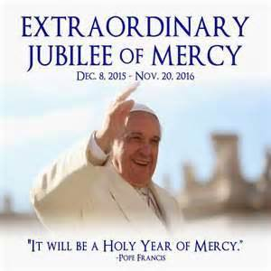

(814) 266-9718 / Ext. 507 Saturday 4:00 pm

Deacon Dave Hornick Sunday Morning 8:00 am

(814) 525-4183 10:30 am

Daily Mass See Bulletin

Office Staff: Holy Days See Bulletin

Secretary: Susan Poldiak Office Hours:

Bookkeeper: Kathy Kalicky 8:30 am to 3:30 pm

DRE: Laurie Sloan Monday, Tues., Thurs., Friday

Maintenance: Rodney Turgeon Confessions:

PHONES: Saturday 3:30 pm to 3:45 pm

Rectory / Office: (814) 495-9640 Sunday 7:30 am to 7:45 am

Fax: (814) 495-9424 10:00 am to 10:15 am

Rel. Education: (814) 495-4873 Anytime Requested

Parish Website Secretaries’ E-mail:

www.saintmichaelchurch.weebly.com [saintmichaelsecretaries@yahoo.com](mailto:saintmichaelsecretaries@yahoo.com)

YEAR: 2016 NUMBER: 47

JUBILEE YEAR OF MERCY

SERVING GOD AND COMMUNITY FOR OVER ONE HUNDRED YEARS!

BAPTISM: By Appointment. Reserve at least one month in advance.

Preparation classes are necessary.

MARRIAGE: Make arrangements at least nine months in advance.

Preparation sessions are necessary.

FUNERALS: Arrangements are made in conjunction with the funeral home.

Eulogies should be given at the funeral home at the time of the wake service or at the luncheon.

REGISTRATION Those new to the area, newlyweds, and single adults, (even if registered

and before with their families) are asked to register by calling the Parish Office.

MEMBERSHIP: Every parishioner must be registered. This is a condition for admission

to our Program and reception of the Sacraments of Baptism, Confirmation, First Penance, First Eucharist, and Matrimony; also, for testimonial letters or sponsorship of Baptism and Confirmation outside the Parish.

VISITATION: We are concerned and want to be advised when someone is ill at home

or in the hospital. Call the rectory to have the shut-in placed on our monthly Holy Communion calls or seriously ill prayer list.

SACRAMENTAL Requires parish registration and active Mass participation for

POLICY: Baptism and Marriage.

BULLETIN ARTICLES: Articles are due to the Parish Office by Noon on Monday.

Our Lord Jesus Christ, King of the Universe November 20, 2016

Month of the Holy Souls in Purgatory

MASS INTENTIONS: (November 21 – November 27, 2016)

[](http://www.churchart.com/subscriber/viewimages.aspx?keywords=In%20memory%20&entry_date=1/1/0001&image_type=,cl#no)

Monday No Mass

Tuesday 8:00 AM Margaret E. Glavinic by Ann Marie Chonko

Wednesday 9:00 AM Barbara Michaels req. by Barbara Starchville

Thursday 9:00 AM Margaret Yanzetich req. by Family

Friday No Mass No Mass / Rectory Office Closed

Saturday 4:00 PM Helen J. Golian req. by sister, Agnes R. Golian

Sunday 8:00 AM Stephen D. Yanzetich Sr. req. by Dolores, Evan & Susan Yanzetich

10:30 AM People of the Parish

LITURGICIAL APPOINTMENTS:

Saturday, November 26 4:00 PM Offertory Procession

Lector: Donald Dipko Ushers

Minister of the Host: Susan Blazosky

Ministers of the Cup: Vince Arena & Babe Richards

Altar Servers: Garrett & Carson Kundrod

Cantor: Amanda Williamson

Greeter: Shirley Walls

Sunday, November 27 8:00 AM Offertory Procession

Lector: Amy Spinos Ushers

Minister of the Host: Marie Bernard

Ministers of the Cup: Cathy Faher & Pauline Minor

Altar Servers: Elyssa Nagy & Hailey Hampton

Cantor: Anita Lorek

Greeter: Betty Long

Sunday, November 2710:30 AM Offertory Procession

Lector: Jacob Stiffler Michael Caddy Family

Minister of the Host: Deacon Dave Hornick

Ministers of the Cup: Dave & Edie Knobloch

Altar Servers: Evan Burkhardt & Zach Fisher

Cantor: Louis McCloskey

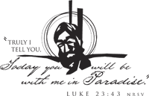

Greeter: Mary Ann Oravis

Sunday, November 27 Collection Counters

Rod Kundrod, John Bizzarri

Mary Ann DeRosa, Phyllis Slonac

[](http://www.churchart.com/Subscriber/ViewImages.aspx?keywords=&entry_date=1/1/0001&image_type=,cl&topic_id=346&image_source_id=&page=1#no)Weare placing names of the sick in the bulletin for prayer providing they give permission. Although we remember all sick and shut-ins at every Mass, we would like our parish family to be aware of the need for special prayer intentions because of a most serious illness or hospital stay. *May the* *Divine Physician send healing grace for those for* *whom we pray:* Josephine Koshute, Allen C. Rosemas, Patricia Murphy, Todd Euen, Bernice Myers, Dwight Fyock, Lori Facciani, Dylon Wills, Dawn Hagen, Debbie Dibert, Missy, Joanne (Kolar) Hufford, Christine Flanagan, Ayden Alan Grata, Remy Beaver, Mary Lou Offman, Marian Chuckalovcak, Arlene Diamond, Mary Zangaglia, Dorothy Rosemas, Natalie Zerby, Patricia Grata, Michael Wadsworth, Valencia & Frank Tursi, Homer Locher, Gloria Weyandt, Brayden Schofield, Steve Faher, Jr, Michelle Kasper, Diane Kingera, Allison Krischer, Ted Paluch, Brandt Hutzel, Nicholas “Hop” Kolar, Pearl Litzinger, Patrick Munro, Fran Baldassarre, Corey Lybarger, Ann Marie Beppler, Kristen Sinosky Long, Helen Ranieri, Cresta Micik, Loretta Panick, Basil Costantino, Madison McCrory, Laura, Maria, Joe Yoder, Dolores Yanzetich, Jill Cekada, Sandy Krug, Wanda Gramling, Merna Smay, Muriel “Jean” Wiesheier, Heidi Allison, Sharon Poldiak, Melinda Jerome, Agnes Plummer, Jennifer Hagans, Katie Ansell, Mary McCall, Suzie Thomas, Sean, Holly, Shane, Joan McDowell, Melisa Ruddek, Joanne Serre, Scott N., Joe Ropecka, Patrick O’Donnell, Owen Taylor, Christine Baxter and all of the sick of our parish, the homebound, those in nursing homes, those who care for them, and those in the military along with their families. (Please call the Rectory to have your name removed from the list when no longer seriously ill. Thank You.)

CHOIR PRACTICES ~ Practice for the Sunday Choir is scheduled for Mondays at 7:00 PM. The Christmas Choir will have its next rehearsal on Wednesday, November 23rd at 7:00 PM. Please bring folders from last year. Everyone is welcome! Practice for the Saturday Choir is scheduled for Thursdays at 5:30 PM.

SECOND SUNDAY FOOD COLLECTION THANK YOU ~ Thanks to all who donated to our Second Sunday Food Collection. $945.00 was collected as well as a large amount of food. These donations will go a long way to help make someone’s Thanksgiving a little brighter!

LECTORS WORKBOOKS ~ The new Lector Workbooks are available in the sacristy. The readings start with the First Sunday of Advent which is next week.

SPECIAL COLLECTION FOR CATHOLIC CHARITIES ~ On November 19th and 20th, you can change a life with one little envelope. Join Catholic Charities of the Diocese of Altoona-Johnstown in celebrating over 75 years of service to our neighbors and our Lord. All money collected at each parish stays in that county. Thank you for your generosity!

TIME TO MAKE THE BASKETS! ~ Our annual REACH Basket Social will be held on Sunday, December 4th. Parishioners can help by assembling a basket alone, or several people together can combine resources for a completed basket. Each basket should be worth $25 to $30. We are in need of any new or unused items you may have for use in assembling extra baskets for the event. This also includes empty basket or containers you may have too! Your help with this is greatly appreciated! Any donated items can be left in the Bride’s Room of the church or dropped off at the Rectory or Religious Education Offices during regular office hours.

*November 20th Luke 23:35-43*

*Today’s gospel reminds us the Kingdom of Heaven is not like Disney’s Magic Kingdom. Admission to Christ’s Kingdom is paid with the currency of acceptance, forgiveness, compassion, service to others, love of enemies and care for the poor and defenseless.*

2016 ANNUAL CATHOLIC APPEAL

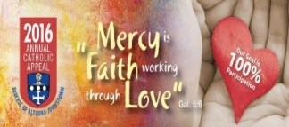

ANNUAL CATHOLIC APPEAL

Diocesan Goal $29,040.00

Pledged $18,173.00

Total Cash Amount $17,993.00

Number of Responses 127 430 30%

[](https://images.search.yahoo.com/search/images;_ylt=A0LEV1kSWptXvOwAKINXNyoA;_ylu=X3oDMTEyZGdkcmRoBGNvbG8DYmYxBHBvcwMxBHZ0aWQDQjIwODlfMQRzZWMDc2M-?p=Clipart+of+a+sanctuary+candle&fr=ush-mailn_02&th=110&tw=110&imgurl=http://www.henningers.com/389-168-wall-sanctuary-lamp.jpg&rurl=http://pixshark.com/sanctuary-lamp.htm&size=43KB&name=Sanctuary+Lamp+Bronze+wall+sanctuary+lamp&h=600&w=600&turl=http://ts2.mm.bing.net/th?id%3DOIP.M68453c67108cdc5ab485d309b395bd03o0%26pid%3D15.1%26rs%3D1%26c%3D1%26qlt%3D95%26w%3D110%26h%3D110#inline&tt=Sanctuary+Lamp+Bronze+wall+sanctuary+lamp&sigr=116keh5le&sigit=13gvlt42j&sigi=11ip0pgm4&sign=119kp6100&sigt=119kp6100)

The Sanctuary Candle will burn

in memory of

Michael Bidelman

requested by Susan Yanzetich

And

The Our Lady of Grace Candle will burn for a Special Intention

requested by Michael Hudak

the week of November 20, 2016.

*Liturgical Reflection…*

This Thursday, November 24, is Thanksgiving Day and a special Day of Prayer in the Diocese of Altoona-Johnstown. The theme of the prayer is the Harvest and Fruits of the Earth. As our country gives thanks to God for our many blessings, Catholics are encouraged to participate at Mass and give thanks to God for all the gifts we have received. *Please join in praying the following:*

*Father all powerful, your gifts of love are countless and your goodness infinite;*

*as we come before you on Thanksgiving Day with gratitude for your kindness,*

*open our hearts to have concern for every man, woman, and child, so that we may share your gifts in loving service. Through Christ our Lord. Amen*

2016, Diocese of Altoona-Johnstown, Liturgy Office, 925 South Logan Boulevard, Hollidaysburg, Pennsylvania 16648.

SACRAMENTS CLASS Offered (2 Locations) ~ This 8 week course will focus on an understanding of the Sacraments today. Participants will study the post Vatican II theologies of Baptism, Reconciliation, Confirmation, Sacrament of Healing, Marriage, Holy Orders and the central mystery of our faith, the Mass. The course is being offered at 2 locations this January, Cathedral of the Blessed Sacrament – Seton Suite, Altoona; Msgr. Robert Mazur, instructor and St. Michael Church Hall, St. Michael; Father D. Timothy Grimme, instructor. The cost of registration and material, which includes a book on each sacrament, is $65.Registration forms are available online at www.dioceseaj.org/lay-ecclesialministry or by contacting Marybeth at 814-361-2000 or by email at mheinze@dioceseaj.org. All are welcome.

PRAY FOR LIVING PRIESTS AND DEACONS IN THE DIOCESE Very Rev. James Crookston, Msgr. John Sasway, Fr. Ananias Buccicone, OSB, Fr. Rod Soha, TOR, Deacon Thomas McFee; and Seminarians Michael Pleva, Austin Keith, Peter Crowe, Jonathan Dickson, Devin Crouse, Mark Groeger and Sean Gibson

[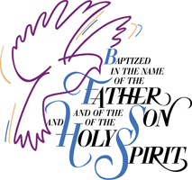](http://www.churchart.com/Subscriber/ViewImages.aspx?keywords=Baptism&entry_date=1/1/0001&image_type=,cl&topic_id=&image_source_id=&page=1#no)BAPTISM ~ On Sunday, November 13th, we celebrated the glorious baptism of

Knox David Layman, son of Jason and Cassandra (George) Layman by Father Bonaventure Curtis. He became a new creation in Christ in the waters of Holy Baptism. Now joined to us by the gifts of faith, hope and charity, we warmly welcome him into our Saint Michael Parish Family.

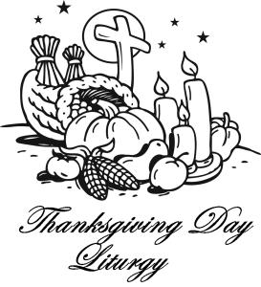 *Thursday, November 24 9:00 AM*

*Lector: Anthony Bambino*

*Minister of the Host: Deacon Dave Hornick*

*Ministers of the Cup: Beth Kundrod & Betty Long*

*Altar Servers: Adam & Alex Bambino*

*Cantor: Shannon Kudlawiec*

*Greeter: Darlene Marshall*

*Offertory Procession: The Yanzetich Family*

STUDENTS HELPING STUDENTS ~ Owen Taylor is a fourth grader at Bedford Elementary and also a family friend of Colby Rearick a 6th grader at Forest Hills Elementary and member of our parish. Shortly after birth, Owen was diagnosed with a rare congenital heart condition that severely hinders the function and development of the heart. This complication is a life threatening condition that occurs in less than 1% of children born with congenital heart defects. Owen has had multiple surgeries over the years to help strengthen his heart. He had a big surgery in July of 2016 that was unsuccessful and ultimately put Owen on the Heart Transplant List. On October 29, 2016 Owen received a heart transplant. He is still recovering in Children’s Hospital in Pittsburgh. Colby is asking for any donation to be given to the family to help with medical expenses. Students will be collecting donations after all three Masses this weekend, November 19-20. May all of us keep Owen in our prayers.

[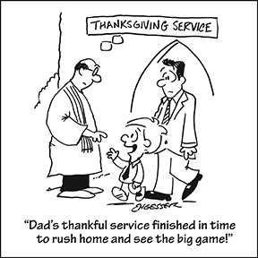](https://www.churchart.com/subscriber/viewimages?topic_id=81&image_type=ca)

LAST WEEK’S COLLECTION

Adults $2,977.00

Loose $ 181.00

Youth $ 44.00

Monthly $ 438.00

Maintenance Fund $ 30.00

All Saints $ 10.00

Catholic Charities $ 30.00

Christmas Flowers $ 50.00

Total $3,760.00

We sincerely thank and ask God’s blessing upon all who have care and concern for our parish.



Religious Education And Christian Helping

November 20, 2016

*Religious Education Classes ~*  For the Thanksgiving Holiday break, there will be No Religious Education classes on Thursday, November 24th (Thanksgiving Day) for K—5 and

No classes held on Sunday, November 27th for grades 6—12.

Classes will resume on Thursday, December 1st for our K—5 students and on Sunday, December 6th for our grades 6—12 students. A Blessed Thanksgiving to all!



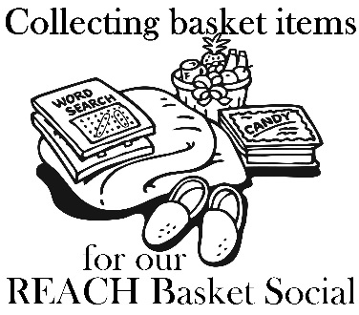*It’s time to make the baskets!* ~ We are asking our Religious Ed families and parisioners to help with this Project. We are in need of any new or unused items you may have for use in assembling extra baskets for the event. This also includes empty basket or containers you may have too! Parishioners can also help by assembling a basket alone, or several people together can combine resources for a completed basket. Any help with this is greatly appreciated! Any donated items or baskets can be left in the Bride’s Room of the church or dropped off at the Rectory or Religious Education Offices.

*We are asking our Religious Ed families to help with the Project:*

*Each Religious Education class, Grades K—12 are sponsoring a basket to be chanced off at this social as a classroom service project. *If you are still able to make a donation, please have them in by Thursday, December 1st. Our Prep Day is December 3rd.*

*(There is no RE Class scheduled for Thursday November 24th (Thanksgiving) of Sunday, November 27th)!*

*When sending your donations, please be sure to mark the envelope or bag “Basket Social” and also include your “Child's Name” and “Grade” to ensure that the correct grade receives them.* Donation envelopes can be dropped in the weekend collection basket at Masses or bagged items can be placed in the Bridal Room or brought to the Religious Education Office or Rectory Office.

*Attention—Parents of REACH Students:* We are asking each REACH student from grades 6—12 to donate the following items to help with our Basket Social fundraiser. Non-perishable items (Soda, Candy, and Snacks) can be dropped off anytime over the next two weeks. Cakes, Desserts and Ice Tea can be brought to the church hall on Sunday, December 4th.

Grades 7 &11 Bag of chocolate candy (Asst. Christmas minis, fun size or kisses)

Grades 6 & 9 Cake / Dessert

Grade 10 Two 2-liters of soda

Grade 8 Bags of snacks (potato chips, pretzels)

Grade 12 One Gallon of Ice Tea

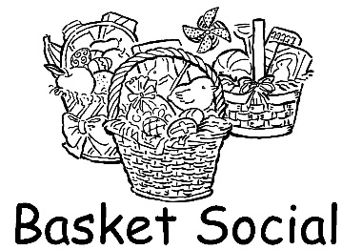

Our REACH Youth Ministry will sponsor their annual REACH Basket Social on Sunday, December 4th this year!

Tickets will be available at the door for $5.00 each which includes 25 perforated basket chances and 1 door prize chance. Multiple tickets may be purchased. *Doors will open at 1:00 p.m. with 'chancing off' beginning at 2:00 p.m.* Come early to purchase your tickets and have ample time to view all baskets available and place your chances before the drawing begins.

*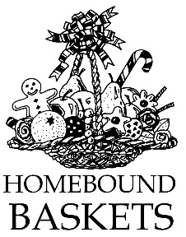REACH Holiday Service Projects*

*Christmas Fruit Baskets for our Homebound Parish Members*

Help is needed to assemble fruit baskets on Wednesday, November 30th at 6:00 p.m. in the Parish Hall. These fruit baskets will be delivered to the homebound members of our parish on the morning of December 1st by Deacon Dave Hornick during his home visits.

Come help spread some holiday cheer and well wishes to our parish shut-ins by being part of this endeavor.

*Holy Name K—5 Treats ~* Our Holy Name Society will sponsor a Christmas Pizza Party for our K—5 students on Thursday, December 15th. Help is needed to pack the Christmas treats that they distribute to the students. They will be gathering to achieve this task on Tuesday, December 13th at 6:00 p.m. in the Parish Hall.

Any interested students should stop in or contact the RE Office at 495-4873 to sign up.

*Military Mail* ~ The youth of the parish will be sending out mail for our military. If you know of anyone in the military that would appreciate receiving mail, please contact us with an address. You can call the rectory at 495-9640 or contact the RE Office at 495-4873. Also, if you have any Christmas cards you will not be using, you can donate them to our Religious Education program.

*\*\*\*\*\*\*\*\*\*\*\*\*\*\*\*\*\*\*\*\*\*\*\*\*\*\*\*\*\*\*\*\*\*\*\*\*\*\*\*\*\*\*\*\*\*\*\*\*\*\*\*\*\*\*\*\*\*\*\*\*\*\*\*\*\*\*\*\*\*\*\*\*\*\*\*\*\*\*\*\*\*\*\*\*\*\*\*\*\*\*\*\*\*\*\*\*\*\*\*\*\*\*\*\*\*\*\*\*\*\*\*\*\**

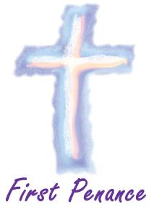

*Sacrament of Reconciliation ~* Our Second graders are preparing to receive their Sacrament of Reconciliation on Saturday, December 10th at 1:00 p.m. in the church. Please remember these children in your prayers as they prepare and anticipate the arrival of this very special day.

Grade 11 ~ Session 11B ~ Sacraments and the Paschal Mystery ~ Sunday, December 11, 2016 ~ All 11th Grade students All will attend their Fall Session 11B from 9 to 10:30 a.m. in the Parish Hall to fulfill this session requirement.*

*\* If the students miss this scheduled session, they are required to attend another*

*parishes scheduled session to fulfill these requirements.*

Sunday, November 20 Catholic Charities Collection at all weekend Masses

Religious Education Grades 6-12 / 9:00-10:20 AM / Hall

Monday, November 21 Sunday Choir Practice / 7:00 PM / Church

Tuesday, November 22 Morning Mass / 8:00 AM

[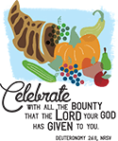](https://www.churchart.com/subscriber/viewimages?topic_id=238&image_type=cl&page=2&ipp=12) Wednesday, November 23 Morning Mass / 9:00 AM

Combined Christmas Choir / 7:00 PM / Church

Thursday, November 24 HAPPY THANKSGIVING!

Morning Mass / 9:00 AM

Rectory Office Closed

No Religious Education Classes

Friday, November 25 No Morning Mass

Rectory Office Closed

Saturday, November 26

Sunday, November 27 No Religious Education Classes

UPCOMING EVENTS

Sunday, December 4 REACH Basket Social / Parish Hall

**THANKSGIVING CONCERT** ~ A concert of sacred choral music will be presented by the Cambria City Choir at The Grand Halle on Broad Street in Johnstown on November 20th beginning at 4:00 PM. The music director is Kim Rauch who will be accompanied by Robert Lacovic. Tickets at the door are $10.00 for adults. For more information please call 536-7986. The concert is being sponsored by Somerset Trust Company

.

ADVENT CHRISTMAS CONCERT will be held 7pm, Saturday, December 17th at St John Gualbert Cathedral, 117 Clinton Street, Johnstown.  The program will feature the Greater Johnstown Diocesan Festival Choir and Youth Chorale under the direction of Cathedral music director, Evonne Yanzetich-Homway. The choral groups will be accompanied by the Hilltop Chamber Music Ensemble. Admission is free and open to the public. A free-will offering will be taken.

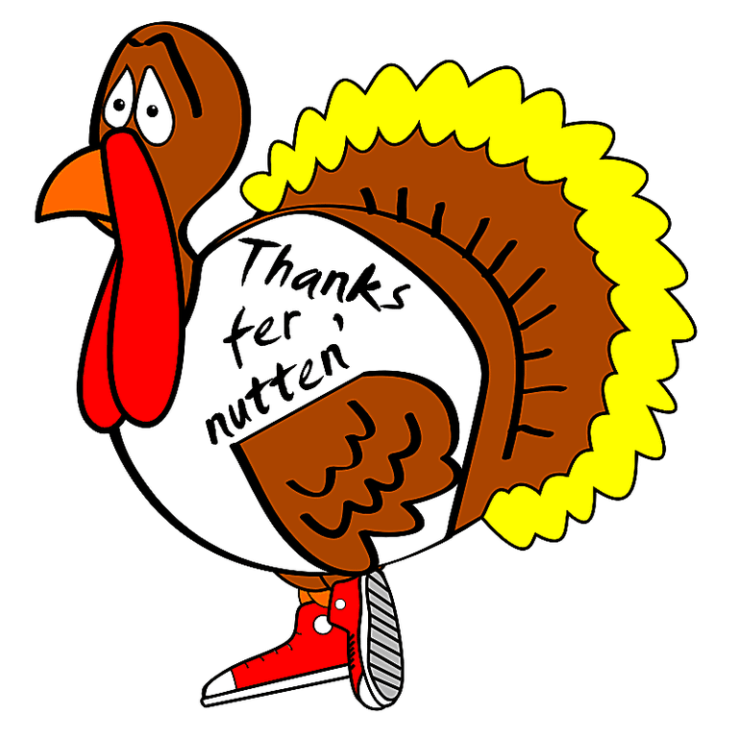*One year at Thanksgiving, my mom went to my sister's house for the traditional feast. Knowing how gullible my sister is, my mom decided to play a trick. She told my sister that she needed something from the store. When my sister left, my mom took the turkey out of the oven, removed the stuffing, stuffed a Cornish hen, and inserted it into the turkey, and re-stuffed the turkey. She then placed the bird(s) back in the oven.*

*When it was time for dinner, my sister pulled the turkey out of the oven and proceeded to remove the stuffing. When her serving spoon hit something, she reached in and pulled out the little bird.*

*With a look of total shock on her face, my mother exclaimed, "Patricia you've cooked a pregnant bird!" At the reality of this horrifying news, my sister started to cry.*

*It took the family two hours to convince her that turkeys lay eggs!*