ST. MICHAEL ROMAN CATHOLIC CHURCH

PO Box 103

St. Michael, Pennsylvania 15951

Rev. Brian L. Warchola, Administrator MASSES:



(814) 495-9640 Saturday 4:00 pm

Sunday Morning 8:00 am

Secretary: Michele Panick 10:30 am

Bookkeeper: Kathy Kalicky Daily Mass See Bulletin

DRE: Laurie Sloan Holy Days See Bulletin

Maintenance: Rodney Turgeon

Office Hours:

PHONES: 8:30 am to 3:30 pm

Rectory / Office: (814) 495-9640 Monday, Tues., Thurs., Friday

Fax: (814) 495-9424 Confessions:

Rel. Education: (814) 495-4873 Saturday 3:30 pm to 3:45 pm

Parish Website Sunday 7:30 am to 7:45 am

www.saintmichaelchurch.weebly.com 10:00 am to 10:15 am

Secretaries’ E-mail Anytime Requested

[saintmichaelsecretaries@yahoo.com](mailto:saintmichaelsecretaries@yahoo.com)

YEAR: 2017 NUMBER: 47

SERVING GOD AND COMMUNITY FOR OVER ONE HUNDRED YEARS!

BAPTISM: By Appointment. Reserve at least one month in advance.

Preparation classes are necessary.

MARRIAGE: Plan at least nine months in advance.

Preparation sessions are necessary.

FUNERALS: Arrangements are made in conjunction with the funeral home.

Eulogies should be given at the funeral home at the time of the wake service or at the luncheon.

REGISTRATION Those new to the area, newlyweds, and single adults, (even if registered

and before with their families) are asked to register by calling the Parish Office.

MEMBERSHIP: Every parishioner must be registered. This is a condition for admission

to our Program and reception of the Sacraments of Baptism, Confirmation, First Penance, First Eucharist, and Matrimony; also, for testimonial letters or sponsorship of Baptism and Confirmation outside the Parish.

VISITATION: We are concerned and want to be advised when someone is ill at

home or in the hospital. Call the rectory to have the shut-in placed on our monthly Holy Communion calls or seriously ill prayer list.

SACRAMENTAL Requires parish registration and active Mass participation for Baptism

POLICY: and Marriage.

BULLETIN ARTICLES: Articles are due to the Parish Office by Noon on Monday.

Thirty-first Sunday in Ordinary Time November 19, 2017

**The Holy Souls in Purgatory**

MASS INTENTIONS: (November 20 – November 26, 2017)

Monday 8:00 AM Twila Grattan req. by Family

Tuesday 8:00 AM Mario DiMarino req. by Ray Katrancha Family

Wednesday 8:00 AM Most Holy Trinity, South Fork & St. Benedict’s, Johnstown

12:05 PM St. Benedict’s, Johnstown

Thursday 9:00 AM Michael Bidelman & Stephen Yanzetich Sr. req. by Susan Yanzetich

Office Closed

Friday 8:00 AM NO MASS / Office Closed

Saturday 4:00 PM William Wilson req. by Mary Ann Murin & Family

Sunday 8:00 AM Carmella Bellvia req. by Don & Marie Jo Plummer & Family

Sunday 10:30 AM Birthday Remembrance for Michael Koshute req. by Paul & Cindy

McCloskey Family & the Koshute Family

LITURGICIAL APPOINTMENTS:

Saturday, November 25 4:00 PM Offertory Procession

Lector: Donald Dipko Mary Ann Murin & Family

Minister of the Host: Helen Slonac

Ministers of the Cup: Mary Partsch & Alice Podrebarac

Altar Servers: Adam & Alex Bambino

Cantor: Susan Blazosky

Greeter: Mary Ann Spangler

Sunday, November 26 8:00 AM Offertory Procession

Lector: David Knepper Don & Marie Jo Plummer

Minister of the Host: Pauline Minor and Family

Ministers of the Cup: Marie Jo Plummer & Cathy Faher

Altar Servers: Griffin & Kaden Christ

Cantor: Susan Yanzetich

Greeter: Lori George

Sunday, November 2610:30 AM Offertory Procession

Lector: Madison Kundrod McCloskey & Koshute Family Minister of the Host: Susan Wieczorek

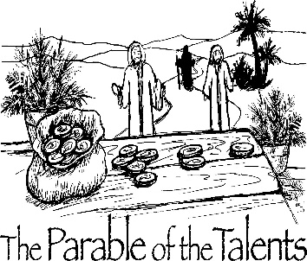Ministers of the Cup: Sharon Paterson & Edie Knobloch

Altar Servers: Ericka Frombach & Alexia Steele

Cantor: Shannon Kudlawiec

Greeter: Mary Ann Oravis

Sunday, November 26 Collection Counters

Tom & Sharon Paterson

Robert Casti & Sara Zybura

[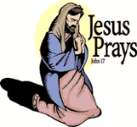](https://www.churchart.com/subscriber/viewimages?book_number=43&chapter=17&verse=1&entry_date=1/1/0001&image_type=cl)

[](http://www.churchart.com/Subscriber/ViewImages.aspx?keywords=&entry_date=1/1/0001&image_type=,cl&topic_id=346&image_source_id=&page=1#no)Weare placing names of the sick in the bulletin for prayer providing they give permission. *May the* *Divine Physician send healing grace for those for* *whom we pray:* Allen C. Rosemas, Patricia Murphy, Bernice Myers, Dwight Fyock, Lori Facciani, Dylon Wills, Dawn Hagen, Debbie Dibert, Missy, Joanne (Kolar) Hufford, Christine Flanagan, Ayden Alan Grata, Remy Beaver, Mary Lou Offman, Marian Chuckalovcak, Arlene Diamond, Mary Zangaglia, Dorothy Rosemas, Natalie Zerby, Patricia Grata, Michael Wadsworth, Valencia & Frank Tursi, Homer Locher, Brayden Schofield, Michelle Kasper, Diane Kingera, Allison Krischer, Ted Paluch, Brandt Hutzel, Pearl Litzinger, Patrick Munro, Fran Baldassarre, Corey Lybarger, Kristen Sinosky Long, Helen Ranieri, Cresta Micik, Basil Costantino, Madison McCrory, Laura, Joe Yoder, Dolores Yanzetich, Sandy Krug, Wanda Gramling, Merna Smay, Muriel “Jean” Wiesheier, Heidi Allison, Agnes Plummer, Jennifer Hagans, Mary McCall, Sean, Holly, Shane, Owen Taylor, Keith & Dawnetta Hoyer, Gail Faher, Marjorie (Latshaw) Feldman, Derrick Varnish, Daniel Koshute, Vincent Koshute, Karen Lovrich, Melissa Cordek, Michelle Elliott, Heather Romanow, Mackston Barrick, Connor Thomas, Erin, Pat, Mary Agnes Nastase, Mary Ann Bertolino, Dick Wilson, Dan Pauley, Peggy Mulvihill, Jane Plummer, Izzy Bihun, Erica Mitzelfeld, Heidi Allison, Dorothy Kaminsky, Ed Ripper Sr., Patricia Oshaben, Craig Kraber, Ashlee Madison, Marlene McCrory and all of the sick of our parish, the homebound, those in nursing homes, those who care for them, and those in the military along with their families. (Please call the Rectory to have your name removed from the list when no longer seriously ill. Thank You.)

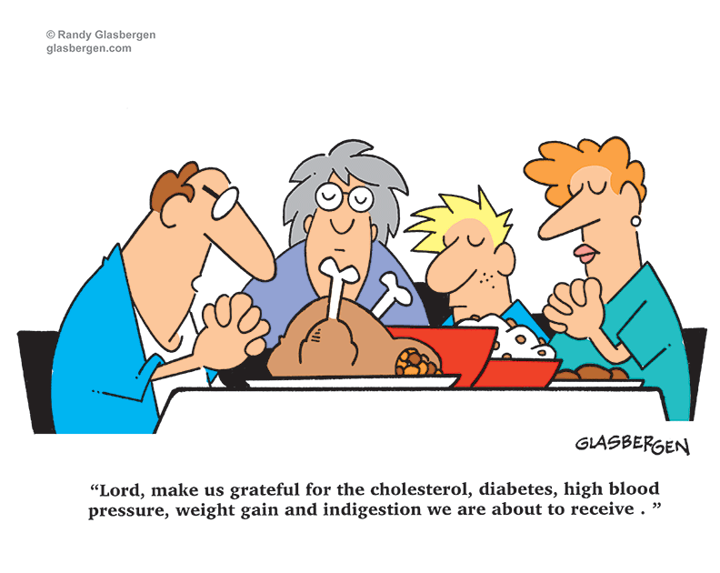

LAST WEEK’S COLLECTION

Adults $4,141.00

Loose $ 239.90

Youth $ 46.10

Monthly $ 255.00

Candles $ 14.00

Maintenance Fund $ 10.00

All Saints $ 5.00

All Souls $ 20.00

Catholic Charities $ 35.00

Christmas Flowers $ 40.00

Total $4,806.00

We sincerely thank and ask God’s blessing upon all who have care and concern for our parish.

*November 19, 2017 Mt. 25:14-30*

*As the man in the gospel entrusted his servants with his money, so God has entrusted our family to us. Like the good servants we are expected, not to play it safe, but to selflessly and totally invest ourselves in each other.*

[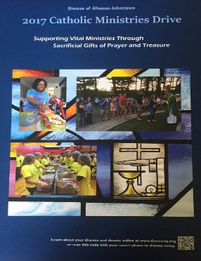](https://www.dioceseaj.org/wp-content/uploads/2017/04/Catholic-Ministries-Drive-2017.jpg)

Catholic Ministries Drive $23,811.00

Raised: $15,575.00

Balance: $ 8,236.00

Number of Responses: 92

Please join them in supporting our Parish and our Diocesan ministries.

If you do not have a pledge card, you may send your gift (made payable

to the “Catholic Ministries Drive”) directly to the parish office. Thank you

for your generous response!

*Stewardship Reflections ~* It is through the faithful use of our God-given gifts that will lead to our full participation in the Kingdom of God. As our blessings increase, so too does our responsibility to use them as God intended.

OVERNIGHT RETREAT – LIVING THE CHRISTMAS STORY, THEN AND NOW ~ December 1-2, 7 PM Friday to 3 PM Saturday. Meet and engage in prayerful reflections with the people of the original advent. Discover these powerful figures as they respond to God’s plan and allow oneself to recognize something of oneself in each character. Retreat includes presentations, time for reflection and prayer and conversation. Meals & housing included. Retreat fee: $40 per person, $55 for married couples. Pre-registration is required by Nov. 27 with a non-refundable deposit of $15 per person. Reservations are limited to 10 participants with private rooms. Sessions & retreats will be held at Carmelite Community of the Work Incarnation Center, 394 Rd., Gallitzin. To register, get directions, or for more information, call 814-886-4098.

TRINITY DOME MOSAIC ~ His Eminence Donald Cardinal Wuerl Archbishop of Washington *and* Chairman of the Board of Trustees Basilica of the National Shrine of the Immaculate Conception *together with* Monsignor Walter R. Rossi Rector are having a dedication of the TRINITY DOME MOSAIC Friday, December 8, 2017 Solemnity of the Immaculate Conception. 12:00 Noon ~ Great Upper Church.

*THANKSGIVING DAY LITURGY*

Thursday, November 23 9:00 AM

Lector: Julia Barton

[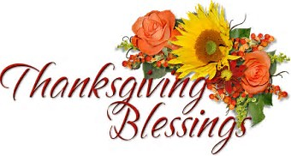](https://www.bing.com/images/search?view=detailV2&ccid=oD6YZKIf&id=AE09B746D77D3C7AE77BD148F7B5C2F8BE9A520B&thid=OIP.oD6YZKIfSJ85Xp98Fi7N8AEsCg&q=thanksgiving+day+liturgy+clipart&simid=607998406980600070&selectedIndex=20) Minister of the Host: Michael Barton

Ministers of the Cup: Beth Kundrod & Pauline Minor

Altar Servers: Evan & Dylan Kundrod

Cantor: Theresa Arena

Greeter: Karen Myers

Offertory Procession: Yanzetich Family

[](https://images.search.yahoo.com/search/images;_ylt=A0LEV1kSWptXvOwAKINXNyoA;_ylu=X3oDMTEyZGdkcmRoBGNvbG8DYmYxBHBvcwMxBHZ0aWQDQjIwODlfMQRzZWMDc2M-?p=Clipart+of+a+sanctuary+candle&fr=ush-mailn_02&th=110&tw=110&imgurl=http://www.henningers.com/389-168-wall-sanctuary-lamp.jpg&rurl=http://pixshark.com/sanctuary-lamp.htm&size=43KB&name=Sanctuary+Lamp+Bronze+wall+sanctuary+lamp&h=600&w=600&turl=http://ts2.mm.bing.net/th?id%3DOIP.M68453c67108cdc5ab485d309b395bd03o0%26pid%3D15.1%26rs%3D1%26c%3D1%26qlt%3D95%26w%3D110%26h%3D110#inline&tt=Sanctuary+Lamp+Bronze+wall+sanctuary+lamp&sigr=116keh5le&sigit=13gvlt42j&sigi=11ip0pgm4&sign=119kp6100&sigt=119kp6100)

The Sanctuary Candle will burn

In Thanksgiving

during the week of November 19, 2017

GODPARENT/SPONSOR QUALIFICATIONS ~ For one to be a Godparent/Sponsor for Baptism or Confirmation, he or she is to be a practicing Catholic who is confirmed and in a valid Sacramental Marriage. If one is not from St. Michael Parish, he or she must obtain a certificate from his or her pastor. This is in full accordance with Canon Law.

BABY BOTTLES FOR PRO-LIFE ~ St. Benedict Parish, Johnstown, PA is collecting donations for pro-life organizations in our local area. In the bridal room, you will find baby bottles that will be used to collect your spare change for donation. Feel free to take as many as you would like, and please return them by Sunday, December 3rd.

SECOND SUNDAY FOOD PANTRY COLLECTION ~ Thanks to all who so generously donated to the Forest Hills Food Pantry. The total money collected was $695.25 along with an assortment of grocery items.

SECOND COLLECTION FOR CATHOLIC CHARITIES ~ For 77 years, Catholic Charities has helped our neighbors throughout Central PA regardless of faith or background. 100% of contributions received through this weekend’s second collection will directly help your neighbors in need. Please return your Catholic Charities envelope or make your gift online at [www.catholiccharitiesaj.org](http://www.catholiccharitiesaj.org). Thank you for helping Catholic Charities of Altoona-Johnstown reduce poverty in communities throughout our diocese.

NOTE ~ The 2018 MARRIAGE PREPARATION Schedule is at the Church entrances. This is for the Pre-Cana Program which every engaged couple MUST attend before marriage.

MILITARY MAIL ~ The youth of the parish will be sending out mail for our military. If you know of anyone in the military that would appreciate receiving mail, please contact us with an address. You can call the rectory at 495-9640 or contact the RE Office at 495-4873.

LECTORS WORKBOOKS ~ The new Lector Workbooks are available in the sacristy. The readings start with the First Sunday of Advent (December 3rd).

KNIGHTS OF COLUMBUS ~ The Knights of Columbus 2275, would like to congratulate Patrick Doyle for joining the Knights of Columbus and obtaining his 1st, 2nd and 3rd Degrees during the past several months. Also, the Council is still looking for Catholic Gentlemen to join the Knights. Anyone interested in joining the Knights, please see David Brown or Donald Dipko of our parish.

Religious Education And Christian Helping

November 19, 2017



*8th Grade Cookie Bake ~* , our 8th grade class will be participating in a "Cookie Bake" Next Sunday, November 19th for their class service project, starting during their morning class time and extending through lunch with a pizza party. They will be baking and decorating cookies that will be included in the fruit baskets taken to our homebound parish members.

*\*\*\*\*\*\*\*\*\*\*\*\*\*\*\*\*\*\*\*\*\*\*\*\*\*\*\*\*\*\*\*\*\*\*\*\*\*\*\*\*\*\*\*\*\*\*\*\*\*\*\*\*\*\*\*\*\*\*\*\*\*\*\*\*\*\*\*\*\*\*\*\*\*\*\*\*\*\*\*\*\*\*\*\*\*\*\*\*\*\*\*\*\**

*Religious Education Classes ~*  For the Thanksgiving Holiday break, there will be No Religious Education classes on Thursday, November 23rd (Thanksgiving Day) for K—5 and

No classes held on Sunday, November 26th for grades 6—12.

Classes will resume on Thursday, November 30th for our K—5 students and on Sunday, December 3rd for our grades 6—12 students. A Blessed Thanksgiving to all!



Fall Confirmation Sessions

Grade 10 ~ Session 10A ~ Scripture: Reflecting on and Living the Word ~ Sunday, November 19, 2017 ~ All 10th Grade students will attend their Fall Session 10A from 9 to 10:30 a.m. in the Parish Hall to fulfill this session requirement.*

Grade 11 ~ Session 11B ~ Sacraments and the Paschal Mystery ~ Sunday, December 10, 2017 ~ All 11th Grade students All will attend their Fall Session 11B from 9 to 10:30 a.m. in the Saint Paul Room to fulfill this session requirement.*

*\* If the students miss this scheduled session, they are required to attend another*

*parishes scheduled session to fulfill these requirements.*

*\*\*\*\*\*\*\*\*\*\*\*\*\*\*\*\*\*\*\*\*\*\*\*\*\*\*\*\*\*\*\*\*\*\*\*\*\*\*\*\*\*\*\*\*\*\*\*\*\*\*\*\*\*\*\*\*\*\*\*\*\*\*\*\*\*\*\*\*\*\*\*\*\*\*\*\*\*\*\*\*\*\*\*\*\*\*\**

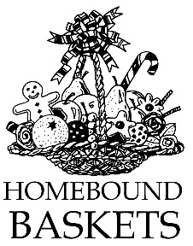  *REACH Holiday Service Projects*

*Christmas Fruit Baskets for our Homebound Parish Members*

Help is needed to assemble fruit baskets on Monday, November 27th at 6:00 p.m. in the Parish Hall. These fruit baskets will be delivered to the homebound members of our parish by Fr. Brian during his home visits.

Come help spread some holiday cheer and well wishes to our parish shut-ins by being part of this endeavor.

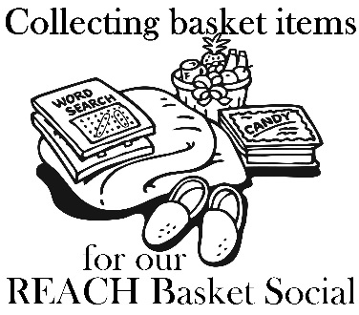

*It’s time to make the baskets!* ~ Our REACH Youth Ministry will sponsor their annual REACH Basket Social on

Sunday, December 3rd!

We are in need of any new or unused items you may have for use in assembling extra baskets for the event. This also includes empty basket or containers you may have too! Parishioners can also help by assembling a basket alone, or several people together can combine resources for a completed basket. Any help with this is greatly appreciated! Any donated items or baskets can be left in the Bride’s Room of the church or dropped off at the Rectory or Religious Education Offices.

This basket social fundraiser helps pay for numerous activities that REACH funds cover such as the cost of our confirmation retreat expenses, the cost to attend SHYCON and Junior High Youth Day, , food provided at various service projects, our 8th Grade Cookie Bake and Homebound Fruit Baskets, K—5 Easter treats, Mother's Day and Father's Day Gifts, and the list goes on. Any help given will be greatly appreciated and put to good use.

*We are asking our Religious Ed families to help with the Project:*

*Each Religious Education class, Grades K—12 are asked to sponsor a basket to be chanced off at this social as a classroom service project. Each Religious Education class, Grades K—12 are sponsoring a basket to be chanced off at this social as a classroom service project. *If you are still able to make a donation, please have them in by Thursday, November 30th. Our Prep Day is December 2nd. (There is no RE Class scheduled for Thursday November 23rd or Sunday, November 26th)!*

*When sending your donations, please be sure to mark the envelope or bag “Basket Social” and also include your “Child's Name” and “Grade” to ensure that the correct grade receives them.* Donation envelopes can be dropped in the weekend collection basket at Masses or bagged items can be placed in the Bridal Room or brought to the Religious Education Office or Rectory Office.

On Sunday December 3rd, tickets will be available at the door for $5.00 each which includes 25 perforated basket chances and 1 door prize chance. Multiple tickets may be purchased. *Doors will open at 1:00 p.m. with 'chancing off' beginning at 2:00 p.m.* Come early to purchase your tickets and have ample time to view all baskets available and place your chances before the drawing begins.

*Attention—Parents of REACH Students:* We are asking each REACH student from grades 6—12 to donate the following items to help with our Basket Social fundraiser. Non-perishable items (Soda, Candy, and Snacks) can be dropped off anytime over the next two weeks. Cakes, Desserts and Ice Tea can be brought to the church hall by Noon on Sunday, December 3.

Grades 7 & 11 Bag of chocolate candy (Asst. minis, snack size or kisses)

Grades 6 & 8 Cake / Dessert

Grade 12 Two 2-liters of soda

Grade 9 Bags of snacks (potato chips or pretzels)

Grade 10 One Gallon of Ice Tea

Sunday, November 19 Religious Education / Grades 6-12 / 9:00 AM-10:20 AM

8th Grade Cookie Bake

Grade 10 Fall Session / 9:00 AM-10:30 AM

Monday, November 20 Mass / 8:00 AM

Sunday Choir Practice / 7:00 PM

Tuesday, November 21 Mass / 8:00 AM

Combined Christmas Choir / 7:00 PM

Wednesday, November 22 No Mass

[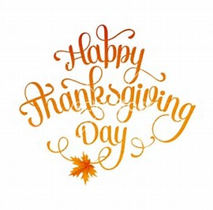](https://www.bing.com/images/search?view=detailV2&ccid=owNsbP9M&id=C0B34F054DD7B5EAE5B8E5E89C80B0CC94BCDC52&thid=OIP.owNsbP9MCT6VygIV8NdgEgEdEs&q=+Thanksgiving+Day&simid=608018086513739465&selectedIndex=106)

Thursday, November 23 Mass / 9:00 AM

NO K – 5 Religious Education Classes

NO Saturday Night Choir Practice

Happy Thanksgiving Day!

Office Closed

Friday, November 24 No Mass

Office Closed

Saturday November 25 Hall Rental

UPCOMING EVENTS

November 27 Making of Christmas Fruit Baskets for the Homebound

December 1 First Friday / Exposition of the Blessed Sacrament

December 3 REACH Basket Party

December 9 & 10 Retirement Fund for Religious Second Collection

2nd Sunday Food Pantry Collection

December 10 11th grade Fall Session

Holy Name Society Meeting

Hall Rental

POLKA DANCE ~ There will be a Polka Dance at the St. Michael Legion on Sunday, October 19th from 2-5:00 PM. Music provided by Bronco and the Rhinelanders. Everyone Welcome!

THANKSGIVING TABLE PRAYER

O Gracious God, we give you thanks for your overflowing generosity to us. Thank you for the blessings of the food we eat and especially for this feast today. Thank you for our home and family and friends, especially for the presence of those gathered here. Thank you for our health, our work and our play. Please send help to those who are hungry, alone, sick and suffering war and violence. Open our hearts to your love. We ask your blessing through Christ your son. Amen.

