John 6:54

ST. MICHAEL ROMAN CATHOLIC CHURCH

PO Box 103

St. Michael, Pennsylvania 15951

Rev. Brian L. Warchola, Administrator MASSES:

(814) 495-9640 Saturday 4:00 pm



Sunday Morning 8:00 am

Secretary: Michele Panick 10:30 am

Bookkeeper: Kathy Kalicky Daily Mass See Bulletin

DRE: Laurie Sloan Holy Days See Bulletin

Maintenance: Rodney Turgeon

Office Hours:

PHONES: 8:30 am to 3:30 pm

Rectory / Office: (814) 495-9640 Monday, Tues., Thurs., Friday

Fax: (814) 495-9424 Confessions:

Rel. Education: (814) 495-4873 Saturday 3:30 pm to 3:45 pm

Parish Website Sunday 7:30 am to 7:45 am

www.saintmichaelchurch.weebly.com 10:00 am to 10:15 am

Secretaries’ E-mail Anytime Requested

[saintmichaelsecretaries@yahoo.com](mailto:saintmichaelsecretaries@yahoo.com)

YEAR: 2018 NUMBER: 46

SERVING GOD AND COMMUNITY FOR OVER ONE HUNDRED YEARS!

BAPTISM: By Appointment. Reserve at least one month in advance.

Preparation classes are necessary.

MARRIAGE: Plan at least nine months in advance.

Preparation sessions are necessary.

FUNERALS: Arrangements are made in conjunction with the funeral home.

REGISTRATION Those new to the area, newlyweds, and single adults, (even if registered

and before with their families) are asked to register by calling the Parish Office.

MEMBERSHIP: Every parishioner must be registered. This is a condition for admission

to our Program and reception of the Sacraments of Baptism, Confirmation, First Penance, First Eucharist, and Matrimony; also, for testimonial letters or sponsorship of Baptism and Confirmation outside the Parish.

VISITATION: We are concerned and want to be advised when someone is ill at

home or in the hospital. Call the rectory to have the shut-in placed on our monthly Holy Communion calls or seriously ill prayer list.

SACRAMENTAL Parish registration and active Mass participation for Baptism is

POLICY: encouraged and is required for Marriage.

BULLETIN ARTICLES: Articles are due to the Parish Office by Noon on Tuesdays.

Thirty–Third Sunday in Ordinary Time

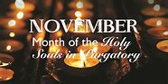 November 18, 2018

**Month of The Holy Souls in Purgatory**

**MASS INTENTIONS**: (November 19 – November 25, 2018)

Monday 8:00 AM Lois Jean Papcunik req. by Steve, Tom & Joe McAneny

Tuesday 8:00 AM Michael Hudak req. by Lenny Fornadel & Karen Neff

Wednesday NO MASS

Thursday 8:00 AM Stephen Yanzetich Sr. & Michael Bidelman req. by Susan Yanzetich

Friday 8:00 AM NO MASS

Saturday 4:00 PM People of the Parish

Sunday 8:00 AM Jane Plummer req. by Terri & Gus Leach

Sunday 10:30 AM William Wilson req. by Mary Ann Murin

LITURGICIAL APPOINTMENTS:

Saturday, November 24 4:00 PM Offertory Procession

Lector: Sherry Dipko Joe & Phyllis Slonac

Minister of the Host: Helen Slonac

Ministers of the Cup: Theresa Carlson & Susan Blazosky

Altar Servers: Caden & Kaylee Roberts

Cantor: Amanda Williamson

Greeter: Darlene Marshall

Sunday, November 25 8:00 AM Offertory Procession

Lector: Arnold Bernard Jane Plummer Family

Minister of the Host: Pauline Minor

Ministers of the Cup: Ellen Grattan & Sally Kolar

Altar Servers: Griffen & Kaden Christ

Cantor: Susan Yanzetich

Greeter: Carol Hautz

Sunday, November 2510:30 AM Offertory Procession

Lector: Jacob Stiffler Ron & Amy Dobbins Family

Minister of the Host: Jennifer Steele

[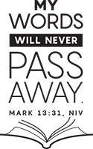](https://www.churchart.com/subscriber/viewimages?book_number=41&chapter=13&entry_date=1/1/0001&image_type=cl,ph,pp,bc,ca,mv,wt,nt,pt,ft,ch&page=1&ipp=12)Ministers of the Cup: Michael Steele & Robert Oshaben

Altar Servers: Haidyn & Amilyah Koch

Cantor: Louis McCloskey

Greeter: Wendy Blough

Sunday, November 25 Collection Counters

Robert Casti, Sharon Paterson

Debbie Dupnock

Weare placing names of the sick in the bulletin for prayer providing they give permission. *May the* *Divine Physician send healing grace for those for* *whom we pray:* Allen C. Rosemas, Patricia Murphy, Bernice Myers, Dwight Fyock, Lori Facciani, Dylon Wills, Debbie Dibert, Missy, Joanne (Kolar) Hufford, Christine Flanagan, Ayden Alan Grata, Mary Lou Offman, Mary Zangaglia, Dorothy Rosemas, Natalie Zerby, Patricia Grata, Michael Wadsworth, Valencia & Frank Tursi, Homer Locher, Brayden Schofield, Michelle Kasper, Diane Kingera, Allison Krischer, Ted Paluch, Brandt Hutzel, Pearl Litzinger, Patrick Munro, Fran Baldassarre, Corey Lybarger, Kristen Sinosky Long, Helen Ranieri, Cresta Micik, Basil Costantino, Madison McCrory, Laura, Joe Yoder, Dolores Yanzetich, Sandy Krug, Wanda Gramling, Merna Smay, Muriel “Jean” Wiesheier, Agnes Plummer, Jennifer Hagans, Shawn, Holly, Shane, Spencer, Owen Taylor, Keith & Dawnetta Hoyer, Derrick Varnish, Daniel Koshute, Vincent Koshute, Karen Lovrich, Melissa Cordek, Michelle Elliott, Heather Romanow, Mackston Barrick, Connor Thomas, Erin, Pat, Mary Agnes Nastase, Mary Ann Bertolino, Dick Wilson, Izzy Bihun, Erica Mitzelfeld, Dorothy Kaminsky, Ed Ripper Sr., Patricia Oshaben, Ashlee Madison, Susan Yanzetich, Mike, Mary Sivec, Danika Faith, Alina Rusnak, Marcia Costlow, Gary Smay, Elizabeth Howell, Mary Ann Cover, Helen Bowen, Bill Gideos, James Macy, Walter Bodziak, Rhonda, Dan Strinkoski, Anne Robinson, Marlene McCrory, Sharon Poldiak, Carter Bobak, Vince Arena, Mike Morris, Sarah Kelt, Marian Madison, Mildred Andrykovitch, Patty Yanzetich Caldwell, Mary Secriskey, Owen Croyle, Colton Snyder and all of the sick of our parish, the homebound, those in nursing homes, those who care for them, and those in the military along with their families. *(Please call the Rectory to have your name removed from the list when no longer seriously ill. Thank You.)*

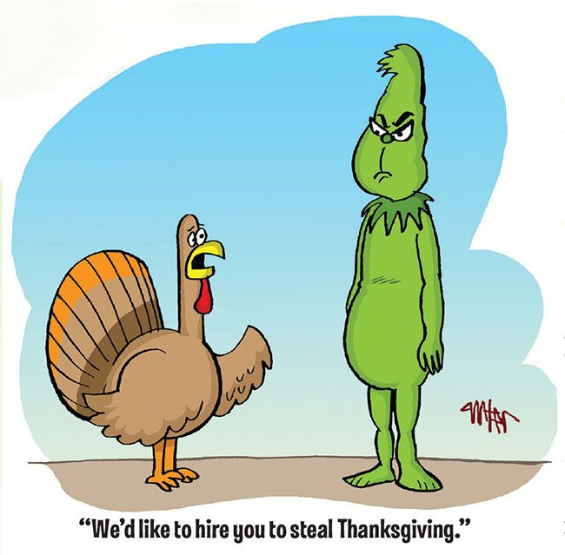

LAST WEEK’S COLLECTION

Adults $3,345.00

Loose $ 260.00

Youth $ 48.25

Monthly $ 205.00

Initial Offering (2019) $ 5.00

Candles $ 34.00

All Saints $ 15.00

All Souls $ 27.00

Christmas $ 50.00

Catholic Charities $ 38.00

Christmas Flowers $ 45.00

Hurricane Relief Fund $ 50.00 Total $4,122.25

We sincerely thank and ask God’s blessing upon all who have care and concern for our parish.

*November 18, 2018 Mk 13:24-32*

*Today’s gospel teaches us UNCERTAINTY is normal. There are some things in life which “no one knows…only the Father.” Marriage and parenting are full of uncertainty for like the fig tree in the gospel, the people we love grow and change.*

PLEASE NOTE! TIME CHANGE! ~ Thanksgiving Day Mass has been changed to 8:00 AM.

THANKSGIVING DAY LITURGY

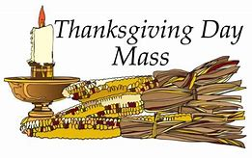 Thursday, November 22 8:00 AM

Lector: Pauline Minor

Minister of the Host: Eric Tedjeske

Ministers of the Cup: Michael Barton & Terri Leach

Altar Servers: Carson & Dylan Kundrod

Cantor: Susan Blazosky

Greeter: Mary Ann Spangler

Offertory Procession: Yanzetich Family

*****************************************************************************************************************

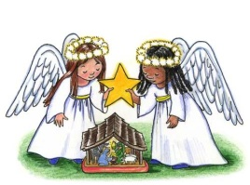

SALVATION ARMY TREASURES FOR CHILDREN PROJECT

*Our parish will again participate in the Salvation Army*

*Treasures for Children Project. We have tags available for both*

*children and senior citizens. The guidelines are as follows:*

* Tags include first name, sex, age, clothing sizes and some gift ideas for a child or senior citizen. The Salvation Army has asked that you consider providing a gift equal to or around $25.00 PLUS an outfit if possible (not mandatory). The Salvation Army will provide each family with a voucher for a local grocery store for their Christmas meal.
* The tags are displayed along the walls of the church. After you’ve chosen a tag, please write your name and phone number on the copy and leave ONLY the copy on a window sill.
* Return your UNWRAPPED gift(s) with the tag attached to the St. Michael Catholic Church

St. Paul Room by December 2nd so that we can check them off and deliver them to the

Salvation Army in time for distribution to the families.

* If you wish, you could provide an “extra” gift of your choice to be used for those tags that are not chosen at all. Gifts and larger clothing for pre-teens ages 11-13 are particularly hard to fill.

The tags will be displayed along the walls of the Church and will be available on

Thanksgiving (November 22nd).

*Stewardship Reflections…*

May we be vigilant at all times by cherishing God’s gifts in a responsible and accountable manner. May we always serve with the fullness of our calling to be good stewards.



Catholic Ministries Drive $24,043.00

Raised: $12,180.00

Balance: $11,863.00

Number of responses: 89

Thank you to all parishioners who have responded to the *2018 Catholic Ministries Drive.* Please join them in supporting our Parish and a select group of ministries that provide outreach to the poor, family life, youth and seminarians. If you did not receive a pledge card in the mail, you may give online at [www.dioceseaj.org](http://www.dioceseaj.org).

The Sanctuary Candle will burn in memory of Stephen Faher

requested by Cathy & Joe Faher

during the week of November 18, 2018.

[](https://images.search.yahoo.com/search/images;_ylt=A0LEV1kSWptXvOwAKINXNyoA;_ylu=X3oDMTEyZGdkcmRoBGNvbG8DYmYxBHBvcwMxBHZ0aWQDQjIwODlfMQRzZWMDc2M-?p=Clipart+of+a+sanctuary+candle&fr=ush-mailn_02&th=110&tw=110&imgurl=http://www.henningers.com/389-168-wall-sanctuary-lamp.jpg&rurl=http://pixshark.com/sanctuary-lamp.htm&size=43KB&name=Sanctuary+Lamp+Bronze+wall+sanctuary+lamp&h=600&w=600&turl=http://ts2.mm.bing.net/th?id=OIP.M68453c67108cdc5ab485d309b395bd03o0&pid=15.1&rs=1&c=1&qlt=95&w=110&h=110#inline&tt=Sanctuary+Lamp+Bronze+wall+sanctuary+lamp&sigr=116keh5le&sigit=13gvlt42j&sigi=11ip0pgm4&sign=119kp6100&sigt=119kp6100)

SECOND COLLECTION FOR CATHOLIC CHARITIES ~ Catholic Charities has helped our neighbors throughout Central PA regardless of faith or background. 100% of contributions received through this weekend’s second collection (November 17 & 18) will directly help your neighbors in need. Please return your Catholic Charities envelope or make your gift online at [www.catholiccharitiesaj.org](http://www.catholiccharitiesaj.org). Thank you for helping Catholic Charities of Altoona-Johnstown reduce poverty in communities throughout our diocese.

SECOND SUNDAY FOOD COLLECTION ~ Thanks to all who so generously donated to the Forest Hills Food Pantry. The total money collected was $622.00 along with an assortment of grocery items.

THANKSGIVING DAY MASS ~ Thanksgiving Day Mass will be at 8:00 AM.

NO MASS ~ There will be NO morning Mass on Friday, November 23rd.

ADVENT CONFESSIONS ~ Advent Confessions will be here at St. Michael Monday, December 10th at 6:00 PM. Other priests will be present to assist Fr. Brian. Mark your calendars now. We will combine with Most Holy Trinity, South Fork.

COMBINED CHRISTMAS CHOIR ~ Combined Choirs for Christmas will rehearse Wed. Nov. 28th at 7 PM. Thanksgiving week – TBA. Please remember your folders. New members are always welcome to join.

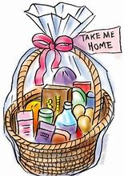

TIME TO MAKE THE BASKETS! ~ Our annual REACH Basket Social will be held on Sunday, December 2nd. Parishioners can help by assembling a basket alone, or several people together can combine resources for a completed basket. Each basket should be worth $25 to $30. We are in need of any new or unused items you may have for use in assembling extra baskets for the event. This also includes empty basket or containers you may have too! Your help with this is greatly appreciated! Any donated items can be left in the Bride’s Room of the church or dropped off at the Rectory or Religious Education Office during regular office hours.

ADVENT “LITTLE BLUE BOOK” ~ December 2nd is the beginning of the Advent Season. The parish is providing the Little Blue Book free of charge to all parishioners. This booklet will be available at the side exit and on a table at the back of the Church this weekend.

OFFICES CLOSED ~ The Parish Offices will be closed on Thursday, November 22nd and Friday, November 23rd for the Thanksgiving Holiday.

CHRISTMAS NUT ROLLS ~ Most Holy Trinity, South Fork, is taking orders for their Christmas Nut Roll Sale-$9.00 each. Orders (along with your phone number) must be placed by Friday, November 30th. Nut Rolls can be picked up on Friday, December 7th at Most Holy Trinity Church Hall from 9:00 AM – Noon at 550 Main St., South Fork, PA. A sign-up sheet is on the table in the back of the Church.

Religious Education And Christian Helping

November 18, 2018



*8th Grade Cookie Bake ~* This Sunday, November 18th, our 8th grade class will be participating in a "Cookie Bake" for their class service project, starting during their morning class time and extending through lunch with a pizza party. They will be baking and decorating cookies that will be included in the fruit baskets taken to our homebound parish members.

**********************************************************************************

Fall Confirmation Sessions

*Grade 10 ~ Session 10A ~ Scripture: Reflecting on and Living the Word*

*Sunday, November 18, 2018*~ All 10th Grade students will attend their Fall Session 10A from

9 to 10:30 a.m. in their class room to fulfill this session requirement.*

*Grade 11 ~ Session 11B ~ Sacraments and the Paschal Mystery*

*Sunday, December 19, 2018* ~ All 11th Grade students All will attend their Fall Session 11B from 9 to 10:30 a.m. in the Saint Paul Room to fulfill this session requirement.*

*\* If the students miss this scheduled session, they are required to attend another*

*parishes scheduled session to fulfill these requirements.*

**********************************************************************************

Eucharistic Adoration Day with Bishop Mark Bartchak

MC900436063[1]

High school students in grades 9—12 are invited to attend a Eucharistic Adoration with Bishop Mark Bartchak. This will be hosted by SS Gregory & Barnabus Parish, Johnstown on Saturday, December 1, 2018. The day will begin at 10:00 AM in the church with Praise and Worship Music and Eucharistic Adoration celebrated by Bishop Mark with an opportunity for reconciliation.

A social gathering will be held afterwards for fellowship with Bishop Mark.

*Teens must pre-register with the Diocese Office by November 23rd.*

*Registration forms are available in our RE Office.*

*As part of the new Diocesan Confirmation Revisions, all students in the 3-year confirmation preparation process, (Grades 9, 10 and 11), are required to attend a Eucharistic Adoration Day with*

*Bishop Mark Bartchak at least 1 time within their 3-year process.*

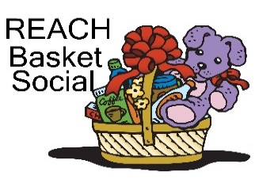

REACH Basket Social ~ Our REACH Youth Ministry will sponsor their annual REACH Basket Social on Sunday, December 2nd this year!

This basket social fundraiser helps pay for numerous activities like food provided at various service projects, Cookie Bake and Homebound Fruit Baskets, K—5 Easter treats, Mother's Day and Father's Day Gifts. REACH funds also cover the cost of our confirmation retreat expenses along with SHYCON and Junior High Youth Day to help assure students can attend.

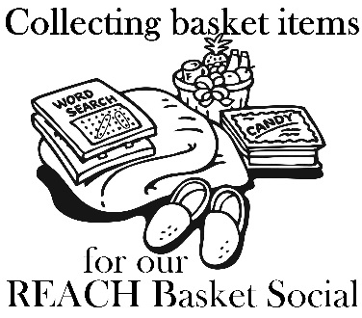

Saint Michael Parishioners can help too! We are in need of any new or unused items you may have for use in assembling extra baskets for the event. This also includes empty basket or containers you may have too! You can also help by assembling a basket alone, or several people together can combine resources for a completed basket. Any help with this is greatly appreciated! Any donated items or baskets can be left in the Bride’s Room of the church or dropped off at the Parish or Religious Education Offices.

*We are asking our Religious Education families to help with the Project:*

*Each Religious Education class, Grades K—12 are asked to sponsor a basket to be chanced off at this social as a classroom service project. Over these next few weeks, students in each grade will pick a theme for their basket. Each class will also decide if they are collecting money or purchased items. We ask that each student then bring their donation in by the beginning of November so that each class has ample time for their class to assemble their class basket by Thursday, November 15th and Sunday, November 18th in time for the social.*

*(There is no RE Class scheduled for Thursday, November 22nd or Sunday, November 25th)!*

*When sending your donations, please be sure to mark the envelope or bag “Basket Social” and also include your “Child's Name” and “Grade” to ensure that the correct grade receives them.* Donation envelopes can be dropped in the weekend collection basket at Masses or bagged items can be placed in the Bridal Room or brought to the Religious Education Office or Rectory Office.

On Sunday December 2nd, tickets will be available at the door for $5.00 each which includes 25 perforated basket chances and 1 door prize chance. Multiple tickets may be purchased. *Doors will open at 1:00 p.m. with 'chancing off' beginning at 2:00 p.m.* Come early to purchase your tickets and have ample time to view all baskets available and place your chances before the drawing begins.

*Attention—Parents of REACH Students:* We are asking each REACH student from grades 6—12 to donate the following items to help with our Basket Social fundraiser. Non-perishable items (Soda, Candy, and Snacks) can be dropped off anytime over the next two weeks. Cakes, Desserts and Ice Tea can be brought to the church hall by Noon on Sunday, December 2.

Grades 7 & 10 Bag of chocolate candy (Asst. minis, snack size or kisses)

Grades 6 & 8 Cake / Dessert

Grade 11 Two 2-liters of soda

Grade 9 Bags of snacks (potato chips or pretzels)

Grade 12 One Gallon of Ice Tea

Sunday, November 18 High School Religious Education / 9 – 10:20 AM

 10th Grade Fall Confirmation Session / 9 – 10:30 AM

Catholic Charities / Second Collection

8th Grade Cookie Bake

Girl Scouts

Monday, November 19 Sunday Choir Practice / 7:00 PM

Tuesday, November 20

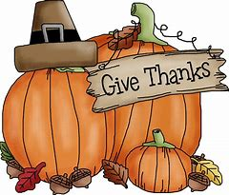 Wednesday, November 21 NO MASS

Thursday, November 22 Thanksgiving Day Mass / 8:00 AM

Parish Offices Closed

Friday, November 23 NO MASS

Parish Offices Closed

Saturday, November 24

UPCOMING EVENTS

November 30 Hall Usage / Girl Scouts

December 1 Eucharistic Adoration with Bishop Mark / SS Gregory & Barnabus Parish

December 2 REACH Basket Social

Girl Scout Meeting

December 7 Exposition of Blessed Sacrament with Adoration

December 8 Immaculate Conception / Holy Day of Obligation

December 8 & 9 Religious Retirement / Second Collection

Second Sunday Food Collection

December 9 Holy Name Meeting & Coffee & Donuts

Baptism



POLKA DANCE ~ There will be a Polka Dance at the St. Michael American Legion on Sunday, November 18th from 2:00 – 5:00 PM. Music will be provided by Bronco and the Rhinelanders. Everyone is welcome to attend!

THANKSGIVING TABLE PRAYER

O Gracious God, we give you thanks for your overflowing generosity to us. Thank you for the blessings of the food we eat and especially for this feast today. Thank you for our home and family and friends, especially for the presence of those gathered here. Thank you for our health, our work and our play. Please send help to those who are hungry, alone, sick and suffering war and violence. Open our hearts to your love. We ask your blessing through Christ your son. Amen.

