ST. MICHAEL ROMAN CATHOLIC CHURCH

751 Locust Street

PO Box 103

St. Michael, Pennsylvania 15951

Rev. Msgr. David A. Lockard, Administrator MASSES:

(814) 495-9640 Saturday 4:00 pm



Sunday Morning 8:00 am

Secretary: Michele Panick 10:30 am

Bookkeeper: Kathy Kalicky Daily Mass: M,T,W,Th,F Noon

DRE: Laurie Sloan Holy Days: See Bulletin

Maintenance: Rodney Turgeon Office Hours:

PHONES: 8:30 am to 3:30 pm

Rectory / Office: (814) 495-9640 Monday, Tues., Thurs., Friday

Fax: (814) 495-9424 Confessions:

Rel. Education: (814) 495-4873 Saturday 3:30 pm to 3:45 pm

Parish Website Sunday 10:00 am to 10:15 am

[www.saintmichaelchurch.weebly.co](http://www.saintmichaelchurch.weebly.co)m By Appointment

Secretaries’ E-mail

[saintmichaelsecretaries@yahoo.com](mailto:saintmichaelsecretaries@yahoo.com)

Facebook page:

St. Michael Catholic Church/St. Michael, PA

33rd Sunday in Ordinary Time

SERVING GOD AND COMMUNITY FOR OVER ONE HUNDRED YEARS!

November 15th, 2020

BAPTISM: By Appointment. Reserve at least one month in advance.

MARRIAGE: Plan at least nine months in advance.

Preparation sessions are necessary.

FUNERALS: Arrangements are made in conjunction with the funeral home.

REGISTRATION Those new to the area, newlyweds, and single adults, (even if registered

and before with their families) are asked to register by calling the Parish Office.

MEMBERSHIP: Every parishioner must be registered. This is a condition for admission

to our Program and reception of the Sacraments of Baptism, Confirmation,

First Penance, First Eucharist, and Matrimony; also, for testimonial letters or sponsorship of Baptism and Confirmation outside the Parish.

VISITATION: We are concerned and want to be advised when someone is ill at home or in the hospital. Call the office to have the shut-in placed on our monthly Holy Communion calls or seriously ill prayer list.

SACRAMENTAL Parish registration and active Mass participation for Baptism is

POLICY: encouraged and is required for Marriage.

BULLETIN ARTICLES: Articles are due to the Parish Office by Noon on Tuesday.

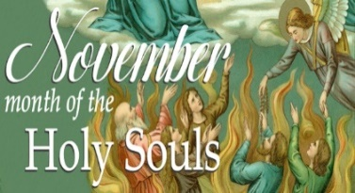

Thirty-Third Sunday in Ordinary Time

November 15th, 2020

The Holy Souls of Purgatory

**MASS INTENTIONS**: (November 16 – November 22, 2020 )

Monday Noon Judy Jarvie req. by Debbie & Frank Dupnock (from 11-9-20)

Tuesday Noon Joseph Ropecka req. by Judith Rigel (from 11-10-20)

Wednesday Noon Janet Smith req. by Nancy & John (from 11-12-20)

Thursday Noon Theressa Stravinsky by the Blazosky Family (from 11-13-20)

Friday Noon Philip Hillegas (B-day remembrance) req. by Reba Vasas

Saturday 4:00 PM Ann Marie Swelfer req. by daughter, Diane Weis & Family

Sunday 8:00 AM Barb Malchesky req. by Chuck & Mary Ann Tedjeske

10:30 AM People of the Parish

LITURGICIAL APPOINTMENTS:

Saturday, November 21 4:00 PM

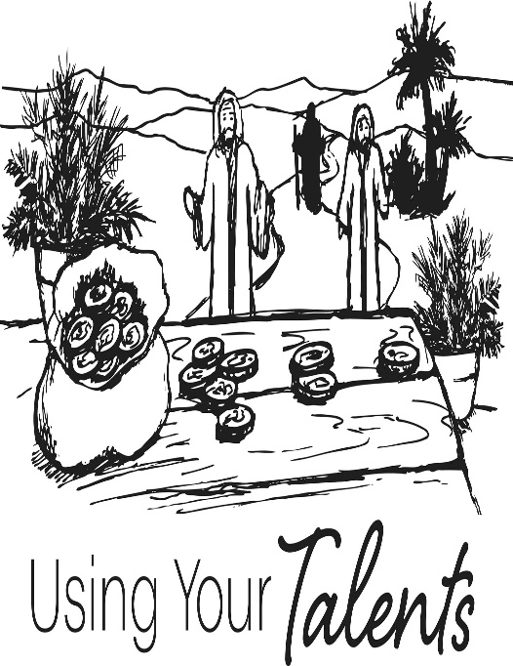

Lector: Sherry Dipko

Minister of the Host: Alice Podrebarac

Altar Server: Ana Spangler

Cantor: Amy Spangler

Sunday, November 22 8:00 AM

Lector: Cathy Faher

Minister of the Host: Terri Leach

Altar Server: Michael Kresic

Cantor: Susan Yanzetich

Sunday, November 22 10:30 AM

Lector: Tony Bambino

Minister of the Host: Amanda Williamson

Altar Server: Kirstyn Vitez

Cantor: Amy Dobbins

Weare placing names of the sick in the bulletin for prayer providing they give permission. *May the* *Divine Physician send healing grace for those for* *whom we pray:* Allen C. Rosemas, Patricia Murphy, Bernice Myers, Dwight Fyock, Dylon Wills, Missy, Joanne (Kolar) Hufford, Christine Flanagan, Ayden Alan Grata, Mary Lou Offman, Mary Zangaglia, Natalie Zerby, Valencia Tursi, Homer Locher, Brayden Schofield, Michelle Kasper, Diane Kingera, Allison Krischer, Ted Paluch, Brandt Hutzel, Pearl Litzinger, Patrick Munro, Fran Baldassarre, Kristen Sinosky Long, Cresta Micik, Basil Costantino, Madison McCrory, Laura, Joe Yoder, Dolores Yanzetich, Sandy Krug, Wanda Gramling, Jennifer Hagans, Shawn, Holly, Shane, Spencer, Owen Taylor, Keith & Dawnetta Hoyer, Derrick Varnish, Vincent Koshute, Melissa Cordek, Michelle Elliott, Heather Romanow, Mackston Barrick, Connor Thomas, Erin, Pat, Mary Agnes Nastase, Mary Ann Bertolino, Dick Wilson, Izzy Bihun, Dorothy Kaminsky, Patricia Oshaben, Ashlee Madison, Susan Yanzetich, Mike, Danika Faith, Alina Rusnak, Gary Smay, Elizabeth Howell, Walter Bodziak, Rhonda, Dan Strinkoski, Anne Robinson, Marlene McCrory, Sharon Poldiak, Carter Bobak, Vince Arena, Mike Morris, Sarah Kelt, Patty Yanzetich Caldwell, Colton Snyder, Betty Delaney, Nancy Edmiston, Leonard Oshaben, Adam, Bill Gideos, Janice Dipyatic, Gerald Delaney, Lily Maloney, Scott, Lisa, Rosalie Ambrose, Audrey Costlow, Cathy Sossong, Rosanne Krug, Becky Kakabar, Catherine Tedjeske, Howard Delaney, Alivia Ickes, John Poldiak Jr., Ed Myers, Dolores Mucko, Tom Vandzura, Elliana, Ashlee, Helen Soohy, Carol K. Fabrizio, Peggy Carpenter, David Poldiak, Mary Kiel, Sarah Vance, Sharon Vance and all of the sick of our parish, the homebound, those in nursing homes, those who care for them, and those in the military along with their families. *(Please call the Rectory to have your name removed from the list when no longer seriously ill. Thank You.)*

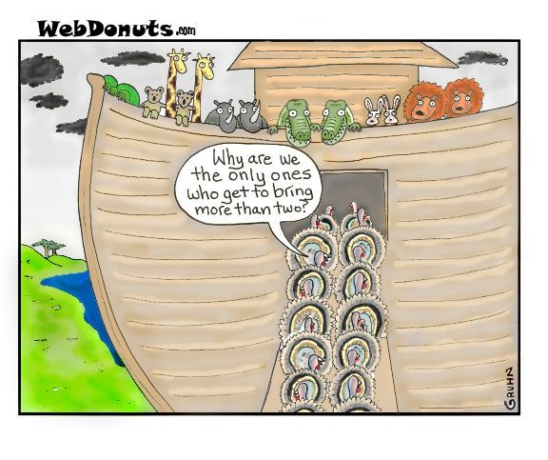

LAST WEEK’S COLLECTION

Adults $3,614.00

Loose $ 157.00

Youth $ 15.00

Monthly $ 940.00

Initial Offering $ 5.00

Candles $ 21.00

Maintenance Fund $ 115.00

Solemnity of Mary $ 5.00

All Saints $ 115.00

All Souls $ 130.00

Immaculate Conception $ 5.00

Christmas $ 20.00

Christmas Flowers $ 110.00

Catholic Charities $ 73.00

Religious Education Fund $ 10.00

Religious Retirement Fund $ 5.00

Retired Priests Med. Exp. $ 30.00

World Mission Sunday $ 20.00

Total $5,390.00

We sincerely thank and ask God’s

blessing upon all who have care

and concern for our parish.

*Stewardship Reflections…*

Good stewards dislike generic appeals and will give generously of themselves and their means to their parish. Good stewards are eager to hear the stories, the modern-day parables of lives changed, enriched, made better and more human because of their intentional generosity.

During the week of November 15th, 2020

The Sanctuary Candle will burn as a

birthday remembrance for

Andrew Pcola

requested by Loving Family

and

The Our Lady of Grace Candle will burn

in memory of

Anthony J. Rizzo

requested by Paul & Cindy McCloskey

[](https://images.search.yahoo.com/search/images;_ylt=A0LEV1kSWptXvOwAKINXNyoA;_ylu=X3oDMTEyZGdkcmRoBGNvbG8DYmYxBHBvcwMxBHZ0aWQDQjIwODlfMQRzZWMDc2M-?p=Clipart+of+a+sanctuary+candle&fr=ush-mailn_02&th=110&tw=110&imgurl=http://www.henningers.com/389-168-wall-sanctuary-lamp.jpg&rurl=http://pixshark.com/sanctuary-lamp.htm&size=43KB&name=Sanctuary+Lamp+Bronze+wall+sanctuary+lamp&h=600&w=600&turl=http://ts2.mm.bing.net/th?id%3DOIP.M68453c67108cdc5ab485d309b395bd03o0%26pid%3D15.1%26rs%3D1%26c%3D1%26qlt%3D95%26w%3D110%26h%3D110#inline&tt=Sanctuary+Lamp+Bronze+wall+sanctuary+lamp&sigr=116keh5le&sigit=13gvlt42j&sigi=11ip0pgm4&sign=119kp6100&sigt=119kp6100)

*COVID* at St. Michael…

Last week I was placed in quarantine because I came in close contact with people who had tested positive for the Corona Virus. For that reason, we had no daily Masses this past week. I am awaiting the results of my COVID Test as I write this. There will be a visiting priest from St. Vincent’s this weekend (Nov. 14/15) for the Masses. Hopefully, I will test negative and be allowed to resume celebrating Mass thereafter. Please pray for all COVID patients and those treating them.

*Msgr. Lockard*

DAILY MASS ~ The Mass time on Wednesday has been moved from 6:00 PM to Twelve Noon. This will make it easier to see this time of year when darkness comes earlier.

LECTOR WORKBOOKS ~ The new Lector Workbooks are available. Please come to the parish office during office hours to pick up your book. The readings start with the First Sunday of Advent – Nov. 29th.

SECOND SUNDAY FOOD COLLECTION ~ Thank you to all who so generously donated to the Forest Hills Food Pantry. The total money collected was $622.00 and an assortment of non-perishable items.

PARISH COUNCIL ~ There will be a Parish Council Meeting next Sunday, November 22nd in the Church Hall following the 10:30 AM Mass.

CATHOLIC CHARITIES ~ There will be a second collection basket next weekend for the Catholic Charities Collection. Your support is appreciated and makes a difference year-round to help struggling individuals and families: stay in their homes, keep their heat & utilities running, afford basic necessities. Use the envelope provided in your packet, give online at [www.catholiccharitiesaj.org](http://www.catholiccharitiesaj.org) or mail to Catholic Charities, 1300 Twelfth Ave, Altoona, PA 16601. Thank you for your generosity.



SALVATION ARMY TREASURES FOR CHILDREN PROJECT ~ We will again participate in the Salvation Army Treasures for Children Project. Tags will be displayed along the walls of the Church. More details and information to follow.



Religious Education And Christian Helping

November 15, 2020

Religious Education News

Home Lesson Packets ~ Lesson Packet #3 will be ready for distribution for Grades K—5 on Thursday, November 19th and for Grades 6—11 on Sunday, November 22nd.

Distribution of CCD Lesson Packet #2 has taken place for all students in Grades K—11. If you were unable to be present to either of these pick-up times, contact the RE Office at 495-4873 or the Parish Office at 495-9640 to make arrangements for another time to pick up new lessons and to drop off the completed lessons.

Parables Retreat ~ Our Saint Michael Confirmation students are scheduled for their Virtual Parables Retreat starting on Sunday, December 13th with Sr. Suzanne Thibault at The Bethany Youth Retreat Center via e-mail and Zoom sessions.  Our parish is registered as a whole, and now our students need to register individually with Sr. Suzanne. An email with the registration form has been sent out to all parents who have students scheduled for this retreat. Registration forms need to be returned directly to Sr. Suzanne A.S.A.P. for students to be included.

VIRTUS AWARENESS ARTICLE FOR NOVEMBER ~ Each month there will be an educational article provided by VIRTUS covering topics of interest to create awareness on trending topics. This month’s featured article is ‘*The Intersection of Caring Adults and Reporting Abuse’*  by Crispin Ketelhut Montelione. A copy of this article can be found at the entrances of the Church and in the green tote box by the Parish Office door.

FREE INTRODUCTORY NATURAL FAMILY PLANNING SESSION ~ An introductory session to the Creighton Model of Natural Family Planning will be held at Good Shepherd Catholic Church in State College on November 21 at 10:00 AM. The session will take place in the upper level of the parish hall. The Creighton Model is the foundation of NaPro Technology, a new women’s health science that works cooperatively with the natural cycle and can be used to diagnose and treat a variety of women’s health problems including infertility and miscarriage by a trained physician or mid-level provider. The Introductory session is free of charge, and at the end of the session opportunities will be given to buy materials and schedule individual follow ups. To confirm attendance and for more information please contact Caroline Gindhart at 814-404-5574 or [cgindhart23@gmail.com](mailto:cgindhart23@gmail.com). If you are unable to attend in person, a virtual introductory session can also be scheduled individually.

Sunday, November 15 Mass ~ 8:00 & 10:30 AM

Confessions / 10:00 – 10:15 AM / St. Paul Room

Girl Scouts / 1 - 2:30 PM

Monday, November 16 Mass ~ Noon

NO Sunday Choir Practice

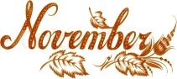

Tuesday, November 17 Mass ~ Noon

Boy Scout Meeting / 7:30 – 9:00 PM

Wednesday, November 18 Mass ~ Noon

Thursday, November 19 Mass ~ Noon

NO Saturday Choir Practice

Friday, November 20 Mass ~ Noon

Saturday, November 21 Mass / 4:00 PM

Confessions / 3:30 – 3:45 / St. Paul Room

Catholic Charities Collection

 UPCOMING EVENTS

November 22 Catholic Charities Collection

Parish Council Meeting

November 26 Thanksgiving

November 26 & 27 Parish Offices Closed

December 4 Exposition of the Blessed Sacrament with Adoration

GRATEFUL GIVING BASKET RAFFLE ~ Our Lady of Loretto Community Hall, Loretto, on Saturday, November 14th: 4-7 PM; Sunday, November 15th: 8 AM-Noon. All winners will be contacted November 15th at noon. For additional information: Amber Mitchell: 814-932-8540.

FRIAR’S NOOK GIFT SHOP ~ Kick off your Christmas shopping by stopping at The Friar’s Nook Gift Shop! Normal business hours will resume Monday, November 2nd and hours will be Monday-Saturday 10AM-4 PM (always closed on Sundays). The address is 793 Monastery Road, Hollidaysburg and our phone number is 814-695-3802 if you have any questions. Please follow us on Facebook for updates!

