ST. MICHAEL ROMAN CATHOLIC CHURCH

PO Box 103

St. Michael, Pennsylvania 15951

Rev. Brian L. Warchola, Administrator MASSES:



(814) 495-9640 Saturday 4:00 pm

Sunday Morning 8:00 am

Secretary: Michele Panick 10:30 am

Bookkeeper: Kathy Kalicky Daily Mass See Bulletin

DRE: Laurie Sloan Holy Days See Bulletin

Maintenance: Rodney Turgeon

Office Hours:

PHONES: 8:30 am to 3:30 pm

Rectory / Office: (814) 495-9640 Monday, Tues., Thurs., Friday

Fax: (814) 495-9424 Confessions:

Rel. Education: (814) 495-4873 Saturday 3:30 pm to 3:45 pm

Parish Website Sunday 7:30 am to 7:45 am

www.saintmichaelchurch.weebly.com 10:00 am to 10:15 am

Secretaries’ E-mail Anytime Requested

[saintmichaelsecretaries@yahoo.com](mailto:saintmichaelsecretaries@yahoo.com)

YEAR: 2017 NUMBER: 46

SERVING GOD AND COMMUNITY FOR OVER ONE HUNDRED YEARS!

BAPTISM: By Appointment. Reserve at least one month in advance.

Preparation classes are necessary.

MARRIAGE: Plan at least nine months in advance.

Preparation sessions are necessary.

FUNERALS: Arrangements are made in conjunction with the funeral home.

Eulogies should be given at the funeral home at the time of the wake service or at the luncheon.

REGISTRATION Those new to the area, newlyweds, and single adults, (even if registered

and before with their families) are asked to register by calling the Parish Office.

MEMBERSHIP: Every parishioner must be registered. This is a condition for admission

to our Program and reception of the Sacraments of Baptism, Confirmation, First Penance, First Eucharist, and Matrimony; also, for testimonial letters or sponsorship of Baptism and Confirmation outside the Parish.

VISITATION: We are concerned and want to be advised when someone is ill at

home or in the hospital. Call the rectory to have the shut-in placed on our monthly Holy Communion calls or seriously ill prayer list.

SACRAMENTAL Requires parish registration and active Mass participation for Baptism

POLICY: and Marriage.

BULLETIN ARTICLES: Articles are due to the Parish Office by Noon on Mondays.

Thirty-first Sunday in Ordinary Time November 12, 2017

**The Holy Souls in Purgatory**

MASS INTENTIONS: (November 13 – November 19, 2017)

Monday 8:00 AM Albert Bela Demko req. by M/M Camillus Long

Tuesday 8:00 AM Birthday Remembrance for S. Sgt. Andrew Chalan

req. by sister, Pauline & Family

Wednesday 8:00 AM Most Holy Trinity, South Fork & St. Benedict’s, Johnstown

12:05 PM St. Benedict’s, Johnstown

Thursday 8:00 AM Wayne C. Cook req. by M/M Paul Pioli

3:30 PM Sylvia Slusser req. by St. Michael RE teachers

(Children’s Thanksgiving Liturgy)

Friday 8:00 AM Rose Hudak req. by Ann Volcjak

Saturday 4:00 PM Maria Liimatainen req. by John & Susan Poldiak & Family

Sunday 8:00 AM Steve Faher req. by Joe & Cathy Faher

Sunday 10:30 AM People of the Parish

LITURGICIAL APPOINTMENTS:

Saturday, November 18 4:00 PM Offertory Procession

Lector: Susan Poldiak Poldiak Family

Minister of the Host: Karen Myers

Ministers of the Cup: Theresa Carlson & Vince Arena

Altar Servers: Caden Roberts & Carson Kundrod

Cantor: Amanda Williamson

Greeter: Darlene Marshall

Sunday, November 19 8:00 AM Offertory Procession

Lector: Amy Spinos Joe & Cathy Faher

Minister of the Host: Walter Christ

Ministers of the Cup: Robert Grattan & Paul Kundrod

Altar Servers: Andrew Martin & Brian Bernard

Cantor: Anita Lorek

Greeter: Carol Hautz

Sunday, November 1910:30 AM Offertory Procession

Lector: Michael Barton Bob & Regina Blanchetti Minister of the Host: Joan Oshaben

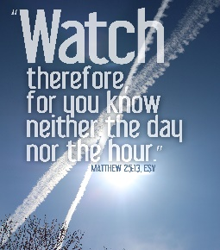Ministers of the Cup: Greg Stiffler & Robert Oshaben Altar Servers: Luke Docherty & Nicholas Caddy

Cantor: Louis McCloskey

Greeter: 7th Grade REACH Students

Sunday, November 19 Collection Counters

Debbie Dupnock, Camillus Long

Mary Ann Davis, Sara Zybura

[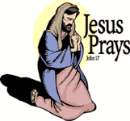](https://www.churchart.com/subscriber/viewimages?book_number=43&chapter=17&verse=1&entry_date=1/1/0001&image_type=cl)[](http://www.churchart.com/Subscriber/ViewImages.aspx?keywords=&entry_date=1/1/0001&image_type=,cl&topic_id=346&image_source_id=&page=1#no)Weare placing names of the sick in the bulletin for prayer providing they give permission. *May the* *Divine Physician send healing grace for those for* *whom we pray:* Allen C. Rosemas, Patricia Murphy, Bernice Myers, Dwight Fyock, Lori Facciani, Dylon Wills, Dawn Hagen, Debbie Dibert, Missy, Joanne (Kolar) Hufford, Christine Flanagan, Ayden Alan Grata, Remy Beaver, Mary Lou Offman, Marian Chuckalovcak, Arlene Diamond, Mary Zangaglia, Dorothy Rosemas, Natalie Zerby, Patricia Grata, Michael Wadsworth, Valencia & Frank Tursi, Homer Locher, Brayden Schofield, Michelle Kasper, Diane Kingera, Allison Krischer, Ted Paluch, Brandt Hutzel, Pearl Litzinger, Patrick Munro, Fran Baldassarre, Corey Lybarger, Kristen Sinosky Long, Helen Ranieri, Cresta Micik, Basil Costantino, Madison McCrory, Laura, Joe Yoder, Dolores Yanzetich, Sandy Krug, Wanda Gramling, Merna Smay, Muriel “Jean” Wiesheier, Heidi Allison, Agnes Plummer, Jennifer Hagans, Mary McCall, Sean, Holly, Shane, Owen Taylor, Keith Hoyer, Gail Faher, Marjorie (Latshaw) Feldman, Derrick Varnish, Daniel Koshute, Vincent Koshute, Karen Lovrich, Melissa Cordek, Michelle Elliott, Heather Romanow, Mackston Barrick, Connor Thomas, Erin, Pat, Mary Agnes Nastase, Mary Ann Bertolino, Dick Wilson, Dan Pauley, Peggy Mulvihill, Jane Plummer, Izzy Bihun, Erica Mitzelfeld, Heidi Allison, Marlene McCrory, Dorothy Kaminsky, Ed Ripper Sr., Patricia Oshaben, Craig Kraber, Ashlee Madison and all of the sick of our parish, the homebound, those in nursing homes, those who care for them, and those in the military along with their families. (Please call the Rectory to have your name removed from the list when no longer seriously ill. Thank You.)

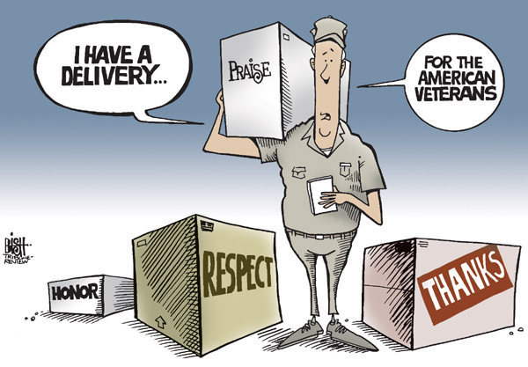

LAST WEEK’S COLLECTION

Adults $4,087.00

Loose $ 234.00

Youth $ 48.50

Monthly $ 1745.00

Initial Offering $ 15.00

Candles $ 22.00

Maintenance Fund $ 80.00

Solemnity of Mary $ 15.00

All Saints $ 900.50

All Souls $ 755.00

Immaculate Conception $ 15.00

Christmas $ 30.00

Catholic Charities $ 35.00

Religious Retirement $ 15.00

Christmas Flowers $ 80.00

Total $8,077.00

We sincerely thank and ask God’s blessing upon all who have care and concern for our parish.

*November 12, 2017 Mt. 25:1-13*

*Five bridesmaids in today’s gospel were considered foolish because they let their lamps go out. Don’t be foolish. Pay attention to the small acts necessary to keep the flame alive in all your relationships.*

[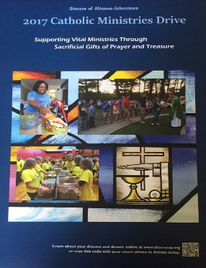](https://www.dioceseaj.org/wp-content/uploads/2017/04/Catholic-Ministries-Drive-2017.jpg)

Catholic Ministries Drive $23,811.00

Raised: $15,575.00

Balance: $ 8,236.00

Number of Responses: 92

Please join them in supporting our Parish and our Diocesan ministries.

If you do not have a pledge card, you may send your gift (made payable

to the “Catholic Ministries Drive”) directly to the parish office. Thank you

for your generous response!

*Stewardship Reflections ~* Good stewards, like the sensible bridesmaids in today’s parable, are ready to share their gifts when the Master calls. It is through the prudent use of our time, abilities, and finances that will always keep us mindful of the presence of the Risen Christ.

OVERNIGHT RETREAT – LIVING THE CHRISTMAS STORY, THEN AND NOW ~ December 1-2, 7 PM Friday to 3 PM Saturday. Meet and engage in prayerful reflections with the people of the original advent. Discover these powerful figures as they respond to God’s plan and allow oneself to recognize something of oneself in each character. Retreat includes presentations, time for reflection and prayer and conversation. Meals & housing included. Retreat fee: $40 per person, $55 for married couples. Pre-registration is required by Nov. 27 with a non-refundable deposit of $15 per person. Reservations are limited to 10 participants with private rooms. Sessions & retreats will be held at Carmelite Community of the Work Incarnation Center, 394 Rd., Gallitzin. To register, get directions, or for more information, call 814-886-4098.

TRINITY DOME MOSAIC ~ His Eminence Donald Cardinal Wuerl Archbishop of Washington *and* Chairman of the Board of Trustees Basilica of the National Shrine of the Immaculate Conception *together with* Monsignor Walter R. Rossi Rector are having a dedication of the TRINITY DOME MOSAIC Friday, December 8, 2017 Solemnity of the Immaculate Conception. 12:00 Noon ~ Great Upper Church.

[](https://www.bing.com/images/search?q=veterans+day&view=detailv2&&id=B8D28AA96B6E0904C0D769CA3309E69D0657758A&selectedIndex=33&ccid=rO2RwpaF&simid=608012541055667471&thid=OIP.Maced91c296859ce9d3ffa848523b3f2do0)

VETERANS DAY is an official [United States public holiday](https://en.wikipedia.org/wiki/Public_holidays_in_the_United_States), observed annually on November 11th, that honors [military veterans](https://en.wikipedia.org/wiki/Veteran), that is, persons who served in the [United States Armed Forces](https://en.wikipedia.org/wiki/United_States_Armed_Forces). It coincides with other holidays, including [Armistice Day](https://en.wikipedia.org/wiki/Armistice_Day) and [Remembrance Day](https://en.wikipedia.org/wiki/Remembrance_Day), celebrated in other countries that mark the anniversary of the end of [World War I](https://en.wikipedia.org/wiki/World_War_I); major hostilities of World War I were formally ended at the 11th hour of the 11th day of the 11th month of 1918, when the [Armistice with Germany](https://en.wikipedia.org/wiki/Armistice_with_Germany) went into effect. The United States previously observed Armistice Day. The U.S. holiday was renamed Veterans Day in 1954. Veterans Day is not to be confused with [Memorial Day](https://en.wikipedia.org/wiki/Memorial_Day); Veterans Day celebrates the service of all U.S. military veterans, while Memorial Day honors those who *died* while in military service.

The Sanctuary Candle will burn for the Birthday Remembrance for Andrew Pcola requested by Loving Family

and

The Our Lady of Grace Candle will burn for the Birthday Remembrance for Rachael Howard requested by Sloan Family

during the week of November 12, 2017

[](https://images.search.yahoo.com/search/images;_ylt=A0LEV1kSWptXvOwAKINXNyoA;_ylu=X3oDMTEyZGdkcmRoBGNvbG8DYmYxBHBvcwMxBHZ0aWQDQjIwODlfMQRzZWMDc2M-?p=Clipart+of+a+sanctuary+candle&fr=ush-mailn_02&th=110&tw=110&imgurl=http://www.henningers.com/389-168-wall-sanctuary-lamp.jpg&rurl=http://pixshark.com/sanctuary-lamp.htm&size=43KB&name=Sanctuary+Lamp+Bronze+wall+sanctuary+lamp&h=600&w=600&turl=http://ts2.mm.bing.net/th?id%3DOIP.M68453c67108cdc5ab485d309b395bd03o0%26pid%3D15.1%26rs%3D1%26c%3D1%26qlt%3D95%26w%3D110%26h%3D110#inline&tt=Sanctuary+Lamp+Bronze+wall+sanctuary+lamp&sigr=116keh5le&sigit=13gvlt42j&sigi=11ip0pgm4&sign=119kp6100&sigt=119kp6100)

GODPARENT/SPONSOR QUALIFICATIONS ~ For one to be a Godparent/Sponsor for Baptism or Confirmation, he or she is to be a practicing Catholic who is confirmed and in a valid Sacramental Marriage. If one is not from St. Michael Parish, he or she must obtain a certificate from his or her pastor. This is in full accordance with Canon Law.

BABY BOTTLES FOR PRO-LIFE ~ St. Benedict Parish, Johnstown, PA is collecting donations for pro-life organizations in our local area. In the bridal room, you will find baby bottles that will be used to collect your spare change for donation. Feel free to take as many as you would like, and please return them by Sunday, December 3rd.

VETERAN’S DAY LITURGY & LUNCHEON ~ This Sunday, November 12th, the REACH students will honor area Veteran’s at the 10:30 AM Mass. There will be a light luncheon after the Mass celebration. All are invited to attend.

SECOND SUNDAY FOOD PANTRY COLLECTION ~ This weekend is our Second Sunday Food Collection. Please bring in non-perishable food items or toiletries with you. Monetary donations are also appreciated.

SECOND COLLECTION FOR CATHOLIC CHARITIES ~ For 77 years, Catholic Charities has helped our neighbors throughout Central PA regardless of faith or background. 100% of contributions received through next weekend’s second collection will directly help your neighbors in need. Please return your Catholic Charities envelope or make your gift online at [www.catholiccharitiesaj.org](http://www.catholiccharitiesaj.org). Thank you for helping Catholic Charities of Altoona-Johnstown reduce poverty in communities throughout our diocese.

NOTE ~ The 2018 MARRIAGE PREPARATION Schedule is at the Church entrances. This is for the Pre-Cana Program which every engaged couple MUST attend before marriage.

MILITARY MAIL ~ The youth of the parish will be sending out mail for our military. If you know of anyone in the military that would appreciate receiving mail, please contact us with an address. You can call the rectory at 495-9640 or contact the RE Office at 495-4873.

COMBINED CHRISTMAS CHOIR ~ Will meet every Tuesday at 7:00 PM starting November 14th.



Religious Education And Christian Helping

November 12, 2017

*Veteran's Day Liturgy and Luncheon ~ Sunday, November 12, 2017*

On November 12th at the 10:30 a.m. Sunday Mass, the REACH students will honor all area Veterans including all those men and women who have served and continue to serve our country through the National Guard and all branches of the military.  Everyone is welcome to participate in this event, *even those individuals who are not members of our parish.*  This is to be a community celebration in honor of all those who have helped make and continue to help keep this country free! All attended are invited to our parish hall for a light luncheon following the Mass celebration.

*Cookies and desserts are needed for this Luncheon -* we are in need of donations cookies or desserts. They can be brought to the church hall the morning of November 12th.

*\*\*\*\*\*\*\*\*\*\*\*\*\*\*\*\*\*\*\*\*\*\*\*\*\*\*\*\*\*\*\*\*\*\*\*\*\*\*\*\*\*\*\*\*\*\*\*\*\*\*\*\*\*\*\*\*\*\*\*\*\*\*\*\*\*\*\*\*\*\*\*\*\*\*\*\*\*\*\*\*\*\*\*\*\*\*\*\*\*\*\*\*\**

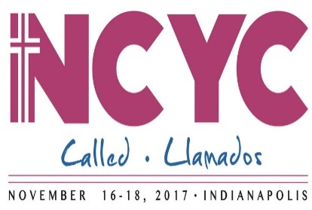

Four students and two chaperones, representing our Saint Michael Parish will be a part of many journeying to Indianapolis, Indiana for the 2017 NCYC (National Catholic Youth Conference) this week, November 16th thru th19th. In a distinctly Catholic setting,

the National Catholic Youth Conference invites participants

to encounter Christ, experience church, and be empowered for discipleship—coming together to pray, learn, and grow in their faith.

*\*\*\*\*\*\*\*\*\*\*\*\*\*\*\*\*\*\*\*\*\*\*\*\*\*\*\*\*\*\*\*\*\*\*\*\*\*\*\*\*\*\*\*\*\*\*\*\*\*\*\*\*\*\*\*\*\*\*\*\*\*\*\*\*\*\*\*\*\*\*\*\*\*\*\*\*\*\*\*\*\*\*\*\*\*\*\*\*\*\*\*\**



Children’s Thanksgiving Liturgy *~ There* will be a special Children’s Thanksgiving Liturgy on Thursday, November 16th at 3:30 p.m. for our K—5 students. Parents, older siblings and any other parishioners are also invited to attend! *Students and adults are reminded to bring in a non-perishable food item or monetary donation for the offertory collection. These items will be donated* to the Forest Hills Food Pantry. This Thanksgiving Liturgy will take place during our regularly scheduled class time. All students will be dismissed from the church at the end of Mass.

*\*\*\*\*\*\*\*\*\*\*\*\*\*\*\*\*\*\*\*\*\*\*\*\*\*\*\*\*\*\*\*\*\*\*\*\*\*\*\*\*\*\*\*\*\*\*\*\*\*\*\*\*\*\*\*\*\*\*\*\*\*\*\*\*\*\*\*\*\*\*\*\*\*\*\*\*\*\*\*\*\*\*\*\*\*\*\*\*\*\*\*\*\**



*8th Grade Cookie Bake ~* Next Sunday, November 19th, our 8th grade class will be participating in a "Cookie Bake" for their class service project, starting during their morning class time and extending through lunch with a pizza party. They will be baking and decorating cookies that will be included in the fruit baskets taken to our homebound parish members.

Fall Confirmation Sessions

Grade 10 ~ Session 10A ~ Scripture: Reflecting on and Living the Word ~ Sunday, November 19, 2017 ~ All 10th Grade students will attend their Fall Session 10A from 9 to 10:30 a.m. in the Parish Hall to fulfill this session requirement.*

Grade 11 ~ Session 11B ~ Sacraments and the Paschal Mystery ~ Sunday, December 10, 2017 ~ All 11th Grade students All will attend their Fall Session 11B from 9 to 10:30 a.m. in the Saint Paul Room to fulfill this session requirement.*

*\* If the students miss this scheduled session, they are required to attend another*

*parishes scheduled session to fulfill these requirements.*

*\*\*\*\*\*\*\*\*\*\*\*\*\*\*\*\*\*\*\*\*\*\*\*\*\*\*\*\*\*\*\*\*\*\*\*\*\*\*\*\*\*\*\*\*\*\*\*\*\*\*\*\*\*\*\*\*\*\*\*\*\*\*\*\*\*\*\*\*\*\*\*\*\*\*\*\*\*\*\*\*\*\*\*\*\*\*\*\*\*\*\*\*\**

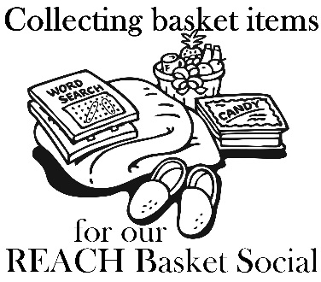

*It’s time to make the baskets!* ~ Our REACH Youth Ministry will

sponsor their annual REACH Basket Social on

Sunday, December 3rd!

We are in need of any new or unused items you may have for use in assembling extra baskets for the event. This also includes empty basket or containers you may have too! Parishioners can also help by assembling a basket alone, or several people together can combine resources for a completed basket. Any help with this is greatly appreciated! Any donated items or baskets can be left in the Bride’s Room of the church or dropped off at the Rectory or Religious Education Offices.

This basket social fundraiser helps pay for numerous activities that REACH funds cover such as the cost of our confirmation retreat expenses, the cost to attend SHYCON and Junior High Youth Day, , food provided at various service projects, our 8th Grade Cookie Bake and Homebound Fruit Baskets, K—5 Easter treats, Mother's Day and Father's Day Gifts, and the list goes on. Any help given will be greatly appreciated and put to good use.

*We are asking our Religious Ed families to help with the Project:*

*Each Religious Education class, Grades K—12 are asked to sponsor a basket to be chanced off at this*

*social as a classroom*

*service project. Students in each grade have picked a basket theme. Each class will also decide if they are collecting money or purchased items. We ask that each student bring their donation by November 19h so there is ample time for their class to assemble their class basket in time for the social. (There is no RE Class scheduled for Thursday November 23rd or Sunday, November 26th)!*

*When sending your donations, please be sure to mark the envelope or bag “Basket Social” and also include your “Child's Name” and “Grade” to ensure that the correct grade receives them.* Donation envelopes can be dropped in the weekend collection basket at Masses or bagged items can be placed in the Bridal Room or brought to the Religious Education Office or Rectory Office.

On Sunday December 3rd, tickets will be available at the door for $5.00 each which includes 25 perforated basket chances and 1 door prize chance. Multiple tickets may be purchased. *Doors will open at 1:00 p.m. with 'chancing off' beginning at 2:00 p.m.* Come early to purchase your tickets and have ample time to view all baskets available and place your chances before the drawing begins.

[](https://www.bing.com/images/search?view=detailV2&ccid=d64L%2bG0N&id=A4F2F23B96DE132CA2EB183282543B79566FD233&thid=OIP.d64L-G0NTiuGsS5090vDlwEsEs&q=veterans+day+clip+art+free&simid=608008817962060246&selectedIndex=17&qpvt=veterans+day+clip+art+free) Sunday, November 12 Religious Education / Grades 6-12 / 9:00 AM-10:20 AM

Second Sunday Food Pantry Collection

Veteran’s Day Liturgy / 10:30 AM Mass & Luncheon

Monday, November 13 Mass / 8:00 AM

Sunday Choir Practice / 7:00 PM

Tuesday, November 14 Mass / 8:00 AM

Combined Christmas Choir / 7:00 PM

Wednesday, November 15 No Mass

Thursday, November 16 Mass / 8:00 AM

Religious Education / Grades K-5 / 3:30 PM-4:30 PM

Saturday Choir Practice / 5:30 PM

K-5 Children’s Thanksgiving Liturgy / 3:30 PM

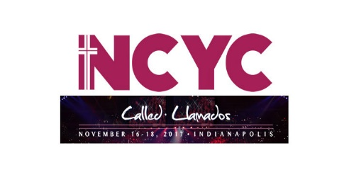 NCYC

Friday, November 17 Mass / 8:00 AM

NCYC

Saturday November 18 Catholic Charities Collection

NCYC

UPCOMING EVENTS

November 19 Catholic Charities Collection

8th Grade Cookie Bake

10th Grade Fall Session

November 23 & 24 Office Closed / Thanksgiving

RESURRECTION LADIES AUXILIARY BASKET PARTY ~ November 12th at Christ the Savior Reception Hall, 307 Garfield St., Johnstown. Doors open at 12:30 PM. $10 includes lunch, 25 chances & eligibility for door prizes. For tickets call parish office at 539-5788, EXT. #3 and ask for Joann.

TURKEY BINGO ~ Holy Family Parish, 509 Caldwell Ave., Portage, PA will hold a Turkey Bingo on Mon., Nov. 13, 2017 at 7 PM in the Parish Hall. 25 Turkeys and 2 $25 Stage Store Gift Certificates will be given as prizes. Admission is $5 per person, under 17 free. Bingo cards are 2 for 25 cents per game. Several Specials, Rip Offs and 50/50 will be played. Refreshments will be available.

FALL BASKET PARTY ~ Nov. 12 at the Beaverdale Fire Hall for the benefit of the Beaverdale Public Library. Doors open at noon. Admission is $5. For more information or to purchase advance tickets call 487-7742.