**ST. MICHAEL ROMAN CATHOLIC CHURCH**

751 Locust Street

PO Box 103

St. Michael, Pennsylvania 15951

Administrator: Rev. Brian Warchola Weekend Masses:

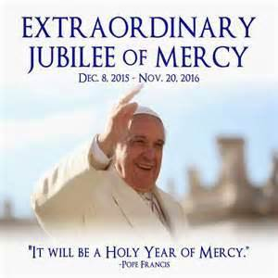

(814) 266-9718 / Ext. 507 Saturday 4:00 pm

Deacon Dave Hornick Sunday Morning 8:00 am

(814) 525-4183 10:30 am

Daily Mass See Bulletin

Office Staff: Holy Days See Bulletin

Secretary: Susan Poldiak Office Hours:

Bookkeeper: Kathy Kalicky 8:30 am to 3:30 pm

DRE: Laurie Sloan Monday, Tues., Thurs., Friday

Maintenance: Edward Homway Confessions:

PHONES: Saturday 3:30 pm to 3:45 pm

Rectory / Office: (814) 495-9640 Sunday 7:30 am to 7:45 am

Fax: (814) 495-9424 10:00 am to 10:15 am

Rel. Education: (814) 495-4873 Anytime Requested

Parish Website Secretaries’ E-mail:

www.saintmichaelchurch.weebly.com [saintmichaelsecretaries@yahoo.com](mailto:saintmichaelsecretaries@yahoo.com)

YEAR: 2016 NUMBER: 44

JUBILEE YEAR OF MERCY

SERVING GOD AND COMMUNITY FOR OVER ONE HUNDRED YEARS!

BAPTISM: By Appointment. Reserve at least one month in advance.

Preparation classes are necessary.

MARRIAGE: Make arrangements at least nine months in advance.

Preparation sessions are necessary.

FUNERALS: Arrangements are made in conjunction with the funeral home.

Eulogies should be given at the funeral home at the time of the wake service or at the luncheon.

REGISTRATION Those new to the area, newlyweds, and single adults, (even if registered

and before with their families) are asked to register by calling the Parish Office.

MEMBERSHIP: Every parishioner must be registered. This is a condition for admission

to our Program and reception of the Sacraments of Baptism, Confirmation, First Penance, First Eucharist, and Matrimony; also, for testimonial letters or sponsorship of Baptism and Confirmation outside the Parish.

VISITATION: We are concerned and want to be advised when someone is ill at home

or in the hospital. Call the rectory to have the shut-in placed on our monthly Holy Communion calls or seriously ill prayer list.

SACRAMENTAL Requires parish registration and active Mass participation for

POLICY: Baptism and Marriage.

BULLETIN ARTICLES: Articles are due to the Parish Office by Noon on Monday.

31st Sunday in Ordinary Time October 30, 2016

[](http://www.churchart.com/subscriber/viewimages.aspx?keywords=In%20memory%20&entry_date=1/1/0001&image_type=,cl#no)

Month of the Holy Rosary

MASS INTENTIONS: (October 31 – November 6, 2016)

Monday 6:00 PM Nora Ripper req. by Boo & Marcella Scott

Tuesday 9:00 AM People of the Parish

Wednesday 6:00 PM Mary & John Brindak req. by the Robert Podrebarac Family

Thursday 8:00 AM Eugene Krupa req. by Michael Hudak

First Friday 9:00 AM Sick & Shut-Ins

Saturday 4:00 PM Ann Blazosky req. by Paul Glovany

Sunday 8:00 AM Josh Faher req. by Mom, Dad & Family

10:30 AM People of the Parish

LITURGICIAL APPOINTMENTS:

Saturday, November 5 4:00 PM Offertory Procession

Lector: Susan Poldiak Blazosky Family

Minister of the Host: Deacon Dave Hornick

Ministers of the Cup: Babe Richards & Robin Yakicic

Altar Servers: Ashley & Haley Cook

Cantor: Susan Blazosky

Greeter: Phyllis Slonac

Sunday, November 6 8:00 AM Offertory Procession

Lector: Terri Leach Joe & Cathy Faher

Minister of the Host: Deacon Dave Hornick

Ministers of the Cup: Marie Bernard & Cathy Faher

Altar Servers: Quinn & Eva Spangler

Cantor: Sharon Dibble

Greeter: Carol Hautz

Sunday, November 610:30 AM Offertory Procession

Lector: Michael Caddy REACH Students

Minister of the Host: Deacon Dave Hornick

Ministers of the Cup: Joan & Robert Oshaben

[](https://www.churchart.com/subscriber/viewimages?book_number=42&chapter=19&entry_date=1/1/0001&image_type=cl,ca)Altar Servers: Elizabeth & Ian Dobbins

Cantor: Tori Dibble

Greeter: Richard Martyak

Sunday, November 6 Collection Counters

Tom & Sharon Paterson

Robert Casti & Sara Zybura

[](http://www.churchart.com/Subscriber/ViewImages.aspx?keywords=&entry_date=1/1/0001&image_type=,cl&topic_id=346&image_source_id=&page=1#no)Weare placing names of the sick in the bulletin for prayer providing they give permission. Although we remember all sick and shut-ins at every Mass, we would like our parish family to be aware of the need for special prayer intentions because of a most serious illness or hospital stay. *May the* *Divine Physician send healing grace for those for* *whom we pray:* Josephine Koshute, Allen C. Rosemas, Patricia Murphy, Todd Euen, Bernice Myers, Dwight Fyock, Lori Facciani, Dylon Wills, Dawn Hagen, Debbie Dibert, Missy, Joanne (Kolar) Hufford, Christine Flanagan, Ayden Alan Grata, Remy Beaver, Mary Lou Offman, Marian Chuckalovcak, Arlene Diamond, Mary Zangaglia, Dorothy Rosemas, Natalie Zerby, Patricia Grata, Michael Wadsworth, Valencia & Frank Tursi, Homer Locher, Gloria Weyandt, Brayden Schofield, Steve Faher, Jr, Michelle Kasper, Diane Kingera, Allison Krischer, Ted Paluch, Brandt Hutzel, Nicholas “Hop” Kolar, Pearl Litzinger, Patrick Munro, Fran Baldassarre, Corey Lybarger, Ann Marie Beppler, Kristen Sinosky Long, Helen Ranieri, Cresta Micik, Loretta Panick, Basil Costantino, Madison McCrory, Laura, Maria, Joe Yoder, Dolores Yanzetich, Jill Cekada, Sandy Krug, Wanda Gramling, Merna Smay, Muriel “Jean” Wiesheier, Heidi Allison, Sharon Poldiak, Melinda Jerome, Nancy Edmiston, Agnes Plummer, Jennifer Hagans, Katie Ansell, Mary McCall, Suzie Thomas, Sean, Holly, Shane, Joan McDowell, Melisa Ruddek, Joanne Serre, Scott N., Joe Ropecka, Patrick O’Donnell, and all of the sick of our parish, the homebound, those in nursing homes, those who care for them, and those in the military along with their families. (Please call the Rectory to have your name removed from the list when no longer seriously ill. Thank You.

CHOIR PRACTICES ~ Practice for the Sunday Choir is scheduled for Mondays at 7:00 PM. The Combined Choir for Christmas will have its next rehearsal on Tuesday, November 1st at 7:00 PM. Please bring folders from last year. Everyone is welcome! Practice for the Saturday Choir is scheduled for Thursdays at 5:30 PM.

BAPTISM ~ On Saturday, October 22nd, we celebrated the glorious baptism by Father Brian L. Warchola of Kolton Gary Shall, son of Nathan and Krysta (Pongrac) Shall. He became a new creation in Christ in the waters of Holy Baptism. Now joined to us by the gifts of faith, hope and charity, we warmly welcome him into our Saint Michael Church Family.

[](http://www.churchart.com/subscriber/ViewImages.aspx?image_id=1412&keywords=New%20life&entry_date=1/1/0001&image_type=,cl&topic_id=)

CELEBRATION OF NEW LIFE *~* A special service for families who suffered the loss of a loved one will be held this Wednesday, November 2nd at a 6:00 p.m. Mass. Although all of the deceased are always remembered, we wish to recognize the families and their loved ones who have died since last October 31, 2015 through September 30, 2016. A letter was sent to the families with more information about this very special memorial service. All are welcome.

TIME TO MAKE THE BASKETS! ~ Our annual REACH Basket Social will be held on Sunday, December 4th. Parishioners can help by assembling a basket alone, or several people together can combine resources for a completed basket. Each basket should be worth $25 to $30. We are in need of any new or unused items you may have for use in assembling extra baskets for the event. This also includes empty basket or containers you may have too! Your help with this is greatly appreciated! Any donated items can be left in the Bride’s Room of the church or dropped off at the Rectory or Religious Education Offices during regular office hours.

How do you know when you're too old to Trick or Treat?

You get winded from knocking on the door.

People say, "What a scary mask!" but you're not wearing a mask!

You're the only Power Ranger in the neighborhood with a walker.  
When the door opens you yell, "Trick ..." and can't remember the rest.

[](https://images.search.yahoo.com/images/view;_ylt=AwrB8plKK_1XrE8ADDKJzbkF;_ylu=X3oDMTIyajBlaTZqBHNlYwNzcgRzbGsDaW1nBG9pZAM0MTMxYjYxYzY5YzhiNGY5MzEwN2RhMGUyZDZiMDFjMgRncG9zAzcEaXQDYmluZw--?.origin=&back=https://images.search.yahoo.com/search/images?p%3DFree%2BClipart%2Bof%2BLottery%2BWinners%26fr%3Dyfp-t%26tab%3Dorganic%26ri%3D7&w=420&h=589&imgurl=images.clipartpanda.com/winner-clipart-clip-art-lottery-431235.jpg&rurl=http://www.clipartpanda.com/categories/winner-20clipart&size=87.3KB&name=%3cb%3eWinner%3c/b%3e+20clipart+|+%3cb%3eClipart%3c/b%3e+Panda+-+%3cb%3eFree%3c/b%3e+%3cb%3eClipart%3c/b%3e+Images&p=Free+Clipart+of+Lottery+Winners&oid=4131b61c69c8b4f93107da0e2d6b01c2&fr2=&fr=yfp-t&tt=%3cb%3eWinner%3c/b%3e+20clipart+|+%3cb%3eClipart%3c/b%3e+Panda+-+%3cb%3eFree%3c/b%3e+%3cb%3eClipart%3c/b%3e+Images&b=0&ni=192&no=7&ts=&tab=organic&sigr=11n47l7ao&sigb=139407utj&sigi=1223krgs8&sigt=12i151aj8&sign=12i151aj8&.crumb=wKQwdzP0bBS&fr=yfp-t)OCTOBER 2016 PARISH TICKET WINNERS

Day Date Amount No. Winner

Friday October 21, 2016 $ 75 797 Don Dipko

Saturday October 22, 2016 $100 449 Ray Haberkorn

Sunday October 23, 2016 $100 599 Helen Slonoc

Monday October 24, 2016 $ 75 751 Saint Michael

Tuesday October 25, 2016 $ 75 142 Joe Selepack

Wednesday October 26, 2016 $ 75 556 Rita Nelson

Thursday October 27, 2016 $ 75 458 Jen Frear

2016 ANNUAL CATHOLIC APPEAL

ANNUAL CATHOLIC APPEAL

Diocesan Goal $29,040.00

Pledged $18,173.00

Total Cash Amount $17,993.00

Number of Responses 127 430 30%

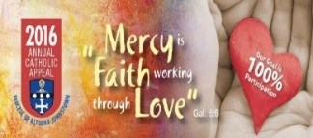

[](https://images.search.yahoo.com/search/images;_ylt=A0LEV1kSWptXvOwAKINXNyoA;_ylu=X3oDMTEyZGdkcmRoBGNvbG8DYmYxBHBvcwMxBHZ0aWQDQjIwODlfMQRzZWMDc2M-?p=Clipart+of+a+sanctuary+candle&fr=ush-mailn_02&th=110&tw=110&imgurl=http://www.henningers.com/389-168-wall-sanctuary-lamp.jpg&rurl=http://pixshark.com/sanctuary-lamp.htm&size=43KB&name=Sanctuary+Lamp+Bronze+wall+sanctuary+lamp&h=600&w=600&turl=http://ts2.mm.bing.net/th?id%3DOIP.M68453c67108cdc5ab485d309b395bd03o0%26pid%3D15.1%26rs%3D1%26c%3D1%26qlt%3D95%26w%3D110%26h%3D110#inline&tt=Sanctuary+Lamp+Bronze+wall+sanctuary+lamp&sigr=116keh5le&sigit=13gvlt42j&sigi=11ip0pgm4&sign=119kp6100&sigt=119kp6100)

The Sanctuary Candle will burn

in memory of

Hilda Yeager

the week of October 30, 2016

requested by Judy Rothgeb.

*Liturgical Reflection...*

Zacchaeus is a chief tax collector and a wealthy man. He needs to see this Jesus so he boosts his short body up into the sycamore tree. Zacchaeus is seeking divine mercy. Mercy incarnate invites himself into the tax collector's house. This man will never be the same after this meeting. He shares half his possessions with the poor. If there has been extortion, there is a four times repayment. The tax collector is on fire with mercy. God's mercy has forgiven his sins; so he now reaches out in mercy to others. Like this tax collector, may we seek out the Lord and receive his mercy. And like the tax collector, may we share that mercy with others.

2016, Diocese of Altoona-Johnstown, Liturgy Office, 925 South Logan Boulevard, Hollidaysburg, Pennsylvania 16648

KNIGHTS OF COLUMBUS MEMBERSHIP DRIVE ~ If you are interested in helping those in need, serving your parish, growing in faith or obtaining exclusive access to top-rated insurance protection for your family, then the Knights of Columbus is the organization for you and your family. Forest Hills Council #2275 is conducting a membership drive during the month of October. Please consider joining our Council #2275. We are a band of brothers, a network of men in communities around the world dedicated to doing good in the Service of God and our Neighbor. For more information on the K of C, contact John Bizzarri, 487-5252, David Brown, 487-5525 or Camillus Long, 495-9003.

PRAY FOR LIVING PRIESTS AND DEACONS IN THE DIOCESE ~ Larry Lacovic, William Rosenbaum, Anthony Spilka OFM Conv., Fabian Sheganoski TOR, Deacon James Leap and Seminarians Michael Pleva, Austin Keith, Peter Crowe, Jonathan Dickson, Devin Crouse, Mark Groeger and Sean Gibson

ALL SAINTS DAY

(HOLY DAY OF OBLIGATION)

Monday October 31 6:00 p.m. Tuesday November 1 9:00 a.m.

Lector: David Knepper Lector: Pauline Minor

Minister of the Host: Deacon Dave Hornick Minister of the Host: Betty Long

Ministers of the Cup: Marie Jo Plummer & Ministers of the Cup: Ellen Grattan &

Beth Kundrod Sally Kolar

Altar Servers: Evan & Dylan Kundrod Altar Servers: None Scheduled

Cantor: Louis McCloskey Cantor: Theresa Arena

Greeter: Carole Mucker Greeter: Karen Myers

Offertory Procession: Kensinger / Schofield Families Offertory Procession: Ushers

**PLEASE NOTE:** St. Bartholomew in Wilmore will have Holy Day Masses on November 1st at 6:00AM and 6:00PM; Most Holy Trinity in South Fork will have a 5:00PM Vigil Mass on October 31st and a 7:00AM Holy Day Mass on November 1st ; St. Benedict in Geistown 6:30PM Vigil Mass; Holy Day Masses are 7:00AM, 9:00AM, 12:05PM & 6:30PM; Immaculate Conception in New Germany 6:30 AM on October 31st and 7:00PM on All Saints Day, November 1st. St. John in Summerhill will have a 7PM Mass on October 31st and an 8:00AM Mass on November 1st.

[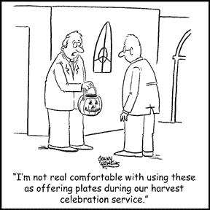](https://www.churchart.com/subscriber/viewimages?topic_id=223&image_type=ca)

LAST WEEK’S COLLECTION

Adults $3,322.00

Loose $ 144.50

Youth $ 51.50

Monthly $ 155.00

Maintenance Fund $ 514.00

World Mission Sunday $ 103.00

Candles $ 20.00

Total $4,310.00

We sincerely thank and ask God’s blessing upon all who have care and concern for our parish.

*October 30th Luke 19:1-10*

*Jesus is saying to you what he said to Zacchaeus, "I must stay at your house today." It doesn't matter if Jesus "intended to pass through Jericho to another town." In families we sometimes stop at the wrong places. It is wisdom to "pass through" annoying family situations so we can enjoy the goodness of each other.*



Religious Education And Christian Helping

October 30, 2016

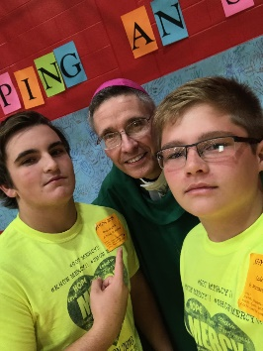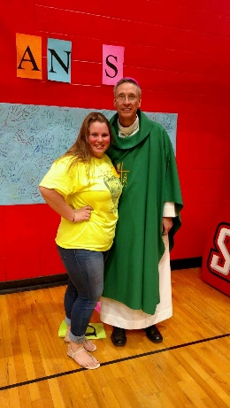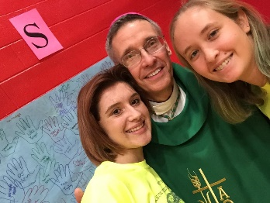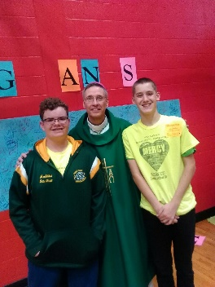SHYCON 2016

We had an awesome day at SHYCON 2016 last Sunday, October 23rd. Our Saint Michael group of 9th and 10th and 11th grade students represented our parish well with enthusiasm and energy that made for a spectacular day together. Our kids were able to participant together with the “Helping Hands” Project to pack meals for the hungry, and living out the first Corporal Work of Mercy!! We had a wonderful Liturgy with Bishop Mark Bartchak and several Priests and Deacons from our Diocese, including our own Fr. Brian Warchola! As you can see above, Bishop Mark posed with some of the kids for “selfies” and our group posed for a picture with Bishop Mark too! What a great day!

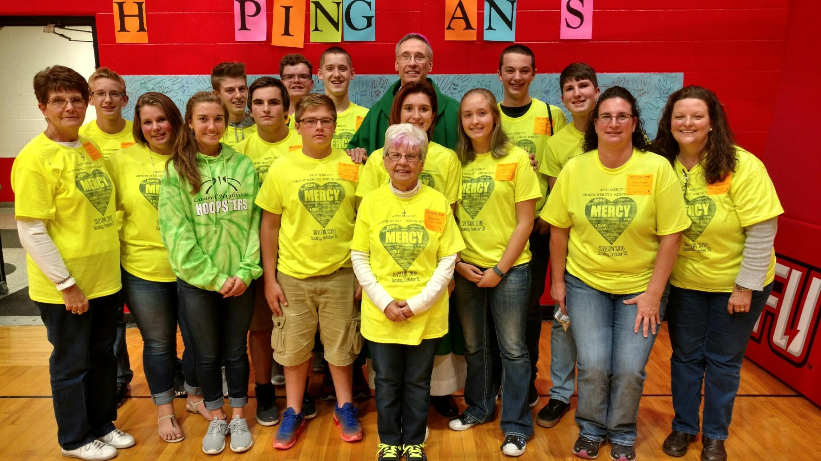

11th Grade Discipleship Retreat is scheduled for Saturday, November 12th at Saint Francis University. This “FIREstarters Retreat” will be held at the Campus Ministry Center (next to Cafe' Gubbio) in Saint Francis Hall. The retreat will begin at 9:00 a.m. and conclude at 5:00 p.m., which includes a 4:00 p.m. Mass. Lunch will be provided and the $25 cost per student will be paid from our REACH Youth Ministry funds. Parents should have students arrive at 8:45 a.m. and pick-up again at 5:00 p.m. Parents also are invited to return and attend the 4:00 p.m. Mass held at the Immaculate Conception Chapel.

Grade 9 ~ Session 9*A ~ The Creed ~* Sunday, November 13, 2016 ~ All 9th Grade students will be attending their Fall Session 9A from 9 to 10:30 a.m. in the Parish Hall to fulfill this session requirement.

Grade 10 ~ Session 10A ~ Scripture: Reflecting on and Living the Word ~ Sunday, November 20, 2016 ~ All 10th Grade students will attend their Fall Session 10A from 9 to 10:30 a.m. in the Parish Hall to fulfill this session requirement.

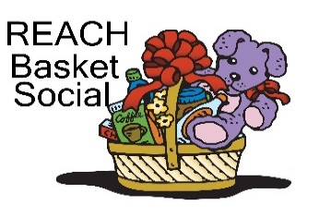REACH Basket Social ~ Our REACH Youth Ministry will sponsor their annual REACH Basket Social on Sunday, December 4th this year!

This basket social fundraiser helps pay for numerous activities like food provided at various service projects, Cookie Bake and Homebound Fruit Baskets, K—5 Easter treats, Mother's Day and Father's Day Gifts. REACH funds also cover the cost of our confirmation retreat expenses along with SHYCON and Junior High Youth Day to help assure students can attend.

*We are asking our Religious Education families to help with the Project:*

*Each Religious Education class, Grades K—12 are asked to sponsor a basket to be chanced off at this social as a classroom service project. Over these next few weeks, students in each grade will pick a theme for their basket. Each class will also decide if they are collecting money or purchased items. We ask that each student then bring their donation in by the beginning of November so that each class has ample time for their class to assemble their class basket by November 20th in time for the social. (There is no RE Class scheduled for Thursday, November 24th or Sunday, November 27th)!*

*When sending your donations, please be sure to mark the envelope or bag “Basket Social” and also include your “Child's Name” and “Grade” to ensure that the correct grade receives them.* Donation envelopes can be dropped in the weekend collection basket at Masses or bagged items can be placed in the Bridal Room or brought to the Religious Education Office or Rectory Office.

Parishioners can help too by assembling a basket alone, or several people together can combine resources for a completed basket. We are also in need of new or unused items you may have for our use in assembling extra baskets for the event. Your help with this is greatly appreciated! Any donated items can be left in the Bride’s Room of the church or dropped off at the Rectory or

Religious Education Offices during regular office hours. Some suggested baskets are as follows:

A “Beary” Nice Basket First Aid Basket Pasta Dinner Basket

Americana Basket Frog Basket Patriotic Basket

Apple Basket Fruit Basket Pharmacy Basket

Baby Basket Games for a Rainy Day Basket Plant a Flower Basket

Baking Basket Garden Basket Popcorn Basket

Barbie Basket Good Grooming Basket Pretzel Basket

Basket for All Seasons Greeting Card Basket Recipe for Relaxation Basket

Basket of Nuts Mystery or Surprise Basket Saint Patrick’s Day Basket

Bath Basket Hair Care Basket School Days Basket

Beach Basket Halloween Basket Set the Table Please Basket

Birdhouse Basket Happy Birthday Basket Sewing Basket

Boys Basket Household Supplies Basket Smile for the Camera Basket

Breakfast Basket Keep in Touch Basket Snack Basket

Candy Basket Keep Your House Clean Basket Snowman Basket

Car Care Basket Keeping Warm Basket Spaghetti Night Basket

Chocolate Lovers Dream Basket Kitchen Helpers Basket Sponge Bob Basket

Christmas Ornament Basket Kitchen Fiesta Basket Stationary Basket

Christmas Theme Basket Laundry Basket Strawberry Basket

Coffee Basket Let’s Have a Picnic Basket Sweetheart Basket

Country Blue Basket Looney Toons Basket Tea for Two Basket

Desk Supplies Basket Make a Sundae Basket Travel Basket

Dog Lovers Basket Manicure Basket Treasure Box Basket

Easter Basket Massage Basket Wine and Cheese Basket

Fall Basket Midnight Munchies Basket Winter Warmth Basket

Favorite Team Basket Movie Basket Work Out Basket

Steelers, Penn State, Pitt. Pancake Basket Yellow Basket

Sunday, October 30 Religious Education Grades 6-12 / 9:00-10:20 AM / Hall

[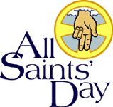](https://www.churchart.com/subscriber/viewimages?keywords=All+Saints+Day&entry_date=1/1/0001&image_type=cl&page=2&ipp=12) Monday, October 31 All Saints Day Mass / 6:00 PM / Church

Sunday Choir Practice / 7:00 PM / Church

Tuesday, November 1 All Saints Day Mass / 9:00 AM / Church

(All Saints Day) Combined Christmas Choir / 7:00 PM / Church

Wednesday, November 2 New Life Celebration Mass / 6:00 PM / Church

(All Souls Day)

Thursday, November 3 Morning Mass / 8:00 AM

Homebound Communion Calls

Religious Education Grades K-5 / 3:30-4:30 PM / Hall

[](https://www.churchart.com/subscriber/viewimages?topic_id=159&image_type=cl&page=6&ipp=12) Saturday Choir Practice / 5:30 PM / Church

First Friday, November 4 Morning Mass / 9:00 AM

Saturday, November 5

Sunday, November 6 Veteran’s Day Luncheon / Following the 10:30 AM Mass

Religious Education Grades 6-12 / 9:00-10:20 AM / Hall

UPCOMING EVENTS

Saturday, November 12 11th Grade “FIREstarters” Retreat / 8:50 AM – 5:00 PM / Saint Francis

Sunday, December 4 REACH Basket Social

DANCE ~There will be a Polka Dance at the St. Michael American Legion on Sunday, October 30th from 2:00pm until 5:00pm. Music will be provided by Bronco and the Rhinelander’s. Everyone is welcome to attend!

**COMMUNITY LAB BLOOD SCREENING** ~ St John the Baptist, Summerhill, PA, in conjunction with Chan Soon-Shiong Medical Center at Windber, will be holding a Community Lab Blood Screening at St John’s Catholic Church Social Hall, 540 Main Street, Summerhill, PA, on Saturday, November 5th from 7 AM to 9 AM. Everyone is welcome. Cost is $30.00.

**PORK & SAUERKRAUT SUPPER** ~ St. John the Baptist, Summerhill, will be hosting a Pork & Sauerkraut Supper, Buffet Style, on Sunday, November 6th from 4:00 PM until 6:00 PM at St. John’s Catholic Church Hall in Summerhill. Everyone is welcome for sauerkraut and homemade pies. Adults $10.00; Children 10 and under are $5.

DIOCESAN PILGRIMAGE~ Most Holy Trinity and St. Bartholomew Parishes are sponsoring a bus for the Diocesan Pilgrimage to the Basilica in Washington DC on Saturday, November 12th. Tickets are $35. Make your reservation by calling 495-4419.

**BASKET PARTY ~** The Ladies Auxiliary of Resurrection Parish will be sponsoring a Basket Party on Sunday, November 13, 2016 at Christ the Savior Reception Hall, 307 Garfield Street in Johnstown. Doors open at 12:30 PM Cost is $10.00 which will include lunch, 25 chances and eligibility for door prizes. For tickets call the Resurrection Parish Office at 539-5788, Ext. #3 and ask for Joanne.