John 6:54

ST. MICHAEL ROMAN CATHOLIC CHURCH

PO Box 103

St. Michael, Pennsylvania 15951

Rev. Brian L. Warchola, Administrator MASSES:

(814) 495-9640 Saturday 4:00 pm



Sunday Morning 8:00 am

Secretary: Michele Panick 10:30 am

Bookkeeper: Kathy Kalicky Daily Mass See Bulletin

DRE: Laurie Sloan Holy Days See Bulletin

Maintenance: Rodney Turgeon

Office Hours:

PHONES: 8:30 am to 3:30 pm

Rectory / Office: (814) 495-9640 Monday, Tues., Thurs., Friday

Fax: (814) 495-9424 Confessions:

Rel. Education: (814) 495-4873 Saturday 3:30 pm to 3:45 pm

Parish Website Sunday 7:30 am to 7:45 am

www.saintmichaelchurch.weebly.com 10:00 am to 10:15 am

Secretaries’ E-mail Anytime Requested

[saintmichaelsecretaries@yahoo.com](mailto:saintmichaelsecretaries@yahoo.com)

YEAR: 2019 NUMBER: 3

SERVING GOD AND COMMUNITY FOR OVER ONE HUNDRED YEARS!

BAPTISM: By Appointment. Reserve at least one month in advance.

Preparation classes are necessary.

MARRIAGE: Plan at least nine months in advance.

Preparation sessions are necessary.

FUNERALS: Arrangements are made in conjunction with the funeral home.

REGISTRATION Those new to the area, newlyweds, and single adults, (even if registered

and before with their families) are asked to register by calling the Parish Office.

MEMBERSHIP: Every parishioner must be registered. This is a condition for admission

to our Program and reception of the Sacraments of Baptism, Confirmation, First Penance, First Eucharist, and Matrimony; also, for testimonial letters or sponsorship of Baptism and Confirmation outside the Parish.

VISITATION: We are concerned and want to be advised when someone is ill at

home or in the hospital. Call the rectory to have the shut-in placed on our monthly Holy Communion calls or seriously ill prayer list.

SACRAMENTAL Parish registration and active Mass participation for Baptism is

POLICY: encouraged and is required for Marriage.

BULLETIN ARTICLES: Articles are due to the Parish Office by Noon on Tuesdays.

 Second Sunday in Ordinary Time

January 20, 2019

**Month of The Holy Name of Jesus**

**MASS INTENTIONS**: (January 21 – January 27, 2019)

Monday 8:00 AM Mildred Beesoick req. by Mary Jo Verdery

Tuesday 8:00 AM Michael Hudak req. by Jim Bertolino

Wednesday NO MASS

Thursday 8:00 AM Lois Jean Papcunik req. by Ginny Hull

Friday 8:00 AM Ann Blazosky req. by Adams Twp. / St. Michael Election Board

Saturday 4:00 PM Samuel & Grace Martin (Months Mind) req. by Saturday Night Choir

Sunday 8:00 AM Georgetta (Minor) Moreau req. by Nick & Pauline Minor

Sunday 10:30 AM People of the Parish

LITURGICIAL APPOINTMENTS:

Saturday, January 26 4:00 PM Offertory Procession

Lector: Sherry Dipko Karen & Ed Myers

Minister of the Host: Theresa Carlson

Ministers of the Cup: Vince Arena & Alice Podrebarac

Altar Servers: Caden & Kaylee Roberts

Cantor: Susan Blazosky

Greeter: Mary Ann Spangler

Sunday, January 27 8:00 AM Offertory Procession

Lector: Cathy Faher George & Janet Minor

Minister of the Host: Robert Grattan

Ministers of the Cup: Paul Kundrod & Marie Jo Plummer

Altar Servers: Griffin & Kaden Christ

Cantor: Anita Lorek

Greeter: Carol Hautz

Sunday, January 2710:30 AM Offertory Procession

Lector: Carole Kakabar John & Michelle Vitez

Minister of the Host: Amanda Williamson

Ministers of the Cup: Robert Oshaben & Michael Barton

Altar Servers: Kristyn & Cameron Vitez

Cantor: Amy Dobbins

Greeter: Deborah Macy

Sunday, January 27 Collection Counters

Mary Ann Davis, Sara Zybura

Mary Ann DeRosa

Weare placing names of the sick in the bulletin for prayer providing they give permission. *May the* *Divine Physician send healing grace for those for* *whom we pray:* Allen C. Rosemas, Patricia Murphy, Bernice Myers, Dwight Fyock, Lori Facciani, Dylon Wills, Missy, Joanne (Kolar) Hufford, Christine Flanagan, Ayden Alan Grata, Mary Lou Offman, Mary Zangaglia, Dorothy Rosemas, Natalie Zerby, Patricia Grata, Michael Wadsworth, Valencia & Frank Tursi, Homer Locher, Brayden Schofield, Michelle Kasper, Diane Kingera, Allison Krischer, Ted Paluch, Brandt Hutzel, Pearl Litzinger, Patrick Munro, Fran Baldassarre, Kristen Sinosky Long, Helen Ranieri, Cresta Micik, Basil Costantino, Madison McCrory, Laura, Joe Yoder, Dolores Yanzetich, Sandy Krug, Wanda Gramling, Merna Smay, Muriel “Jean” Wiesheier, Agnes Plummer, Jennifer Hagans, Shawn, Holly, Shane, Spencer, Owen Taylor, Keith & Dawnetta Hoyer, Derrick Varnish, Daniel Koshute, Vincent Koshute, Melissa Cordek, Michelle Elliott, Heather Romanow, Mackston Barrick, Connor Thomas, Erin, Pat, Mary Agnes Nastase, Mary Ann Bertolino, Dick Wilson, Izzy Bihun, Erica Mitzelfeld, Dorothy Kaminsky, Ed Ripper Sr., Patricia Oshaben, Ashlee Madison, Susan Yanzetich, Mike, Mary Sivec, Danika Faith, Alina Rusnak, Marcia Costlow, Gary Smay, Elizabeth Howell, Helen Bowen, Bill Gideos, James Macy, Walter Bodziak, Rhonda, Dan Strinkoski, Anne Robinson, Marlene McCrory, Sharon Poldiak, Carter Bobak, Vince Arena, Mike Morris, Sarah Kelt, Mildred Andrykovitch, Patty Yanzetich Caldwell, Mary Secriskey, Owen Croyle, Colton Snyder, Betty Delaney, Nancy Edmiston, Elizabeth Stoker Thomas and all of the sick of our parish, the homebound, those in nursing homes, those who care for them, and those in the military along with their families. *(Please call the Rectory to have your name removed from the list when no longer seriously ill. Thank You.)*



LAST WEEK’S COLLECTION

Adults $3,557.00

Loose $ 216.00

Youth $ 23.25

Monthly $ 625.00

Candles $ 51.25

Maintenance $ 60.00

Initial Offering $ 46.00

Solemnity of Mary $ 55.00

Christmas Offering (2018) $ 8.00

Total $4,641.50

We sincerely thank and ask God’s

blessing upon all who have

care and concern for

our parish.

*January 20, 2019 John 2:1-11*

*At Cana, we get a good insight into Mary’s parenting style. She did not plead, argue, demand or manipulate. She merely pointed out the situation and trusted her son would make the best decision.*

[](https://images.search.yahoo.com/search/images;_ylt=A0LEV1kSWptXvOwAKINXNyoA;_ylu=X3oDMTEyZGdkcmRoBGNvbG8DYmYxBHBvcwMxBHZ0aWQDQjIwODlfMQRzZWMDc2M-?p=Clipart+of+a+sanctuary+candle&fr=ush-mailn_02&th=110&tw=110&imgurl=http://www.henningers.com/389-168-wall-sanctuary-lamp.jpg&rurl=http://pixshark.com/sanctuary-lamp.htm&size=43KB&name=Sanctuary+Lamp+Bronze+wall+sanctuary+lamp&h=600&w=600&turl=http://ts2.mm.bing.net/th?id=OIP.M68453c67108cdc5ab485d309b395bd03o0&pid=15.1&rs=1&c=1&qlt=95&w=110&h=110#inline&tt=Sanctuary+Lamp+Bronze+wall+sanctuary+lamp&sigr=116keh5le&sigit=13gvlt42j&sigi=11ip0pgm4&sign=119kp6100&sigt=119kp6100)

The Sanctuary Candle will burn for

Priestly Vocations in our Diocese

during the week of January 20, 2019.



BAPTISM ~ On Sunday, January 13th, 2019, we celebrated the glorious baptism of Luke Easton Baker, son of Joshua Baker and Lindsay (Roush) Baker by Fr. Brian Warchola. He became a new creation in Christ in the waters of Holy Baptism. Now joined to us by the gifts of faith, hope and charity, we warmly welcome him into our St. Michael Parish Family.

[](http://www.churchart.com/subscriber/viewimages.aspx?keywords=In%20Sympathy&entry_date=1/1/0001&image_type=,cl#no)

MAY HE REST IN PEACE ~ In your charity, please pray for the eternal rest of Robert Sivec whose Funeral Mass was celebrated on Friday, January 18th, 2019 by Fr. Brian Warchola. May he know the eternal peace and happiness promised by our Savior, Lord Jesus. Please pray for the consolation of all his family and friends.

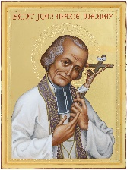

ST JOHN VIANNEY RELIC PILGRIMAGE ~ The Diocese of Altoona-Johnstown has been selected to participate in the St. John Vianney Relic Pilgrimage. On Thursday, January 31, 2019, the relic of St. John Vianney (his entire incorrupt heart) will be in the Cathedral of the Blessed Sacrament. It will be placed there at the conclusion of the 6:45 AM Mass and remain throughout the day. The usual Mass schedule at the Cathedral (8:00 AM & 12:00 Noon) will be observed and there will be a concelebrated Mass at 5:30 PM. The relic will remain in the Cathedral for a short time after Mass for private veneration (until about 7:30 PM). The relic pilgrimage is sponsored by the *Knights of Columbus*. Anybody interested in carpooling, please be in our church parking lot on Thursday, January 31st at 3:00 PM.

SCOUT SUNDAY ~ Our Parish will hold a Scout Sunday Mass on February 3rd, during the 10:30 AM Mass. We are the sponsor/charter for three scout troops: Girl Scout Troops #16337 & #40991, and Boy Scout Troop #2251. The scouts from these troops and any scout from the parish that is a member of any scout troop are asked to sit in the front pews of the church and be dressed in their uniforms. The scouts will be taking an active part in the mass. After the mass, an open house will be held in the church hall. Everyone is cordially invited to attend the open house. Come and see what scouting is all about at St. Michael Parish. We hope to see you there!

MOM’S HOUSE COLLECTION ~ We need financial assistance, especially in these hard times. We are asking again for your financial help. The Knights of Columbus will be taking up a collection for donations to Mom’s House. Please make checks out to Moms House. Extra envelopes are at the entrances of the Church. They will be collecting this weekend (January 19th & 20th.)

MARCH FOR LIFE ON THE MOUNTAIN 2019 ~ Join the Saint Francis University community as we welcome Bishop Mark Bartchak for our 6th annual March on the Mountain on Tuesday, January 22nd. Schedule: Rosary - 10:30 AM, March Begins – 11:00 AM, Mass – 12:00 PM and Adoration – 12:30 PM. Join us for the whole walk or just 5 – 10 minutes. If you have any questions, please feel free to contact Paul Girardi in the Campus Ministry department at Saint Francis University @ 814-472-3328. The March on the Mountain is sponsored by the Saint Francis University Campus Ministry Department and Students for Life.

2019 CATHOLIC SCHOOLS COLLECTION ~ Envelopes are attached to this week’s bulletin for the 2019 Catholic Schools Collection. Your donations will help financially qualified students attending our area’s Catholic grade schools, middle school or Bishop McCort. If donating by check, please make out to our parish and add the memo “Catholic Education Fund.” You may direct your gift to a specific school or several schools. Envelopes can be put in next week’s regular collection.



JO JO’S PIZZA FUNDRAISER ~ Jo Jo’s Pizza, St. Michael, will donate 20% of your total sales (excluding tax & tip) from the flyers collected during our fundraiser dates – Saturday & Sunday, February 9th & 10th, 2019. Flyers will be given out the weekend of February 2nd & 3rd. You can give out as many flyers to your family & friends. Present flyer to your server and St. Michael will earn 20% of your total bill!



SOUP SALE ~ The Holy Name Society will be making chicken soup for our parish sick and shut-ins on Saturday, January 26th. They are also offering it for sale to members of the parish. The cost is $6.00 per quart. Sign-up sheets are available in the back of the church. Orders can be picked up in the church hall on Saturday, January 26th from 11:00 AM to 2:00 PM or after each weekend Mass on the 26th and 27th.

SECOND SUNDAY FOOD COLLECTION ~ Thank you to all who so generously donated to the Forest Hills Food Pantry. The total money collected was $778.00 and an assortment of non-perishable items.

[](http://www.churchart.com/search/ImageDetail.asp?image_id=93074236)

CONTRIBUTION STATEMENTS ~The Parish Office has closed the books for 2018 parishioner’s contributions. You may request a statement of your tax-deductible donations at any time by calling the rectory at 495-9640. If a contribution was made to the CMD, you should have received a statement from the diocese. We are updating our parish records, so please remember to notify the Rectory Office of any changes in address or telephone numbers. If you no longer have a land line and your cellphone is your primary house phone, please call us or drop a note in the collection basket.



Religious Education And Christian Helping

January 20, 2019

11th Grade Discipleship Retreat is scheduled for Saturday, February 23rd at Saint Francis University for our 11th Grade Confirmation Class. This “FIREstarters Retreat” will be held at the Campus Ministry Center (next to Cafe' Gubbio) in Saint Francis Hall. The retreat will begin at 9:00 a.m. and conclude at 5:00 p.m., which includes a 4:00 p.m. Mass. Lunch will be provided and the $25 cost per student will be paid from our REACH Youth Ministry funds. Parents should have students arrive at 8:45 a.m. and pick-up again at 5:00 p.m. Parents also are invited to return and attend the 4:00 p.m. Mass held at the Immaculate Conception Chapel. "Application for Participation" forms will be provided to the 11th Grade students and permission is required for the students to attend. These forms need returned to the RE Office by February 10th and forwarded to St. Francis to hold our group reservation.

Upcoming Confirmation Sessions

Grade 9 ~ Session 9 B ~ Prayer: Communion with God

Sunday, February 3, 2019

All 9th Grade students will attend their Session 9 B from 9 to 10:20 a.m.

*\* If the students miss this scheduled session, they are required to attend another*

*Parishes scheduled session to fulfill these requirements.*





MESSAGE FROM FR. BRIAN ~ Recently, we received some very generous donations from parishioners and friends of the parish. These donations have been used to remodel the church restroom done by Pop’s Painting and Services. A sincere thank you to them and to all those who graciously donate to our parish!

[](https://soulcore.com/)

My sincere thank you to all those who took part in the SoulCore Workshop. We had nearly 40 individuals come and participate in praying the rosary and exercising. My dearest thanks also to Mallory Hurley from Pittsburgh, a SoulCore leader for coming to instruct us. We are in talks now with some parishioners about the possibility of having something similar on a regular basis at the parish. We will see where the Holy Spirit leads us!

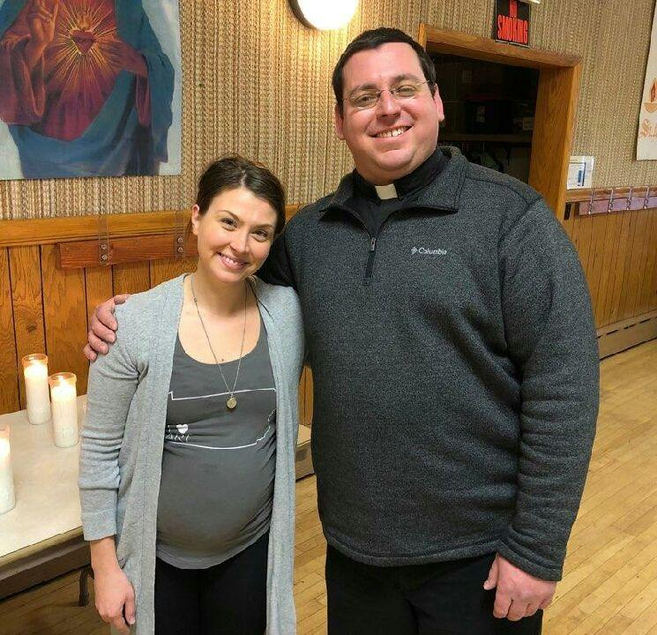

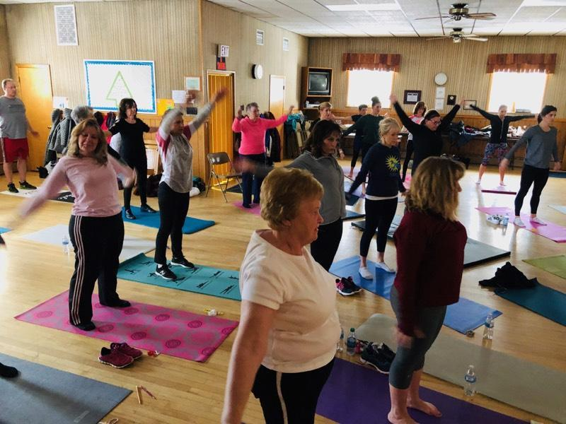

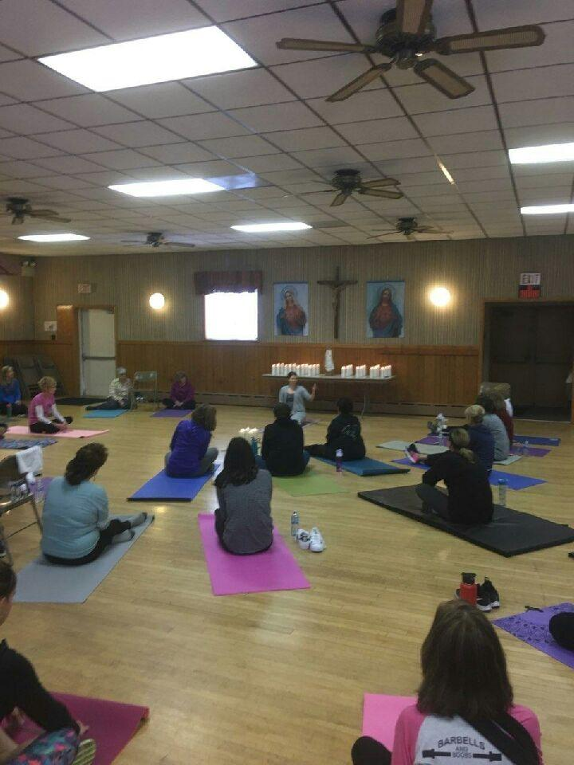

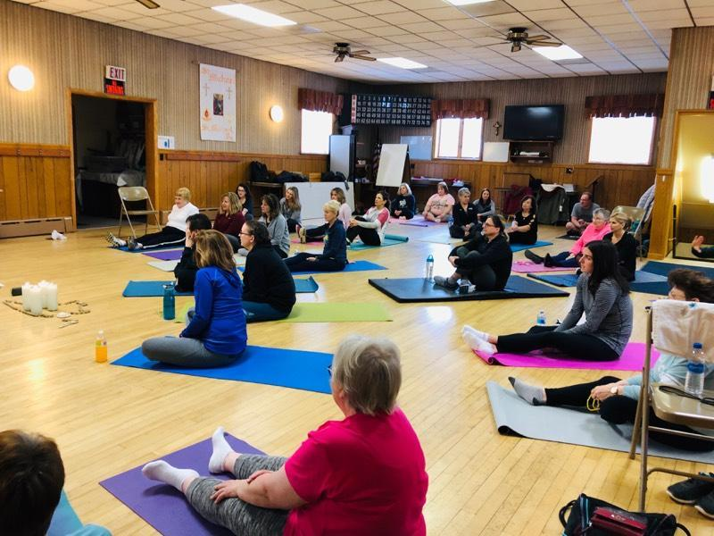

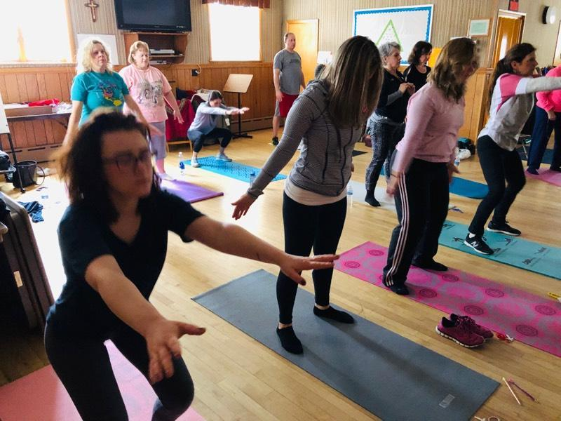

 Sunday, January 20 High School Religious Ed. / 9:00 – 10:20 AM

Mom’s House Collection

Monday, January 21 Parish Offices Closed

Sunday Choir Practice / 7:00 PM

Tuesday, January 22 Boy Scouts / 7:30-9:00 PM

March for Life / St. Francis University

Wednesday, January 23 NO MASS

Thursday, January 24 K-5 Religious Education / 3:30 – 4:30 PM

Saturday Choir Practice / 4:30 PM



Friday, January 25

Saturday, January 26 Holy Name Soup Sale

UPCOMING EVENTS

January 27 Holy Name Soup Sale

January 29 Boy Scouts

January 31 St. John Vianney Relic Pilgrimage

February 1 Exposition of the Blessed Sacrament with Adoration

February 2 & 3 Blessing of Throats

February 3 9th Grade Confirmation Session

Hall Rental



PAINTING PARTY ~ Sunday, Jan. 26 at Noon at Most Holy Trinity hall. 11” x 14” painting. $25 – canvas, paint, brushes. Soup & refreshments available. Call Carol Cecere 341-4025 to register.

MOUNT CARMEL CONCERT SERIES ~ Our Lady of Mount Carmel Church, 809 11th St., Altoona 16602. Sunday, Jan. 27th at 3 PM. “Select Singers” from the Grier School, under the direction of Ms. Ginger Reinhardt. The “Select Singers” is a distinctively audition only group of singers in grades 7-12. Much of their music is done acapella. A free will offering will be taken at the end of the concert to benefit the Pipe Organ.

BISHOP CARROLL HIGH SCHOOL OPEN HOUSE ~ For parents & students on Wednesday, Jan. 30 from 6-7:30 PM. A financial aid meeting will follow at 7:30 pm in the cafeteria. For more information, call the school at 814-472-7500 extension 105 or email [jnagy@bishopcarroll.org](mailto:jnagy@bishopcarroll.org).

SUPERBOWL PORKETTE SALE ~ St. Anthony of Padua Church, Windber is having a Super Bowl Porkette Sale. Porkettes are $4 each and must be ordered by January 25. Pick-up Saturday, February 2 from 9:00 AM – Noon in the Church Hall. To Order, call 814-467-7292.

SPAGHETTI DINNER FUNDRAISER ~ Salix Cub Scout Pack 51 is holding a spaghetti dinner on Saturday, February 2, from 4:00 – 6:30 PM. The spaghetti dinner will be served at the St. Michael Firehall, eat in or take out available. The cost is $8 for adults, $4 for children 4-12, and free for children 3 and under. Dinner will include spaghetti with meat sauce, meatballs, Italian bread, side salad, cake and drink. Walk-ins are welcome, but if possible, please purchase tickets ahead of time by calling Nicole at 814-410-9991 or Stacy at 814-244-6192.