ST. MICHAEL ROMAN CATHOLIC CHURCH

PO Box 103

St. Michael, Pennsylvania 15951

Rev. Brian L. Warchola, Administrator MASSES:



(814) 495-9640 Saturday 4:00 pm

Sunday Morning 8:00 am

Secretary: Michele Panick 10:30 am

Bookkeeper: Kathy Kalicky Daily Mass See Bulletin

DRE: Laurie Sloan Holy Days See Bulletin

Maintenance: Rodney Turgeon

Office Hours:

PHONES: 8:30 am to 3:30 pm

Rectory / Office: (814) 495-9640 Monday, Tues., Thurs., Friday

Fax: (814) 495-9424 Confessions:

Rel. Education: (814) 495-4873 Saturday 3:30 pm to 3:45 pm

Parish Website Sunday 7:30 am to 7:45 am

www.saintmichaelchurch.weebly.com 10:00 am to 10:15 am

Secretaries’ E-mail Anytime Requested

[saintmichaelsecretaries@yahoo.com](mailto:saintmichaelsecretaries@yahoo.com)

YEAR: 2018 NUMBER: 2

SERVING GOD AND COMMUNITY FOR OVER ONE HUNDRED YEARS!

BAPTISM: By Appointment. Reserve at least one month in advance.

Preparation classes are necessary.

MARRIAGE: Plan at least nine months in advance.

Preparation sessions are necessary.

FUNERALS: Arrangements are made in conjunction with the funeral home.

Eulogies should be given at the funeral home at the time of the wake service or at the luncheon.

REGISTRATION Those new to the area, newlyweds, and single adults, (even if registered

and before with their families) are asked to register by calling the Parish Office.

MEMBERSHIP: Every parishioner must be registered. This is a condition for admission

to our Program and reception of the Sacraments of Baptism, Confirmation, First Penance, First Eucharist, and Matrimony; also, for testimonial letters or sponsorship of Baptism and Confirmation outside the Parish.

VISITATION: We are concerned and want to be advised when someone is ill at

home or in the hospital. Call the rectory to have the shut-in placed on our monthly Holy Communion calls or seriously ill prayer list.

SACRAMENTAL Requires parish registration and active Mass participation for Baptism

POLICY: and Marriage.

BULLETIN ARTICLES: Articles are due to the Parish Office by Noon on Tuesdays.

Second Sunday In Ordinary Time

January 14, 2018

**Month of The Holy Name of Jesus**

**MASS INTENTIONS**: (January 15 – January 21, 2018)

Monday 8:00 AM George & Rose Bopp req. by Paul & Clare Kundrod

Tuesday 8:00 AM Mario DiMarino req. by Children

Wednesday 8:00 AM Most Holy Trinity, South Fork & St. Benedict’s, Johnstown

12:05 PM St. Benedict’s, Johnstown

Thursday 8:00 AM Lois Jean Papcunik req. by Brian Cunningham

Friday 8:00 AM Helen Varner req. by St. Michael Funeral Committee

Saturday 4:00 PM Ed Yauneridge req. by Mom & Dad

Sunday 8:00 AM Stephen Faher req. by Cathy & Joe Faher

Sunday 10:30 AM People of the Parish

LITURGICIAL APPOINTMENTS:

Saturday, January 20 4:00 PM Offertory Procession

Lector: Devon Michaels Family of Ed Yauneridge

Minister of the Host: Susan Blazosky

Altar Servers: Victoria Russic & Elisabeth Zajdel

Cantor: David Zajdel

Greeter: Darlene Marshall

Sunday, January 21 8:00 AM Offertory Procession

Lector: David Knepper Cathy & Joe Faher

Minister of the Host: Eric Tedjeske

Altar Servers: Andrew Martin & Michael Kresic

Cantor: Sharon Dibble

Greeter: Pauline Minor

Sunday, January 2110:30 AM Offertory Procession

Lector: Michael Barton Rick Roberts Family

[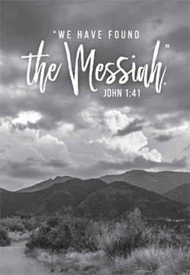](https://www.churchart.com/subscriber/viewimages?book_number=43&chapter=1&verse=41&entry_date=1/1/0001&image_type=cl,ph,pp,bc,ca,mv,wt,nt,pt,ft,ea)Minister of the Host: Edie Knobloch

Altar Servers: Haidyn & Amilyah Koch

Cantor: Ian Wieczorek

Greeter 9th Grade REACH Students

Sunday, January 21 Collection Counters

Debbie Dupnock, Camillus Long

Mary Ann Davis, Sara Zybura

[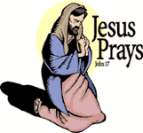](https://www.churchart.com/subscriber/viewimages?book_number=43&chapter=17&verse=1&entry_date=1/1/0001&image_type=cl)[](http://www.churchart.com/Subscriber/ViewImages.aspx?keywords=&entry_date=1/1/0001&image_type=,cl&topic_id=346&image_source_id=&page=1#no)Weare placing names of the sick in the bulletin for prayer providing they give permission. *May the* *Divine Physician send healing grace for those for* *whom we pray:* Allen C. Rosemas, Patricia Murphy, Bernice Myers, Dwight Fyock, Lori Facciani, Dylon Wills, Dawn Hagen, Debbie Dibert, Missy, Joanne (Kolar) Hufford, Christine Flanagan, Ayden Alan Grata, Remy Beaver, Mary Lou Offman, Marian Chuckalovcak, Arlene Diamond, Mary Zangaglia, Dorothy Rosemas, Natalie Zerby, Patricia Grata, Michael Wadsworth, Valencia & Frank Tursi, Homer Locher, Brayden Schofield, Michelle Kasper, Diane Kingera, Allison Krischer, Ted Paluch, Brandt Hutzel, Pearl Litzinger, Patrick Munro, Fran Baldassarre, Corey Lybarger, Kristen Sinosky Long, Helen Ranieri, Cresta Micik, Basil Costantino, Madison McCrory, Laura, Joe Yoder, Dolores Yanzetich, Sandy Krug, Wanda Gramling, Merna Smay, Muriel “Jean” Wiesheier, Agnes Plummer, Jennifer Hagans, Mary McCall, Sean, Holly, Shane, Owen Taylor, Keith & Dawnetta Hoyer, Gail Faher, Marjorie (Latshaw) Feldman, Derrick Varnish, Daniel Koshute, Vincent Koshute, Karen Lovrich, Melissa Cordek, Michelle Elliott, Heather Romanow, Mackston Barrick, Connor Thomas, Erin, Pat, Mary Agnes Nastase, Mary Ann Bertolino, Dick Wilson, Dan Pauley, Jane Plummer, Izzy Bihun, Erica Mitzelfeld, Heidi Allison, Dorothy Kaminsky, Ed Ripper Sr., Bob Debias, Patricia Oshaben, Craig Kraber, Ashlee Madison, Marlene McCrory, Bob Casti, Frank McCleester, Susan Yanzetich and all of the sick of our parish, the homebound, those in nursing homes, those who care for them, and those in the military along with their families. (Please call the Rectory to have your name removed from the list when no longer

sereriously ill. Thank You.

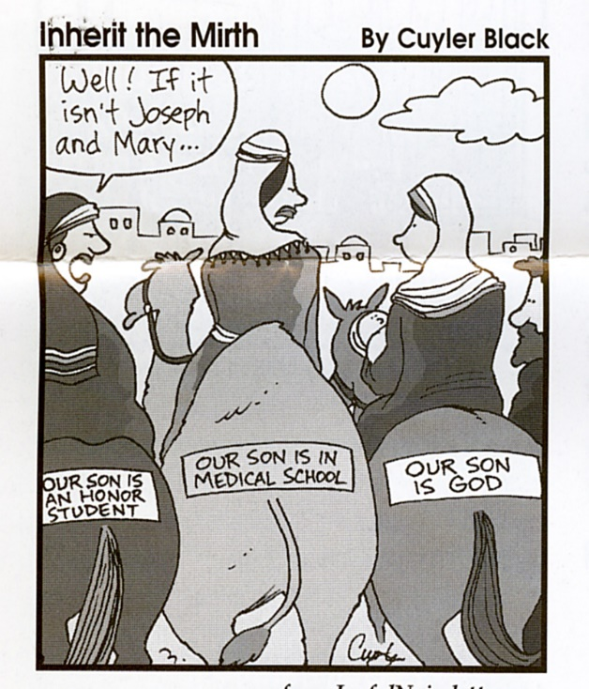

LAST WEEK’S COLLECTION

Adults $2,702.50

Loose $ 172.10

Youth $ 32.40

Monthly $1,068.00

Candles $ 12.00

Maintenance Fund $ 55.00

Initial Offering $ 458.00

Christmas (2017) $ 260.00

Solemnity of Mary $ 229.00

Catholic Charities (2017) $ 5.00

Mandeville Diocese $ 10.00

Black & Indian US Missions $ 10.00

Easter Flowers $ 10.00

Total $5,024.00

We sincerely thank and ask God’s blessing upon all who have care and concern for our parish.

*January 14, 2018 John 1:35-42*

*Jesus’ question in today’s gospel is still valid today: “What are you looking for?” What do you want from your spouse, children or parents? Families are populated with imperfect people. To expect perfection is unreal. To expect and accept imperfection is wisdom.*

MINISTERS OF THE CUP ~ Bishop Mark has directed parishes in the Diocese to not distribute the Precious Blood in any form effective January 13-14. It is the belief of the Catholic Church that the whole Body of Christ is present under either form of consecrated bread and wine. The Bishop has also directed that the faithful should avoid bodily contact, such as shaking hands, during the Sign of Peace. A genuine nod of the head with eye contact with others at Mass will be the temporary practice. This will be followed throughout the winter months or until the flu season ends.

OFFICES CLOSED ~ The offices will be closed on Monday, January 15th, for the Martin Luther King Holiday.

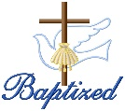BAPTISM ~ On Saturday, January 6th, we celebrated the glorious baptism of Weston Andrew Gallaher, son of Andrew Gallaher and Lindsey Moore by Father Brian Warchola. He became a new creation in Christ in the waters of Holy Baptism. Now joined to us by the gifts of faith, hope and charity, we warmly welcome him into our St. Michael Parish Family.

BAPTISM ~ On Saturday, January 6th, we celebrated the glorious baptism of Calleigh Ann Gallaher, daughter of Cody and Lari (McNerney) Gallaher by Father Brian Warchola. She became a new creation in Christ in the waters of Holy Baptism.

CONTRIBUTION STATEMENTS ~ The Parish Office has closed the books for 2017 parishioner’s contributions. You may request a statement of your tax-deductible donations at any time by calling the rectory at 495-9640. Tax laws state that any amount given as a donation needs to have documentation if you are claiming the donation for tax purposes. If a contribution was made to the CMD, you should have received a statement from the diocese.

We are updating our parish records, so please remember to notify the Office of any changes in address or telephone numbers. If you no longer have a land line and your cellphone is your primary house phone, please call us or drop a note in the collection basket.

LAY MINISTRY SCHEDULES REQUESTS ~ Lay Ministry schedule requests are currently being taken for the Spring schedule which covers February through May 2018. If you have a request for dates you are not available or for dates that you are only available, please contact Suzi Blazosky at 495-5287 or email: [sublazosky@gmail.com](mailto:sublazosky@gmail.com) by Sunday, January 21. Lay ministers are being sought for all masses and all ministries – Cantors, Readers, Eucharistic Ministers, Greeters, Altar Servers, and Collection Counters. Please contact Fr. Brian or Suzi for further details or if you would like to volunteer.

SUNDAY MASS WITH SPORTS STARS ~ Here at St. Michael’s Church on Sunday, January 28, 2018 at 2:00 PM with a Meet and Greet with Talks and 3:00 PM Holy Sacrifice of the Mass. Come see these dedicated athletes: Rick Roberts, Gene Pentz, John Strittmatter and more, who have excelled in sports and fitness, while keeping their Catholic Faith strong in their lives.

SECOND SUNDAY FOOD COLLECTION ~ This weekend is our Second Sunday Food Collection. Please bring in non-perishable food items or toiletries with you. Monetary donations are also appreciated.

HOLY NAME SOCIETY MEETING ~ The Holy Name Society meeting will be held this Sunday, January 14th after the 8:00 AM Mass.

SOUP SALE ~ The Holy Name Society will be making chicken soup for our parish sick and shut-ins on Saturday, January 27th. They are also offering it for sale to members of the parish. The cost is $6.00 per quart. Sign-up sheets are available in the back of the church. Orders can be picked up in the church hall on Saturday, January 27th from 11:00 AM to 2:00 PM or after each weekend Mass on the 27th and 28th.



Religious Education And Christian Helping

January 14, 2018

* Notice Change of Date for Confirmation Retreat

*The Confirmation Retreat* is rescheduled for Saturday, February 10, 2018, 1—6:30 PM

(Due to HS District Jazz Band & Snowball Dance schedules)

All students in grades 9, 10, & 11 will take part in their annual confirmation retreat. This retreat will take place on Saturday, February 10, 2018, 1—6:30 PM. The retreat will focus on the three required retreat topics of ~ “Baptism”, “Gifts of the Holy Spirit” and “Parables”.

The program will begin in the church hall on Saturday, February 3rd for the students. The students come to the church hall and join classmates for specific topic discussions with their grade level leader in designated classrooms for their specific retreat from 1 to 3 PM.

At 3:15 PM, sponsors and/or parents are asked to join the confirmation students in the church for a Rosary lead by our 11th grade Confirmation Class followed by the 4 PM Mass. During this Mass, the 9th grade students will celebrate their “‘Rite of Blessing” and the 10th Grade students will celebrate their “Rite of Commitment” as part of their confirmation journey.

At the conclusion of Mass, students will celebrate the Sacrament of Reconciliation, followed by a pizza social in the church hall for all students, parents and sponsors, including time for reflection on the day and also time for the confirmation candidates and their sponsors to spend time together discussing their sponsor / candidate session activities.

Upcoming Confirmation Sessions

Grade 10 ~ Session 10 B ~ Witness: Word, Worship, Community & Service,

Sunday, January 21, 2018

All 10th Grade students will attend this Session 10B from 9 to 10:20 am.



PRE-K AND KINDERGARTEN REGISTRATION ~ Pre-K and Kindergarten registration will be conducted at Forest Hills Elementary School for children enrolling for the 2018-19 school year. Registrations will be processed in the Multi-Purpose Room at the Elementary School:

Pre-K – March 20th (9:00-11:30 am & 1:00-3:00 PM) and March 21st (9:00-11:30 AM)

In order to qualify for Pre-K placement, a child must be 4 years old on or before September 1, 2018.

*Please note there is NO TRANSPORTATION provided for Pre-K students

Kindergarten – March 21st (1:00-3:00 PM) and March 22nd (9:00-11:30 AM & 1:00-3:00 PM)

In order to qualify for Kindergarten placement, a child must be 5 years old on or before September 1, 2018.

We encourage you to Pre-Register your child prior to the Registration Dates above by returning the enrollment forms to the school. Forms are available at the elementary office.

Please call the Forest Hills Elementary School at (814) 487-7613 for more information.

~~~~~~~~~~~~~~~~~~~~~~~~~~~~~~~~~~~~~~~~~~~~~~~~~~~~~~~~~~~~~~~~~~~~~~~~~~

 We received the following note from Patsy Senft who is

in charge of the Food Pantry:

St. Michael Catholic Church,

I sincerely appreciate your faithful and generous donations

to the Forest Hills Food Pantry. Without people like you this much

needed service to our community wouldn’t be possible.

Thanks again,

*Patsy*

 Sunday, January 14 Religious Education Classes / 6 – 12 / 9:00 – 10:20 AM

Second Sunday Food Pantry Collection

Holy Name Society Meeting / After 8:00 AM Mass

Hall Rental

Monday, January 15 Sunday Choir Practice / 7:00 PM

Tuesday, January 16 Sacrament Class w/ Fr. Grimme / 6:30 – 8:30 PM

Wednesday, January 17 No Mass

Thursday, January 18 K – 5 Religious Education Classes / 3:30-4:30 PM

Saturday Night Choir Practice / 5:30 PM



Friday, January 19

Saturday January 20

UPCOMING EVENTS

January 21 10th Grade Confirmation Session

Hall Rental

January 27 & 28 Holy Name Society Soup for Shut Ins & Soup Sale

January 28 Sunday Mass with Sports Stars

February 3 & 4 St. Blaise, Blessing of Throats

February 10 Confirmation Retreat / Grades 9-11

February 14 Ash Wednesday

HOLY FAMILY PARISH BINGO ~ Join Holy Family Parish at 509 Caldwell Ave., Portage for a night of Bingo, Sun., Jan. 28th in the Parish Hall. Admission is $20 per person. Extra specials and cards will be available. Doors open at 5 PM. Early bird games will begin promptly at 5:30 PM and the regular games will begin at 6:15 PM. Food and refreshments will be available.



BISHOP CARROLL CATHOLIC HIGH SCHOOL OPEN HOUSE ~ Bishop Carroll Catholic High School will hold an Open House for parents and students on Wednesday, January 31 from 6-7 PM. A financial aid meeting will follow from 7-8 PM in the cafeteria. All new students will be eligible for a drawing for a $250 scholarship. Parents can fill out a ticket at the door ad the drawing will be held at the end of the financial aid meeting. You must be present to win. Representatives from Saint Francis University, Saint Vincent College, and Mount Aloysius College will also be on hand to explain the financial and educational advantages for attending Bishop Carroll and continuing on to one of these institutions. For more information, please call the school at 472-7500 extension 105 or email [jnagy@bishopcarroll.org](mailto:jnagy@bishopcarroll.org)