ST. MICHAEL ROMAN CATHOLIC CHURCH

751 Locust Street

PO Box 103

St. Michael, Pennsylvania 15951

Rev. Msgr. David A. Lockard, Administrator MASSES:

(814) 495-9640 Saturday 4:00 pm

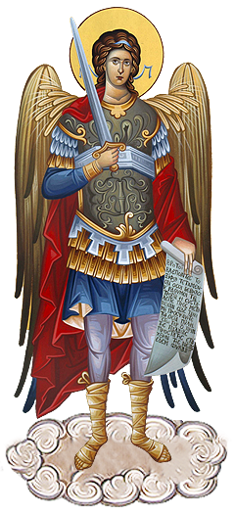 Sunday Morning 8:00 am

Secretary & Bookkeeper: 10:30 am

Michele Panick Daily Mass: M, T, W, Th, F

DRE: Laurie Sloan 9:00 am

Maintenance: Holy Days: See Bulletin

PHONES: Office Hours:

Rectory / Office: (814) 495-9640 8:30 am to 3:30 pm

Fax: (814) 495-9424 Monday, Tues., Thurs., Friday

Rel. Education: (814) 495-4873 Closed Wednesdays

Parish Website Confessions:

[www.saintmichaelchurch.weebly.com](http://www.saintmichaelchurch.weebly.com) Saturday 3:30 pm to 3:45 pm

Secretaries’ E-mail Sunday 7:30 am to 7:45 am

[saintmichaelsecretaries@yahoo.com](mailto:saintmichaelsecretaries@yahoo.com) 10:00 am to 10:15 am

Facebook page: By Appointment

St. Michael Catholic Church/St. Michael, PA

Twentieth Sunday in Ordinary Time

SERVING GOD AND COMMUNITY FOR OVER ONE HUNDRED YEARS!

August 14th, 2022

BAPTISM: By Appointment. Reserve at least one month in advance.

MARRIAGE: Plan at least nine months in advance.

Preparation sessions are necessary.

FUNERALS: Arrangements are made in conjunction with the funeral home.

REGISTRATION Those new to the area, newlyweds, and single adults, (even if

and registered before with their families) are asked to register by calling

MEMBERSHIP: the Parish Office. Every parishioner must be registered. This is a condition for admission to our Program and reception of the Sacraments of Baptism, Confirmation, First Penance, First Eucharist, and Matrimony; also, for testimonial letters or sponsorship of Baptism and Confirmation outside the Parish.

VISITATION: We are concerned and want to be advised when someone is ill at home or in the hospital. Call the office to have the shut-in placed on our monthly Holy Communion calls or seriously ill prayer list.

SACRAMENTAL Parish registration and active Mass participation for Baptism is

POLICY: encouraged and is required for Marriage.

BULLETIN ARTICLES: Articles are due to the Parish Office by Noon on Tuesday

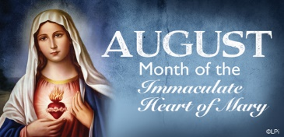Twentieth Sunday in Ordinary Time

August 14th, 2022

Month of The Immaculate Heart of Mary

**MASS INTENTIONS**: (August 15 – August 21, 2022)

Monday, August 15 9:00 AM Betty & Earl Penatzer req. by Family

Tuesday, August 16 9:00 AM Personal Intentions

Wednesday, August 17 9:00 AM Valencia H. Tursi req. by nephew Thomas & Renee

Brattelli

Thursday, August 18 9:00 AM Emile & Irene Danel req. by Daniel & Shelley DeLuca

Friday, August 19 9:00 AM Marlena Holdsworth req. by Family

Saturday, August 20 4:00 PM Ed Myers req. by Tim & Cheryl Pearson

Sunday, August 21 8:00 AM People of the Parish

10:30 AM Regina Anderko req. by Mary Ann Murin & Family

LITURGICIAL APPOINTMENTS:

Saturday, August 20 4:00 PM Offertory Procession

Lector: Madison Kundrod Ed Myers Family

Minister of the Host: Alice Podrebarac

Choir Minister: Karen Myers

Altar Server: Kaylee Roberts

Cantor: Susan Blazosky

Greeter: Helen Slonac

Sunday, August 21 8:00 AM Offertory Procession

Lector: Cathy Faher Terri Leach & Sally Kolar

Minister of the Host: Eric Tedjeske

Choir Minister: Ellen Grattan

Altar Server: Kaden Christ

Cantor: Anita Lorek

Greeter: Carol Hautz

Sunday, August 21 10:30 AM Offertory Procession

Lector: Ryan Jones Michael Steele Family

Minister of the Host: Jennifer Steele

Choir Minister: Robert Oshaben

Altar Server: Mackenzie Steele

Cantor: Louis McCloskey

Greeter: Wendy Blough

Monday, August 22 Collection Counters

George & Pauline Minor

Weare placing names of the sick in the bulletin for prayer providing they give permission. *May the* *Divine Physician send healing grace for those for* *whom we pray:* Allen C. Rosemas, Patricia Murphy, Dwight Fyock, Dylon Wills, Missy, Joanne (Kolar) Hufford, Christine Flanagan, Ayden Alan Grata, Mary Lou Offman, Natalie Zerby, Brayden Schofield, Michelle Kasper, Diane Kingera, Ted Paluch, Pearl Litzinger, Patrick Munro, Fran Baldassarre, Kristen Sinosky Long, Cresta Micik, Basil Costantino, Laura, Joe Yoder, Dolores Yanzetich, Sandy Krug, Wanda Gramling, Jennifer Hagans, Shawn, Holly, Shane, Spencer, Owen Taylor, Derrick Varnish, Vincent Koshute, Michelle Elliott, Heather Romanow, Connor Thomas, Erin, Pat, Mary Agnes Nastase, Mary Ann Bertolino, Dick Wilson, Dorothy Kaminsky, Ashlee Madison, Susan Yanzetich, Alina Rusnak, Gary Smay, Elizabeth Howell, Walter Bodziak, Rhonda, Carter Bobak, Mike Morris, Patty Yanzetich Caldwell, Colton Snyder, Leonard Oshaben, Adam, Lily Maloney, Scott, Lisa, Audrey Costlow, Rosanne Krug, Becky Kakabar, Dolores Mucko, Elliana, Ashlee, Helen Soohy, Carol K. Fabrizio, Peggy Carpenter, Dave Seder, Rosalie Ambrose, Pearl Borlie, Joe (Runk) Slonac, Lori Gramling, Ruth Ferchalk, Ernie Martinage, Mildred Andrykovitch, Katelyn Engle, Colin Wingard, Betty Duray, Jim Fisher, Joy McClain, Brenda Kundrod, Bill Gideos, Corrine Onder, Dennis Richards, Anne Robinson, Joseph Litzinger and all of the sick of our parish, the homebound, those in nursing homes, those who care for them, and those in the military along with their families. *(Please call the Rectory to have your name removed from the list when no longer seriously ill. Thank You.)*

During the week of August 14th, 2022

the Sanctuary Candle will burn in memory of

Rose Chalan

requested by Family

will

[](https://images.search.yahoo.com/search/images;_ylt=A0LEV1kSWptXvOwAKINXNyoA;_ylu=X3oDMTEyZGdkcmRoBGNvbG8DYmYxBHBvcwMxBHZ0aWQDQjIwODlfMQRzZWMDc2M-?p=Clipart+of+a+sanctuary+candle&fr=ush-mailn_02&th=110&tw=110&imgurl=http://www.henningers.com/389-168-wall-sanctuary-lamp.jpg&rurl=http://pixshark.com/sanctuary-lamp.htm&size=43KB&name=Sanctuary+Lamp+Bronze+wall+sanctuary+lamp&h=600&w=600&turl=http://ts2.mm.bing.net/th?id%3DOIP.M68453c67108cdc5ab485d309b395bd03o0%26pid%3D15.1%26rs%3D1%26c%3D1%26qlt%3D95%26w%3D110%26h%3D110#inline&tt=Sanctuary+Lamp+Bronze+wall+sanctuary+lamp&sigr=116keh5le&sigit=13gvlt42j&sigi=11ip0pgm4&sign=119kp6100&sigt=119kp6100)

LAST WEEK’S COLLECTION

Regular Offertory $5,499.00

Maintenance $ 40.00

Feast of Assumption $ 92.00

Total $5,631.00

We sincerely thank and

ask God’s blessing

upon all who have

care and concern

for our parish.

LAST WEEK’S COLLECTION

Regular Offertory $5,499.00

Maintenance $ 40.00

Feast of Assumption $ 92.00

Total $5,631.00

We sincerely thank and

ask God’s blessing

upon all who have

care and concern

for our parish.

*August 14th, 2022 LK 12:49-53*

*Today Jesus warns us his Word will create conflict between parents and children. In a permissive society which advocates individualism and consumerism, parents must continue to teach and live the gospel values of respect, service to others, forgiveness, generosity and compassion. A Christian family is a countercultural family.*

CONGRATULATIONS! ~ Congratulations to two of our young adult parishioners – Elizabeth Dobbins and Eva Spangler! They recently received the Gold Award, which is the highest achievement in Girl Scouting. Both are now pursuing university degrees, Elizabeth at Penn State University and Eva at the University of Virginia. Elizabeth is the daughter of Rob and Amy Dobbins. Eva is the daughter of Bryan and Amy Spangler.

SECOND SUNDAY FOOD PANTRY COLLECTION ~ This weekend is our Second Sunday Food Pantry Collection. Please bring in non-perishable food items or toiletries with you. Monetary donations are also appreciated.

HOLY NAME SOCIETY ~ Will hold their meeting this Sunday, August 14th after the 8 AM Mass in the Hall.

FEAST OF THE ASSUMPTION OF THE BLESSED VIRGIN MARY ~ August 15th – the Assumption of the Blessed Virgin Mary - falls on a Monday this year, so it is not a Holy Day of Obligation. Mass will be at 9:00 AM.

END OF SUMMER CORN ROAST! ~ Come one! Come all! The Holy Name Society will be sponsoring an End of the Summer Corn Roast on Sunday, August 28th at 5 PM at the Pavilion. The corn, hot dogs, and drinks will be provided. There will be games! Bring yourself and a covered dish! Sign-up sheets are on the table at the back of the Church. Please join us for our End of Summer Fling!

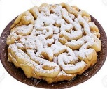

HOLY NAME SOCIETY FUNNEL CAKE BOOTH ~ Sign-up sheets are available on the easel at the back of the church for the Funnel Cake Booth at the Forest Hills Festival on September 3rd, 4th, and 5th. Please consider helping! You don’t have to be a member of the Holy Name Society. This is the Holy Name Society’s biggest fundraiser of the year!

LAY MINISTRY SCHEDULE REQUESTS ~ Lay Ministry schedule requests are currently being taken for the winter months of October through January 2023. If you have dates you are not available or dates that you are only available, please contact Suzi Blazosky at 495-5287 or email: [sublazosky@gmail.com](mailto:sublazosky@gmail.com) by Sunday, September 18th. And please contact Suzi with your Holiday preferences (Any Holy Days, Christmas, and New Year’s). Lay ministers are being sought for all Masses and all ministries – Cantors, Readers, Eucharistic Ministers, Greeters, and Altar Servers.

RITE OF CHRISTIAN INITIATION OF ADULTS (R.C.I.A.) ~ Are you interested, or do you know someone who is interested in becoming a Catholic? Are you a Catholic who would like to grow in faith understanding or has not been confirmed for one reason or another? The R.C.I.A. sessions will resume in October here at St. Michael. For more information, please call Suzi Blazosky at 814-495-5287 or email [sublazosky@gmail.com](mailto:sublazosky@gmail.com).

POSITION OPEN ~ We need someone here at St. Michael to do all the repair work that is needed from time to time. If you are interested, please notify the parish office. Msgr. Lockard will meet with you to go over the salary and explain the job description in more detail.

**FEAST OF THE ASSUMPTION OF MARY~ August 15th**

**9:00 AM MASS**

**Minister of the Host: Helen Slonac**

**Choir Minister: Karen Myers**

HOLY SPIRIT MINISTRY ~ Praise & Worship. The speaker is Andrew Potopa. Andrew will be entering the Loretto Franciscans in the fall. Come and be blessed by his vocation & journey to the Franciscans. Tuesday, August 16th at 7 PM, St. Michael’s Church, Hollidaysburg.

**MINISTRY WORKSHOP** ~ There will be a Ministry Workshopon Saturday, August 20th, from 9 AM – 1:30 PM, at St. Matthew Parish in Tyrone. The Workshop is free and open to anyone. Pre-registration is required to ensure there are enough materials. Refreshments and Lunch will be provided. To register, please contact the Family Life Office at 814-695-5579 x0. You may also register online by emailing your name, phone #, and parish of origin to [familylife@dioceseaj.org](mailto:familylife@dioceseaj.org).

ANNUAL WEDDING ANNIVERSARY LITURGY ~ Couples celebrating 1,5,10,15,20,25,30,35,40,45,50,55,60 + years of marriage in 2022 and their families are invited to the Annual Wedding Anniversary Liturgy. Sunday, September 18th in ALTOONA at Cathedral of the Blessed Sacrament or Sunday, September 25th in JOHNSTOWN at St. John Gualbert Cathedral. Handicap accessible. Both locations begin at 2 PM. Reservations must be made through your parish for either celebration by Monday. August 29th.

WOMEN’S CONFERENCE ~ The Diocese of Altoona-Johnstown women’s conference “Women Find Strength in Christ” will take place on September 10th at Holy Name Parish in Ebensburg. Kelly Walquist, founder of WINE: Women in the New Evangelization, will be the keynote speaker Also presenting will be Denne Miller and Colleen Scariano, co-founders of SoulCore. The conference includes Eucharistic Adoration, the Sacrament of Reconciliation, and lunch. The cost is only $10 per person. Please register online at dioceseaj.org or pick up a hard copy registration form at your parish office and mail it and a check to the diocese. The deadline for reservations is August 31st.

40 HOURS EUCHARISTIC DEVOTION ~ Our Lady of the Alleghenies Parish in Lilly will host a 40 Hours Devotion on Sunday through Tuesday September 11th through September 13th with newly ordained priest Fr. Brian Norris as celebrant and homilist each night. Priests will be available to hear Confessions after the devotions each evening. On the final night, there will be an outdoor Eucharistic procession around the grounds of the church, weather permitting.

EUCHARISTIC REVIVAL ~ Our Diocese launched a Eucharistic Revival along with Dioceses throughout the United States on the Feast of Corpus Christi, June 19, 2022. Together we embarked on a three-year National Eucharistic Revival. The Theme is *“My flesh for the life of the World.”* Our Mission is to renew the Church by enkindling a living relationship with the Lord in the Eucharist. The revival is a personal call, a parish call, and a diocesan call. The Vision is for Catholics across the United States to become unified by an encounter with Jesus in and through the Eucharist where we are invited to experience his true presence. In this first year 2022-2023, we plan to have a Diocesan Day, September 17th, with Priests from our diocese highlighting the Eucharist and inviting us to acknowledge that now is the time to RECOGNINZE JESUS AGAIN in the breaking of the Bread and receiving his presence. We will also provide Eucharistic Readings for Small Group Faith Sharing during the Advent and Lenten Season. Stay tuned to Proclaim for updates and highlights.

MARK YOUR CALENDAR!

CONCERTS

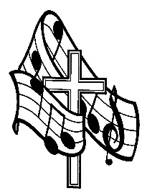Holy Name Church, Ebensburg on Sunday, September 18th at 7 PM will sponsor Catholic Musician Daniel Obereuter and his mission concert. No cost, but a free will offering will be taken for Daniel at the conclusion.

Also, on Saturday, October 15th at 7 PM. Scott Blasey, the lead singer of the band *The Clarks* will be having a solo concert at Holy Name Church, Ebensburg, church hall. Tickets are $10 and attendees must be 21 and older to attend.

ANNUAL MARIAN CELEBRATION FAMILY MASS AND ROSARY ~ Sunday, October 2nd at 3:00 PM. Theme – *“Mary and the Holy Eucharist”*. Principal Celebrant, Bishop Mark Bartchak. St. Benedict Church 2310 Bedford St. Johnstown, PA 15904.

THE EUCHARIST ~ *Believed, Celebrated & Lived* ~ October 23 – 25th Sunday – Tuesday -

7 PM Nightly. Guest Speaker *- Thomas Smith* atSt. Benedict Church, 2310 Bedford St. Johnstown, PA

All are welcome. Free to all. A Love Offering will be taken.

For more info the Rectory 814-266-9718 or

Deacon Michael Russo 814-288-3036

 Religious Education And Christian Helping

August 14, 2022

Religious Education Scheduled to Begin

Religious Education Registration packets have been mailed to all families in our Saint Michael Parish with school aged children.

Our Religious Education classes will begin on Sunday, September 18 for Grades 6—12 from 9:00—10:20 a.m. and on Thursday, September 22 for K—5 students from 3:30—4:30 p.m.

Completed registration forms can be returned to the RE Office by way of the weekend collection basket at any of the masses or by dropping them off in person at the Parish office, or in the Drop-off box outside the office door. K—5 Bus Permission can be returned to the FH Elementary School.

*********************************************************************************

Upcoming REACH Service Project

**

Forest Hills Labor Day Festival ~ The annual Forest Hills Labor Day Festival will be held September 3rd, September 4th & September 5th.

The Festival is a great opportunity for our REACH students to help and at the same time to earn 'Service Hour Credit' towards the community service requirement for their confirmation process.

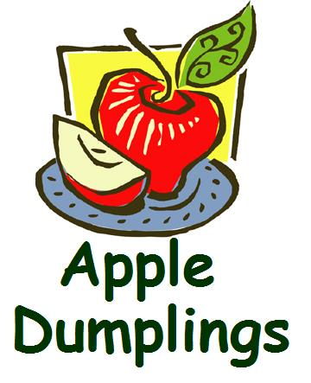

REACH Festival Booth Fundraiser ~ The REACH Festival Booth sign-up sheets are ready and available for our students to choose a preferred day and time to help with our 2 booths. We will be selling Apple Dumplings and Ice Cream Sundaes. Proceeds will go towards future REACH activities. It’s a great opportunity for our REACH families to offer their assistance to our REACH Youth Ministry.

Sign-up sheets are on the easel in the back of the church for REACH students and parents to sign-up for preferred time slots.

*REACH Student and Parent volunteers are needed to help with both booths for the 3-day weekend. Parent chaperones are needed in each booth for all 2-Hour time slots.*

*Call the RE Office at 814-495-4873 to volunteer.*

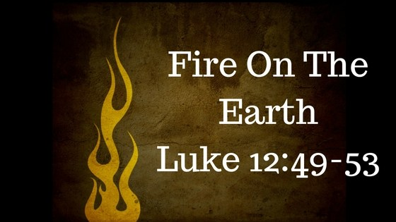

Sunday, August 14 Mass ~ 8:00 AM & 10:30 AM

Confessions / 7:30 – 7:45 AM & 10:00 - 10:15 AM / Confessional

Second Sunday Food Pantry Collection

Holy Name Society Meeting / Hall / After 8:00 AM Mass

Pavilion Rental

Monday, August 15 Mass ~ 9:00 AM

Sunday Choir Practice / 7:00 PM

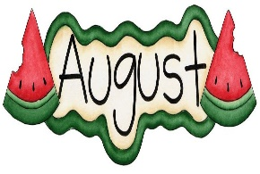

Tuesday, August 16 Mass ~ 9:00 AM

Young Adult Leadership Meeting / Hall / 6:30 PM

Boy Scout Meeting / Pavilion / 7:00 PM

Wednesday, August 17 Mass ~ 9:00 AM

Thursday, August 18 Mass ~ 9:00 AM

Saturday Choir Practice / 4:30 PM

Knights of Columbus / Pavilion / 6:00 PM

Friday, August 19 Mass ~ 9:00 AM

 Saturday, August 20 Mass ~ 4:00 PM

Confessions / 3:30 – 3:45 PM / Confessional

Kayla Walls / Zachary Ferchalk Nuptials / 1:30 PM

UPCOMING EVENTS

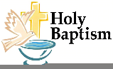 August 21 Emma Grace Baker Baptism

August 25 Religious Education Teacher’s Meeting

August 28 Parish Corn Roast / Pavilion

September 1 St. Michael Cemetery Committee Meeting

September 3, 4 & 5 Forest Hills Festival

September 3 & 4 Missionary Co-Op Weekend

September 5 Labor Day / Parish Offices Closed