ST. MICHAEL ROMAN CATHOLIC CHURCH

751 Locust Street

PO Box 103

St. Michael, Pennsylvania 15951

Rev. Msgr. David A. Lockard, Administrator MASSES:

(814) 495-9640 Saturday 4:00 pm



Sunday Morning 8:00 am

Secretary & Bookkeeper: 10:30 am

Michele Panick Daily Mass: M, T, W, Th, F

Noon

DRE: Laurie Sloan Holy Days: See Bulletin

Maintenance: Rodney Turgeon Office Hours:

PHONES: 8:30 am to 3:30 pm

Rectory / Office: (814) 495-9640 Monday, Tues., Thurs., Friday

Fax: (814) 495-9424 Closed Wednesdays

Rel. Education: (814) 495-4873 Confessions:

Parish Website Saturday 3:30 pm to 3:45 pm

[www.saintmichaelchurch.weebly.co](http://www.saintmichaelchurch.weebly.co)m Sunday 7:30 am to 7:45 am

Secretaries’ E-mail 10:00 am to 10:15 am

[saintmichaelsecretaries@yahoo.com](mailto:saintmichaelsecretaries@yahoo.com) By Appointment

Facebook page:

St. Michael Catholic Church/St. Michael, PA

Thirteenth Sunday in Ordinary Time

SERVING GOD AND COMMUNITY FOR OVER ONE HUNDRED YEARS!

June 27th, 2021

BAPTISM: By Appointment. Reserve at least one month in advance.

MARRIAGE: Plan at least nine months in advance.

Preparation sessions are necessary.

FUNERALS: Arrangements are made in conjunction with the funeral home.

REGISTRATION Those new to the area, newlyweds, and single adults, (even if registered

and before with their families) are asked to register by calling the Parish Office.

MEMBERSHIP: Every parishioner must be registered. This is a condition for admission

to our Program and reception of the Sacraments of Baptism, Confirmation,

First Penance, First Eucharist, and Matrimony; also, for testimonial letters or sponsorship of Baptism and Confirmation outside the Parish.

VISITATION: We are concerned and want to be advised when someone is ill at home or in the hospital. Call the office to have the shut-in placed on our monthly Holy Communion calls or seriously ill prayer list.

SACRAMENTAL Parish registration and active Mass participation for Baptism is

POLICY: encouraged and is required for Marriage.

BULLETIN ARTICLES: Articles are due to the Parish Office by Noon on Tuesday.

 Thirteenth Sunday in Ordinary Time

June 27th, 2021

Month of the Sacred Heart of Jesus

**MASS INTENTIONS**: (June 28 – July 4, 2021)

Monday, June 28 Noon Agnes Noon req. by Larry Celmer

Tuesday, June 29 Noon Francis X. Powers req. by sister, Patty Steves

Wednesday, June 30 Noon Thomas Andrew Kovach req. by Mary Jean Brown

Thursday, July 1 Noon Ed Myers req. by Ruth Armold

Friday, July 2 Noon Marie Minor req. by Pam, Mike, Julie, Justin, Merielle & Levi

Saturday July 3 4:00 PM People of the Parish

Sunday, July 4 8:00 AM Paul D. Yanzetich req. by Susan

10:30 AM Anna Wilson req. by Mary Ann Murin & family

LITURGICIAL APPOINTMENTS:

Saturday, July 3 4:00 PM Offertory Procession

Lector: Sherry Dipko Bryan Spangler Family

Minister of the Host: Alice Podrebarac

Choir Minister: Susan Blazosky

Altar Server: Brooke Williamson

Cantor: Amanda Williamson

Greeter: Darlene Marshall

Sunday, July 4 8:00 AM Offertory Procession

Lector: Terri Leach Paul Yanzetich Family

Minister of the Host: Pauline Minor

Choir Minister: Sally Kolar

Altar Server: Ian Dobbins

Cantor: Anita Lorek

Greeter: Carol Hautz

Sunday, July 4 10:30 AM Offertory Procession

Lector: James Lashinsky Michael Steele Family

Minister of the Host: Susan Wieczorek

Choir Minister: Jennifer Steele

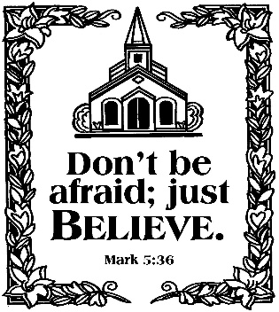Altar Server: Jackson Henderson

Cantor: Elizabeth Dobbins

Greeter: Volunteer

Tuesday, July 6 Collection Counters

George & Pauline Minor

Weare placing names of the sick in the bulletin for prayer providing they give permission. *May the* *Divine Physician send healing grace for those for* *whom we pray:* Allen C. Rosemas, Patricia Murphy, Bernice Myers, Dwight Fyock, Dylon Wills, Missy, Joanne (Kolar) Hufford, Christine Flanagan, Ayden Alan Grata, Mary Lou Offman, Mary Zangaglia, Natalie Zerby, Valencia Tursi, Homer Locher, Brayden Schofield, Michelle Kasper, Diane Kingera, Ted Paluch, Pearl Litzinger, Patrick Munro, Fran Baldassarre, Kristen Sinosky Long, Cresta Micik, Basil Costantino, Laura, Joe Yoder, Dolores Yanzetich, Sandy Krug, Wanda Gramling, Jennifer Hagans, Shawn, Holly, Shane, Spencer, Owen Taylor, Derrick Varnish, Vincent Koshute, Michelle Elliott, Heather Romanow, Mackston Barrick, Connor Thomas, Erin, Pat, Mary Agnes Nastase, Mary Ann Bertolino, Dick Wilson, Izzy Bihun, Dorothy Kaminsky, Ashlee Madison, Susan Yanzetich, Mike, Alina Rusnak, Gary Smay, Elizabeth Howell, Walter Bodziak, Rhonda, Anne Robinson, Carter Bobak, Mike Morris, Sarah Kelt, Patty Yanzetich Caldwell, Colton Snyder, Nancy Edmiston, Leonard Oshaben, Adam, Janice Dipyatic, Lily Maloney, Scott, Lisa, Audrey Costlow, Cathy Sossong, Rosanne Krug, Becky Kakabar, Dolores Mucko, Elliana, Ashlee, Helen Soohy, Carol K. Fabrizio, Peggy Carpenter, Dave Seder, Rosalie Ambrose, Pearl Borlie, Joe (Runk) Slonac, Sharon Poldiak, Patty Gdula, Judy Barr, Ric Szelong and all of the sick of our parish, the homebound, those in nursing homes, those who care for them, and those in the military along with their families. *(Please call the Rectory to have your name removed from the list when no longer seriously ill. Thank You.)*

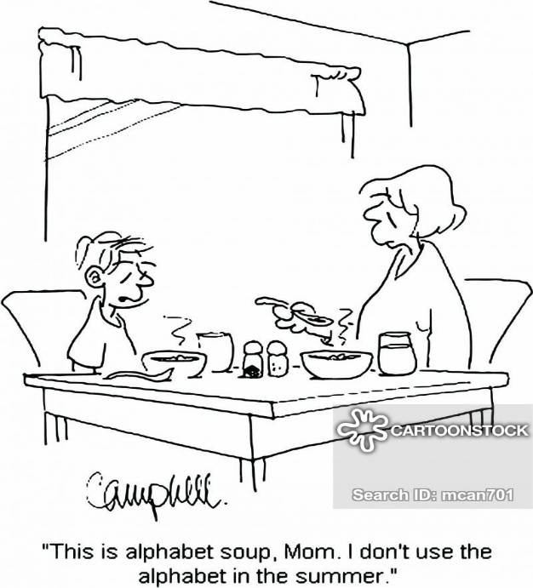

LAST WEEK’S COLLECTION

Adults $3,585.00

Loose $ 171.00

Youth $ 22.50

Monthly $ 650.00

Candles $ 43.00

Maintenance Fund $ 55.00

Father’s Day $ 506.00

Ascension Thursday $ 20.00

Feast of the Assumption $ 35.00

Peter’s Pence (Holy Father) $ 61.00

Total $5,148.50

We sincerely thank and ask

God’s blessing upon all who

have care and concern

for our parish.

June 27, 2021

The First Reading from the Book of Wisdom explains to us the importance of striving to understand the mysteries of faith. However, the great challenge is the action, living it out in our daily lives. That demonstrates wisdom. Today’s Second Reading speaks clearly of Christian stewardship, “out of his richness, Jesus became poor, and through his poverty, he became rich.” Share all your gifts in justice and love. You allow others to meet their *needs* by denying yourself of your *wants.*

[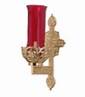](https://images.search.yahoo.com/search/images;_ylt=A0LEV1kSWptXvOwAKINXNyoA;_ylu=X3oDMTEyZGdkcmRoBGNvbG8DYmYxBHBvcwMxBHZ0aWQDQjIwODlfMQRzZWMDc2M-?p=Clipart+of+a+sanctuary+candle&fr=ush-mailn_02&th=110&tw=110&imgurl=http://www.henningers.com/389-168-wall-sanctuary-lamp.jpg&rurl=http://pixshark.com/sanctuary-lamp.htm&size=43KB&name=Sanctuary+Lamp+Bronze+wall+sanctuary+lamp&h=600&w=600&turl=http://ts2.mm.bing.net/th?id=OIP.M68453c67108cdc5ab485d309b395bd03o0&pid=15.1&rs=1&c=1&qlt=95&w=110&h=110#inline&tt=Sanctuary+Lamp+Bronze+wall+sanctuary+lamp&sigr=116keh5le&sigit=13gvlt42j&sigi=11ip0pgm4&sign=119kp6100&sigt=119kp6100)

During the week of June 27th, 2021

the Sanctuary Candle will burn for

the Sick and Shut-ins

of St. Michael Parish

LAY MINISTERS ~ There are two names to add to the Lay Minister schedules. If you need a substitute for a Lector, please call Terry Crissey (814-266-4501) or if you need a Eucharistic Minister, please call Haidyn Koch (814-495-8120). Thank you.

PETER’S PENCE COLLECTION ~ Today is the Peter’s Pence Second Collection, a worldwide collection that supports the work of the Universal Church, including the work of the Holy See and the charitable works of Pope Francis. Take this opportunity to join with Pope Francis and be a sign of mercy to our suffering brothers and sisters. Please be generous today. For more information, visit [www.peterspence.va/en.html](http://www.peterspence.va/en.html).

HOLY NAME SOCIETY ~ There will be a Holy Name Society meeting on Wednesday, June 30th at 7:00 PM in the Hall.

PUBLIC ROSARY ~ In Honor of Our Lady of Mount Carmel and to Pray for the U.S.A. Saturday, July 10th at NOON / Central Park, Downtown Johnstown.

JOB OPENINGS ~ Two maintenance positions and a cafeteria worker needed at Holy Name School, Ebensburg. Please call Fr. Brian Warchola at Holy Name Church (814) 472-7244.

JUNE 2021 PARISH TICKET WINNERS

UNSOLD TICKETS/NOT RETURNED TICKETS ~ If the winning number is a ticket that was not sold or returned, the money will be split with the number above the winning number and the number below the winning number. If the number above or below the winning number was not returned, we will go above or below that number.

Day Date Amount Number Winner

Friday June 18, 2021 $75 780 Ticket Not Sold

 $37.50 781 Jen Poldiak

779 Ticket Not Sold

$37.50 778 Dorothy Mucha

Saturday June 19, 2021 $100 489 Mark Bambino

Sunday June 20, 2021 $150 980 Ticket Not Sold

981 Ticket Not Sold

$75 982 Margo Myers

$75 979 William Vasbinder

Monday June 21, 2021 $75 361 Annette Kestermont

Tuesday June 22, 2021 $75 775 Stacy Varner Wednesday June 23, 2021 $75 397 Brandon Hampton

Thursday June 24, 2021 $75 807 Jean Rearick



Religious Education And Christian Helping

June 27, 2021

Camp Zacchaeus Summer Camp



2

0

2

1



FAITH

SHARING

LGE’s

F

U

N

ARTS

&

CRAFTS

BEING

WITH

FRIENDS



Our Diocese of Altoona-Johnstown is offering three great days of Faith, Fun and Friendship this summer at Camp Zacchaeus. Any students entering grades 3-9 in September of 2021 are eligible to attend. Day camp is being offered in three areas: Altoona and State College on July 19, 20 and 21, 2021. Our Johnstown area site will be held at Resurrection Picnic Grove on July 26, 27 & 28, 2021. Registrations will be accepted on a first come basis until each site is full with a registration deadline of June 25th. (Contact Francine Swope, Camp Director, at the Youth Ministry Office at 814-317-2646 to see if space is still available). A Camp Zacchaeus brochure with registration information is available at the church entrances or in the Parish Office for those interested.

******************************************************************************************

Final Home Lesson Packets ~ We are continuing to collect completed lessons for our Religious Education students. When home lessons are completed, they can be returned to the Blue Tote outside the Parish Office door marked: "Religious Education Pick-Ups & Drop Offs", or you can also place them in the Bridal room of the church. A reminder to also return any textbooks that were used throughout the year. Returned lessons and textbooks will be given to each catechist as they are received.

*New volunteers are always needed to help with our parish children.*

We need your help to carry out our activities and projects at the parish.

If you are willing to do so, FIRST we need to obtain your clearances.

The PENNSYLVANIA CHILD PROTECTIVE SERVICE LAW requires all PA clearances and training for anyone working with our parish children. All helpers, volunteers and any other adults who wish to help chaperone or mentor our children in any way are required to have and will need these clearances. The clearances are free of charge for all volunteers.

Our Diocese of Altoona-Johnstown also requires all volunteers to be registered with VIRTUS Online and complete the Youth Protection Awareness Training. Our Parish is then required to have copies of these clearances on file in our Parish Office.

Please contact the Religious Education Office at 495-4873 or the Parish Office at 495-9640 for information on how to obtain these clearances. Your swiftness to complete the clearance process over the summer will help assure that we have an adequate number of compliant volunteers able to help with our youth when needed for our Religious Education and Youth Ministry programs and activities.

Sunday, June 27 Mass ~ 8:00 & 10:30 AM

Confessions / 7:30 – 7:45 AM & 10:00 – 10:15 AM / In the Confessional

Peter’s Pence Second Collection

 Monday, June 28 Mass ~ Noon

Tuesday, June 29 Mass ~ Noon

Wednesday, June 30 Mass ~ Noon

Holy Name Society Meeting / 7:00 PM / Hall

Thursday, July 1 Mass ~ Noon

Friday, July 2 Mass ~ Noon

Saturday, July 3 Mass / 4:00 PM

Confessions / 3:30 – 3:45 / In the Confessional

Garrison Hood / Ashley Delfonso Nuptials / 1:30 PM

 UPCOMING EVENTS

July 5 4th of July Holiday / Parish Offices Closed

July 11 Parish Council Meeting



FOURTH OF JULY PICNIC ~ Immaculate Conception Church, New Germany Grove. Saturday, July 3rd in the Beverage Hall: 7-10 PM Food & Beverages, 7:30 PM Cornhole Tournament (age 21 & over). Sunday, July 4th: 8 AM Firecracker Frolic 5K, 9 AM Children’s Lollipop Run, 11 AM – 6 PM Food, Games, Bingo & More. 11 AM – 11 PM Beverage Hall, Noon – 2 PM Music by “Joe Caroff” and 2:30 – 5:30 PM music by “Darrell Dumm”. 11 AM – 3 PM Chicken Noodle Soup, BBQ Chicken, BBQ Beef Sandwiches & More.



BASKET RAFFLE ~ District 14J Lions 2 Day Event. Saturday, July 10th from 10 AM – 5 PM. Sunday, July 11th from 10 AM – 3 PM. St. Michael Festival Grounds. Drawing live on Facebook Sunday, July 11th after 3 PM. For more information phone: 814-487-5988 OR 814-487-4132.



ETHNIC FESTIVAL FOOD ~ St. Anthony of Padua, Windber the weekend of July 10 & 11 for take-out only. Sat. July 10 3-7 PM and Sun. July 11, 11 AM-4 PM. We are also selling 4th of July/Festival tickets. $20 each and have 4 – 3-digit numbers on each ticket & is based off of the PA Lottery. They run July 3-11 with prizes of $150, $300 or $500 each night. For tickets, call the parish office 814-467-7292.

ST. JOAN OF ARC CHURCH ~ Route 53, Frugality, PA (near Prince Gallitzin State Park and Glendale Lake) will be holding their fundraiser on, Sunday, July 18th. We are featuring a Takeout Only ROAST BEEF DINNER from 11:00 AM to 3:00 PM only and also a Basket Auction from 11:00 AM to 4:00 PM. Winners will be notified by telephone on the day of the drawing and prizes can be picked up the next day – Monday, July 19 from 1:00 PM to 5:00 PM at the Parish Hall. Roast Beef Dinner Cost is : $10.00.