ST. MICHAEL ROMAN CATHOLIC CHURCH

751 Locust Street

PO Box 103

St. Michael, Pennsylvania 15951

Rev. Msgr. David A. Lockard, Administrator MASSES:

(814) 495-9640 Saturday 4:00 pm



Sunday Morning 8:00 am

Secretary & Bookkeeper: 10:30 am

Michele Panick Daily Mass: M, T, W, Th, F

Noon

DRE: Laurie Sloan Holy Days: See Bulletin

Maintenance: Rodney Turgeon Office Hours:

PHONES: 8:30 am to 3:30 pm

Rectory / Office: (814) 495-9640 Monday, Tues., Thurs., Friday

Fax: (814) 495-9424 Closed Wednesdays

Rel. Education: (814) 495-4873 Confessions:

Parish Website Saturday 3:30 pm to 3:45 pm

[www.saintmichaelchurch.weebly.co](http://www.saintmichaelchurch.weebly.co)m Sunday 10:00 am to 10:15 am

Secretaries’ E-mail By Appointment

[saintmichaelsecretaries@yahoo.com](mailto:saintmichaelsecretaries@yahoo.com)

Facebook page:

St. Michael Catholic Church/St. Michael, PA

The Most Holy Trinity

SERVING GOD AND COMMUNITY FOR OVER ONE HUNDRED YEARS!

May 30th, 2021

BAPTISM: By Appointment. Reserve at least one month in advance.

MARRIAGE: Plan at least nine months in advance.

Preparation sessions are necessary.

FUNERALS: Arrangements are made in conjunction with the funeral home.

REGISTRATION Those new to the area, newlyweds, and single adults, (even if registered

and before with their families) are asked to register by calling the Parish Office.

MEMBERSHIP: Every parishioner must be registered. This is a condition for admission

to our Program and reception of the Sacraments of Baptism, Confirmation,

First Penance, First Eucharist, and Matrimony; also, for testimonial letters or sponsorship of Baptism and Confirmation outside the Parish.

VISITATION: We are concerned and want to be advised when someone is ill at home or in the hospital. Call the office to have the shut-in placed on our monthly Holy Communion calls or seriously ill prayer list.

SACRAMENTAL Parish registration and active Mass participation for Baptism is

POLICY: encouraged and is required for Marriage.

BULLETIN ARTICLES: Articles are due to the Parish Office by Noon on Tuesday.

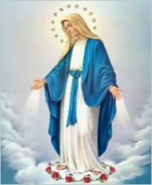 Most Holy Trinity

May 30th, 2021

Month of the Blessed Virgin Mother

**MASS INTENTIONS**: (May 31 – June 6, 2021)

Monday, May 31 10:00 AM All the Deceased (St. Joseph Cemetery)

Tuesday, June 1 Noon Ronald Peschock req. by Msgr. David Lockard

Wednesday, June 2 Noon Hermine Sivec req. by husband, Bob

Thursday, June 3 Noon Irene & Ray Baldwin req. by Carl & Pam Freidhoff

Friday, June 4 Noon Janet Smith req. by sister, Reba Vasas & family

Saturday June 5 4:00 PM Mary Perich req. by Albert Sracic

Sunday, June 6 8:00 AM Peter Bernard Jr. req. by Joan & Bob Oshaben

10:30 AM People of the Parish

LITURGICIAL APPOINTMENTS:

Saturday, June 5 4:00 PM Offertory Procession

Lector: Susan Poldiak John & Susan Poldiak

Minister of the Host: Babe Richards

Choir Minister: Karen Myers

Altar Server: Ana Spangler

Cantor: Amy Spangler

Greeter: Mary Ann Spangle

Sunday, June 6 8:00 AM Offertory Procession

Lector: Joe Faher Arnold & Marie Bernard

Minister of the Host: Sally Kolar

Choir Minister: Eric Tedjeske

Altar Server: Griffin Christ

Cantor: Amy Dobbins

Greeter: Pauline Minor

Sunday, June 6 10:30 AM Offertory Procession

Lector: Carole Kakabar Michael Steele Family

Minister of the Host: Susan Wieczorek

Choir Minister: Mike Barton

Altar Server: Alexis Henderson

Cantor: Elizabeth Dobbins

Greeter: Nancy Wessel

Monday, June 7 Collection Counters

George & Pauline Minor

Weare placing names of the sick in the bulletin for prayer providing they give permission. *May the* *Divine Physician send healing grace for those for* *whom we pray:* Allen C. Rosemas, Patricia Murphy, Bernice Myers, Dwight Fyock, Dylon Wills, Missy, Joanne (Kolar) Hufford, Christine Flanagan, Ayden Alan Grata, Mary Lou Offman, Mary Zangaglia, Natalie Zerby, Valencia Tursi, Homer Locher, Brayden Schofield, Michelle Kasper, Diane Kingera,

Ted Paluch, Pearl Litzinger, Patrick Munro, Fran Baldassarre, Kristen Sinosky Long, Cresta Micik, Basil Costantino, Laura, Joe Yoder, Dolores Yanzetich, Sandy Krug, Wanda Gramling, Jennifer Hagans, Shawn, Holly, Shane, Spencer, Owen Taylor, Derrick Varnish, Vincent Koshute, Michelle Elliott, Heather Romanow, Mackston Barrick, Connor Thomas, Erin, Pat, Mary Agnes Nastase, Mary Ann Bertolino, Dick Wilson, Izzy Bihun, Dorothy Kaminsky, Ashlee Madison, Susan Yanzetich, Mike, Alina Rusnak, Gary Smay, Elizabeth Howell, Walter Bodziak, Rhonda, Anne Robinson, Carter Bobak, Mike Morris, Sarah Kelt, Patty Yanzetich Caldwell, Colton Snyder, Nancy Edmiston, Leonard Oshaben, Adam, Janice Dipyatic, Lily Maloney, Scott, Lisa, Audrey Costlow, Cathy Sossong, Rosanne Krug, Becky Kakabar, Dolores Mucko, Elliana, Ashlee, Helen Soohy, Carol K. Fabrizio, Peggy Carpenter, Dave Seder, Rosalie Ambrose, Pearl Borlie, Joe (Runk) Slonac, Sharon Poldiak, Patty Gdula, Judy Barr, Ric Szelong and all of the sick of our parish, the homebound, those in nursing homes, those who care for them, and those in the military along with their families. *(Please call the Rectory to have your name removed from the list when no longer seriously ill. Thank You.)*

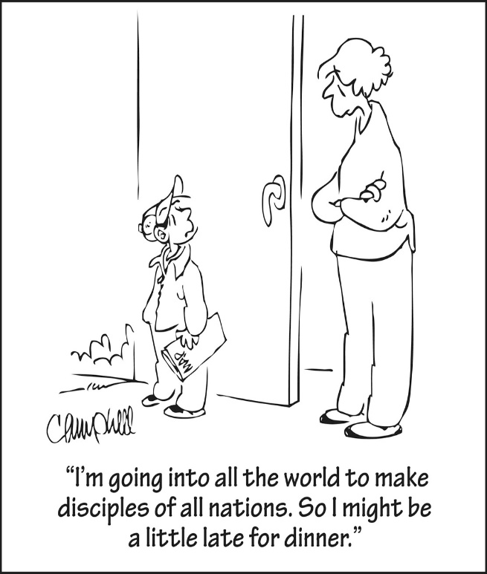

LAST WEEK’S COLLECTION

Adults $2,361.00

Loose $ 137.00

Youth $ 20.00

Monthly $ 120.00

Candles $ 3.00

Maintenance Fund $ 281.00

Mother’s Day $ 10.00

Easter Offering $ 3.00

Ascension Thursday $ 32.00

Cemetery Maintenance $ 466.00

Holy Thursday $ 1.00

Catholic Communication $ 56.00

Total $3,490.00

We sincerely thank and ask God’s

blessing upon all who have care

and concern for our parish.

May 30, 2021 Matthew 28:16-20

In today’s gospel Jesus commands, “Teach them to carry out everything I have commanded you.” This command is meant for every Christian. In light of this command, parenting is not only the most difficult task a person can take on, it is also one of the most apostolic and missionary tasks. Jesus commands all parents to teach their children “all that I have commanded you.”

[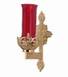](https://images.search.yahoo.com/search/images;_ylt=A0LEV1kSWptXvOwAKINXNyoA;_ylu=X3oDMTEyZGdkcmRoBGNvbG8DYmYxBHBvcwMxBHZ0aWQDQjIwODlfMQRzZWMDc2M-?p=Clipart+of+a+sanctuary+candle&fr=ush-mailn_02&th=110&tw=110&imgurl=http://www.henningers.com/389-168-wall-sanctuary-lamp.jpg&rurl=http://pixshark.com/sanctuary-lamp.htm&size=43KB&name=Sanctuary+Lamp+Bronze+wall+sanctuary+lamp&h=600&w=600&turl=http://ts2.mm.bing.net/th?id=OIP.M68453c67108cdc5ab485d309b395bd03o0&pid=15.1&rs=1&c=1&qlt=95&w=110&h=110#inline&tt=Sanctuary+Lamp+Bronze+wall+sanctuary+lamp&sigr=116keh5le&sigit=13gvlt42j&sigi=11ip0pgm4&sign=119kp6100&sigt=119kp6100)

During the week of May 30th, 2021

the Sanctuary Candle will burn for

All the Souls in Purgatory

[](http://www.churchart.com/subscriber/viewimages.aspx?keywords=In%20Sympathy&entry_date=1/1/0001&image_type=,cl#no)

MAY SHE REST IN PEACE ~ In your charity, please pray for the eternal rest of Dolores Meier whose funeral Mass was celebrated on Thursday, May 27th, 2021. May she know the eternal peace and happiness promised by our Savior, Lord Jesus. Please pray for the consolation of all her family and friends.

CONFESSIONS ~ Have returned to the old Reconciliation Room (cry room) as the place for confession. We have also returned to the old schedule of confession: Saturday from 3:30 PM to 3:45 PM, Sunday from 7:30 AM to 7:45 AM and from 10:00 AM to 10:15 AM.

MEMORIAL DAY ~ Mass for Memorial Day Monday, May 31st will be at St. Joseph Cemetery, Beaverdale at 10:00 AM. There is seating for 40 people inside & tents will be set up outside the Chapel or visitors could bring lawn chairs, so you don’t have to stand. There will be NO Mass here at St. Michael. The Parish Offices will be closed on Memorial Day. Office hours will resume on Tuesday, June 1st at 8:00 AM.

MAINTENANCE FUND TICKETS ~ Please remember to return your stub, money, or your unsold tickets to the parish office by today, Sunday, May 30th.

WINNERS! ~ The winners of the Knights of Columbus Scholarship Council 2275 are: Jonathan Charney of Most Holy Trinity Church, South Fork and Dylan Kundrod of St. Michael Church, St. Michael. Thanks to all the applicants for this years scholarships.

BABY BOTTLES ~ The empty baby bottles are available in the Bridal Room. Please take a bottle, fill it up with change and return it to the Bridal Room by Father’s Day, June 20th. Sponsored by PRECIOUS LIFE, a Christian ministry providing positive alternatives to abortion.

OUTDOOR MASSES ~ Will be celebrated at the Our Lady of the Alleghenies Shrine in Loretto every Sunday night at 7 PM beginning on Memorial Day weekend–May 30 and continuing through Labor Day weekend–September 5. Those attending are asked to bring their own lawn chair. In the event of inclement weather, Mass will be celebrated inside the Basilica of St. Michael the Archangel next to the Shrine. The Prince Gallitzin Chapel House, next to the Shrine, will be open for self-guided tours from 3-6 PM on June 6th & 20th; July 18th; and August 1st, 15th and 29th.

SELF-GUIDED TOURS ~ Saint Joseph Mission Church, Hart’s Sleeping Place, Carrolltown, PA. This historic Church will be opening once a month for visitation and self-guided tours. Schedule is: Church is open from Noon – 3 PM on Sundays June 6th, July 4th, and September 5th. A special outdoor Mass with Bishop Mark as Main Celebrant will be held on Sunday August 1 at 4 PM. The Church will be open from Noon – 3:30 PM, with Confessions form 1 – 3 PM. Curator: Marian Farabaugh: [stjosephmissionchurch1830@gmail.com](mailto:stjosephmissionchurch1830@gmail.com).



Catholic Ministries Drive / 2021

Diocesan Goal $ 27,192.00

Pledged $ 9,192.50

Balance $ 17,999.50

Number of Responses 36

Thank you to all parishioners who have responded to the *2021 Catholic Ministries Drive.* Please join them in supporting our Parish and a select group of ministries that provide outreach to the poor, family life, youth, and seminarians. If you did not receive a pledge card in the mail, you may give online at [www.dioceseaj.org](http://www.dioceseaj.org).



Religious Education And Christian Helping

May 30, 2021

ANCHORED! VACATION BIBLE CAMP 2021 ~ Our Forest Hills Parishes have joined forces for this year’s VBC Anchored! VBC will run Monday, June 21st – Friday, June 25th from 9am-12pm at The New Germany Grove grounds. First Mates, 2017 (birth year) through those entering 7th grade, need to register by June 13th. Cost is $8 per child. $2 discount per additional child for multiple children from same household. Volunteers, 8th grade through adults also need to be registered by June 13th. Teen volunteers can earn 15 service hours for helping at VBC. Volunteers need to complete all state and diocese requirements to volunteer.

Registration information and forms are available at the entrances of the church or in the Parish offices.

Registrations can be returned in the weekly collection basket or to the Parish Office.

*******************************************************************************************************************

Camp Timothy ~ Youth in grades 10—12 and newly graduated Seniors 2021. Are you tired of the same old, same old? Are you ready for a much-needed change of pace? Are you looking for a way to increase and strengthen your faith? Are you ready for something new, challenging and fun?? Then YOU NEED TO JOIN US FOR CAMP TIMOTHY 2021!! June 21, 22, and 23.

Camp Timothy is being held at Resurrection Picnic Grove in Johnstown, PA. We will offer Virtual, Day Camp, and an Overnight Tent camping option! Camp Timothy will be held following all current Federal (CDC), State and Diocesan protocols for COVID. For those who wish to stay over for the two nights of Camp Timothy, we will offer tent camping. The registration deadline is June 7, 2021. A limited number of campers will be accepted on a first come, first serve basis. Brochures are available in the Parish Office for anyone interested in attending. For more information, you can also contact Francine Swope in the Youth Ministry Office at (814)317-2646.

*********************************************************************************************************

Camp Zacchaeus Day Camp ~ Our Diocese of Altoona-Johnstown is offering three great days of Faith, Fun and Friendship this summer at Camp Zacchaeus. Any students entering grades 3-9 in September of 2021 are eligible to attend. Day camp is being offered in three areas: Altoona and State College on July 19, 20 and 21, 2021. Our Johnstown area site will be held at Resurrection Picnic Grove on July 26, 27 & 28, 2021. Registrations will be accepted on a first come basis until each site is full with a registration deadline of June 25th.

*\*Note: Date change for Johnstown location.* Brochures that were previously sent home with our students have the old date on the information brochure. Our Diocese has now provided an updated registration brochure. This updated Camp Zacchaeus brochure with the revised dates is available in the Parish Office for those interested in attending.

Final Home Lesson Packets ~ Final lesson packets for April were distributed to all students in grades K—10 and are available in our pick-up tote. When previous month’s lessons are completed, they can be returned to the Blue Tote outside the Parish Office door marked: "Religious Education Pick-Ups & Drop Offs", along with textbooks that were used throughout the year.

Sunday, May 30 Mass ~ 8:00 & 10:30 AM

Confessions / 7:30 – 7:45 AM & 10:00 – 10:15 AM / Confessional



Monday, May 31 Mass ~ St. Joseph Cemetery / 10:00 AM

NO MASS at St. Michael Church

Memorial Day

Parish Offices Closed

Tuesday, June 1 Mass ~ Noon

Wednesday, June 2 Mass ~ Noon

Thursday, June 3 Mass ~ Noon

 Friday, June 4 Mass ~ Noon

Saturday, June 5 Mass / 4:00 PM

Confessions / 3:30 – 3:45 / Confessional

UPCOMING EVENTS

June 7 Girls Scouts / Pavilion

June 8 & 9 No Mass at St. Michael Church

June 26 & 27 Peter’s Pence Collection

STUFFED CHICKEN BREAST DINNER ~ June 6th from 10 AM – 2 PM at The Church of the Transfiguration, Conemaugh. Stuffed Chicken breast, mashed potatoes, vegetable, salad, roll & butter and dessert.

GOB SALE ~ The Church of the Transfiguration, Conemaugh. Orders are due Monday, June 7th. Cost is $1.25/gob, $7.50/half dozen or $15/dozen. Call Irene Cristoff at 814-322-4914 or Andy Solomon 814-322-3287.

CRAFT & VENDOR SHOW ~ Sunday, June 13th, 9 AM – 4 PM at the St. Nicholas Church Hall, Nicktown. There will be a variety of crafters/vendors, food trucks, & Sodality will be having a Bake Sale! Check us on Facebook or contact [hall.stnicholaschurch@gmail.com](mailto:hall.stnicholaschurch@gmail.com) or 814-418-5080 with any questions.

JOB OPENING ~ St. Catherine of Siena Parish, Duncansville, is seeking an Organist/Choir Director to be responsible for the parish’s liturgical music, be available to play two Masses each weekend as well as holy days, funerals and other liturgies. The Choir Director portion of the position has been paused during the pandemic and will be developed when we are able to resume choir functions. Complete description of the position as well as instruction to apply can be found on the diocesan website: dioceseaj.org (click on Diocese at the top and scroll down to the Careers tab).