ST. MICHAEL ROMAN CATHOLIC CHURCH

751 Locust Street

PO Box 103

St. Michael, Pennsylvania 15951

Rev. Msgr. David A. Lockard, Administrator MASSES:

(814) 495-9640 Saturday 4:00 pm



Sunday Morning 8:00 am

Secretary & Bookkeeper: 10:30 am

Michele Panick Daily Mass: M, T, W, Th, F

Noon

DRE: Laurie Sloan Holy Days: See Bulletin

Maintenance: Rodney Turgeon Office Hours:

PHONES: 8:30 am to 3:30 pm

Rectory / Office: (814) 495-9640 Monday, Tues., Thurs., Friday

Fax: (814) 495-9424 Confessions:

Rel. Education: (814) 495-4873 Saturday 3:30 pm to 3:45 pm

Parish Website Sunday 10:00 am to 10:15 am

[www.saintmichaelchurch.weebly.co](http://www.saintmichaelchurch.weebly.co)m By Appointment

Secretaries’ E-mail

[saintmichaelsecretaries@yahoo.com](mailto:saintmichaelsecretaries@yahoo.com)

Facebook page:

St. Michael Catholic Church/St. Michael, PA

Third Sunday of Easter

SERVING GOD AND COMMUNITY FOR OVER ONE HUNDRED YEARS!

April 18th, 2021

BAPTISM: By Appointment. Reserve at least one month in advance.

MARRIAGE: Plan at least nine months in advance.

Preparation sessions are necessary.

FUNERALS: Arrangements are made in conjunction with the funeral home.

REGISTRATION Those new to the area, newlyweds, and single adults, (even if registered

and before with their families) are asked to register by calling the Parish Office.

MEMBERSHIP: Every parishioner must be registered. This is a condition for admission

to our Program and reception of the Sacraments of Baptism, Confirmation,

First Penance, First Eucharist, and Matrimony; also, for testimonial letters or sponsorship of Baptism and Confirmation outside the Parish.

VISITATION: We are concerned and want to be advised when someone is ill at home or in the hospital. Call the office to have the shut-in placed on our monthly Holy Communion calls or seriously ill prayer list.

SACRAMENTAL Parish registration and active Mass participation for Baptism is

POLICY: encouraged and is required for Marriage.

BULLETIN ARTICLES: Articles are due to the Parish Office by Noon on Tuesday.

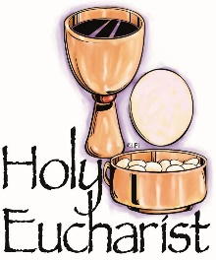

Third Sunday of Easter

April 18th, 2021

Month of the Holy Eucharist

**MASS INTENTIONS**: (April 19 – April 25, 2021)

Monday, April 19 Noon Josephine Koshute req. by Paul & Cynthia McCloskey family

Tuesday, April 20 Noon Michael Hudak req. by Galen & Carol Horner

Wednesday, April 21 Noon Thomas Vandzura req. by Deacon Steve & Sandy Black

Thursday, April 22 Noon Janet Smith req. by Doug & Marcie Roxby

Friday, April 23 Noon Albert & Clara Long req. by Carl & Pam Freidhoff

Saturday April 24 4:00 PM People of the Parish

Sunday, April 25 8:00 AM Theresa Fleck req. by Charles & Mary Ann Bertolino

10:30 AM Mary Sivec (100th Birthday Remembrance) req. by family

LITURGICIAL APPOINTMENTS:

Saturday, April 24 4:00 PM

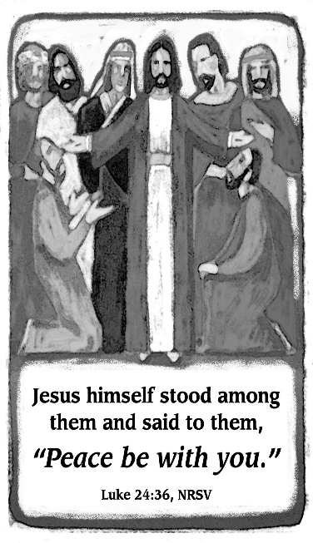

Lector: Sandy Bambino

Minister of the Host: Susan Blazosky

Altar Server: Alex Bambino

Cantor: David Zajdel

Sunday, April 25 8:00 AM

Lector: Cathy Faher

Minister of the Host: Sally Kolar

Altar Server: Michael Kresic

Cantor: Sharon Dibble

Sunday, April 25 10:30 AM

Lector: Mike Barton

Minister of the Host: Mike Steele

Altar Server: Kirstyn Vitez

Cantor: Lou McCloskey

Monday, April 26 Collection Counters

George & Pauline Minor

Weare placing names of the sick in the bulletin for prayer providing they give permission. *May the* *Divine Physician send healing grace for those for* *whom we pray:* Allen C. Rosemas, Patricia Murphy, Bernice Myers, Dwight Fyock, Dylon Wills, Missy, Joanne (Kolar) Hufford, Christine Flanagan, Ayden Alan Grata, Mary Lou Offman, Mary Zangaglia, Natalie Zerby, Valencia Tursi, Homer Locher, Brayden Schofield, Michelle Kasper, Diane Kingera, Ted Paluch, Pearl Litzinger, Patrick Munro, Fran Baldassarre, Kristen Sinosky Long, Cresta Micik, Basil Costantino, Laura, Joe Yoder, Dolores Yanzetich, Sandy Krug, Wanda Gramling, Jennifer Hagans, Shawn, Holly, Shane, Spencer, Owen Taylor, Derrick Varnish, Vincent Koshute, Michelle Elliott, Heather Romanow, Mackston Barrick, Connor Thomas, Erin, Pat, Mary Agnes Nastase, Mary Ann Bertolino, Dick Wilson, Izzy Bihun, Dorothy Kaminsky, Patricia Oshaben, Ashlee Madison, Susan Yanzetich, Mike, Alina Rusnak, Gary Smay, Elizabeth Howell, Walter Bodziak, Rhonda, Anne Robinson, Carter Bobak, Vince Arena, Mike Morris, Sarah Kelt, Patty Yanzetich Caldwell, Colton Snyder, Nancy Edmiston, Leonard Oshaben, Adam, Janice Dipyatic, Lily Maloney, Scott, Lisa, Audrey Costlow, Cathy Sossong, Rosanne Krug, Becky Kakabar, Howard Delaney, Dolores Mucko, Elliana, Ashlee, Helen Soohy, Carol K. Fabrizio, Peggy Carpenter, Dave Seder, Rosalie Ambrose, Pearl Borlie, Joe (Runk) Slonac, Diane Neri, Sharon Poldiak, Patty Gdula, Judy Barr and all of the sick of our parish, the homebound, those in nursing homes, those who care for them, and those in the military along with their families. *(Please call the Rectory to have your name removed from the list when no longer seriously ill. Thank You.)*

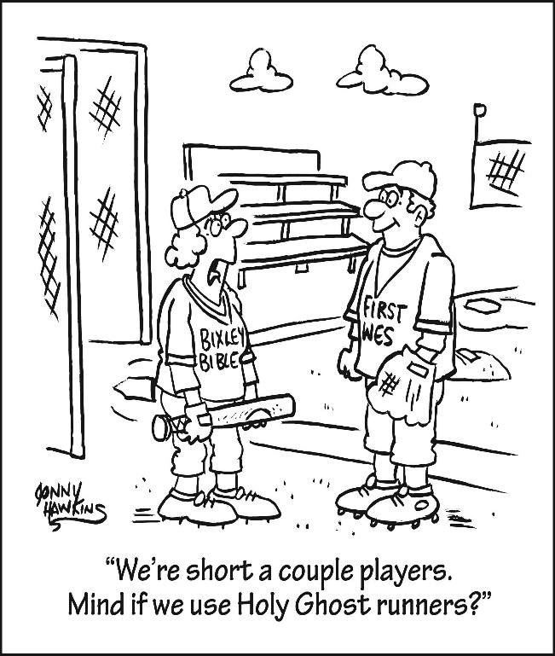

LAST WEEK’S COLLECTION

Adults $4,146.00

Loose $ 95.00

Youth $ 17.00

Monthly $1,109.00

Candles $ 6.00

Maintenance Fund $ 185.00

Easter Offering $1,338.00

Catholic Relief Services $ 20.00

Catholic Home Missions $ 80.00

Holy Land $ 120.00

Holy Thurs./Food Pantry $ 115.00

Total $7,231.00

We sincerely thank and ask God’s

blessing upon all who have care

and concern for our parish.

April 18, 2021 Lk 20:35-48

The apostles were afraid of Jesus until he ate with them and they touched him. In your family the ordinary acts of eating together, touching, embracing not only confirm our love for each other, but also celebrate God’s presence in your family. These ‘ordinary’ moments contain the “Extraordinary.”

During the week of April 18th, 2021

the Sanctuary Candle will burn in memory of

John Progar

requested by Bev & family

and

the Our Lady of Grace Candle will burn in memory of

Josephine Koshute

requested by Paul & Cynthia McCloskey family

[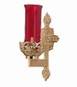](https://images.search.yahoo.com/search/images;_ylt=A0LEV1kSWptXvOwAKINXNyoA;_ylu=X3oDMTEyZGdkcmRoBGNvbG8DYmYxBHBvcwMxBHZ0aWQDQjIwODlfMQRzZWMDc2M-?p=Clipart+of+a+sanctuary+candle&fr=ush-mailn_02&th=110&tw=110&imgurl=http://www.henningers.com/389-168-wall-sanctuary-lamp.jpg&rurl=http://pixshark.com/sanctuary-lamp.htm&size=43KB&name=Sanctuary+Lamp+Bronze+wall+sanctuary+lamp&h=600&w=600&turl=http://ts2.mm.bing.net/th?id=OIP.M68453c67108cdc5ab485d309b395bd03o0&pid=15.1&rs=1&c=1&qlt=95&w=110&h=110#inline&tt=Sanctuary+Lamp+Bronze+wall+sanctuary+lamp&sigr=116keh5le&sigit=13gvlt42j&sigi=11ip0pgm4&sign=119kp6100&sigt=119kp6100)

FINANCE COUNCIL MEETING ~ There will be a Finance Council Meeting this Sunday, April 18th in Room #2 of the Church Hall after the 10:30 AM Mass.

SECOND SUNDAY FOOD COLLECTION ~ Thank you to all who so generously donated to the Forest Hills Food Pantry. The total money collected was $782.00 and an assortment of non-perishable items.

HOLY WATER BOTTLES ~ Blessed Holy Water Bottles are located on the small table at the back of the church for anyone wanting Holy Water.

CATHOLIC HOME MISSIONS APPEAL ~ Next week we will take up the Catholic Home Missions Appeal. Today, over 40% of dioceses in the United States and its territories are unable to fund the essential pastoral work their communities need. Your support of this appeal helps them meet these faith formation and sacramental needs. Please prayerfully consider how you can support this appeal. More information can be found at [www.usccb.org/home-missions](http://www.usccb.org/home-missions). Special envelopes can be found in your packets. Please put your envelopes in the basket marked “Catholic Home Missions”.

PRINCE GALLITZIN SCHOLARSHIP PROGRAM ~ The Knights of Columbus Prince Gallitzin Council 2275 Scholarship Program. Two education Scholarships of $500 each for Graduating High School Seniors in the Class of 2020-2021. Applicants for the scholarships will come from the following churches: St. Michael Catholic Church, St. Michael, PA, St. John’s Catholic Church, Summerhill, PA, St. Bartholomew, Wilmore, PA, Most Holy Trinity, South Fork, PA and Immaculate Conception, New Germany, PA. Seniors can pick up an application at the Parish Office during Parish Office hours.

ROSARY ~ Every Thursday at 3:00 PM on Franklin Street across from Planned Parenthood. Praying for the pre-born, their Moms, the abortion workers and all those who support abortion.

Prayer for Healing

God of endless love, ever caring, ever strong, always present, always just:

You gave your only Son to save us by his blood on the cross.

Gentle Jesus, shepherd of peace, join to your own suffering

the pain of all who have been hurt in body, mind, and spirit

by those who betrayed the trust placed in them.

Hear the cries of our brothers and sisters who have been gravely harmed,

and the cries of those who love them.

Soothe their restless hearts with hope, steady their shaken spirits with faith.

Grant them justice for their cause, enlightened by your truth.

Holy Spirit, comforter of hearts, heal your people’s wounds

and transform brokenness into wholeness.

Grant us the courage and wisdom, humility, and grace, to act with justice.

Breathe wisdom into our prayers and labors.

Grant that all harmed by abuse may find peace in justice.

We ask this through Christ, our Lord. Amen.

APRIL Is Child Abuse Prevention Month

Every April, Catholic parishes and schools across the United States participate in

National Child Abuse Prevention Month.

Together for the next nine days, let’s pray that the vulnerable are protected from abuse, and that

survivors of abuse may be accompanied on their paths to healing.

Novena

For protection and Healing from Abuse

Intercessions

Day 1: May the most vulnerable be protected from all types of abuse and exploitation.

Day 2: May those who have been sexually abused receive comfort and healing.

Day 3: May those who work with children and young people be vigilant in protecting them from harm.

Day 4: May those who provide help for the abused act with wisdom and compassion in their

healing ministries.

Day 5: May all families strive to provide safe and nurturing environments for children and young

people.

Day 6: May all those who have committed abuse acknowledge the harm they have done, repent,

and accept justice that ultimately comes from God.

Day 7: May those who have been abused receive the courage to tell their story, and may they be

believed and supported.

Day 8: May Church leaders, with the guidance of the Holy Spirit, promote justice and healing for

survivors of abuse.

Day 9: May our Holy Father, Pope Francis, fulfill his role as good shepherd and protect the most

vulnerable in his flock.

Prayers: *Our Father, 3 Hail Marys, Glory Be, Prayer for Healing*

Saint John Paul II and the Church’s devotion to Saint Joseph

“After three days they found him in the temple, sitting among the teachers, listening to them and asking them questions. And all who heard him were amazed at his understanding and his answers. When his parents saw him, they were astonished; and his mother said to him, ”Child why have you treated us like this? Look, your father and I have been searching for you in great anxiety. Then he went down with them to Nazareth and was obedient to them.”

(Lk 2:46-49)

Saint John Paul II speaks of the Church’s devotion to St. Joseph: “This patronage must be invoked as ever necessary for the Church, not only as a defense against all dangers, but also, and indeed primarily, as an impetus for her renewed commitment to *evangelization* in the world and to *re-evangelization* in those lands and nations where religion and the Christian life were formerly flourishing and are now put to a hard test.”

“Besides trusting in Joseph’s sure protection, the Church also trusts in his noble example, which transcends all individual states of life and serves as a model for the entire Christian community, whatever the condition and duties of each of its members may be.” *Homily of St. John Paul II,* Solemnity of St. Joseph, 19, March 1998. 2021, Diocese of Altoona-Johnstown Liturgy Committee, Liturgy Office, *Mary, Mother of the Church Pastoral Center,* 2713 W. Chestnut Avenue, Altoona, PA 16601.

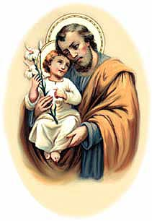

YEAR OF SAINT JOSEPH CELEBRATIONS

*Here ye! Here Ye! All pilgrims of the Diocese of Altoona-Johnstown!*

Saint Joseph the Worker Church, Williamsburg

You are invited for a special day of prayer on May 1, the Feast Day of Saint Joseph the Worker.

Schedule for the Day: 9 AM Morning Prayer; 9:30 AM-Joyful Mysteries of the Rosary; 11:30 AM- Sorrowful Mysteries of the Rosary; 1:30 PM-Luminous Mysteries of the Rosary; 3:30 PM-Glorious Mysteries of the Rosary; 4 PM Confessions; 5 PM Vigil Mass of the 5th Sunday of Easter. *Please stay for as long as you are able to.* Deacon Kevin Nester, Administrator: [knester@dioceseaj.org](mailto:knester@dioceseaj.org). 628 West 1st Street, Williamsburg, PA 16693

Saint Joseph Mission Church, Hart’s Sleeping Place, Carrolltown

This historic Church, blessed by Servant of God, Demetrius Gallitzin himself on October 10, 1830, will be opening once a month for visitation and self-guided tours beginning after May 1, Feast of St. Joseph the Worker. Schedule: The Church will be open from Noon-3 PM on Saturday, May 1, then on Sundays: May 2, June 6, July 4, and September 5. A Special outdoor Mass with Bishop Mark as Main Celebrant, will be held on Sunday August 1 at 4 PM. The Church will be open from Noon-3:30 PM, with Confessions from 1-3 PM. Curator: Marian Farabaugh: [stjosephmissionchurch1830@gmail.com](mailto:stjosephmissionchurch1830@gmail.com)

 Religious Education And Christian Helping

April 18, 2021

Religious Education News

Final Home Lesson Packets ~ April lessons packets for all students in grades K—10 were distributed. When these lessons are completed, they can be returned to the Blue Tote outside our Parish Office Door along with textbooks that were used throughout the year.

For those that missed any lesson pick-ups, your students lessons can be picked-up in the Blue Tote outside the Parish Office door marked: "Religious Education Pick-Ups & Drop Offs".  Look for your "Family Name" on the name tag attached to the bag. You can Drop-off completed lessons by placing them in this bin also.

Camp Zacchaeus Day Camp ~ Our Diocese of Altoona-Johnstown is offering three great days of Faith, Fun and Friendship this summer at Camp Zacchaeus. Day camp is being offered in three areas: Altoona and State College on July 19, 20 and 21, 2021. Our Johnstown area site will be held at Resurrection Picnic Grove on July 26, 27 & 28, 2021. Any students entering grades 3-9 in September of 2021 are eligible to attend. Registrations will be accepted on a first come basis until each site is full with a registration deadline of June 25th.

A Camp Zacchaeus brochure with information and registration is available in the Parish Office.

╬ ╬ ╬ ╬ ╬ ╬ ╬ ╬ ╬ ╬ ╬ ╬ ╬ ╬ ╬ ╬ ╬ ╬ ╬ ╬ ╬ ╬ ╬ ╬ ╬ ╬ ╬

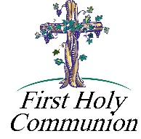

2nd Grade Class Meeting In-Person ~ Our 2nd Grade students will be attending in-person classes to continue their preparation for the reception of their First Eucharist. They will attend two classes, one on Thursday, April 15th and a second Class on Thursday, April 22nd from 3:30 to 4:30 PM.

First Holy Communion ~ Our Second-Grade class is preparing to receive First Holy Communion on Saturday, May 1st, 2021 at a 10:00 AM Mass. They will celebrate Reconciliation on Wednesday, April 28th at 6:30 PM. First Communion Practice will be on Friday, April 30th at 6:30 PM.



11th Grade Class Meeting In-Person ~ Our 11th Grade Confirmation students are attending class on Sunday mornings from 9—10:20 AM in the upstairs hall. They will continue to meet throughout the month of April leading up to receiving their sacrament of Confirmation in May.

Confirmation ~ Our 11th Grade Confirmation candidates will receive their Sacrament of Confirmation on Thursday, May 6, 2021. A 7:00 PM Mass will be celebrated here at our Saint Michael Parish by Msgr. Lockard. *Confirmation Practice will be held on Wednesday evening, May 5 at 6:30 PM.*

Sunday, Apri 18 Mass ~ 8:00 & 10:30 AM

Confessions / 10:00 – 10:15 AM / St. Paul Room

Finance Council Meeting / After 10:30 AM Mass / Hall Room #2



Monday, April 19 Mass ~ Noon

NO Sunday Choir Practice

Tuesday, April 20 Mass ~ Noon

Boy Scouts / 7:30 - 9:00 PM

Wednesday, April 21 Mass ~ Noon



Thursday, April 22 Mass ~ Noon

NO Saturday Choir Practice

Friday, April 23 Mass ~ Noon

Saturday, April 24 Mass / 4:00 PM

Confessions / 3:30 – 3:45 / St. Paul Room

Catholic Home Missions Appeal Collection

UPCOMING EVENTS

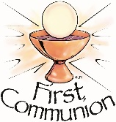 April 25 Catholic Home Missions Appeal Collection

April 28 Second Grade Reconciliation

April 30 First Holy Communion Practice

May 1 First Holy Communion

May 5 Confirmation Practice

May 6 Confirmation

PRO-LIFE DINNER ~ Friday April 23. Clear Ridge Independent Fellowship Church, 516 Stayer Rd, Everett on PA rt 26, South of Everett. Featured Speaker: Maria Gallagher. Maria will tell the history of Roe, how we can prepare Pennsylvania for an overtun of Roe, and what life after Roe will mean in PA and beyond. Adults $20, Students $10, 4 & under free. RSVP 276-3638 or 652-6755 by 4/18/21. Checks made payable to Bedford County CCHL 7 mail checks to Pam Lucas; 262 Zion Rd; Everett, PA 15537. Sponsored by Bedford County Citizens Concerned for Human Life.

JOURNEY THROUGH SCOTLAND & ENGLAND ~ With Fr. Brian Saylor. Nov. 3 – Nov. 16, 2021, 14 Days & 19 Meals. Highlights: Edinburgh Castle, Lake District, Liverpool, Choice on Tour, Cotswolds, Bath, Glastonbury Abbey, Cornwall, Great Western Railway, London. Double: $4,499 pp or Single $5,399 pp. For more information or to sign up call Collette 844-218-2148. Please refer to Booking #987192 or Fr. Brian Saylor 814-944-8509.

ONLINE AUCTION ~ Bishop Carroll Catholic High School. Running from April 21 at 1 AM until April 24 at 9 PM. [www.32AUCTIONS.COM/BC2021](http://www.32AUCTIONS.COM/BC2021). Log in today, create a free account, preview prizes and start bidding on April 21.

SWISS STEAK DRIVE BY ~ The Church of the Transfiguration will be having a Swiss Steak Drive-By Dinner at 201 Third St. on Sunday, April 25th from 10 AM-2 PM. Dinnner includes Swiss Steak, mashed potatoes & gravy, vegetables, salad, roll w/butter & dessert.