ST. MICHAEL ROMAN CATHOLIC CHURCH

751 Locust Street

PO Box 103

St. Michael, Pennsylvania 15951

Rev. Msgr. David A. Lockard, Administrator MASSES:

(814) 495-9640 Saturday 4:00 pm



Sunday Morning 8:00 am

Secretary & Bookkeeper: 10:30 am

Michele Panick Daily Mass: M, T, Th, F Noon

Wed. 6:00 PM

DRE: Laurie Sloan Holy Days: See Bulletin

Maintenance: Rodney Turgeon Office Hours:

PHONES: 8:30 am to 3:30 pm

Rectory / Office: (814) 495-9640 Monday, Tues., Thurs., Friday

Fax: (814) 495-9424 Confessions:

Rel. Education: (814) 495-4873 Saturday 3:30 pm to 3:45 pm

Parish Website Sunday 10:00 am to 10:15 am

[www.saintmichaelchurch.weebly.co](http://www.saintmichaelchurch.weebly.co)m By Appointment

Secretaries’ E-mail

[saintmichaelsecretaries@yahoo.com](mailto:saintmichaelsecretaries@yahoo.com)

Facebook page:

St. Michael Catholic Church/St. Michael, PA

Fifth Sunday of Lent

SERVING GOD AND COMMUNITY FOR OVER ONE HUNDRED YEARS!

March 21st, 2021

BAPTISM: By Appointment. Reserve at least one month in advance.

MARRIAGE: Plan at least nine months in advance.

Preparation sessions are necessary.

FUNERALS: Arrangements are made in conjunction with the funeral home.

REGISTRATION Those new to the area, newlyweds, and single adults, (even if registered

and before with their families) are asked to register by calling the Parish Office.

MEMBERSHIP: Every parishioner must be registered. This is a condition for admission

to our Program and reception of the Sacraments of Baptism, Confirmation,

First Penance, First Eucharist, and Matrimony; also, for testimonial letters or sponsorship of Baptism and Confirmation outside the Parish.

VISITATION: We are concerned and want to be advised when someone is ill at home or in the hospital. Call the office to have the shut-in placed on our monthly Holy Communion calls or seriously ill prayer list.

SACRAMENTAL Parish registration and active Mass participation for Baptism is

POLICY: encouraged and is required for Marriage.

BULLETIN ARTICLES: Articles are due to the Parish Office by Noon on Tuesday.

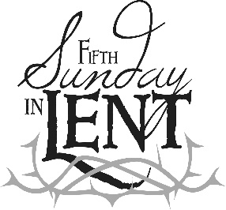

Fifth Sunday of Lent

March 21st, 2021

Month of Saint Joseph

**MASS INTENTIONS**: (March 22 – March 28, 2021)

Monday, Mar. 22 Noon Kevin Smay req. by Susan, Dolores & E.J. Yanzetich

Tuesday, Mar. 23 Noon Sylvia Michaels req. by Michaels children & grandchildren

Wednesday, Mar. 24 6:00 PM Thomas Paterson req. by James Bertolino & family

Thursday, Mar. 25 Noon Agnes Plummer req. by Jessica Gressick & family

(rescheduled from 3/15/2021)

Friday, Mar. 26 Noon Betty & Earl Penatzer req. by Susan & Paul Snyder

Saturday, Mar. 27 4:00 PM People of the Parish

Sunday, Mar. 28 8:00 AM Michael Cononie Jr. req. by Mike & Lucia Ann Brezovec

10:30 AM Catherine Olszewski req. by family

LITURGICIAL APPOINTMENTS:

Saturday, March 27 4:00 PM

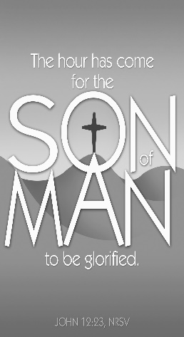Lector: Narrator: Sherry Dipko, Voice: Mike Barton

Minister of the Host: Susan Blazosky

Altar Server: Chase Williamson

Cantor: Amanda Williamson

Sunday, March 28 8:00 AM

Lector: Narrator: Pauline Minor, Voice: Joe Faher

Minister of the Host: Eric Tedjeske

Altar Server: Kaden Christ

Cantor: Susan Yanzetich

Sunday, March 28 10:30 AM

Lector: Narrator: Tony Bambino, Voice: Carole Kakabar

Minister of the Host: Robert Oshaben

Altar Server: Alexis Henderson

Cantor: Lou McCloskey

Weare placing names of the sick in the bulletin for prayer providing they give permission. *May the* *Divine Physician send healing grace for those for* *whom we pray:* Allen C. Rosemas, Patricia Murphy, Bernice Myers, Dwight Fyock, Dylon Wills, Missy, Joanne (Kolar) Hufford, Christine Flanagan, Ayden Alan Grata, Mary Lou Offman, Mary Zangaglia, Natalie Zerby, Valencia Tursi, Homer Locher, Brayden Schofield, Michelle Kasper, Diane Kingera, Ted Paluch, Pearl Litzinger, Patrick Munro, Fran Baldassarre, Kristen Sinosky Long, Cresta Micik, Basil Costantino, Laura, Joe Yoder, Dolores Yanzetich, Sandy Krug, Wanda Gramling, Jennifer Hagans, Shawn, Holly, Shane, Spencer, Owen Taylor, Derrick Varnish, Vincent Koshute, Michelle Elliott, Heather Romanow, Mackston Barrick, Connor Thomas, Erin, Pat, Mary Agnes Nastase, Mary Ann Bertolino, Dick Wilson, Izzy Bihun, Dorothy Kaminsky, Patricia Oshaben, Ashlee Madison, Susan Yanzetich, Mike, Alina Rusnak, Gary Smay, Elizabeth Howell, Walter Bodziak, Rhonda, Anne Robinson, Carter Bobak, Vince Arena, Mike Morris, Sarah Kelt, Patty Yanzetich Caldwell, Colton Snyder, Nancy Edmiston, Leonard Oshaben, Adam, Janice Dipyatic, Lily Maloney, Scott, Lisa, Audrey Costlow, Cathy Sossong, Rosanne Krug, Becky Kakabar, Howard Delaney, Dolores Mucko, Elliana, Ashlee, Helen Soohy, Carol K. Fabrizio, Peggy Carpenter, Dave Seder, Rosalie Ambrose, Pearl Borlie, Joe (Runk) Slonac, Diane Neri, Sharon Poldiak, Patty Gdula and all of the sick of our parish, the homebound, those in nursing homes, those who care for them, and those in the military along with their families. *(Please call the Rectory to have your name removed from the list when no longer seriously ill. Thank You.)*

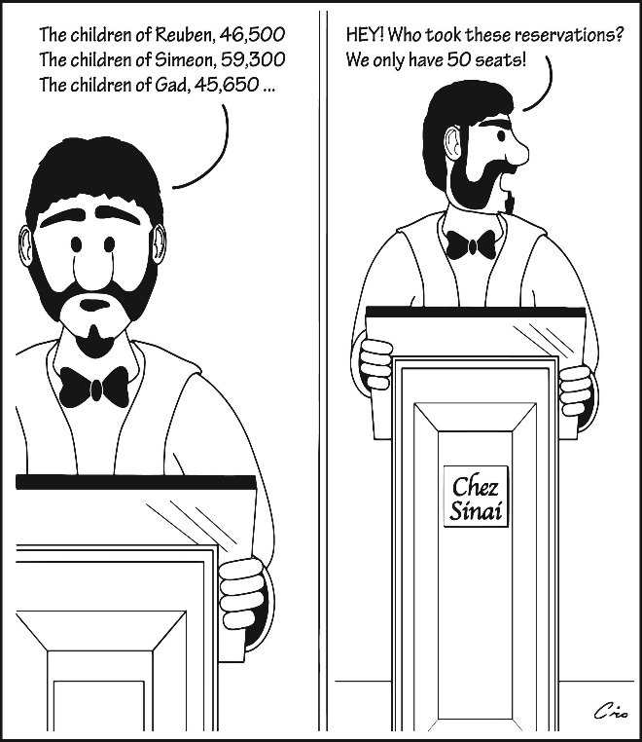

LAST WEEK’S COLLECTION

Adults $3,595.00

Loose $ 119.25

Youth $ 24.00

Monthly $1,755.00

Candles $ 40.00

Maintenance Fund $ 105.00

Easter Offering $ 178.00

Easter Flowers $ 120.00

Catholic Relief Services $ 304.00

Black & Indian $ 15.00

Catholic Home Missions $ 10.00

Holy Land $ 40.00

Holy Thurs./Food Pantry $ 40.00

Mandeville Diocese $ 15.00

Total $6,360.25

We sincerely thank and ask God’s

blessing upon all who have care

and concern for our parish.

*Stewardship Reflections…*

You are like a grain of wheat. Keeping your time, talent, and treasure to yourself yields no harvest. With God’s grace we can die to ourselves and bear fruit for His kingdom. When you live for others, the evangelizing mission of Jesus Christ is revealed. Is God calling you to be charitable in a specific way this week? We are called to detach from our own desires and entrust our lives to all that God has in store for us. As this Lenten season comes to a close, let us strive to partake in the richness God has offered to us through his covenant by more faithfully living out our service to our families and neighbors. *(Stewardship Bulletin Reflection,* Catholic Stewardship Consultants, February 22,2021)

During the week of March 21st, 2021

the Sanctuary Candle will burn in memory of

Francis Powers

requested by Jeanne English

[](https://images.search.yahoo.com/search/images;_ylt=A0LEV1kSWptXvOwAKINXNyoA;_ylu=X3oDMTEyZGdkcmRoBGNvbG8DYmYxBHBvcwMxBHZ0aWQDQjIwODlfMQRzZWMDc2M-?p=Clipart+of+a+sanctuary+candle&fr=ush-mailn_02&th=110&tw=110&imgurl=http://www.henningers.com/389-168-wall-sanctuary-lamp.jpg&rurl=http://pixshark.com/sanctuary-lamp.htm&size=43KB&name=Sanctuary+Lamp+Bronze+wall+sanctuary+lamp&h=600&w=600&turl=http://ts2.mm.bing.net/th?id=OIP.M68453c67108cdc5ab485d309b395bd03o0&pid=15.1&rs=1&c=1&qlt=95&w=110&h=110#inline&tt=Sanctuary+Lamp+Bronze+wall+sanctuary+lamp&sigr=116keh5le&sigit=13gvlt42j&sigi=11ip0pgm4&sign=119kp6100&sigt=119kp6100)

PALM SUNDAY ~ Sunday, March 28th – Palm Sunday - the blessed Palms will be handed out by the Ushers after Mass, not before Mass because of Covid precautions.

[](http://www.churchart.com/subscriber/viewimages.aspx?keywords=In%20Sympathy&entry_date=1/1/0001&image_type=,cl#no)MAY HE REST IN PEACE ~ In your charity, please pray for the eternal rest of John Progar whose funeral Mass was on Saturday, March 13th, 2021. May he know the eternal peace and happiness promised by our Savior, Lord Jesus. Please pray for the consolation of all his family and friends.

THE CATHOLIC RELIEF SERVICES COLLECTION ~ Thank you for your generous support of the Catholic Relief Services Collection and for helping Jesus in disguise. Your contributions make a difference for the poor and marginalized around the world. If you missed the collection, it’s not too late to give! Just visit [www.usccb.org/nationalcollections](http://www.usccb.org/nationalcollections) for more information on how to give.

SECOND SUNDAY FOOD COLLECTION ~ Thank you to all who so generously donated to the Forest Hills Food Pantry. The total money collected was $1,074.00 and an assortment of non-perishable items.



EASTER FLOWERS ~ To offer an Easter flower for a living (In Honor Of) or a deceased (In Memory Of) member of your family, please do so by legibly signing the Easter Flower envelope in your packet. The normal offering is $10. Please return the envelopes by next Sunday, March 28th.

WEDNESDAY EVENING MASS ~ We will be having an evening Mass on Wednesdays at 6:00 PM through March 31st for Lent. This is a wonderful opportunity to attend a daily Mass to help us in our Lenten journey. There will be NO Noon Mass on Wednesdays during Lent.

See the source image

STATIONS OF THE CROSS ~ We will pray the Stations of the Cross on the Fridays of Lent at 6:00 PM.

WEEKLY CONFESSIONS ~ Msgr. will be hearing confessions every Friday following the Stations of the Cross until 7:00 PM in addition to the regularly scheduled confessions on Saturday & Sunday.

HOLY WEEK SCHEDULES ~ Please check the insert for the schedule of Holy Week & the Lay Ministry schedule for Holy Week. If you cannot fill your obligation, please find a replacement. Thank you.

DAILY MASS CHANGE ~ There will not be a Noon Mass on Monday, March 29th due to Msgr. Lockard attending the Chrism Mass in Altoona. There will be a 6:00 PM Mass that day.

PARISH OFFICES CLOSED ~ Parish offices will be closed Good Friday, April 2nd, and Easter Monday, April 5th. Office hours will resume on Tuesday, April 6th at 8:00 AM.

BINGO! ~ Bishop Carroll Catholic High School 814-472-7500. Sunday March 21, 1:00 PM. Prizes: Instant Lottery Tickets & more. Doors open at Noon. Admission $25. Call Bishop Carroll for Tickets.

MEN’S TURKEY DINNER ~ The Basilica of St. Michael the Archangel, Loretto, Annual Men’s Turkey Dinner will be held on Sunday, March 21st as a drive-thru dinner. Simply stay in your vehicle ~ multiple lines for faster service! 11 AM – 3 PM or sold out. Turkey dinner with all the trimmings - $12.00.

SPAGHETTI DRIVE-BY ~ The Church of the Transfiguration, Conemaugh, will be having a Spaghetti Drive-By on Sunday, March 21st from 10 AM-1:30 PM at the church hall parking lot. Meal includes spaghetti, meatballs, salad, roll & dessert all for only $8.

CRAFT & VENDOR FAIR ~ Saturday, March 27, 9:00 AM – 3:00 PM. Huge Bake Sale & Foods to Go – Haluski, Halupki, Soups, Gobs, Cinnamon Rolls & an Egg Hunt @ 1:30 PM at Bishop Carroll High School 814-472-7500.

CATHOLIC MINISTRIES DRIVE 2021

One of the most favorite topics of Pope Francis is *hope.* He often reminds us that *hope has a name, and it is Jesus Christ.* Pope Francis says: “Christ is alive! He is our hope, and in a wonderful way he brings youth to our world, and everything he touches becomes young, new and full of life!” Be a DISCIPLE OF HOPE! and participate in the 2021 Catholic Ministries Drive.

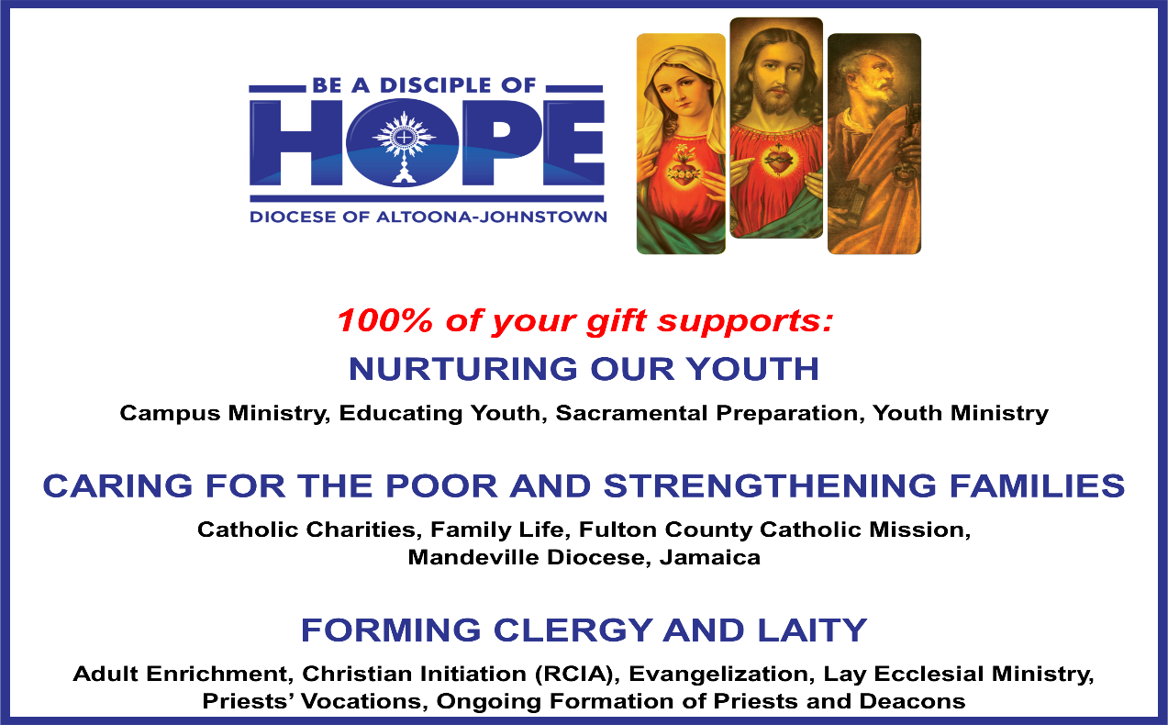

March 21, 2021 *Consecration to St. Joseph: The Wonders of our Spiritual Father*

During this Special Year of Saint Joseph, you may want to enter into the 33-day prayer to consecrate yourself to Saint Joseph. What does it mean for a person? It is basically you acknowledging that he is your spiritual father, and you want to be like him. To show it, you entrust yourself entirely into his paternal care so that he can help you acquire his virtues and become holy, you make a formal act of entrustment in prayer to you spiritual father. Saint Joseph in turn, will give those consecrated to him his undivided attention, protection, and guidance.

Father Donald Calloway, MIC has written a book, *Consecration to St. Joseph: The Wonders of our Spiritual Father,* to assist you. The prayer can be made in a group or by a single person. Based on the Litany to Saint Joseph and his 24 different titles, a series of special prayers and quotes of holy man and women is followed by a reflection on a wonder of St. Joseph. You are bound to be enlightened by your broadened sense and appreciation of the “silent St. Joseph” and find a trusting companion and protector in him and the entire Holy Family. 2021, Diocese of Altoona-Johnstown Liturgy Committee, Liturgy Office, *Mary, Mother of the Church Pastoral Center,* 2713 W. Chestnut Avenue, Altoona, PA 16601.

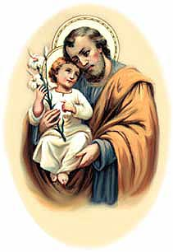

YEAR OF SAINT JOSEPH CELEBRATIONS

*Here ye! Here Ye! All pilgrims of the Diocese of Altoona-Johnstown!*

Saint Joseph the Worker Church, Williamsburg

You are invited for a special day of prayer on May 1, the Feast Day of Saint Joseph the Worker.

Schedule for the Day: 9 AM Morning Prayer; 9:30 AM-Joyful Mysteries of the Rosary; 11:30 AM- Sorrowful Mysteries of the Rosary; 1:30 PM-Luminous Mysteries of the Rosary; 3:30 PM-Glorious Mysteries of the Rosary; 4 PM Confessions; 5 PM Vigil Mass of the 5th Sunday of Easter. *Please stay for as long as you are able to.* Deacon Kevin Nester, Administrator: [knester@dioceseaj.org](mailto:knester@dioceseaj.org). 628 West 1st Street, Williamsburg, PA 16693

Saint Joseph Mission Church, Hart’s Sleeping Place, Carrolltown

This historic Church, blessed by Servant of God, Demetrius Gallitzin himself on October 10, 1830, will be opening once a month for visitation and self-guided tours beginning after May 1, Feast of St. Joseph the Worker. Schedule: The Church will be open from Noon-3 PM on Saturday, May 1, then on Sundays: May 2, June 6, July 4, and September 5. A Special outdoor Mass with Bishop Mark as Main Celebrant, will be held on Sunday August 1 at 4 PM. The Church will be open from Noon-3:30 PM, with Confessions from 1-3 PM. Curator: Marian Farabaugh: [stjosephmissionchurch1830@gmail.com](mailto:stjosephmissionchurch1830@gmail.com)



Religious Education And Christian Helping

March 21, 2021

Religious Education News

Final Home Lesson Packets are being prepared for all students in grades K—10. They will be distributed the week following Easter. Our K—5 parents can pick up packets on Thursday, April 8 from 4 to 5 PM. Our Grades 6—10 parents can pick up on Sunday, April 11 from 9 to 10:15 AM.

Lesson Packet #6 was distributed to all students in Grades K—11 the first week of March. For those that missed any past lesson pick-ups, your students lessons can be picked-up in the Big Blue Tote outside the Parish Office door marked: "Religious Education Pick-Ups & Drop Offs".  It can be accessed anytime at your convenience to make it easier.  Look for your "Family Name" on the name tag attached to the bag. You can Drop-off completed lessons by placing them in this bin also.

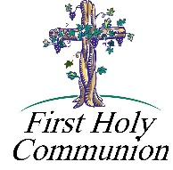

2nd Grade Class Meeting In-Person ~ Our 2nd Grade students will be attending in-person classes to continue their preparation for the reception of their sacrament of First Eucharist. They will attend two classes, one on Saturday, April 17th and a second on Saturday, April 24th from 10:00 to 11:00 AM.

First Holy Communion ~ Our Second-Grade class is preparing to receive First Holy Communion on Saturday, May 1st, 2021 at a 10:00 AM Mass. Their 2nd Reconciliation will be on Wednesday, April 28th at 6:30 PM. First Communion Practice will be on Friday, April 30th at 6:30 PM.



11th Grade Class Meeting In-Person ~ Our 11th Grade Confirmation students are attending class on Sunday mornings from 9—10:20 AM in the upstairs hall. They will continue to meet throughout the month of April leading up to receiving their sacrament of Confirmation in May.

Confirmation ~ Our 11th Grade Confirmation candidates will receive their Sacrament of Confirmation on Thursday, May 6, 2021. A 7:00 PM Mass will be celebrated here at our Saint Michael Parish by Msgr. Lockard.

*Confirmation Practice will be held on Wednesday evening, May 5 at 6:30 PM.*

 Sunday, March 21 Mass ~ 8:00 & 10:30 AM

Confessions / 10:00 – 10:15 AM / St. Paul Room

Monday, March 22 Mass ~ Noon

NO Sunday Choir Practice

 Tuesday, March 23 Mass ~ Noon

Boy Scouts / 7:30 - 9:00 PM

Wednesday, March 24 Mass ~ 6:00 PM

Thursday, March 25 Mass ~ Noon

NO Saturday Choir Practice

Friday, March 26 Mass ~ Noon

Stations of the Cross / 6:00 PM

Abstinence from Meat

Confessions after Stations of the Cross until ?

Saturday, March 27 Mass / 4:00 PM

Confessions / 3:30 – 3:45 / St. Paul Room

UPCOMING EVENTS

March 28 Palm Sunday

 March 29 Chrism Mass / Altoona Cathedral

April 1 Holy Thursday

Holy Thursday/Food Pantry Collection

April 2 Good Friday Celebration of the Lord’s Passion

Holy Land Collection

Stations of the Cross

Parish Officed Closed

April 3 Easter Food Basket Blessing

Easter Vigil

LOCAL FISH FRY ~ The St. Michael Fire Department is holding their Lenten Fish Fries each Friday during Lent. Meals are by Take out only or local delivery. Fried Fish, Baked Fish or Shrimp Dinners are available. Sides include your choice of Mac & Cheese, French Fies, or Pierogies. Dinners also include a roll and cole slaw. Meals begin at 11 AM thru 6 PM.

FISH FRY ~ Take out only! No need to get out of your car! Immaculate Conception Parish in Summerhill, PA. On the following dates ONLY: March 5th, 12th, 19th, 26th and Good Friday, April 2nd from 4 – 6:30 PM at the New Germany Grove Hall, 1635 New Germany Road. Drive through only – NO phone orders! Adult size only, cost for each dinner is $10. All Dinners include: Choice of: Baked or Fried Fish, Baked Potato only (NO French Fries), Mac & Cheese, Haluski, Green Beans, Cole Slaw; and cake of the week. There will be no fish sandwiches. Thank you for your continued support!

BASKET RAFFLE ~ The Adams Township Lions Club will be holding a Basket Raffle at the St. Michael Firehall from 10 AM – 5 PM on Saturday April 10th & 10 AM – 3 PM on Sunday April 11th. $5 per ticket. Drawings will be posted on Facebook.

[](http://www.churchart.com/Subscriber/ViewImages.aspx?keywords=&entry_date=&image_type=,cl&topic_id=116&image_source_id=&page=15#no)

|  |  |
| --- | --- |
| Monday of Holy Week  March 28 | 11:00 AM – Chrism Mass in Altoona Cathedral  Mass here at 6:00 PM  NO Noon Mass here at St. Michael Church |
| Tuesday of Holy Week  March 29 | Mass at Noon |
| Wednesday of Holy Week  March 30 | Mass at 6:00 PM |
| [http://download.churchart.com/ArtLineLibrary/s/su/supper5.gif](http://www.churchart.com/Subscriber/ViewImages.aspx?keywords=&entry_date=&image_type=,cl,ea&topic_id=424&image_source_id=&page=4#no)Holy Thursday  March 31 | 7:00 PM – Mass of the Lord’s Supper  (Altar Servers please arrive at 6:30 PM)  Adoration of the Blessed Sacrament until 11:00 PM |
| Good Friday  April 1  [http://download.churchart.com/ArtLineLibrary/c/cr/crucifix_6521c.gif](http://www.churchart.com/Subscriber/ViewImages.aspx?keywords=&entry_date=&image_type=,cl&topic_id=138&image_source_id=&page=6#no) | 1:00 PM – Commemoration of the Passion of the Lord  (Altar Servers please arrive at 12:30 PM)  6:00 PM – Stations of the Cross    *FASTING and ABSTINENCE on GOOD FRIDAY*  All Catholics from ages 15 to 60 are bound by the law of fast  on Good Friday. Abstinence means abstaining from meat, and the required  Fast involves eating only one full meal. One or two smaller meals may be  taken on those days but may not total one full meal.  The required fast does  not allow eating anything between meals. |
| http://captioneditor.churchart.com/CaptionEditor/ProcessedImages/vigil_56311_web.jpg?guid=b08eca12-b29a-4875-87f6-d336842a122c    April 3 | C:\Documents and Settings\Susan\Local Settings\Temporary Internet Files\Content.IE5\P8TTLNMM\baskt42_print[1].tiff  1:30 PM – Blessing of the Easter Baskets  (Altar Servers practice at 2:00 PM)  6:00 PM – Easter Vigil |
| [http://download.churchart.com/ArtLineLibrary/r/ri/risen1.gif](http://www.churchart.com/Subscriber/ViewImages.aspx?keywords=&entry_date=&image_type=,cl&topic_id=426&image_source_id=&page=6#no)  Easter Sunday  April 4 | 8:00 AM & 10:30 AM – Easter Sunday Masses  Lenten Folders – Lenten folders can be brought to church  at any of the Liturgies of Holy Week.  Please return them as soon as possible. |



Holy Week Lay Ministry Schedules

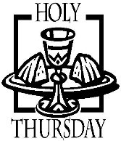Holy Thursday, April 1, 7:00 PM

Lector: Sandy Bambino

Eucharistic Minister: Sally Kolar

Alter Severs: Alex Bambino & Jackson Henderson

Incense Altar Server: Carson Kundrod

Cantor: David Zajdel

Good Friday, April 2, 1:00 PM



Lectors: Narrator: Pauline Minor, Voice: Susan Poldiak

Eucharistic Minister: Eric Tedjeske

Altar Servers: Elizabeth Dobbins & Michael Kresic

Cross Altar Server: Ian Dobbins

Cantor: Amy Spangler or Anita Lorek

Easter Vigil, April 3, 6:00 PM

Lectors: Donald Dipko & Sherry Dipko

Eucharistic Minister: Mike Barton

Prayer of Faithful: Tony Bambino

Altar Servers: Eva Spangler & Dylan Kundrod

Incense Altar Server: Carson Kundrod

Cantor: Susan Blazosky

Easter Sunday, April 4

8:00 AM Mass 10:30 AM Mass

 Lector: Arnold Bernard Lector: James Lashinsky

Eucharistic Minister: Marie Bernard Eucharistic Minister: Jennifer Steele

Altar Servers: Kaden & Griffin Christ Altar Servers: Haidyn Koch & Kirstyn Vitez

Cantor: Sharon Dibble Cantor: Amy Dobbins

Choir/Hall Minister: Mike Steele

Please check the Schedule. Anyone not able to fulfill their obligation,

please find a replacement for you ministry.

Thank you.