ST. MICHAEL ROMAN CATHOLIC CHURCH

751 Locust Street

PO Box 103

St. Michael, Pennsylvania 15951

Rev. Msgr. David A. Lockard, Administrator MASSES:

(814) 495-9640 Saturday 4:00 pm

 Sunday Morning 8:00 am

Secretary & Bookkeeper: 10:30 am

Michele Panick Daily Mass: M, T, W, Th, F

DRE: Laurie Sloan 9:00 am

Maintenance: Rodney Turgeon Holy Days: See Bulletin

PHONES: Office Hours:

Rectory / Office: (814) 495-9640 8:30 am to 3:30 pm

Fax: (814) 495-9424 Monday, Tues., Thurs., Friday

Rel. Education: (814) 495-4873 Closed Wednesdays

Parish Website Confessions:

[www.saintmichaelchurch.weebly.com](http://www.saintmichaelchurch.weebly.com) Saturday 3:30 pm to 3:45 pm

Secretaries’ E-mail Sunday 7:30 am to 7:45 am

[saintmichaelsecretaries@yahoo.com](mailto:saintmichaelsecretaries@yahoo.com) 10:00 am to 10:15 am

Facebook page: By Appointment

St. Michael Catholic Church/St. Michael, PA

First Sunday of Lent

SERVING GOD AND COMMUNITY FOR OVER ONE HUNDRED YEARS!

March 6th, 2022

BAPTISM: By Appointment. Reserve at least one month in advance.

MARRIAGE: Plan at least nine months in advance.

Preparation sessions are necessary.

FUNERALS: Arrangements are made in conjunction with the funeral home.

REGISTRATION Those new to the area, newlyweds, and single adults, (even if

and registered before with their families) are asked to register by calling

MEMBERSHIP: the Parish Office. Every parishioner must be registered. This is a condition for admission to our Program and reception of the Sacraments of Baptism, Confirmation, First Penance, First Eucharist, and Matrimony; also, for testimonial letters or sponsorship of Baptism and Confirmation outside the Parish.

VISITATION: We are concerned and want to be advised when someone is ill at home or in the hospital. Call the office to have the shut-in placed on our monthly Holy Communion calls or seriously ill prayer list.

SACRAMENTAL Parish registration and active Mass participation for Baptism is

POLICY: encouraged and is required for Marriage.

BULLETIN ARTICLES: Articles are due to the Parish Office by Noon on Tuesday

First Sunday of Lent

March 6th, 2022

Month of St. Joseph

**MASS INTENTIONS**: (March 7 – March 13, 2022)

Monday, March 7 9:00 AM Health & Safety of Family in Ukraine req. by Pauline Minor

& family

Tuesday, March 8 9:00 AM John Progar req. by Bev & family

Wednesday, March 9 6:00 PM Robert & Dolores Meier req. by son, Michael Meier

Thursday, March 10 9:00 AM Dennis Grattan req. by Bob & Ellen Grattan

Friday, March 11 9:00 AM Judith Barr req. by mother, Violet Barr

Saturday, March 12 4:00 PM People of the Parish

Sunday, March 13 8:00 AM Stephen D. Yanzetich Sr. req. by Dolores, Evan & Susan

10:30 AM Robert Wilson req. by Mary Ann Murin & family

LITURGICIAL APPOINTMENTS:

Saturday, March 12 4:00 PM Offertory Procession

Lector: Donald Dipko Cheryl & Deborah Macy

Minister of the Host: Babe Richards

Choir Minister: Karen Myers

Altar Server: Caden Roberts

Cantor: Susan Blazosky

Greeter: Cheryl Macy

Sunday, March 13 8:00 AM Offertory Procession

Lector: Peter Bernard Stephen Yanzetich Sr. Family

Minister of the Host: Pauline Minor

Choir Minister: Ellen Grattan

Altar Server: Kaden Christ

Cantor: Susan Yanzetich

Greeter: Carol Hautz

Sunday, March 13 10:30 AM Offertory Procession

Lector: James Lashinsky James Fisher Family

Minister of the Host: Susan Wieczorek

Choir Minister: Jennifer Steele

Altar Server: Haidyn Koch

Cantor: Alexis Henderson

Greeter: REACH

Sunday, March 13 Collection Counters

Chris Smay, Sara Zybura

Mary Ann DeRosa

Weare placing names of the sick in the bulletin for prayer providing they give permission. *May the* *Divine Physician send healing grace for those for* *whom we pray:* Allen C. Rosemas, Patricia Murphy, Dwight Fyock, Dylon Wills, Missy, Joanne (Kolar) Hufford, Christine Flanagan, Ayden Alan Grata, Mary Lou Offman, Natalie Zerby, Valencia Tursi, Brayden Schofield, Michelle Kasper, Diane Kingera, Ted Paluch, Pearl Litzinger, Patrick Munro, Fran Baldassarre, Kristen Sinosky Long, Cresta Micik, Basil Costantino, Laura, Joe Yoder, Dolores Yanzetich, Sandy Krug, Wanda Gramling, Jennifer Hagans, Shawn, Holly, Shane, Spencer, Owen Taylor, Derrick Varnish, Vincent Koshute, Michelle Elliott, Heather Romanow, Mackston Barrick, Connor Thomas, Erin, Pat, Mary Agnes Nastase, Mary Ann Bertolino, Dick Wilson, Izzy Bihun, Dorothy Kaminsky, Ashlee Madison, Susan Yanzetich, Alina Rusnak, Gary Smay, Elizabeth Howell, Walter Bodziak, Rhonda, Anne Robinson, Carter Bobak, Mike Morris, Sarah Kelt, Patty Yanzetich Caldwell, Colton Snyder, Nancy Edmiston, Leonard Oshaben, Adam, Janice Dipyatic, Lily Maloney, Scott, Lisa, Audrey Costlow, Rosanne Krug, Becky Kakabar, Dolores Mucko, Elliana, Ashlee, Helen Soohy, Carol K. Fabrizio, Peggy Carpenter, Dave Seder, Rosalie Ambrose, Pearl Borlie, Joe (Runk) Slonac, Patty Gdula, Lori Gramling, Babe Richards, Ruth Ferchalk, Kathy Glenn Ripper, Ernie Martinage, Mildred Andrykovitch, Katelyn Engle, John Patterson, Colin Wingard, Betty Duray and all of the sick of our parish, the homebound, those in nursing homes, those who care for them, and those in the military along with their families. *(Please call the Rectory to have your name removed from the list when no longer seriously ill. Thank You.)*

LAST WEEK’S COLLECTION

Regular Offertory $3,484.00

Maintenance $ 431.00

Diocesan Collection $ 50.00

Easter Flowers $ 20.00

Total $3,985.00

We sincerely thank

and ask God’s blessing

upon all who have care

and concern for

our parish.

*First Sunday of Lent*

In the First Reading from Deteronomy, Moses teaches the people to respond as grateful stewards for all that God has done for them. He tells the Israelites to declare to God, “Therefore, I have now brought you the first fruits of the products of the soil which you O Lord, have given me.” As the priest received the harvest basket to be placed in front of the altar, the gratitute for God’s promise to rescue them from oppression and slavery in Egypt was made visible.

[](https://images.search.yahoo.com/search/images;_ylt=A0LEV1kSWptXvOwAKINXNyoA;_ylu=X3oDMTEyZGdkcmRoBGNvbG8DYmYxBHBvcwMxBHZ0aWQDQjIwODlfMQRzZWMDc2M-?p=Clipart+of+a+sanctuary+candle&fr=ush-mailn_02&th=110&tw=110&imgurl=http://www.henningers.com/389-168-wall-sanctuary-lamp.jpg&rurl=http://pixshark.com/sanctuary-lamp.htm&size=43KB&name=Sanctuary+Lamp+Bronze+wall+sanctuary+lamp&h=600&w=600&turl=http://ts2.mm.bing.net/th?id%3DOIP.M68453c67108cdc5ab485d309b395bd03o0%26pid%3D15.1%26rs%3D1%26c%3D1%26qlt%3D95%26w%3D110%26h%3D110#inline&tt=Sanctuary+Lamp+Bronze+wall+sanctuary+lamp&sigr=116keh5le&sigit=13gvlt42j&sigi=11ip0pgm4&sign=119kp6100&sigt=119kp6100)

During the week of March 6th, 2022

the Sanctuary Candle will burn in memory of

John Progar

requested by Bev & family

CONFESSIONS & STATIONS OF THE CROSS ~ We will pray the Stations of the Cross on the Fridays of Lent at 6:00 PM. Following the Stations there will be an opportunity to go to confession. Let us make the most of this opportunity to participate in these Lenten devotions.

WEDNESDAY EVENING MASS ~ We will be having an evening Mass at 6:00 PM every Wednesday during Lent. This is a wonderful opportunity to attend a daily Mass to help us in our Lenten journey. There will be NO 9:00 AM Mass on Wednesdays during Lent.

FINANCE COUNCIL MEETING ~ This Tuesday, March 8th, there is a Finance Council Meeting in the Hall, Rm 2, at 3:30 PM.

PASTORAL COUNCIL MEETING ~ There will be a Pastoral Council meeting this Thursday, March 10th, in the Church Hall, Rm 2, at 6:30 PM.

SECOND SUNDAY FOOD PANTRY COLLECTION ~ Next weekend is our Second Sunday Food Pantry Collection. Please bring in non-perishable food items or toiletries with you. Monetary donations are also appreciated.

HOLY NAME SOCIETY ~ Will hold their monthly meeting next Sunday, March 13th in the Church Hall after the 8:00 AM Mass.

COFFEE & DONUTS ~ There will be coffee & donuts in the Church Hall next Sunday, March 13th after the 8:00 AM Mass.

SCOUT SUNDAY ~ On March 13th during the 10:30 AM Mass, the parish will celebrate Scout Sunday to honor Girl & Boy Scouts. Any Scouts from the parish or members of our parish troops are asked to wear their uniforms to Mass on the 13th. Scouts will be seated together in the front pews and are asked to participate in reciting the Pledge of Allegiance and the Scout Oath and Law. Scouts will also be participating in various ministries during the Mass.

SOUP SALE ~ The Holy Name Society will be making chicken soup for our parish sick and homebound on Saturday, March 19th. They are also offering it for sale to members of the parish. The cost is $6 per quart. Sign-up sheets are available in the back of the church. Orders can be picked up in the church hall on Saturday, March 19th, from 11 AM – 2 PM or after each weekend Mass on the 19th & 20th.

COMBINED CHOIRS FOR EASTER ~ Will rehearse on Fridays after stations from 7 – 8 PM. All members are welcome to join and prepare for this holiest time of the church year. Come and bring a friend.

EASTER FLOWERS ~ If you would like to purchase an Easter Flower for a living (In Honor Of) or a deceased (In Memory Of) member of your family, please do so by using the Easter Flower envelope in your packet. The normal offering is $10. Please return the envelopes on or before April 10th. Extra envelopes can be found at the Church entrances.

BLACK & INDIAN MISSION ~ This weekend, our parish will take up the 138th annual National Black and Indian Mission - second collection. Our support of this collection helps build the Church in African American, Native American, and Alaska Native communities from coast to coast. Schools, parish religious education programs, and diocesan ministries depend on your generosity to help them spread the Gospel of Jesus Christ! You can help meet unmet needs with a generous contribution today. Thank you for your support. Envelopes can be found in your packet.

LAND OF PEACE MISSION ~ Our brothers and sisters representing the Land of Peace mission – a nonprofit organization will be visiting our Parish next weekend, March 12th & 13th, speaking about the Christian and the ongoing situation in the Holy Land. They will be selling Crucifixes, religious art work, and rosaries - all made of olive wood, which is native to Israel and Bethlehem, to raise funds to help support our fellow brothers and sisters. Since tourism has greatly depleted, Christian families in the holy land, who depend on tourists, have been greatly affected. The goal of this mission is to help the poor and needy families in Bethlehem and Jerusalem. Sale of these goods will help them very much and also give you the opportunity to have “something” authentic from the holy land. Please browse and buy some articles. It is for a good cause and also a help to your personal devotion. Please visit our website: [www.landofpeace.org](http://www.landofpeace.org).

SCRIPTURAL FAITH SHARING GROUP ~ Scriptural faith sharing groups are forming for the Lenten season. Consider joining a Synodal Faith Sharing Group based on scripture, to be held during the Lenten season. Two groups are offered to best suit your schedule. Each group will run for six consecutive weeks. Group 1: Starting Tuesday, March 8th in the Church Hall at 9:30 AM (after the morning Mass). Group 2: Starting Wednesday, March 9th, in the Church Hall at 6:30 PM (after the evening Mass). Sign-up sheets are in the back of the Church.

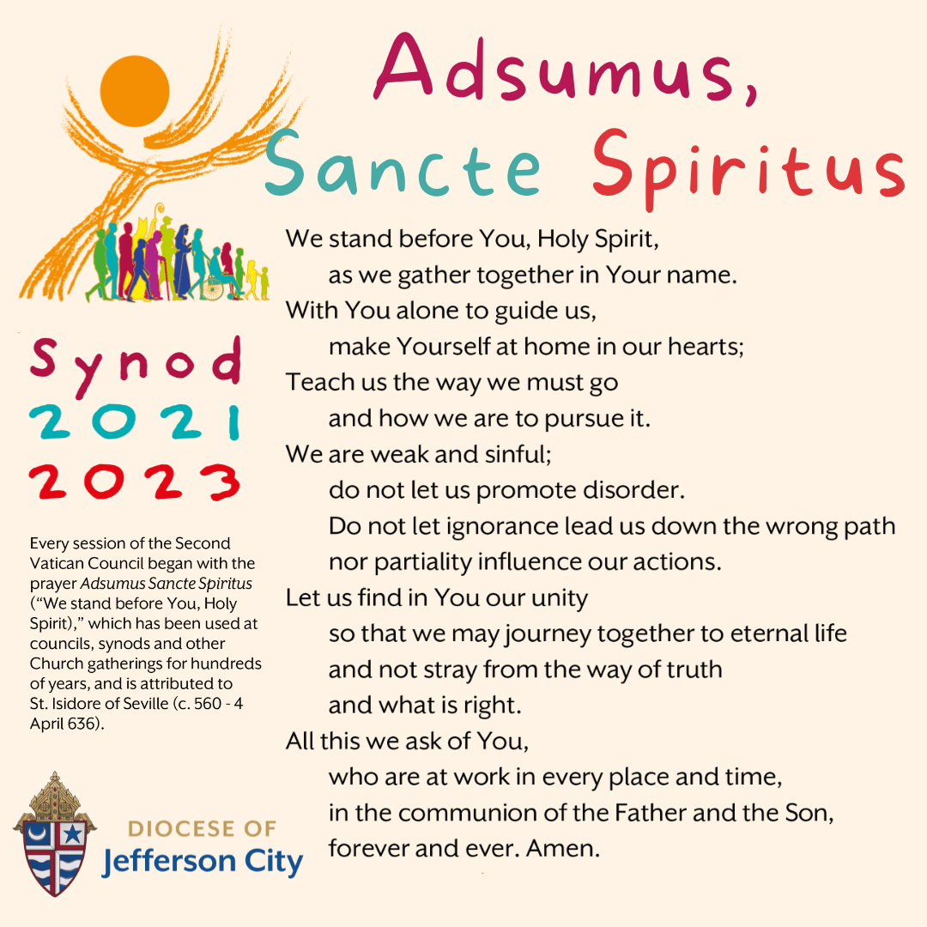

SYNOD SURVEYS ~ Synod Surveys can be found online at dioceseaj.org/synod or paper surveys can be found at the entrances of the Church, or you can join our Scriptural Faith Sharing Group. Please return your surveys by Offertory Collection, mail them to the Office or place them in the drop off box located by the Office door.

GREATER JOHNSTOWN COMMUNITY CHORUS ~ Do you like to sing? The Greater Johnstown Community Chorus is accepting new members. We are a local performing and social group of singers who enjoy all forms of music from classical to pop. Under the direction of Michael Miketa, we meet Tuesdays 7 – 9 PM at Mount Calvary United Methodist Church on Scalp Ave. in the back lower level. If you are interested come on over and join us or you can contact Anita Lorek at 814-487-7769, 814-243-0149 or email [wlorek1852@comcast.net](mailto:wlorek1852@comcast.net) for additional information. Auditions are not required. Covid vaccinations and masks are required.

FEBRUARY 2022 PARISH TICKET WINNERS

UNSOLD TICKETS/NOT RETURNED TICKETS ~ If the winning number is a ticket that was not sold or returned, the money will be split with the number above the winning number and the number below the winning number. If the number above or below the winning number was not returned, we will go above or below that number.

Day Date Amount Number Winner



Friday February 18 $75 038 Theresa Arena

Saturday February 19 $100 632 No Winner

631 No Winner

$50 630 Theresa Arena

633 No Winner

$50 634 Mary Adams

Sunday February 20 $100 948 Bob Casti

Monday February 21 $150 074 Catherine Yanzetich



Religious Education And Christian Helping

March 6, 2022



*Sacrament of First Reconciliation ~* Our First Holy Communion class has been preparing for and will receive their Sacrament of Reconciliation for the first time this Saturday, March12, 2022 at 1:00 PM in the church.

Please remember these children in your prayers as they prepare and anticipate the arrival of this very special day.

*********************************************************************

Spring Confirmation Session

Grade 9 ~ Session 9 B ~ Prayer: Communion with God

Our 9th Grade students will be participating in their Spring Session 9 B from 9 to 10:20 a.m. with their classmates today, Sunday, March 6, 2022.

***************************************************************************

*Confirmation Retreats*

Confirmation retreats are scheduled to take place for our 10th, and 11th grade candidates during class time, 9—10:20 a.m. as follows:

Sunday, March 6th ~ 10th Grade – Baptism Retreat (Make-up from 9th Grade year)

11th Grade – Parables Retreat

*Confirmation candidates must be present for their retreat date to fulfill their confirmation requirements and be eligible to receive their Sacrament of Confirmation*

***************************************************************************

Grades 9, 10, 11 and 12

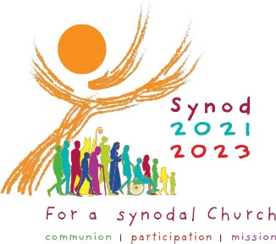 Sunday, March 20, 2022

Evening class 6:30 to 8:00 PM, in lieu of our AM class

On Sunday, March 20, 2022, in lieu of our AM class, we will have an evening class from 6:30—8:00 PM for all our students in Grades 9, 10, 11 and 12 to welcome Pastoral Consultant, Mr. John Livingston. John is a young, inspirational speaker who immediately engages and inspires his audience in faith. He is currently Pastoral Associate for Music and Evangelization at St. Thomas More University Parish.

Junior High Youth Day ~ Sunday, March 20, 2022 ~ Grades 6, 7 & 8

Junior High Youth Day 2022 is scheduled for Sunday, March 20.  JHYD is now part of our Religious Education curriculum for our 6th, 7th & 8th grade students in our Diocese of Altoona-Johnstown. All of our students in grades 6th, 7th and 8th will participate in JHYD in lieu of their CCD class for that Sunday.

Due to continued COVID issues, JHYD will be a virtual Zoom event on site at our Saint Michael Parish. The day will begin at 10:00 AM and last until 12:30 PM. Refreshments will be provided for the day.

Jesse Mannibusan will be the keynote speaker this year. Bishop Mark will also be joining us. There is no fee to participate. We will be on a zoom link with all the other parishes throughout our Altoona/Johnstown Diocese and will participate in group activities together.

\**Since JHYD is taking place over our 10:30 AM Mass, students will need to attend our Saturday, 4 PM Mass or the Sunday, 8:00 AM Mass to fulfill their Sunday Mass obligation.*

A completed registration/permission form is required and is due back to the RE Office by Sunday, March 13th so I can register our group with the diocese.

*********************************************************************

Catholic Relief Services ~ RICE BOWLS

Catholic Relief Services Rice Bowls have been distributed to the Religious Education students, one per family, in their RE classes. These Rice Bowls can be used by families during the Lenten season. Through CRS, your donations can help reach more than 140 Million people with lifesaving support. Thank You for changing lives this Lent!

*********************************************************************



Confirmation ~ Our 11th Grade Confirmation class is preparing to receive their Sacrament of Confirmation on Thursday, April 21st, 2022. A 7:00 PM Mass will be celebrated at Saint John Gualbert Cathedral in Johnstown. *Confirmation Practice will be held on Wednesday evening, April 20th at 6:30 PM.*

First Holy Communion ~ Our First Holy Communion class is preparing to receive their Sacrament of First Holy Communion on

Sunday, May 1, 2022 at 2:00 PM.

LENTEN FISH FRY ~ The St. Michael Fire Department is hosting our annual Lenten Fish Fries – Every Friday during lent thru Good Friday – April 15th. Meals are Fried or Baked Fish or Shrimp Dinners. A Grab-n-Go sandwich and child’s dinners are also available. Meals are takeout only and local delivery. Adult Fish Dinners are $11 and Adult Shrimp dinners are $12. Please Phone at 814-495-4111. Hours are 11 AM to 6 PM.

FISH FRY ~ Every Friday during Lent including Good Friday. 4:00 – 6:30 PM New Germany Grove Hall, 1635 New Germany Road, Summerhill. Dine-In now open. Adults: $15, Children 6-11, $7.50, children under 6 – Free. Take-out available by drive thru only. Drive-thru price is $14 with choice of baked or fried fish.

Sunday, March 6 Mass ~ 8:00 AM & 10:30 AM

Confessions / 7:30 – 7:45 AM & 10:00 - 10:15 AM / Confessional

HS Religious Education / Hall / 9 – 10:15 AM

9th Grade Session / Hall / 9:00 AM – 10:20 AM

10th & 11th Grades Retreat / Hall / 9:00 AM – 10:20 AM

Black & Indian Mission Second Collection

Monday, March 7 Mass ~ 9:00 AM

Sunday Choir Practice / 7:00 PM

Tuesday, March 8 Mass ~ 9:00 AM

 Boy Scout Meeting / Hall / 7:30 – 9:00 PM

Finance Council Meeting / Hall Rm #2 / 3:30 PM

Wednesday, March 9 Mass ~ 6:00 PM

Thursday, March 10 Mass ~ 9:00 AM

K – 5 Religious Education / Hall / 3:30 – 4:30 PM

Saturday Choir Practice / 4:30 PM

Pastoral Council Meeting / Hall Rm #2 / 6:30 PM

Friday, March 11 Mass ~ 9:00 AM

Stations of the Cross / 6:00 PM

Confessions following Stations of the Cross

Saturday, March 12 Mass ~ 4:00 PM

Confessions / 3:30 – 3:45 PM / Confessional

Second Grade First Reconciliation / Church / 1:00 PM

Land of Peace Religious Articles

UPCOMING EVENTS



March 13 Scout Sunday

Land of Peace Religious Articles

Holy Name Society Meeting

Coffee & Donuts

March 19 & 20 Catholic Ministries Drive Announcement/Kickoff

Holy Name Society Chicken Soup Sale & Pickup