ST. MICHAEL ROMAN CATHOLIC CHURCH

751 Locust Street

PO Box 103

St. Michael, Pennsylvania 15951

Rev. Msgr. David A. Lockard, Administrator MASSES:

(814) 495-9640 Saturday 4:00 pm



Sunday Morning 8:00 am

Secretary & Bookkeeper: 10:30 am

Michele Panick Daily Mass: M,T,W,Th,F Noon

DRE: Laurie Sloan Holy Days: See Bulletin

Maintenance: Rodney Turgeon Office Hours:

PHONES: 8:30 am to 3:30 pm

Rectory / Office: (814) 495-9640 Monday, Tues., Thurs., Friday

Fax: (814) 495-9424 Confessions:

Rel. Education: (814) 495-4873 Saturday 3:30 pm to 3:45 pm

Parish Website Sunday 10:00 am to 10:15 am

[www.saintmichaelchurch.weebly.co](http://www.saintmichaelchurch.weebly.co)m By Appointment

Secretaries’ E-mail

[saintmichaelsecretaries@yahoo.com](mailto:saintmichaelsecretaries@yahoo.com)

Facebook page:

St. Michael Catholic Church/St. Michael, PA

First Sunday of Lent

SERVING GOD AND COMMUNITY FOR OVER ONE HUNDRED YEARS!

February 21st, 2021

BAPTISM: By Appointment. Reserve at least one month in advance.

MARRIAGE: Plan at least nine months in advance.

Preparation sessions are necessary.

FUNERALS: Arrangements are made in conjunction with the funeral home.

REGISTRATION Those new to the area, newlyweds, and single adults, (even if registered

and before with their families) are asked to register by calling the Parish Office.

MEMBERSHIP: Every parishioner must be registered. This is a condition for admission

to our Program and reception of the Sacraments of Baptism, Confirmation,

First Penance, First Eucharist, and Matrimony; also, for testimonial letters or sponsorship of Baptism and Confirmation outside the Parish.

VISITATION: We are concerned and want to be advised when someone is ill at home or in the hospital. Call the office to have the shut-in placed on our monthly Holy Communion calls or seriously ill prayer list.

SACRAMENTAL Parish registration and active Mass participation for Baptism is

POLICY: encouraged and is required for Marriage.

BULLETIN ARTICLES: Articles are due to the Parish Office by Noon on Tuesday.

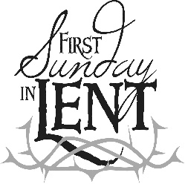

First Sunday of Lent

February 21, 2021

Month of The Holy Family

**MASS INTENTIONS**: (February 22 – February 28, 2021)

Monday, Feb. 22 Noon Agnes Noon req. by Ed & Henrietta Snyder

Tuesday, Feb. 23 Noon Irene & Ray Baldwin req. by Carl & Pam Freidhoff

Wednesday, Feb. 24 6:00 PM Stella Pinkas req. by Mary Ann Murin

Thursday, Feb. 25 Noon Thomas Vandzura req. by Vince & Theresa Arena

Friday, Feb. 26 Noon Francis Powers req. by Jeanne English

Saturday, Feb. 27 4:00 PM People of the Parish

Sunday, Feb. 28 8:00 AM Jane Plummer req. by Susan Blazosky

10:30 AM Michael Koshute req. by Paul & Cynthia McCloskey

LITURGICIAL APPOINTMENTS:

Saturday, February 27 4:00 PM

Lector: Susan Poldiak

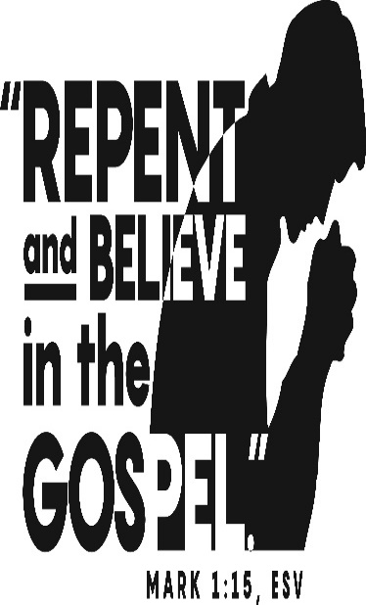Minister of the Host: Babe Richards

Altar Server: Brooke Williamson

Cantor: Amanda Williamson

Sunday, February 28 8:00 AM

Lector: Pauline Minor

Minister of the Host: Marie Bernard

Altar Server: Kaden Christ

Cantor: Anita Lorek

Sunday, February 28 10:30 AM

Lector: Tony Bambino

Minister of the Host: Robert Oshaben

Altar Server: Jackson Henderson

Cantor: Lou McCloskey

Sunday, February 28 Collection Counters

Chris Smay & Sara Zybura

Mary Ann DeRosa

Weare placing names of the sick in the bulletin for prayer providing they give permission. *May the* *Divine Physician send healing grace for those for* *whom we pray:* Allen C. Rosemas, Patricia Murphy, Bernice Myers, Dwight Fyock, Dylon Wills, Missy, Joanne (Kolar) Hufford, Christine Flanagan, Ayden Alan Grata, Mary Lou Offman, Mary Zangaglia, Natalie Zerby, Valencia Tursi, Homer Locher, Brayden Schofield, Michelle Kasper, Diane Kingera, Ted Paluch, Pearl Litzinger, Patrick Munro, Fran Baldassarre, Kristen Sinosky Long, Cresta Micik, Basil Costantino, Laura, Joe Yoder, Dolores Yanzetich, Sandy Krug, Wanda Gramling, Jennifer Hagans, Shawn, Holly, Shane, Spencer, Owen Taylor, Derrick Varnish, Vincent Koshute, Michelle Elliott, Heather Romanow, Mackston Barrick, Connor Thomas, Erin, Pat, Mary Agnes Nastase, Mary Ann Bertolino, Dick Wilson, Izzy Bihun, Dorothy Kaminsky, Patricia Oshaben, Ashlee Madison, Susan Yanzetich, Mike, Alina Rusnak, Gary Smay, Elizabeth Howell, Walter Bodziak, Rhonda, Anne Robinson, Carter Bobak, Vince Arena, Mike Morris, Sarah Kelt, Patty Yanzetich Caldwell, Colton Snyder, Nancy Edmiston, Leonard Oshaben, Adam, Janice Dipyatic, Lily Maloney, Scott, Lisa, Audrey Costlow, Cathy Sossong, Rosanne Krug, Becky Kakabar, Howard Delaney, Ed Myers, Dolores Mucko, Elliana, Ashlee, Helen Soohy, Carol K. Fabrizio, Peggy Carpenter, Janet Minor, Dave Seder, Rosalie Ambrose, Pearl Borlie, Joe (Runk) Slonac, Diane Neri, Sharon Poldiak and all of the sick of our parish, the homebound, those in nursing homes, those who care for them, and those in the military along with their families. *(Please call the Rectory to have your name removed from the list when no longer seriously ill. Thank You.)*

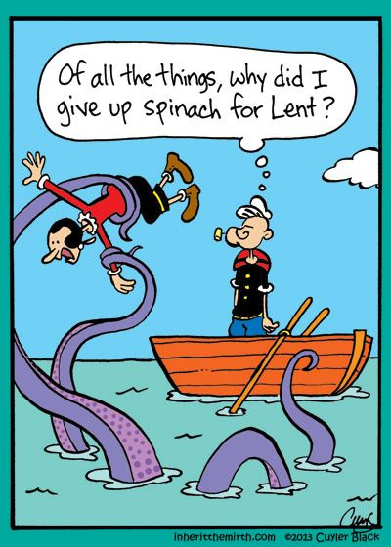

LAST WEEK’S COLLECTION

Adults $2,933.00

Loose $ 104.25

Youth $ 24.00

Monthly $1,922.00

Initial Offering $ 11.00

Candles $ 103.00

Maintenance Fund $ 90.00

Solemnity of Mary $ 11.00

Easter Flowers $ 110.00

Black & Indian $ 77.00

Mandeville Diocese $ 62.00

Total $5,447.25

We sincerely thank and

ask God’s blessing upon

all who have care and

concern for our parish.

*February 21, 2021 Mark 1:12-15*

*Jesus went into the desert to put his life in perspective. This lent, take a fresh look at a difficult relationship in your life. Concentrate on the positive things that person does, not just the negatives. Try to understand why their behaviors “bug” you. Can you honestly share your feelings with them without attacking them? Make Lent a time to MEND and FORGIVE!*

During the week of February 21st, 2021

The Sanctuary Candle will burn in memory of

Aloysius Neff

requested by wife, sons, and grandchildren

and

The Our Lady of Grace Candle will burn for

God’s Grace and Healing for cousin

Steve Koshute

requested by Paul and Cynthia McCloskey

[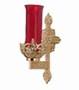](https://images.search.yahoo.com/search/images;_ylt=A0LEV1kSWptXvOwAKINXNyoA;_ylu=X3oDMTEyZGdkcmRoBGNvbG8DYmYxBHBvcwMxBHZ0aWQDQjIwODlfMQRzZWMDc2M-?p=Clipart+of+a+sanctuary+candle&fr=ush-mailn_02&th=110&tw=110&imgurl=http://www.henningers.com/389-168-wall-sanctuary-lamp.jpg&rurl=http://pixshark.com/sanctuary-lamp.htm&size=43KB&name=Sanctuary+Lamp+Bronze+wall+sanctuary+lamp&h=600&w=600&turl=http://ts2.mm.bing.net/th?id=OIP.M68453c67108cdc5ab485d309b395bd03o0&pid=15.1&rs=1&c=1&qlt=95&w=110&h=110#inline&tt=Sanctuary+Lamp+Bronze+wall+sanctuary+lamp&sigr=116keh5le&sigit=13gvlt42j&sigi=11ip0pgm4&sign=119kp6100&sigt=119kp6100)

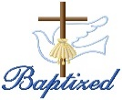

BAPTISM ~ On Saturday February 13th, 2021, we celebrated the baptism of Liam Joseph Marks son of Joseph and Kelly Ann (Green) Marks by Msgr. David Lockard. Liam Joseph became a new creation in Christ in the waters of Holy Baptism. Now joined to us by the gifts of faith, hope, and charity, we warmly welcome him into our St. Michael Parish Family.

SECOND SUNDAY FOOD COLLECTION ~ Thank you to all who so generously donated to the Forest Hills Food Pantry. The total money collected was $1,034.00 and an assortment of non-perishable items.

BLACK AND INDIAN MISSION COLLECTION ~ Today, our parish will take up the 137th annual National Black and Indian Mission Collection. Our support of this collection helps build the Church in African American, Native American, and Alaska Native communities from coast to coast. Schools, parish religious education programs, and diocesan ministries depend on your generosity to help them spread the Gospel of Jesus Christ! You can help meet unmet needs with a generous contribution today. Thank you for your support. Envelopes can be found in your packet.

HAM & CHICKEN TAKE-OUT DINNER ~ Boy Scout Troop #2251 is holding a Take-Out Ham and Chicken Dinner on March 6th, from 5:00 – 6:30 PM. The dinner includes Ham, Chicken, Potatoes, Green Beans, Coleslaw, Roll, and Cake. Adults - $12 & Children - $8. Dinners may be picked up in the back parking lot behind the St. Michael Catholic Church Hall. Tickets are being presold, but a limited number of walkup tickets will be sold on the day of the dinner. To preorder tickets, please call Mrs. Amy Dobbins at 487-4569 or email [dobbins400@comcast.net](mailto:dobbins400@comcast.net). Thank you in advance for your support of the troop.

*Stewardship Reflections…*

Today’s readings remind us that “baptism is God’s most beautiful and magnificent gift” (*Catechism of the Catholic Church; 1216).* In your Lenten Journey, may you recommit yourself to living as Jesus’ disciple and a passionate steward of all God’s gifts in the kingdom of God. We should strive to fully participate in this Lenten season by mirroring Jesus, the model steward by whom we are called to imitate. Through our time in the desert, we will confront evil by weeding out the roots of sin in our lives through fasting. May we be sustained and nourished in the desert by prayer. (Stewardship Reflections, Catholic Stewardship Consultant, January 25, 2021)



Religious Education And Christian Helping

February 21, 2021

Religious Education News

Home Lesson Packet #5 has been distributed for all students in Grades K—11.

For those that missed the scheduled pick-up times with catechists, an alternate pick-up option is available. There is a Big Blue Tote outside the Parish Office door marked: "Religious Education Pick-Ups & Drop Offs".  It can be accessed anytime to make it easier to Pick-up missed lessons and also Drop-off the completed ones.  Look for your "Family Name" on the name tag attached to the bag.

You can stop anytime at your convenience even after office hours.  Completed lessons can also be placed in the tote and will be given to each grade’s catechist.

First Reconciliation Retreat ~ Our eligible Second Grade students will be attending their Reconciliation Retreat and receiving their sacrament of First Reconciliation on Saturday, March 6th beginning at 10:00 AM in the church.

10th Grade Gifts of the Holy Spirit Retreat: Our 10th grade confirmation candidates will participate in a virtual Gifts of the Holy Spirit Retreat provided through the diocese beginning on February 28th via Zoom and home assignments.

*******************************************************************************************************************

FEBRUARY 2021 PARISH TICKET WINNERS

UNSOLD TICKETS/NOT RETURNED TICKETS ~ If the winning number is a ticket that was not sold or returned, the money will be split with the number above the winning number and the number below the winning number. If the number above or below the winning number was not returned, we will go above or below that number.

Day Date Amount Number Winner

Friday February 12, 2021 $75 502 Nathan Kundrod

Saturday February 13, 2021 $100 769 Ticket Not Sold

$50 768 Elaine Barton

770 Ticket Not Sold

771 Ticket Not Sold

$50 772 Margo Myers

Sunday February 14, 2021 $150 530 Paul McCloskey

Monday February 15, 2021 $150 160 Larry & Judy Lacko

Tuesday February 16, 2021 $75 036 Lucia Ann Brezovec

Wednesday February 17, 2021 $75 064 Charlotte Debias

Thursday February 18, 2021 $75 100 Dennis Grattan

 Sunday, February 21 Mass ~ 8:00 & 10:30 AM

Confessions / 10:00 – 10:15 AM / St. Paul Room

Black & Indian US Mission Collection

Monday, February 22 Mass ~ Noon

NO Sunday Choir Practice

 Tuesday, February 23 Mass ~ Noon

Boy Scouts / 7:30 - 9:00 PM

Wednesday, February 24 Mass ~ 6:00 PM

Thursday, February 25 Mass ~ Noon

NO Saturday Choir Practice

Friday, February 26 Mass ~ Noon

Stations of the Cross / 6:00 PM

Abstinence from Meat

Saturday, February 27 Mass / 4:00 PM

Confessions / 3:30 – 3:45 / St. Paul Room

Molly Catherine Brandle Baptism

UPCOMING EVENTS

 February 28 Nora Leigh & Jovie Ann Sloan Baptisms

March 6 Second Grade Retreat & Reconciliation

Boy Scouts Chicken & Ham Take-Out Dinner

March 7 Liturgy Meeting

March 13 & 14 Catholic Relief Services Collection

March 13 Confessions with Msgr. L. & Fr. Nale / 1:30 PM

March 14 Parish Council Meeting

CHURCH HISTORY ZOOM CLASS ~ Church History: The story of diversity, multiple developments, and pluralism. In this 8 – week Zoom online class, Deacon Don Gibboney gives an overview of Church history focusing upon Christianity in Europe from apostolic times to the present. Classes are Wednesdays from 6:00 – 8:30 PM beginning February 24th. Registration fee is $45. To register please contact the Office of Lay Ecclesial Ministry at 814-361-2000 or [mheinze@dioceseaj.org](mailto:mheinze@dioceseaj.org). All are welcome!

PILGRIMAGE TO THE HOLY LAND RESCHEDULED ~ Since there is uncertainty concerning overseas travel, Fr. Dave Peles & Deacon Michael Russo from St. Benedict’s Church, Johnstown, have rescheduled their pilgrimage to the Holy Land. The new dates are April 25 to May 4, 2022. We are able to open the reservations to more pilgrims since we rescheduled our date. For a copy of the brochure & more information, please contact Deacon Michael Russo: 288-3036 or [michael.russo@atlanticbb.net](mailto:michael.russo@atlanticbb.net)

BISHOP CARROLL CATHOLIC HIGH SCHOOL POSITIONS ~ Positions Available: Full-time or part time maintenance/custodian. Head volleyball coach. Please call the school: 814-472-7500 ext.106 for more information.